Part 2 — Extending the Series, 1996–2024
Actual outcomes carried forward from GEAR's 2000 endpoint to the most recent complete year, plotted against GEAR's targets.

Figures
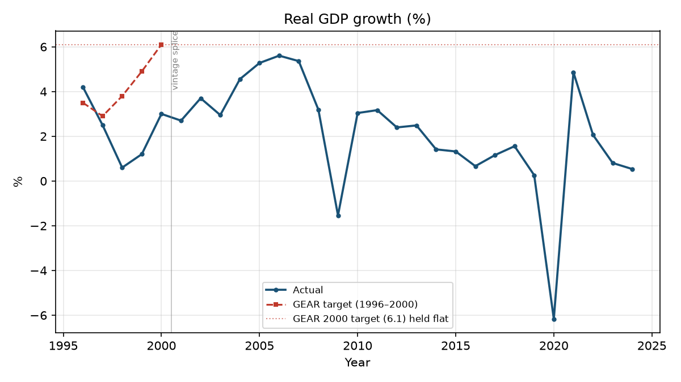
Figure: Real GDP growth (%) — actual vs GEAR target
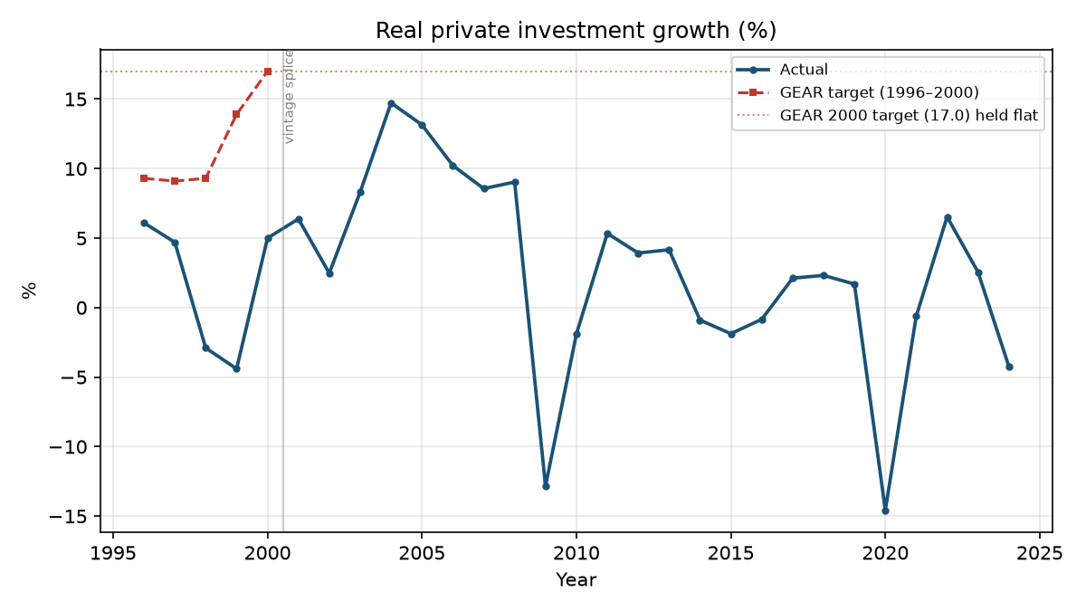
Figure: Real private investment growth (%) — actual vs GEAR target
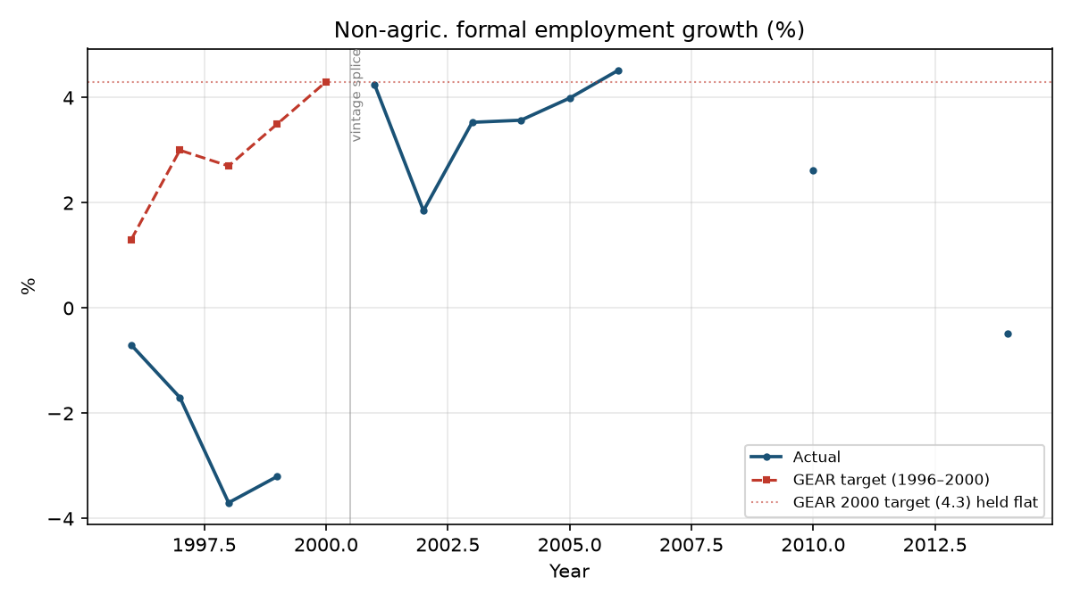
Figure: Non-agric. formal employment growth (%) — actual vs GEAR target
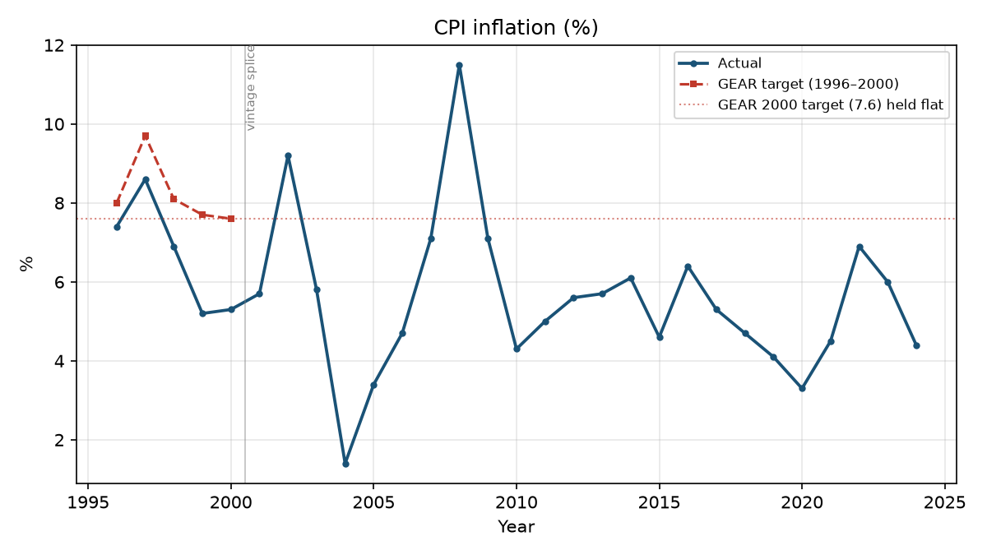
Figure: CPI inflation (%) — actual vs GEAR target
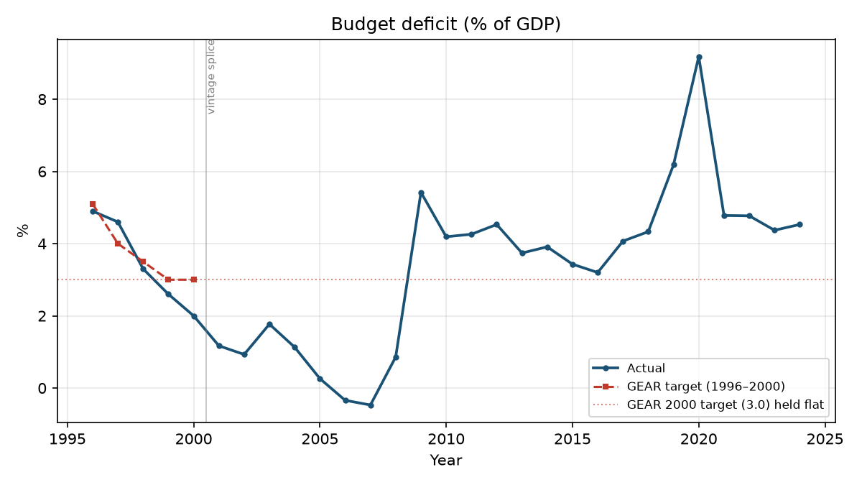
Figure: Budget deficit (% of GDP) — actual vs GEAR target
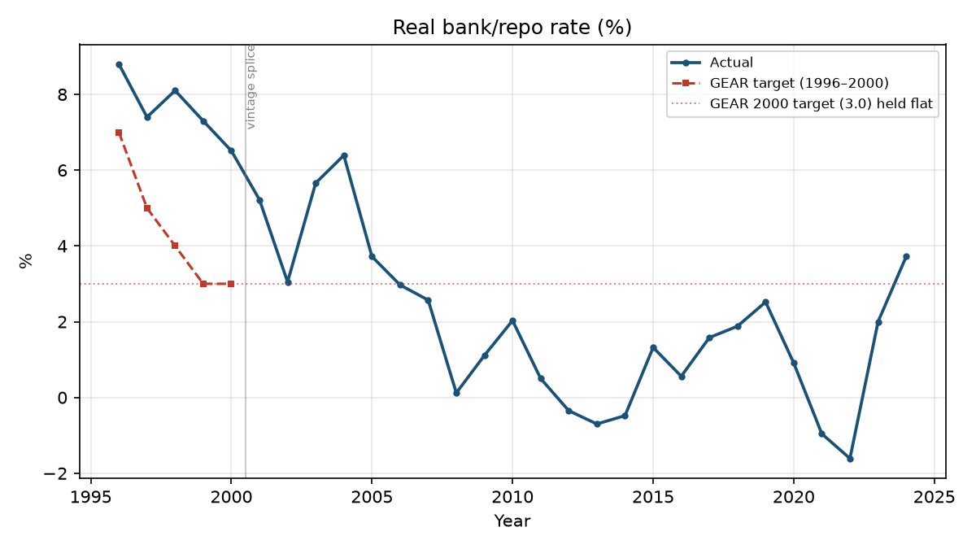
Figure: Real bank/repo rate (%) — actual vs GEAR target

Which targets were met, and when
A target is scored as met if the actual value beat or matched GEAR's own target for that year (1996–2000), or — for years after GEAR's targets stop — beat or matched GEAR's final (2000) target level, treated as the strategy's implied steady-state goal.
Indicator | Years met (of years with data) | Years the target was met
Real GDP growth (%) | 1 / 29 | 1996
Real private investment growth (%) | 0 / 29 | — never
Non-agric. formal employment growth (%) | 1 / 12 | 2006
CPI inflation (%) | 27 / 29 | 1996, 1997, 1998, 1999, 2000, 2001, 2003, 2004, 2005, 2006, 2007, 2009, 2010, 2011, 2012, 2013, 2014, 2015, 2016, 2017, 2018, 2019, 2020, 2021, 2022, 2023, 2024
Budget deficit (% of GDP) | 12 / 29 | 1996, 1998, 1999, 2000, 2001, 2002, 2003, 2004, 2005, 2006, 2007, 2008
Real bank/repo rate (%) | 18 / 29 | 2006, 2007, 2008, 2009, 2010, 2011, 2012, 2013, 2014, 2015, 2016, 2017, 2018, 2019, 2020, 2021, 2022, 2023

Is there a pattern? (There is.)
Yes, and it is stark: the three ‘stabilisation’ indicators (inflation, the deficit, the real interest rate) were met in the overwhelming majority of years after 2000. The three ‘growth’ indicators (GDP growth, private investment growth, employment growth) were essentially never met.
Inflation beat its steady-state target in 27 of 29 years; the deficit beat its target in 13 of 29 (with a clean run 1998–2008 before the post-2008 fiscal deterioration); the real interest rate beat its target in 18 consecutive years from 2006. Real GDP growth beat its target in exactly one year — 1996, before the strategy had time to act. Private investment growth never once reached its target, in either the 1996–2000 window Nattrass covered or the 24 years since.
Why this matters:
GEAR's architects (SAF/GEAR, per Nattrass) bet that credible fiscal and monetary discipline would restore business confidence, and that confidence — not demand — was the binding constraint on private investment. The results here are close to a clean test of that bet, and it fails on its own terms: South Africa delivered the discipline far more successfully than it delivered growth or investment. If confidence were the binding constraint, sustained stabilisation success should have been followed by a sustained investment and growth response. It was not. That is the pattern GEAR's critics — the LABOUR/ILO side, in Nattrass's framing — pointed to: investment looks far more tied to demand conditions (tested directly in Part 3) than to the confidence signals GEAR targeted.
A caveat belongs here too, because the brief warns against a lazy ‘GEAR simply failed’ reading: growth did accelerate for a real stretch, 2004–2007 (peaking near 5.6% in 2006), alongside a budget surplus and the lowest inflation of the whole series (2004: 1.4%) — the one period where stabilisation and growth moved together. That episode complicates a simple ‘stabilisation without growth’ story and is engaged with directly in Parts 3 and 4, not glossed over.

Data-quality flag carried over from this step
Non-agric. formal employment growth is only observable for 12 of the 29 years (1996–1999, 2001–2006, 2010, 2014). The run from 2016–2024 — exactly the period that would show how employment behaved after the 2008 financial crisis and through the COVID shock — is not covered by any source supplied. This is reported as a genuine limitation of the available data, per trap #1, rather than bridged by interpolation or a spliced-together series that would misrepresent three incompatible surveys (OHS, LFS/QLFS, QES) as one continuous measure.

