Part 3 — Testing the Gamble: Private Investment, Demand and the Fiscal Signal

Specification
inv_growthₜ = β₀ + β₁·gdp_growthₜ₋₁ + β₂·real_rateₜ + β₃·deficit_gdpₜ + εₜ
Annual data, 1994–2024, N = 31, estimated on a single consistent current vintage (SARB / StatsSA). Newey–West (HAC, lag 1) standard errors throughout.
Sign convention: deficit_gdp is POSITIVE when the budget is in deficit. The LABOUR/ILO ‘demand’ position predicts β₁ > 0 (investment follows demand). The SAF/GEAR ‘confidence/signal’ position predicts β₃ < 0 (a larger deficit damages confidence, so consolidation crowds investment in).

Main result
Full sample, 1994–2024
Variable | Coefficient | HAC s.e. | p-value
Intercept | 8.264 * | 2.701 | 0.002
Lagged real GDP growth (DEMAND) | 0.521 | 0.389 | 0.180
Real bank rate | -0.062 | 0.372 | 0.868
Deficit, % of GDP (SIGNAL) | -1.831 * | 0.596 | 0.002
N = 31; R² = 0.422; adj. R² = 0.358. * = p < 0.05.

Read alone, this looks like a clean win for GEAR: the signal channel is significant with exactly the predicted sign, and the demand channel is not significant. Two tests show it should not be read alone.

Diagnostics
Test | Statistic | Conclusion
Durbin–Watson | 1.184 | Below 2 — positive autocorrelation likely
Breusch–Godfrey AR(1) | LM = 5.01, p = 0.025 | Autocorrelation present — HAC s.e. required
Breusch–Pagan | LM = 3.75, p = 0.290 | No evidence of heteroskedasticity
Jarque–Bera | JB = 0.08, p = 0.960 | Normality not rejected

All variance inflation factors are below 1.6, so multicollinearity is not a concern.

Test 1 — the sign reverses across the 2008 split
Chow test for a structural break at 2008: F(4, 23) = 4.01, p = 0.013 — parameter stability is rejected.
Sub-sample A: 1994–2007
Variable | Coefficient | HAC s.e. | p-value
Intercept | 9.950 * | 4.412 | 0.024
Lagged real GDP growth (DEMAND) | 0.870 | 0.548 | 0.113
Real bank rate | -1.374 * | 0.346 | 0.000
Deficit, % of GDP (SIGNAL) | 1.666 * | 0.628 | 0.008
N = 14; R² = 0.506; adj. R² = 0.357. * = p < 0.05.

Sub-sample B: 2008–2024
Variable | Coefficient | HAC s.e. | p-value
Intercept | 10.561 * | 2.309 | 0.000
Lagged real GDP growth (DEMAND) | 0.297 | 0.300 | 0.322
Real bank rate | -0.871 | 0.582 | 0.134
Deficit, % of GDP (SIGNAL) | -2.311 * | 0.506 | 0.000
N = 17; R² = 0.521; adj. R² = 0.410. * = p < 0.05.

The signal coefficient does not merely weaken — it flips sign and is significant in both directions (+1.67 before 2008, −2.31 after). A coefficient that reverses like this is not measuring a stable behavioural parameter; the full-sample estimate is an average of two opposite regimes.

Test 2 — two recession years drive the entire result
This is the endogeneity trap made concrete. In 2009 and 2020 the deficit exploded and private investment collapsed — but the recession caused both. Automatic stabilisers widen the deficit in a downturn by construction, so the correlation runs recession → deficit, not deficit → lost confidence → falling investment.
Full sample excluding 2009 and 2020
Variable | Coefficient | HAC s.e. | p-value
Intercept | 4.490 | 2.393 | 0.061
Lagged real GDP growth (DEMAND) | 0.941 * | 0.324 | 0.004
Real bank rate | -0.027 | 0.329 | 0.933
Deficit, % of GDP (SIGNAL) | -0.697 | 0.483 | 0.150
N = 29; R² = 0.333; adj. R² = 0.253. * = p < 0.05.

2008 onwards, excluding 2009 and 2020
Variable | Coefficient | HAC s.e. | p-value
Intercept | 2.076 | 2.950 | 0.482
Lagged real GDP growth (DEMAND) | 0.747 * | 0.144 | 0.000
Real bank rate | -0.984 * | 0.318 | 0.002
Deficit, % of GDP (SIGNAL) | -0.143 | 0.656 | 0.827
N = 15; R² = 0.575; adj. R² = 0.459. * = p < 0.05.

Removing two observations out of 31 reverses the interpretation entirely: the signal channel loses significance (p = 0.15, then p = 0.83) while the demand channel becomes strongly significant and economically large — a one-point rise in last year's GDP growth is associated with roughly a one-point rise in private investment growth.
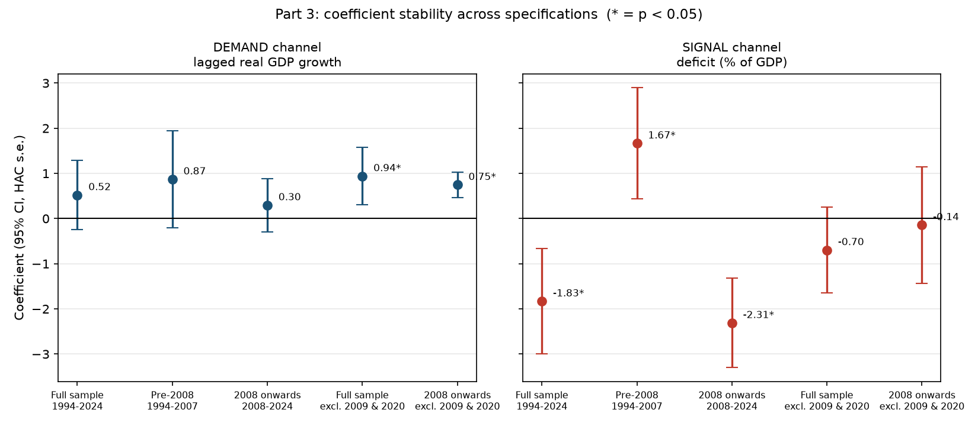
Figure: coefficient stability across specifications. The demand coefficient is positive throughout and tightens as crisis outliers are removed; the signal coefficient swings from +1.67 to −2.31 and collapses toward zero without them.

Which stable does the evidence favour?
On balance the demand (LABOUR/ILO) channel — but with real qualifications, and the honest answer is that the evidence is mixed in a specific, diagnosable way.
The case for demand: β₁ is positive in every specification run, and becomes significant precisely when the observations most contaminated by reverse causation are removed. That is the pattern expected from a real relationship obscured by noise, not one manufactured by it.
The case against over-claiming it: β₁ is not significant on the full sample (p = 0.18), and it depends on the GDP series used. Re-running with Boshoff & Fourie's factor-cost GDP gives β₁ = 0.264 (p = 0.774) — nothing survives. That is a genuine fragility: the demand result holds on SARB market-price GDP and vanishes on B&F factor-cost GDP over a shorter (1994–2018) sample, and the shorter sample cannot be cleanly separated from the definitional switch.
What can be said with more confidence is the negative finding: there is no robust evidence for the confidence channel GEAR was built on. The one specification where the signal channel is significant with GEAR's predicted sign is also the one most obviously contaminated by recession-driven simultaneity, and it does not survive removing two outlier years. GEAR's central bet — that consolidation would signal credibility and thereby unlock private investment — is not supported here, consistent with Part 2's finding that South Africa delivered the consolidation without ever once hitting an investment target.
The pre-2008 positive deficit coefficient (+1.67) deserves a note rather than a celebration. It has the demand sign, but 1994–2007 is exactly when deficits were shrinking while investment was rising, so a positive coefficient is as easily read as coincident trends as causation. With N = 14 and no instrument, it cannot bear weight.

Does the answer change if you split at 1994, or at 2008?
At 2008: yes, decisively — the Chow test rejects stability and the signal coefficient reverses sign. This is the most informative single result in Part 3.
At 1994: the split cannot be run. The supplied deficit and policy-rate series both begin in 1994, so there are zero pre-1994 observations for two of the three regressors. This is a data-availability limit, not a modelling choice, and is reported as not estimable rather than approximated with a different specification presented as the requested test.

Limitations
- Endogeneity is diagnosed, not solved. Investment, growth and the deficit are jointly determined; no instrument is used, so no coefficient here can be read as causal. The crisis-year exercise shows which results are most contaminated by simultaneity — a weaker but honest claim.
- N = 31, with sub-samples of 14 and 17. Power is low and the sub-sample results should be read as suggestive.
- The dependent variable's definition is not fully verified: the private investment series carries no source or series code. Its 2009/2020 contraction magnitudes are consistent with a private-only series, but that is corroboration, not confirmation.
- GDP vintage matters to the answer. The demand result holds on SARB market-price GDP and does not hold on Boshoff & Fourie factor-cost GDP. Both are reported.
- The real rate is ex-post (nominal minus realised CPI), following Nattrass's own construction, not an ex-ante rate using inflation expectations.

