1. A Boolean value is either True or False. Expression:

3 == 2 + 1 (True)

5 > 1 (True)

Len(“hi”) = 3 (False)

2. A flowchart is a type of diagram that represents an algorithm. 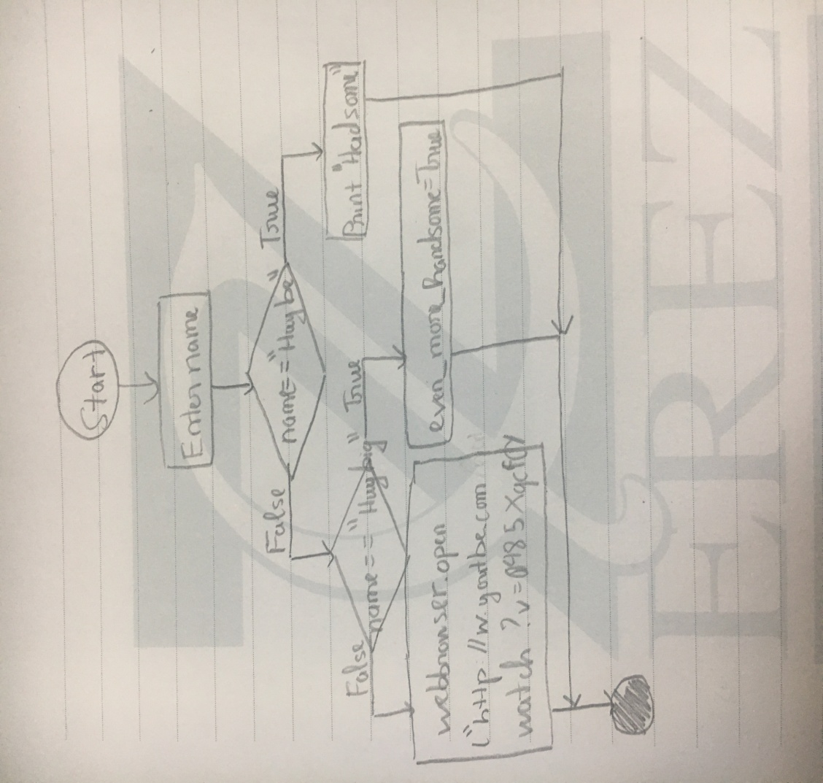

3. A nested conditional is a type conditional that inside another conditional.

If x > 0:

print(“Gia tri duong”)

else:

if x<0:

print(“Gia tri am”)

else:

print(“Gia trị bang 0”)