Project Proposal

WORKLOG Mobile Application

WorkLog

Purpose:

The purpose of the app is to enable users to log their shift timings and hourly rate. Thus, this app gives a total earned of the shift and reminds to swipe-in, swipe-out, suggest taking a break as a notification.

Wireframe:

<https://wireframe.cc/pro/pp/d60f9d5a9517376>

Scope:

1. Login Screen:

Design a login screen or use the system pin to authorize into the app.

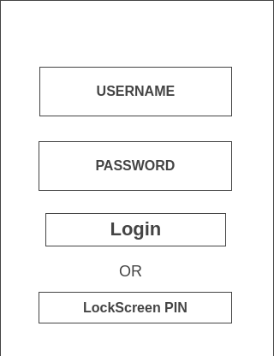

1. Dashboard

This screen gives the overview of decks user created. A button to create new deck, total earnings text view at the bottom gets the total earnings from all the decks.

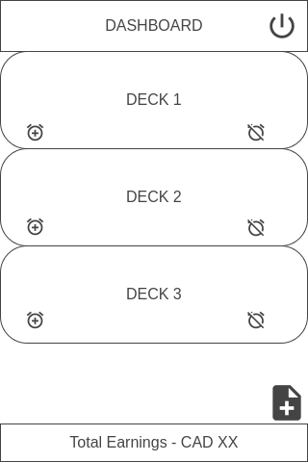

1. WorkDeck

This screen takes the user input of the company name, shift start, shift end, hourly rate, tips. There will be two buttons swipe-in and swipe-out. The user should log both swipe-in and swipe-out to calculate the total earnings for the shift.

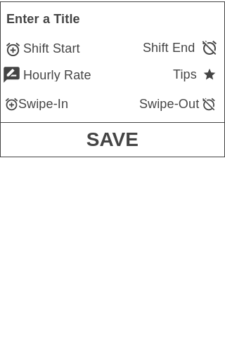

1. Screen Notifying

This screen takes full view of the mobile screen highlighting the details. Like notifying not to forget the swipe-in, swipe-out at the start of the shift and end of the shift. It also displays a random fact using third party API to cheer.

