Exercice d’application :

base de donnée : scolarité

Table : stagiaire

Connexion :

Script : connexion.php
<?php

//PDO

$servername = 'localhost';
$username = 'root';
$password = '';
//$db = 'scolarite';

try {

$dsn = "mysql:host=$servername";
$conn = new PDO($dsn, $username,$password);
// set the PDO error mode to exception
$conn->setAttribute(PDO::ATTR_ERRMODE, PDO::ERRMODE_EXCEPTION);
echo "Connected successfully";
} catch(PDOException $e) {
echo "Connection failed: " . $e->getMessage();
}
$conn = null;
?>

Le résultat :


Création de la base de données :

Script : creation_db.php
<?php
$servername = "localhost";
$username = "root";
$password = "";

try {
$conn = new PDO("mysql:host=$servername", $username, $password);
// set the PDO error mode to exception
$conn->setAttribute(PDO::ATTR_ERRMODE, PDO::ERRMODE_EXCEPTION);

$sql = "CREATE DATABASE scolarite";

// use exec() because no results are returned
$conn->exec($sql);
echo "Database created successfully<br>";
} catch(PDOException $e) {
echo $sql . "<br>" . $e->getMessage();
}

$conn = null;
?>

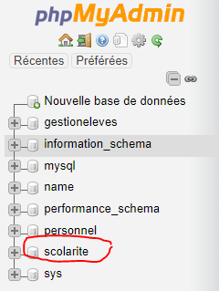
Le résultat :
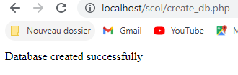

Création de la table : stagiaire
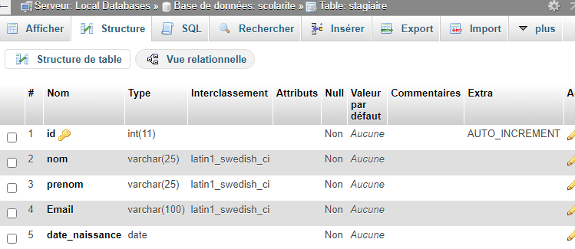

Script : creation_db.php
<?php
$servername = "localhost";
$username = "root";
$password = "";
$dbname = "scolarite";

try {
$conn = new PDO("mysql:host=$servername;dbname=$dbname", $username, $password);
// set the PDO error mode to exception
$conn->setAttribute(PDO::ATTR_ERRMODE, PDO::ERRMODE_EXCEPTION);

// sql to create table
$sql = "CREATE TABLE stagiaire (
id INT NOT NULL AUTO_INCREMENT PRIMARY KEY,
nom VARCHAR(25) NOT NULL,
prenom VARCHAR(25) NOT NULL,
email VARCHAR(100),
date_naissance DATE NOT NULL
)";

// use exec() because no results are returned
$conn->exec($sql);
echo "Table stagiaire created successfully";
} catch(PDOException $e) {
echo $sql . "<br>" . $e->getMessage();
}

$conn = null;
?>

Le résultat :
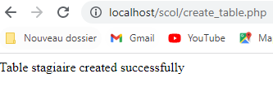
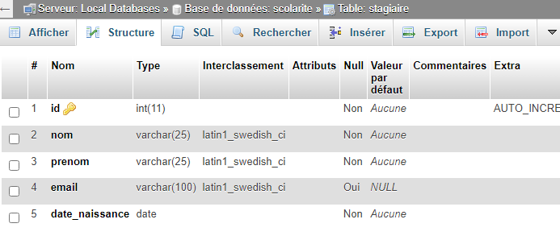

INSERT
On souhaite insérer une entrée dans la table stagiaire.

Script : insert_data_table.php
<?php
$servername = "localhost";
$username = "root";
$password = "";
$dbname = "scolarite";

try {
$conn = new PDO("mysql:host=$servername;dbname=$dbname", $username, $password);
// set the PDO error mode to exception
$conn->setAttribute(PDO::ATTR_ERRMODE, PDO::ERRMODE_EXCEPTION);

$sql= "insert into stagiaire (nom,prenom,email,date_naissance) values('sais','lamia', 'karmer8281@gmail.com,', '2000-11-02')";

$conn->exec($sql);
echo "New records created successfully";
} catch(PDOException $e) {

echo "Error: " . $e->getMessage();
}

$conn = null;

Le résultat :

Vérification dans phpmyadmin :
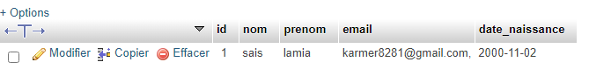

SELECT
On souhaite récupérer les données qui se trouvent dans la table stagiaire.
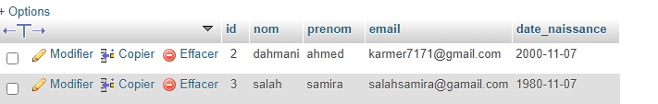

Script : select_data.php
$servername = "localhost";
$username = "root";
$password = "";
$dbname = "scolarite";

try {
$conn = new PDO("mysql:host=$servername;dbname=$dbname", $username, $password);
// set the PDO error mode to exception
$conn->setAttribute(PDO::ATTR_ERRMODE, PDO::ERRMODE_EXCEPTION);

$stag=$conn->query("select * from stagiaire ");

$stagiaires=$stag->fetchAll(PDO::FETCH_ASSOC);
foreach ($stagiaires as $stag){
echo $stag['nom'] . "\t";
echo $stag['prenom'] . "\t";
echo $stag['email'] . "\t";
echo $stag['date_naissance'] . "\t";
echo "<br>";
}
} catch(PDOException $e) {

echo "Error: " . $e->getMessage();
}

$conn = null;
?>

Le résultat :

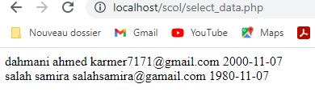

UPDATE



On veut mettre à jour l’entrée numéro 1:
$Nom='oualid';
$Prenom='karim';

$Nom='sais';
Devient
$Prenom=lamia';

Script : update_data.php
<?php
$servername = "localhost";
$username = "root";
$password = "";
$dbname = "scolarite";

try {
$conn = new PDO("mysql:host=$servername;dbname=$dbname", $username, $password);
// set the PDO error mode to exception
$conn->setAttribute(PDO::ATTR_ERRMODE, PDO::ERRMODE_EXCEPTION);
$Nom='oualid';
$Prenom='karim';
$id=1;

$sql= "UPDATE stagiaire SET nom='$Nom', prenom='$Prenom' where id='$id'";

$conn->exec($sql);
echo "New records created successfully";
} catch(PDOException $e) {

echo "Error: " . $e->getMessage();
}

$conn = null;

Le résultat :

Vérification dans phpmyadmin :
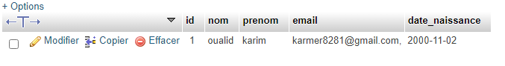
Ou bien :
<?php
$servername = "localhost";
$username = "root";
$password = "";
$dbname = "scolarite";

try {
$conn = new PDO("mysql:host=$servername;dbname=$dbname", $username, $password);
// set the PDO error mode to exception
$conn->setAttribute(PDO::ATTR_ERRMODE, PDO::ERRMODE_EXCEPTION);
/*$Nom='oualid';
$Prenom='karim';
$id=1;

$sql= "UPDATE stagiaire SET nom='$Nom', prenom='$Prenom' where id='$id'";*/
// $sql= "UPDATE stagiaire SET nom='sabri', prenom='sara' where id='1'";*/

$conn->exec("UPDATE stagiaire SET nom='sabri', prenom='sara' where id='1'");
echo "New records created successfully";
} catch(PDOException $e) {

echo "Error: " . $e->getMessage();
}

$conn = null;

Vérification dans phpmyadmin :
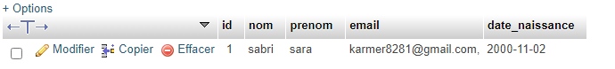

DELETE

Supprimer l’entrée dont le id est : 1

Script : delete_data.php
$servername = "localhost";
$username = "root";
$password = "";
$dbname = "scolarite";

try {
$conn = new PDO("mysql:host=$servername;dbname=$dbname", $username, $password);
// set the PDO error mode to exception
$conn->setAttribute(PDO::ATTR_ERRMODE, PDO::ERRMODE_EXCEPTION);
$id=1;
$sql= "delete from stagiaire where (id=$id)";

$conn->exec($sql);
echo "enregistrement supprimé";
} catch(PDOException $e) {

echo "Error: " . $e->getMessage();
}

$conn = null;
?>

Le résultat :
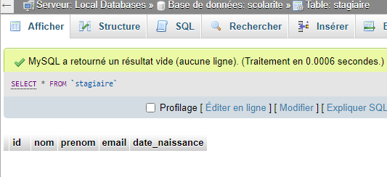
Exemple : Supprimer l’entrée dont le prénom est : sara

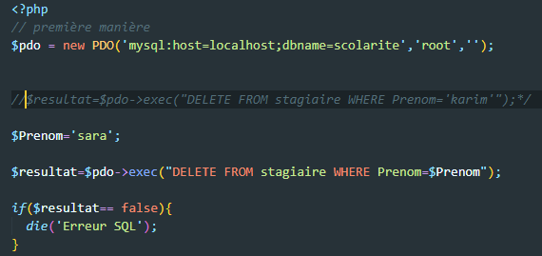
Ou bien : utiliser uniquement l’objet : $pdo
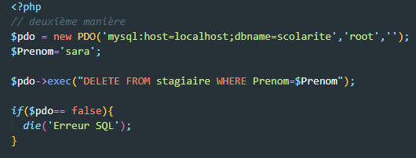
Vérification dans phpmyadmin :
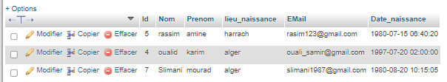
Ou bien :
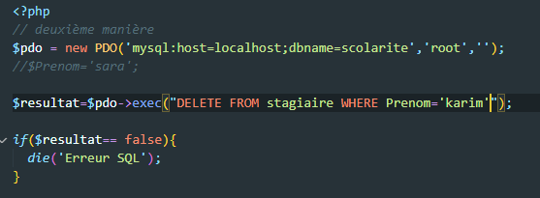
Vérification dans phpmyadmin :
