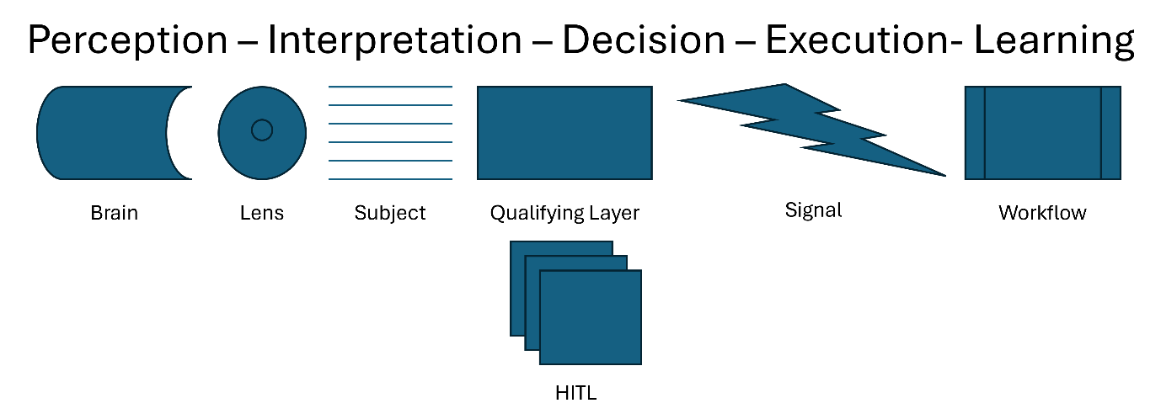

The goals of this channel is to train participants. Can you create training from below? As an executive I am not interested in more data or information. I want better decisions. Decisions that move me faster toward my goal.

Data and information are abundant. Even good information can be ‘produced’ if prompted well enough.

But does this information lead to better decisions or actions? No. It doesn’t.

The past few months I gave building agents a go. With in the back of my mind this exact question. I have built a few mvp’s -- almost ready for production.

Reverse engineering this approach I started sketching this flow.

What is this model trying to bridge:
Most agentic models produce excellent information. Few lead to better decision making. Understanding better how agentic systems work I designed this model to bridge the gap between information and action.

Perception
This part aligns closely with the context engineering context.

What I tried to add: perception is never neutral.
So who you are – your brain - and what lens you choose – the lens - are both implicit and explicit choices that impact how you and the agentic system interpret the subject. The same reality can be observed in very different ways, depending on that combination.

A CFO and a Production manager looking at the same plant, thinking about risk, will not see the same thing. The CFO sees location as potential exposure to foreign exchange risk. The production manager sees a risk in cultural differences on the workflow as source of operational friction. Same plant, both think about risk -- completely different signals.

Interpretation
As we know, LLM’s can analyze vast amounts of data at high speed and low cost. They can also interpret this data remarkably well, especially if Brain and Lens are clearly defined.

The real value gets recognized when the data is interpreted considering the Lens, filtered for what actually matters.
The real breakthrough in my thinking was this: just categorizing the data is not enough.

This is the difference between analysis and qualification.

Decision and Execution
Now we will move from ‘qualified signals’ to action. A qualified signal – or triggers - marks the moment where interpretation becomes actionable.

A good trigger starts an event. No additional noise. Action ready.
- In sales: a change at an existing customer — such as new leadership or expansion into a new market — becomes a signal for a new conversation or offering.

- In finance: a political event or policy shift (for example around trade or tariffs) becomes a signal for foreign exchange exposure and pricing riskIn operations: recurring delays or deviations in a process become a signal for structural friction, not just isolated incidents.

- In product: a change in user behaviour or feature adoption becomes a signal for prioritization and roadmap decisions.

Without a qualified signal, action is guesswork

HITL/ Learning
And as a traditionally trained Master in Business Administration, I appreciate this closes the loop:

a modern interpretation of the PDCA cycle, with the human explicitly in the loop.
Decision and outcomes are reviewed by a human. Not just as approval step but as part of the learning process.

The feedback is then used to sharpen the Brain, Adjust the Lens and Improve the workbench. In that sense, the system does not just produce signals.

It continuously improves how signals are recognized.

Concluding Thoughts
Using LLM’s and designing agentic systems is becoming more accessible with all the great tools made available like Cursor, OpenClaw and Supabase. The real work is in designing the perception layer. Defining the Brain. Choosing the Lens. Getting the focus right. That makes agentic systems effective, not more data. Not longer prompts.

Great systems don’t just generate answers. They qualify signals.

