Online Retail ETL & BI Pipeline
Author: Lennix Stevens
Project Overview
This project demonstrates a complete end-to-end data pipeline that transforms raw retail sales data into actionable business insights. It showcases data cleaning, aggregation, semantic modeling, and interactive BI reporting — highlighting skills in Python, SQL, Microsoft Fabric, and Power BI.

Dataset
- Kaggle Online Retail dataset (~500,000 invoice records)
- Key fields: InvoiceDate, CustomerID, Description, Quantity, UnitPrice

Workflow / Steps
1. Data Cleaning & Silver Layer
- Loaded raw dataset into Python / PySpark.
- Cleaned and standardized columns (CustomerID, InvoiceDate, etc.)
- Removed nulls and invalid data to ensure accurate analysis
- Stored cleaned data as the Silver table for downstream processing
2. Gold Layer Creation
- Aggregated daily revenue, total transactions, and prepared key metrics
- Built the Gold table in Fabric Delta Lake for reporting
3. Semantic Model
- Created a semantic model on top of the Gold table for easier BI consumption
- Model includes three tables: Silver Online Retail, Gold Daily Sales, and a Product/Customer lookup
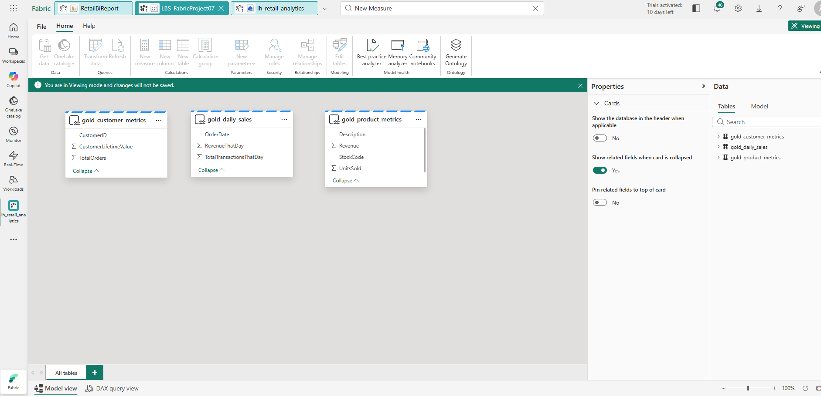
4. BI Dashboard / Reporting
- Built an interactive dashboard including:
  - Line chart of daily revenue with date slicer
  - Bar chart showing top products by revenue
  - KPI card for total revenue
