>> I measured competitive fitness of lines evolved on control (YPD) medium and dietary restriction (DR) medium. I assayed on both YPD and DR. In both cases, lines assayed on the same medium they were evolved on has significantly higher (*P* = 0.025; 0.039, respectively) relative fitness than lines assayed on the medium they were not evolved on.

The values for W were quite high. This indicates that natural selection worked. Interestingly, values for W were (significantly) larger than 1 even when assaying on the media that the lines were not evolved on. This indicates positive pleiotropy: Mutations that increase fitness in one environment also, on average, increase fitness in the alternate environment (although the magnitude of increase is on average smaller). This is perhaps not surprising, given how similar the media types are. Any mutation that enhances adaptation to any aspect of the environment other than glucose concentration could reasonably be expected to also increase fitness in the alternate environment.

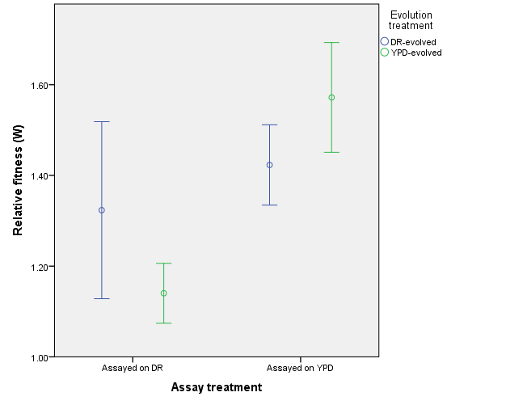

>> Measuring CLS of the University of Washington strains is proceeding as planned. I have identified 5 strains that are chronologically long-lived. The next step is to measure their competitive fitness to determine whether the strains exhibit the expected fitness defects.

Other news:

>> I probed again at getting in contact with someone at DTRA for DoD scholarship.

Related, I started the process of putting paperwork through ORA so that I could actually receive the DoD scholarship. You are the PI and I am the Co-PI, I’ll handle as much of it for you as I am allowed to.