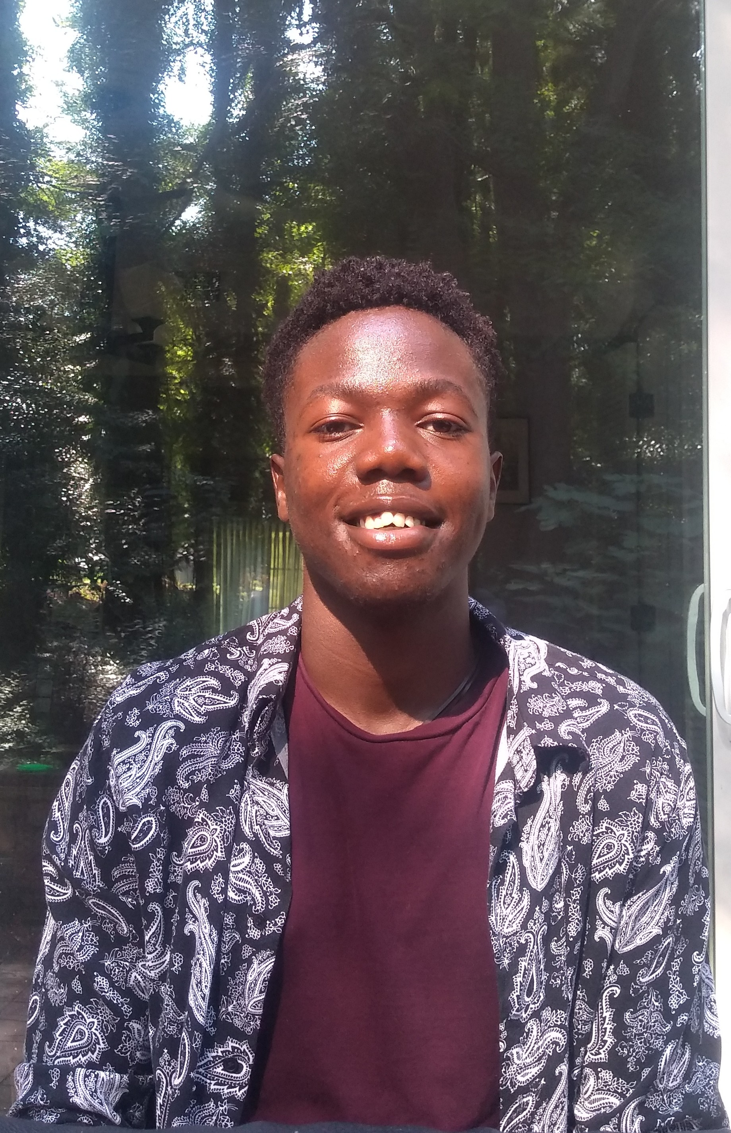

Lennox Apudo | 000000000000 | sle*******@gmail.com

# ABOUT ME

I love coding!

# WORK EXPERIENCE

**Wagner College** *2020 2021*I am involved in undergraduate research with a couple of students and a few professors.

# SKILLS

* C++
* Python
* Wolfram Mathematica