**portalDatabase.py**

The __init__() function is the main classes’ object constructor. It initializes the attributes of the Database() class object. The attributes specify the (host, port, database name, server user, and server password).

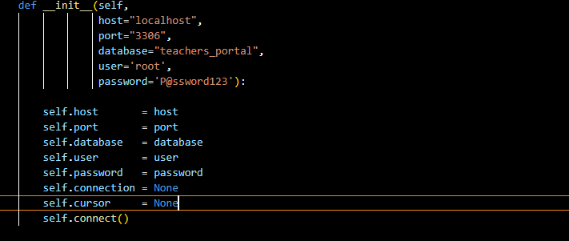

We use the connect () function to initialize a constructor from the module mysql.connector to create a connection to the MySQL server to access a database running on MySQL server (localhost: port 3306) using the provided login credentials.

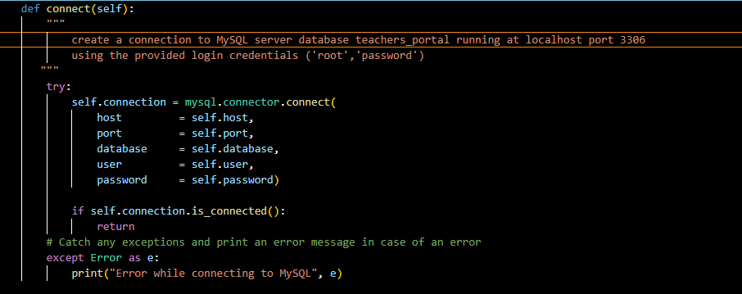

The getAllStudents() function creates a new cursor (if connection to the server is established), by default a MySQLCursor object, using the connection's cursor() method and calls a stored procedure from the database running on the server and stores the results in a variable which it returns.

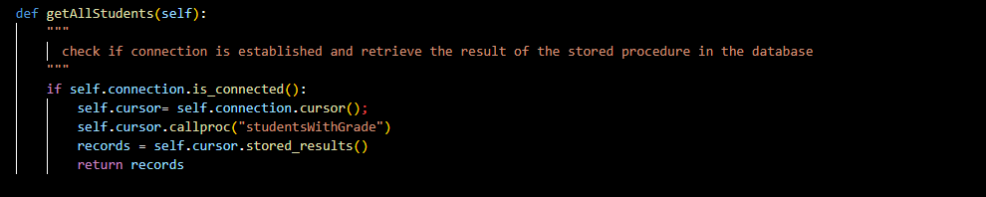

The addStudent() function is initialized with the parameters (student name, coursed, and grade) which are used to insert a new student record into the students table via the SQL commands executed by the MYSQL cursor object and committed to the server by the connection object. The rollback() function is used to revert any changes made to the tables incase of an error (This provides the functionality of It’s either everything is executed and committed or nothing is executed).

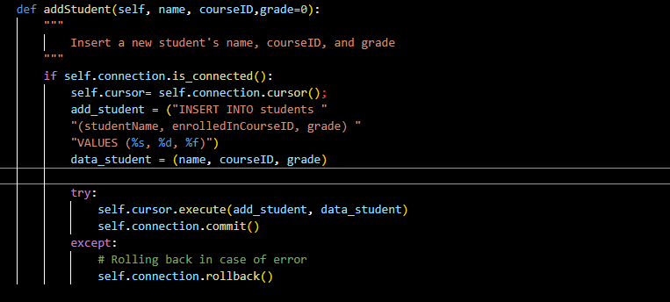

The addCourse() function just like the addStudent() is used to insert a new course into the courses table and commit any changes made to the table.

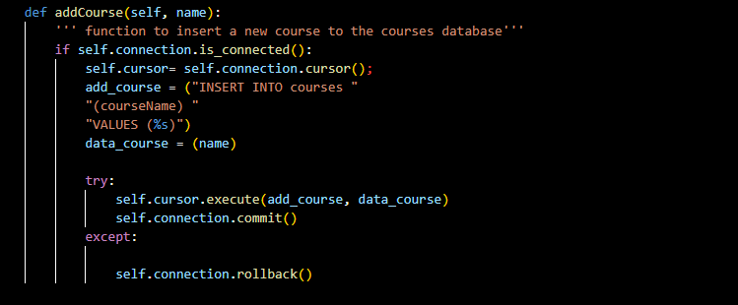

The addCourse() function is used to update the grade records of a given student in the students table using a provided studentID.

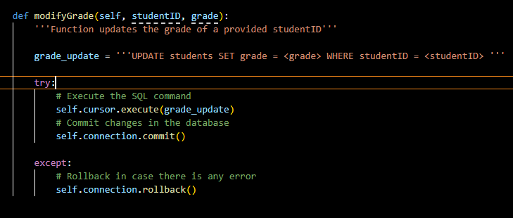

**portalServer.py**

This module defines a class portal server that inherits the BaseHTTPRequestHandler class from the http.server module which creates and listens at the specified HTTP socket (localhost:8000), dispatching the requests to a handler. It is subclassed to handle the request methods (GET and POST).

The do_GET() and do_POST() functions are used to get and post data to the running HTTP server to retrieve user inputs (from forms) and display html content on the server. The functions also call the respective Database() functions from the portalDatabase.py module to: Retrieve database information ( getAllStudents() ), Insert a new student ( addStudent() ), add a new course (addCourse() ), or modify a student’s grade (modifyGrade() ).

