C4 Diagrams

# Context Diagram

<https://lucid.app/lucidchart/c839d51a-a288-4b85-8b49-cde22f5352db/edit?viewport_loc=-649%2C-134%2C3332%2C1499%2C0_0&invitationId=inv_09a1b434-5e03-492b-887d-ecab7ccff0b5>

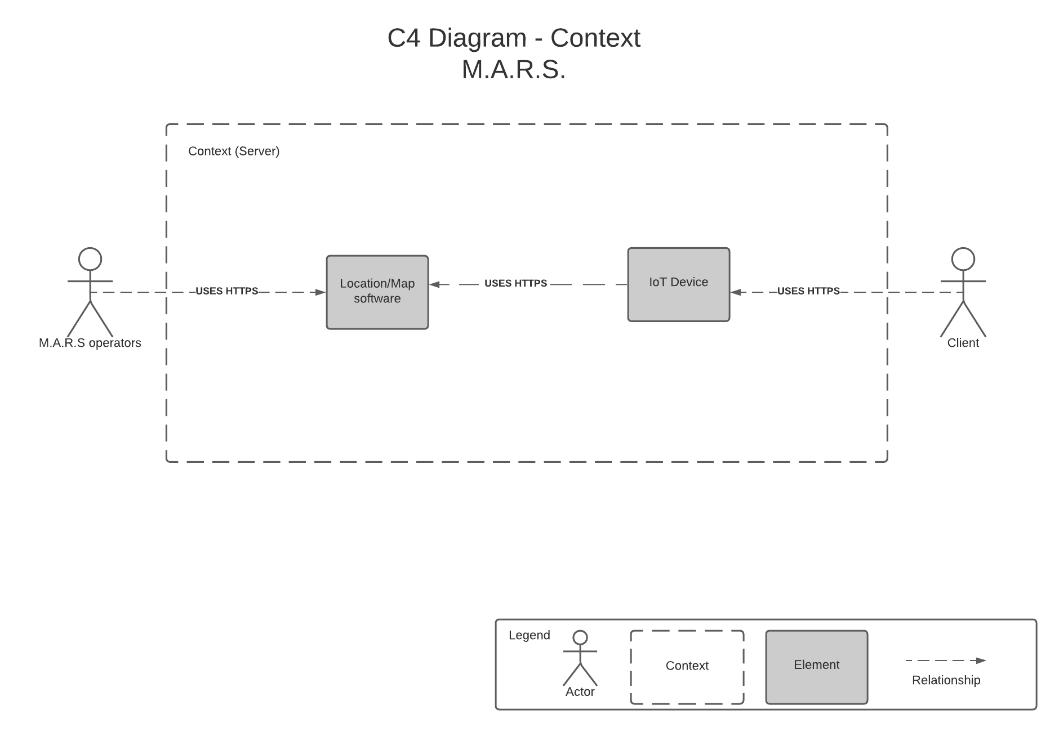

# 

# Deployables/Container

<https://lucid.app/lucidchart/ce17fe4c-8eb7-42f1-903b-4f0489b3fb79/edit?viewport_loc=-981%2C-1357%2C3770%2C1697%2C0_0&invitationId=inv_da6f2cb4-c71b-4d61-a1e7-1716e30d2da6>

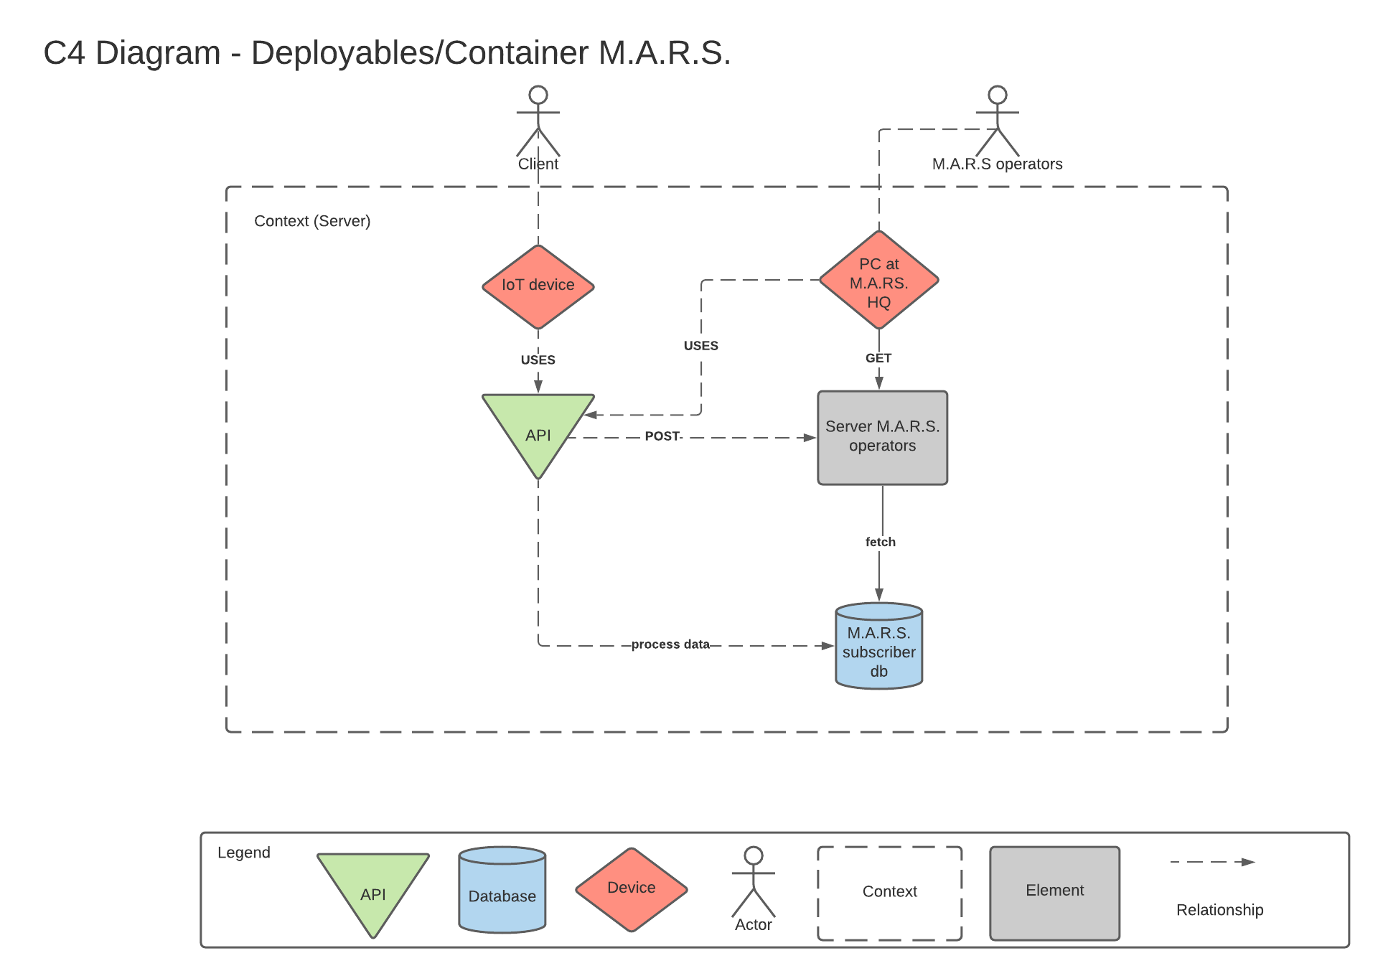

# 

# Server Component Diagram

<https://lucid.app/lucidchart/fd4e4c29-47f8-4a46-ad52-1adc539856a8/edit?viewport_loc=-365%2C-55%2C3343%2C1504%2C0_0&invitationId=inv_40255908-91d1-47ed-8e04-a3935bf49128>

