Center Console
The center console knobs/switches and the levers for the heater core and fan box are connected to the heater core/fan box.
One should test the fan blower motor while the unit is outside of the car. One should also probably remove the heater core to see if it is viable or will need to be repaired.
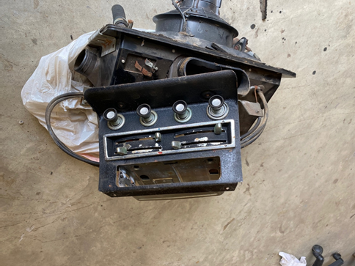 | 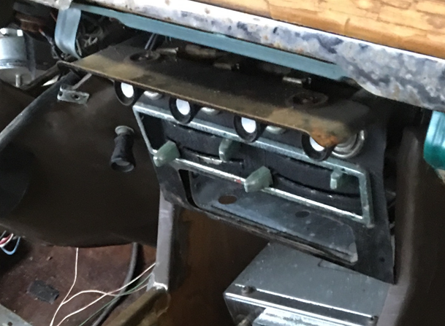
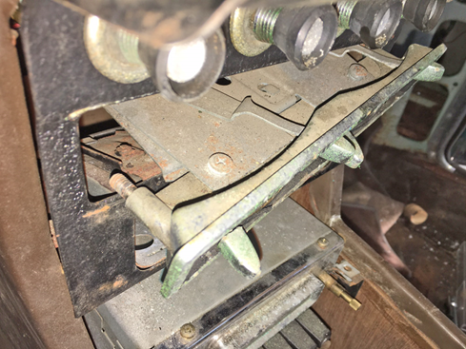 | 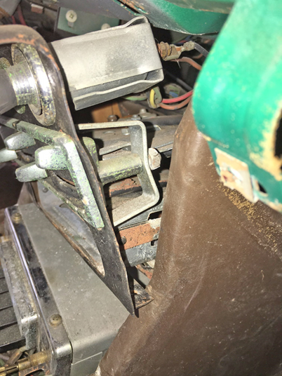

To re-install
1) Remount the heater box/fan blower unit back to the firewall location.
2) Connect the wire to the control knobs (see directions “Wire, Interior – Center Console”

