Under Dash Vent System
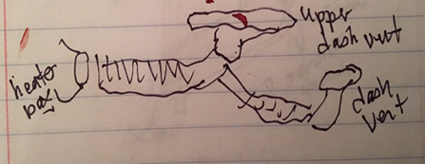  Passenger side  (same applies for driver side) | 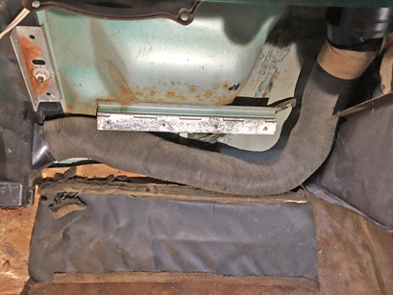  heater core to upper vent and junction to second smaller hose to mid-dash vent
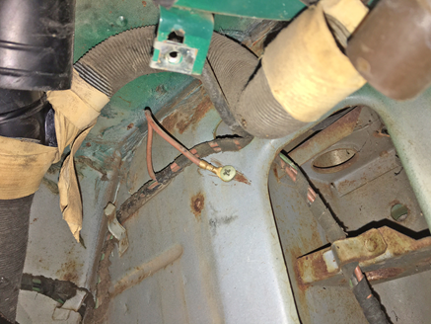  upper vent junction lesser hose (mid-dash vent) | 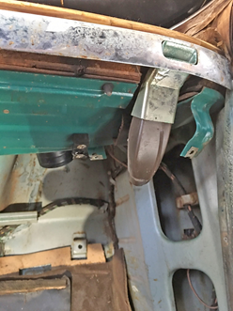  mid-dash vent

