To calculate how long the battery can run the led with 3.3 ohm for 5 hours, we first calculate the current flowing through the circuit using the equation:

Current=Voltage/Resistance=12/3.3=3.64 Amp

Givens:

Capacity: 5200mAh

The maximum discharge rate: 80C

Let’s assume the Depth of Discharge Limit: 50%

Then to calculate for how long the battery can run the led, we can use the equation:

C-rate=current (in Amp)/Capacity=3.64/5.2*0.5=1.4

Time=1/C-rate=1/1.4=0.714 hours

Therefore, to operate the led for 5 hours:

Number of batteries= 5/0.714=7 batteries

--------------------------------------------------------------------------------------------------------------------

**Battery Management System (BMS)**

**Introduction:**

A Battery Management System (BMS) is an integral part of modern energy storage systems, responsible for monitoring and controlling the operation of batteries. BMS plays a crucial role in optimizing battery performance, ensuring safety, and prolonging battery life. This article provides an overview of BMS, its functions, and different types of BMS commonly used in various applications.

**Functions of a Battery Management System:**  
A BMS performs several key functions to manage and protect batteries effectively:

* Balancing and Equalization: In systems with multiple battery cells or modules, BMS ensures that each cell or module is charged and discharged uniformly. Balancing helps to maintain the overall capacity and performance of the battery pack.
* Overcurrent and Overvoltage Protection: BMS monitors current and voltage levels to protect the battery from overcurrent and overvoltage conditions, which can lead to damage or safety hazards.
* Temperature Management: BMS monitors battery temperature and implements appropriate measures to prevent overheating or excessive temperature conditions that can degrade battery performance and safety.

**Types of Battery Management Systems:**

There are different types of BMS available, each designed to meet specific requirements and applications. Some common types include:

* Passive BMS: Passive BMS is a simple and cost-effective solution suitable for applications with fewer cells or lower power requirements. It relies on passive balancing techniques, such as resistor-based balancing, to equalize cell voltages. Passive BMS often has limited monitoring capabilities compared to active BMS.
* Active BMS: Active BMS offers advanced monitoring and control features. It actively balances cell voltages using active components like switches or DC-DC converters. Active balancing allows for more precise cell voltage equalization and is often employed in high-power applications or systems with large battery packs.
* 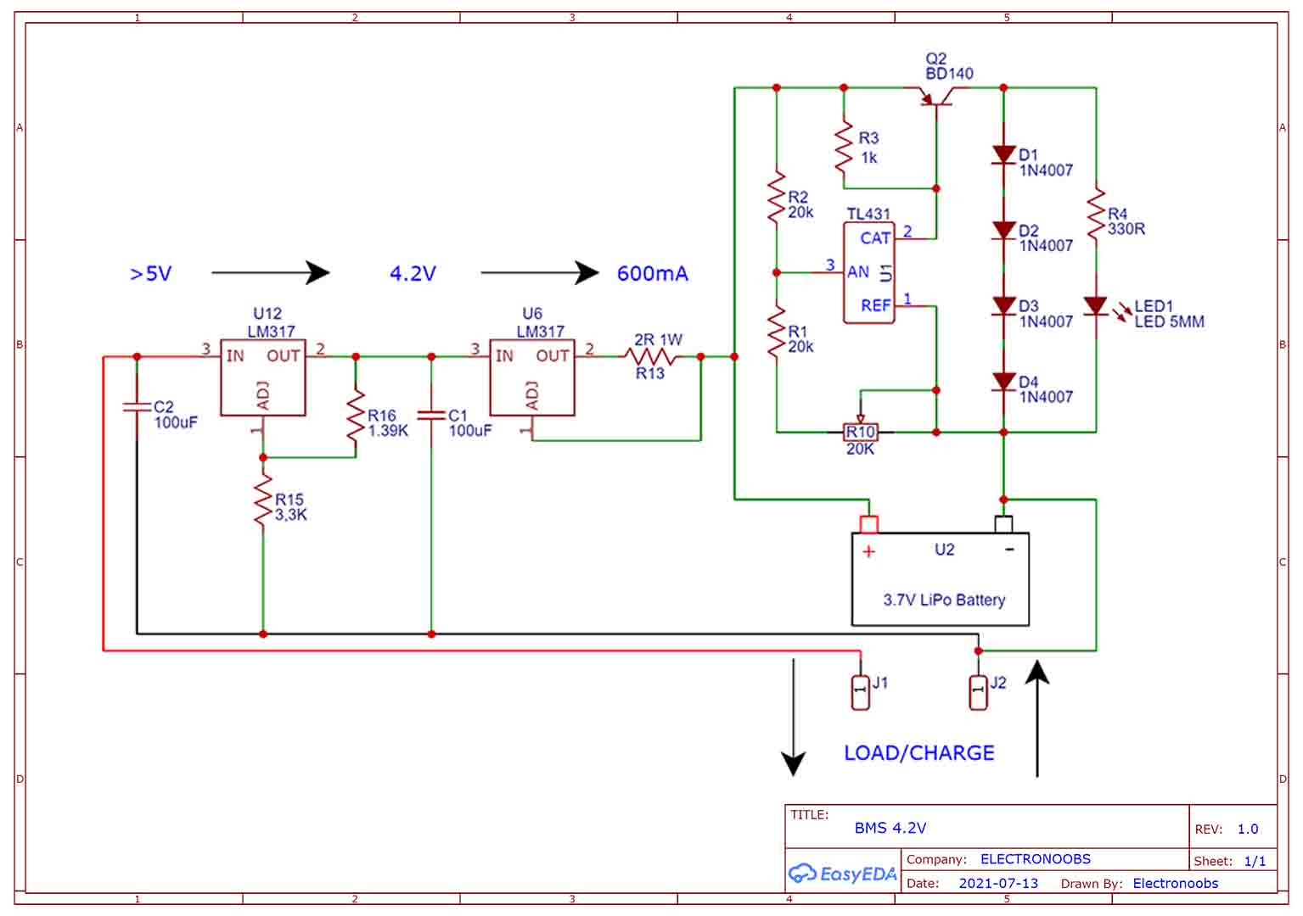Distributed BMS: Distributed BMS consists of individual cell-level monitoring and control units distributed across the battery pack. Each cell or module has its own monitoring circuit, and the information is communicated to a central controller or monitoring system. Distributed BMS offers scalability, modularity, and fault tolerance.

**Figure 1.Balanced BMS charger circuit.**