**Executing Linux commands**

1. pwd: present working directory

it writes to standard output the full path name of your current directory

1. ls

it lists the files inside the current directory

1. ls -al (directory)

It lists the files with more details such as the size of the file, date of creation , the user who created the file and the file permissions

1. clear

it clear the commands in the terminal.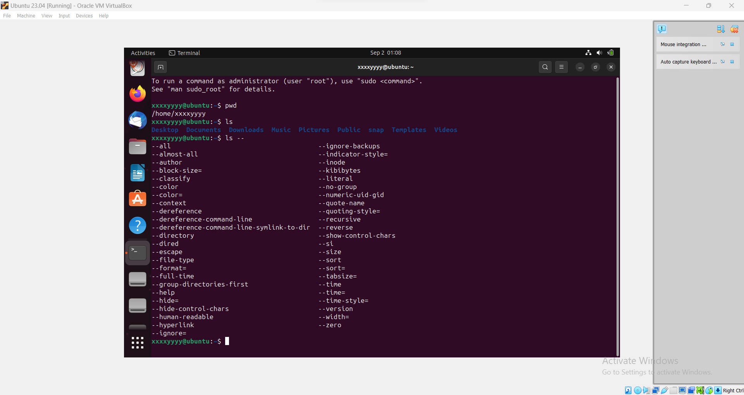

1. 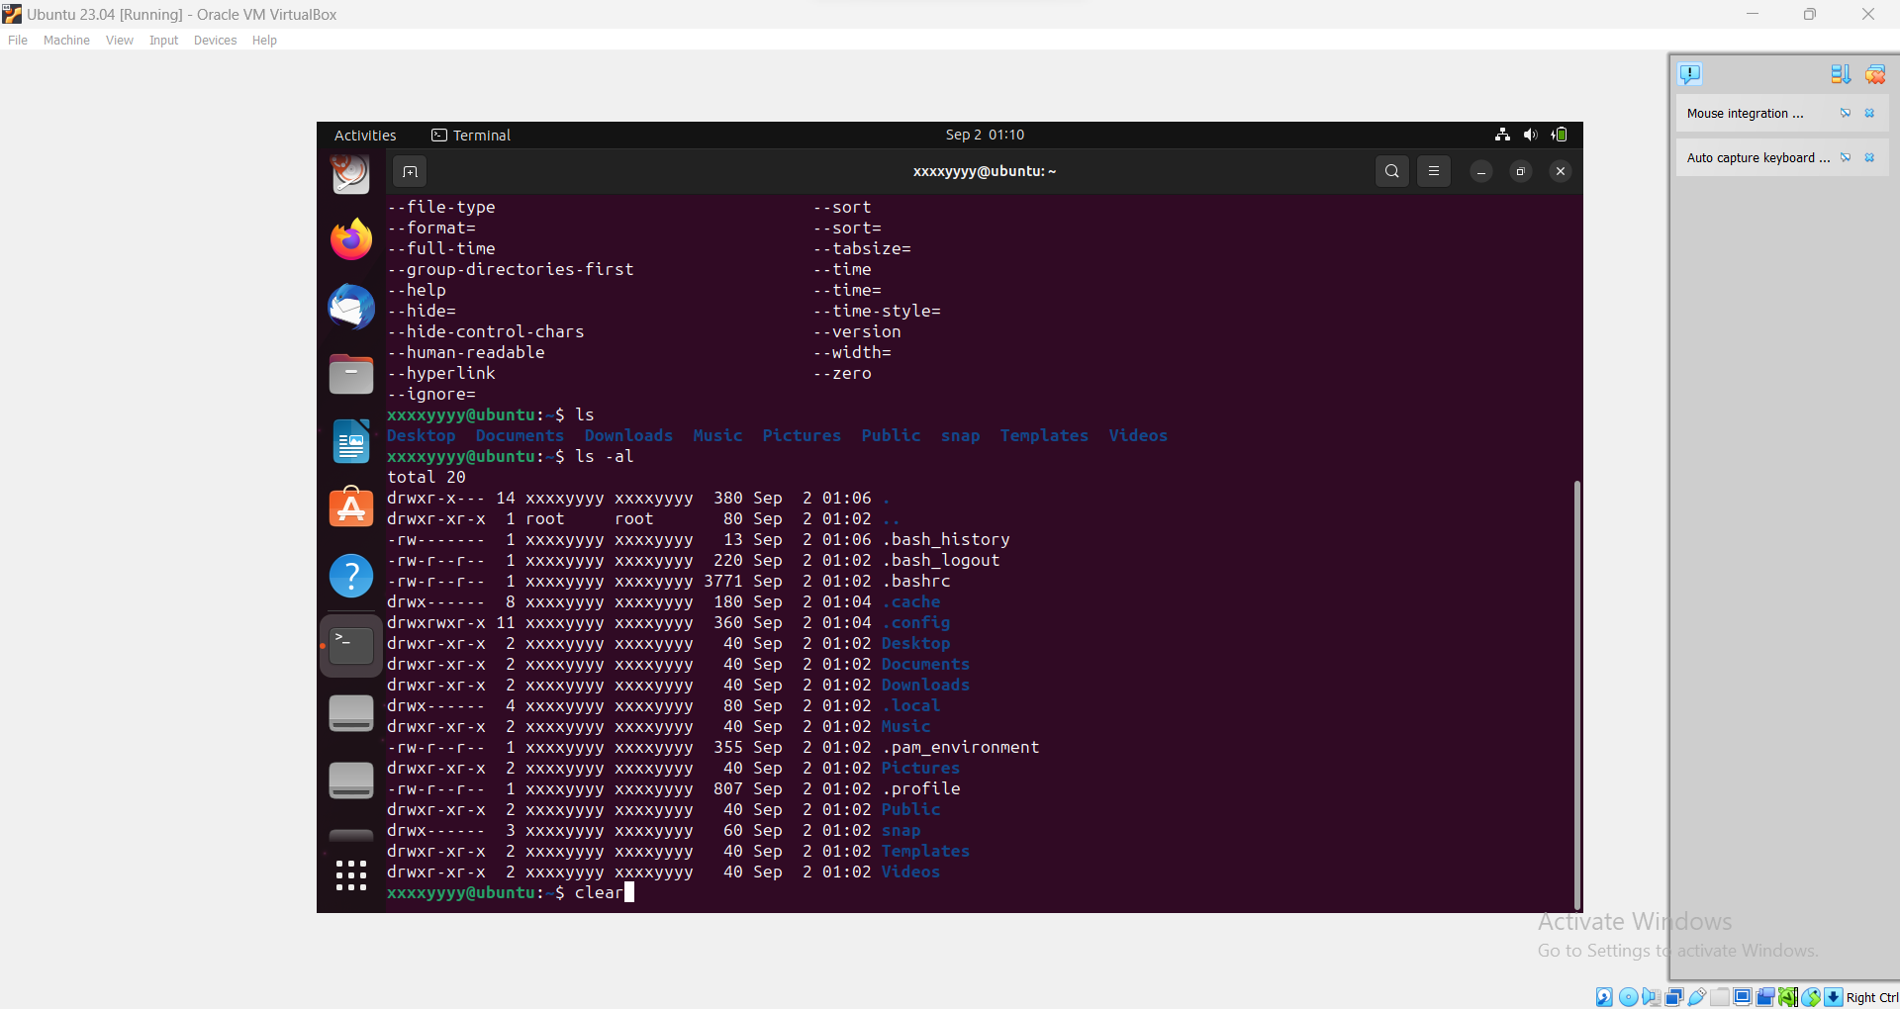cd: change directory

it returns back to the previous directory

1. sudo (command): allow a user with proper permissions to execute a command as another user
2. cd (directory): it returns to the specified directory
3. touch (filename): it creates new file
4. cat: it shows the content of the file inside the terminal
5. mv (old filename) (new filename): it renames the file
6. rm (filename): it deletes the file
7. mv (filename) ~: it moves the file to the home directory
8. mkdir: it makes new directory
9. rm-r: it removes all files included in the directory and the directory itself
10. man (command) : abbrev for manual which explains what the specified command do
11. htop: displays real-time information about your computer’s processes. This information includes how much CPU and memory each process is using. The Htop command is very helpful when you want to troubleshoot problems with your computer or optimize its performance.

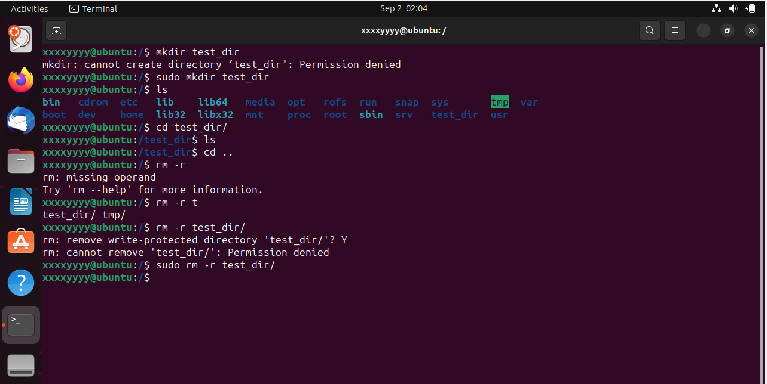

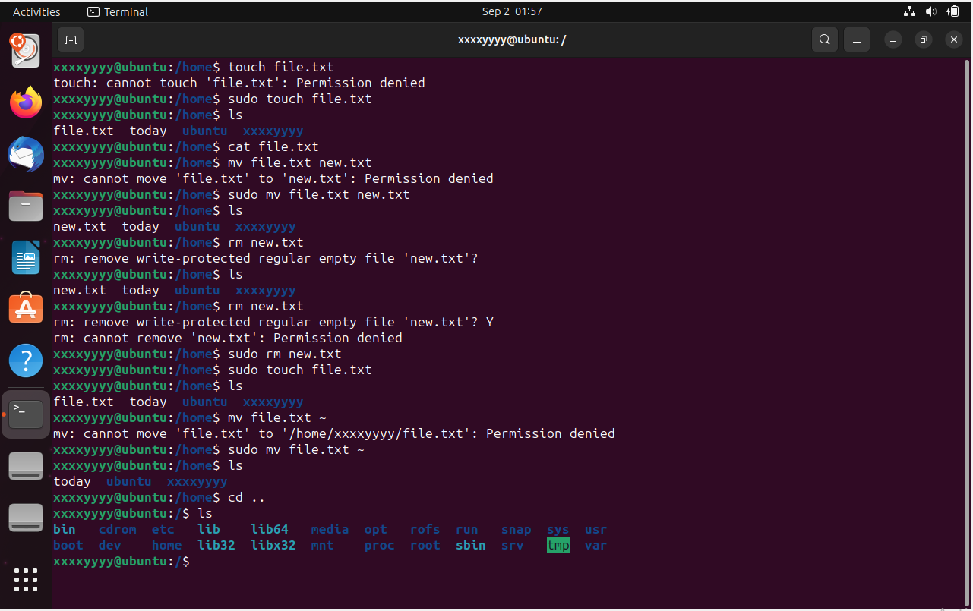

1. ifconfig: displays the current configuration for a network interface when no optional parameters are supplied
2. nano (filename) : it acts as a text editor where you can overwrite in the file

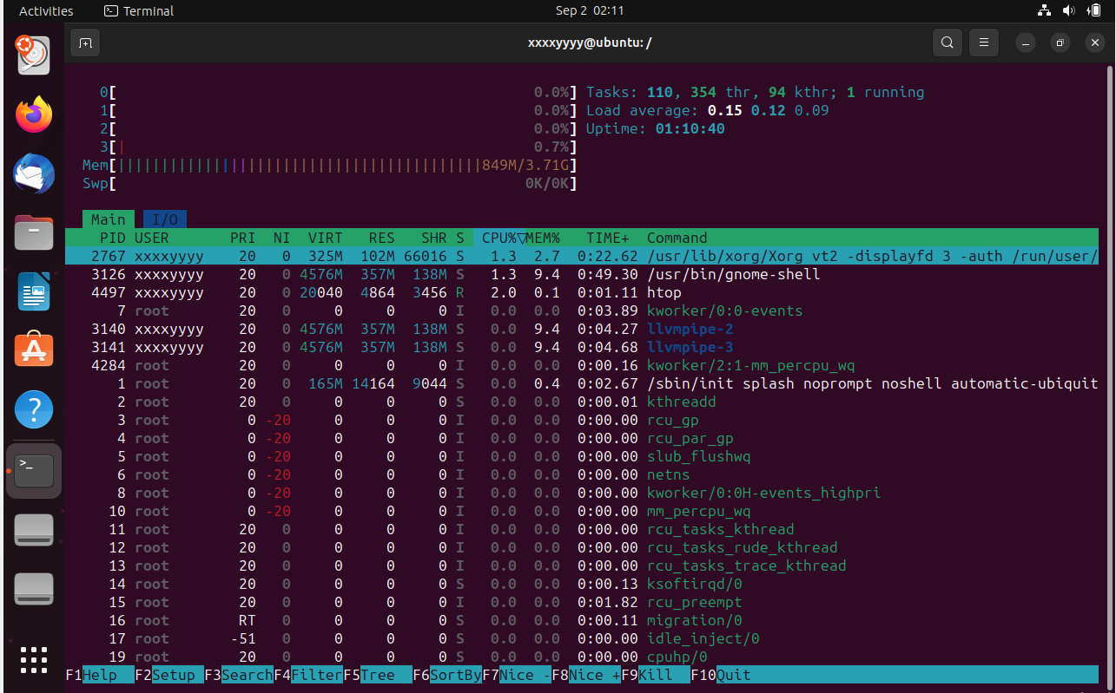

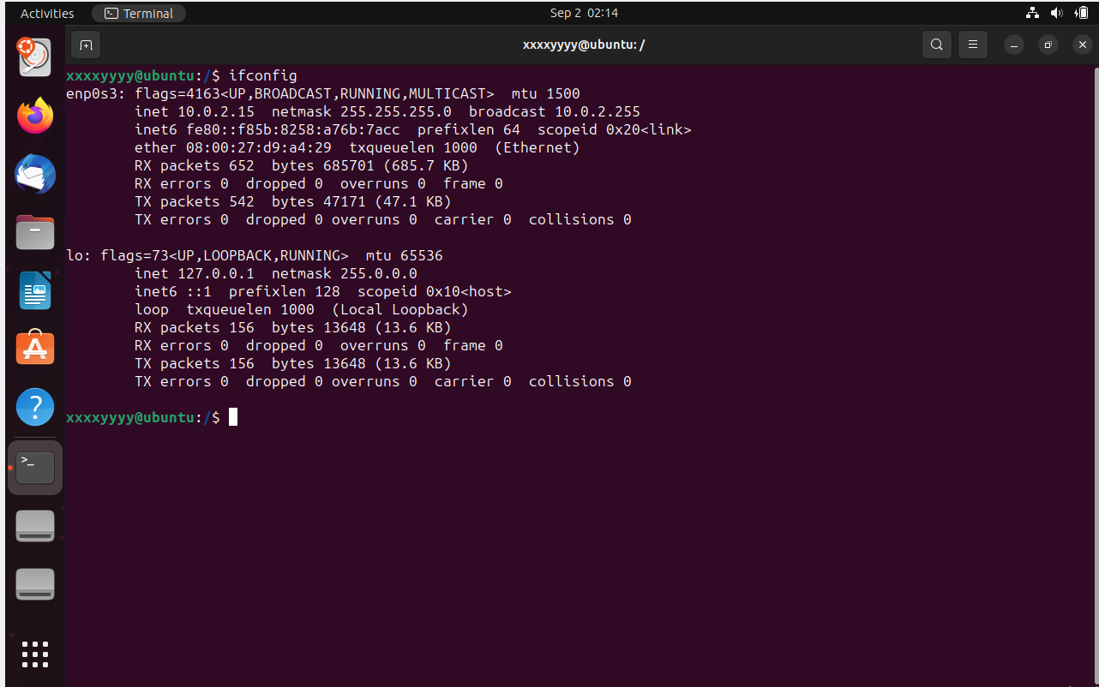

1. cat (filename1) > (filename2): it copies the content in filename1 and paste it in filename2
2. cat (filename1) >> (filename2): it copies the content in filename1 and append it to filename2
3. cat (filename) | grep (keyword) : it copies the content in filename and insert it as an input to the command grep which search for the keyword inside the content and prints it within the context if found.
4. catt (filename) &> err.txt : it sends the error message found in command to err.txt file and if there is no error in command it will sends the content of the filename to err.txt
5. gedit & : it shows the text editor without hanging the terminal.
6. bg: it shows the background processes

