Practical Assignment - OS

RISHABH DAHIYA A2345924136

BTECH CSE EVENING 1 - X

Q1) I. Write a command that shows the contents of a file called report.txt one page at a time.
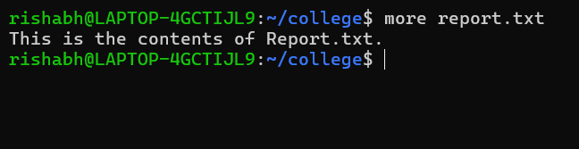

- Write a command to show the current working directory and all files, even hidden ones.
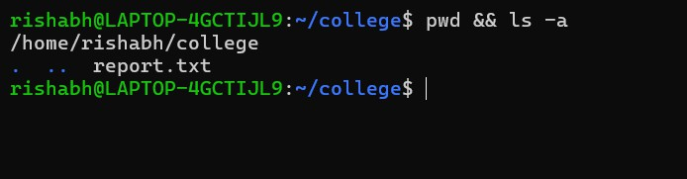

- Write a command to make a folder called "project" inside "/home/user/".
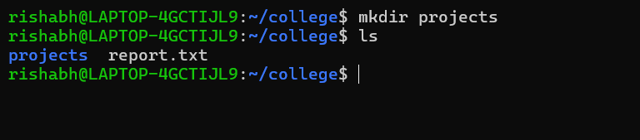

- Write a command that will tell you how many lines, words, and characters are in a file called data.log.
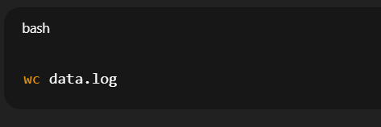
- Make a command that copies all .txt files from the current directory to /home/backup/.
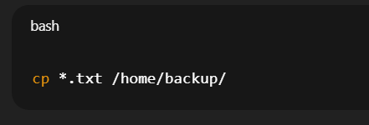

- Write a command that will look for all files in the /var/log directory that are bigger than 10MB.
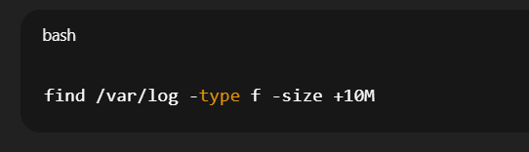

- Write a command that will sort the file names.txt in reverse order.
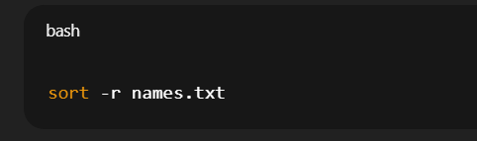

Q2) I. Write a command that adds the output of the date command to a file called system.log.
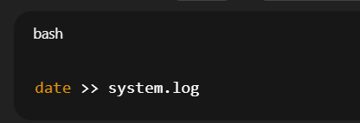

- Write a command that sends error messages from a command to a file called error.txt.
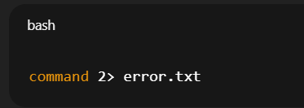

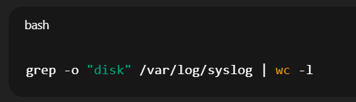
- Write a pipeline that looks for the word "disk" in /var/log/syslog, counts how many times it appears, and only shows the count.

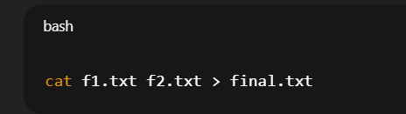
- Write a command that combines the contents of f1.txt and f2.txt and saves the result in final.txt.

- Write a command that uses pipes to show the 10 most used commands from .bash_history.
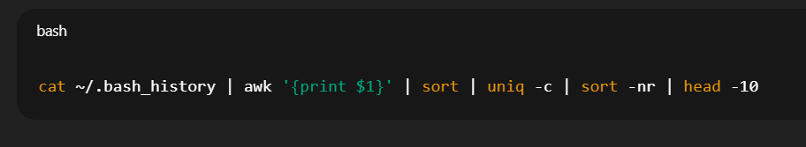

- Write a command that compares the two files old.txt and new.txt and shows the differences.
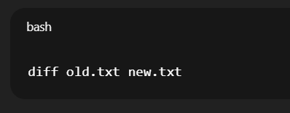

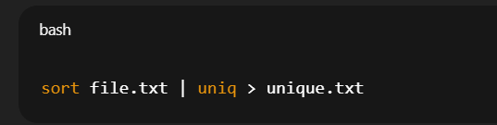
- Write a command that sorts, removes duplicates, and saves the results to a new file called unique.txt.

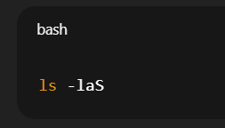
Q3) I. List all files (including hidden files) in the current directory, sorted by file size in descending order.
- Display the total number of lines, words, and characters in a file named report.txt.
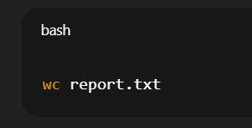

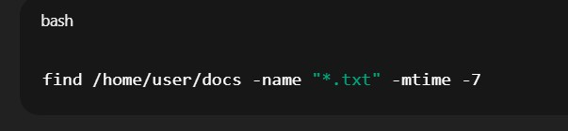
- Find all .txt files in the /home/user/docs directory and its subdirectories that were modified in the last 7 days.

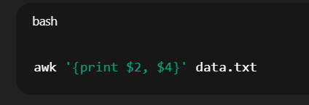
- Extract and display only the second and fourth columns from a space-separated file named data.txt.

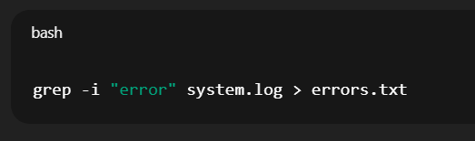
- Search for the word error (case-insensitive) in a log file system.log and redirect the output to errors.txt.

- Show the top 5 processes consuming the highest CPU usage on the system.
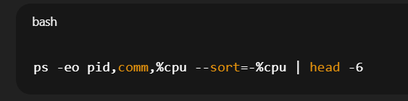

- Compress the directory project/ into a file named project_backup.tar.gz.
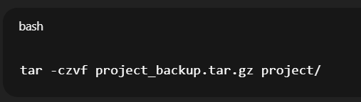

Q4. Write a C program to implement Non-Preemptive Shortest Job First (SJF) scheduling algorithm.
#include <stdio.h> int main() {
int n, i, j;
int bt[20], wt[20], tat[20];

printf("Enter number of processes: "); scanf("%d", &n);

printf("Enter burst time:\n"); for(i=0;i<n;i++)
scanf("%d",&bt[i]);

for(i=0;i<n;i++){ for(j=i+1;j<n;j++){
if(bt[i] > bt[j]){
int temp = bt[i]; bt[i] = bt[j];
bt[j] = temp;
}
}
}

wt[0] = 0;

for(i=1;i<n;i++)
wt[i] = wt[i-1] + bt[i-1];

for(i=0;i<n;i++)
tat[i] = wt[i] + bt[i];

printf("\nProcess\tBT\tWT\tTAT\n"); for(i=0;i<n;i++)
printf("%d\t%d\t%d\t%d\n",i+1,bt[i],wt[i],tat[i]);

return 0;
}

Q5. Write a C program to implement Preemptive SJF (Shortest Remaining Time First – SRTF) scheduling.

#include <stdio.h> #include <limits.h>

int main(){
int n, i, time=0, min, shortest;
int bt[10], rt[10], wt[10], tat[10], complete=0;

printf("Enter number of processes: "); scanf("%d",&n);

printf("Enter burst times:\n"); for(i=0;i<n;i++){
scanf("%d",&bt[i]); rt[i] = bt[i];
}

while(complete != n){ min = INT_MAX;

for(i=0;i<n;i++){
if(rt[i] > 0 && rt[i] < min){ min = rt[i];
shortest = i;
}
}

rt[shortest]--; time++;

if(rt[shortest] == 0){ complete++; tat[shortest] = time;
wt[shortest] = tat[shortest] - bt[shortest];
}
}

printf("\nProcess\tBT\tWT\tTAT\n"); for(i=0;i<n;i++)
printf("%d\t%d\t%d\t%d\n",i+1,bt[i],wt[i],tat[i]);

return 0;
}

Q6. Write a C/Java/Python program to detect deadlock using the Wait-For Graph (WFG) algorithm.

from collections import defaultdict

def dfs(node, visited, stack, graph, cycle): visited[node] = True
stack[node] = True

for neighbour in graph[node]: if not visited[neighbour]:
if dfs(neighbour, visited, stack, graph, cycle): cycle.append(neighbour)
return True
elif stack[neighbour]: cycle.append(neighbour) return True

stack[node] = False return False

n = int(input("Enter number of processes: ")) e = int(input("Enter number of edges: "))

graph = defaultdict(list)

print("Enter edges (Pi Pj meaning Pi waits for Pj):") for _ in range(e):
u,v = map(int,input().split())

graph[u].append(v)

visited = [False]*n stack = [False]*n cycles = []

for i in range(n): cycle = []
if not visited[i]:
if dfs(i, visited, stack, graph, cycle): cycles.append(cycle)

print("\nDeadlock cycles:") for c in cycles:
print(c)
print("Number of deadlocks:", len(cycles)) if cycles:
print("Processes to terminate:", cycles[0])

Q7. # bankers.py
def bankers_algorithm(allocation, maximum, available): n = len(allocation) # number of processes
m = len(available) # number of resource types

# Compute Need = Max - Allocation
need = [[maximum[i][j] - allocation[i][j] for j in range(m)] for i in range(n)]

print("Allocation:") for i in range(n):
print(f"P{i+1}:", allocation[i]) print("\nMaximum:")
for i in range(n): print(f"P{i+1}:", maximum[i])
print("\nNeed:") for i in range(n):
print(f"P{i+1}:", need[i]) print("\nAvailable:", available) print()

# Banker's safety algorithm work = available[:] # copy

finish = [False]*n safe_seq = []

changed = True while changed:
changed = False for i in range(n):
if not finish[i]:
# check if need[i] <= work
if all(need[i][j] <= work[j] for j in range(m)): # can satisfy process i
print(f"P{i+1} can run; need {need[i]} <= work {work}") for j in range(m):
work[j] += allocation[i][j] # release resources after finishing finish[i] = True
safe_seq.append(i+1) changed = True

if all(finish):
print("\nSystem IS in a safe state.")
print("Safe sequence:", " -> ".join(f"P{p}" for p in safe_seq)) return True, safe_seq
else:
print("\nSystem is NOT in a safe state.")
unfinished = [i+1 for i, f in enumerate(finish) if not f] print("Processes that couldn't finish in check:", unfinished) return False, None

if name == " main ":
# Given data from the assignment allocation = [
[0, 1, 0], # P1
[2, 0, 0], # P2
[3, 0, 2], # P3
]
maximum = [
[7, 5, 3], # P1
[3, 2, 2], # P2
[9, 0, 2], # P3
]
available = [3, 3, 2]

bankers_algorithm(allocation, maximum, available)

Q8. #include <stdio.h>

int main() { int n = 5;
int at[] = {0,1,2,3,4};
int bt[] = {6,8,7,3,4};
int pr[] = {3,1,4,2,5};
int ct[5], tat[5], wt[5]; int done[5]={0};
int time=0, completed=0;

while(completed < n){
int idx=-1, highest=999;

for(int i=0;i<n;i++){
if(at[i] <= time && done[i]==0){ if(pr[i] < highest){
highest = pr[i]; idx = i;
}
}
}

if(idx!=-1){
time += bt[idx]; ct[idx] = time;
tat[idx] = ct[idx] - at[idx];
wt[idx] = tat[idx] - bt[idx];

done[idx]=1; completed++;
}
else{
time++;
}
}
printf("Process AT BT PR CT TAT WT\n"); for(int i=0;i<n;i++){
printf("P%d %d %d %d %d %d %d\n", i+1,at[i],bt[i],pr[i],ct[i],tat[i],wt[i]);
}

return 0;
}
Q9. #include <stdio.h> int main() {
int n = 4;
int at[] = {0,1,2,3};
int bt[] = {10,5,8,6};
int rt[] = {10,5,8,6};
int tq = 4;

int ct[4], tat[4], wt[4];
int time = 0, completed = 0;
int queue[100], front = 0, rear = 0; int visited[4] = {0};

queue[rear++] = 0;
visited[0] = 1;

while(completed < n) { int i = queue[front++];

if(rt[i] > tq) { time += tq; rt[i] -= tq;
} else {
time += rt[i]; rt[i] = 0;
ct[i] = time; completed++;
}

for(int j = 0; j < n; j++) {
if(at[j] <= time && visited[j] == 0) { queue[rear++] = j;
visited[j] = 1;
}
}

if(rt[i] > 0) queue[rear++] = i;
}

printf("Process AT BT CT TAT WT\n"); float avg_wt = 0, avg_tat = 0;
for(int i = 0; i < n; i++) { tat[i] = ct[i] - at[i];
wt[i] = tat[i] - bt[i];

avg_wt += wt[i]; avg_tat += tat[i];

printf("P%d %d %d %d %d %d\n", i+1, at[i], bt[i], ct[i], tat[i], wt[i]);
}

printf("\nAverage Waiting Time = %.2f\n", avg_wt/n); printf("Average Turnaround Time = %.2f\n", avg_tat/n);

return 0;
}
Q10. #include <stdio.h> int main() {
int n = 4;
int at[] = {0, 2, 4, 6};
int bt[] = {6, 4, 5, 3};
int ct[4], wt[4], tat[4];

int time = 0;
for(int i = 0; i < n; i++) { if(time < at[i])
time = at[i]; time += bt[i]; ct[i] = time;
tat[i] = ct[i] - at[i];
wt[i] = tat[i] - bt[i];
}
printf("Process AT BT CT TAT WT\n"); for(int i = 0; i < n; i++) {
printf("P%d %d %d %d %d %d\n", i+1, at[i], bt[i], ct[i], tat[i], wt[i]);
}
return 0;
}

