**Super Mario**

Training Project Lab

Dong Sizhe

CWHIBN

# Description of the task

I’m going to write a Super Mario game with Java language , which can realize the Mario go from birth place and successfully to the end of map seeing as Game Win , collision with monster or fall out to the map seeing as Game over .

Planning Object :

Mario .

Bricks: Including normal bricks and boxes that Mario can get mushroom .

Mushroom: Jump out from boxes and Mario can get point from it .

Monsters: Different kind of monsters , if Mario collision with monster , then Mario will die ,game will over.

Planning Technic:

Object Collision and gravity drop simulation

Map drawing and interface by Swing.

Game starting and restarting.

Judgement of falling out of map .

Planning Game feature:

When game start , Mario will start at the birth place , user can use keyboard to control Mario moving on the map .

From start place , the Mario will going through different places , including bricks on the ground , also bricks above the ground that can jump on it to avoid monsters and deep holes , also there are boxes Mario can touch it with head , it can come out mushrooms to get points, if it can successfully reach the end of map , there will be a finish point , touch the point will make game win .

If the Mario collision with monsters , he will die and game will over . Also if he fall into deep hole and fall out to the map , then game will over ,too.

# Functional requirements

## Primary requirements

|  |  |  |
| --- | --- | --- |
| **Identifier** | **Description** | **Use case** |
| R01 | The Player controls Mario | Move mario |
| R02 | The Player let Mario eat star | Move mario |
| R03 | The Player let Mario reach castle | Move mario |
| R04 | The Player Check Score | Move mario |
| R05 | The mario die by fall in the hole | Move mario |
| R06 | The mario die by collision with monster | Move mario  Controller |

# Use cases

## Use case diagram

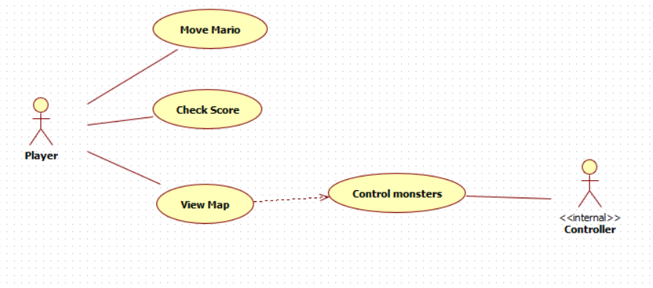

# Class diagram

## Class diagram