Interb-blink intervals detection and analysis for mental state recongition

**Full paper**

**Jurnal**

**Teknologi**

Teme, Rafal, Artem Lenskiy*

School or Electrical, Electronics and Communication Engineering, Korea University of Technology and Education

*Corresponding author: lensky@koreatech.ac.kr

|  |  |  |
| --- | --- | --- |
| **Article history**  Received :8 August 2015  Received in revised form :  Accepted :15 October 2014  **Graphical abstract** | **Abstract**  The electroencephalography reflects stable individual difference's in brain function and blinking so it makes it a powerful instrument for exploring the biological basis of intelligence. We present a method of recognizing mental state by using eye blink dynamics measured by EEG (electroencephalographic) . Since EEG data is prone to noise we used multiple filters to clean the data. We developed an algorithm to detect eye blinks. This developed algorithm can measure the distance's between the interlinks which we can use to study the relation of blinks to a certain activity. Our lab to calculate the interval of the blinks dynamics while subjects are performing tasks requiring different brain activities.  *Keywords*: Mental activity recognition, Blink dynamics  © 2015 Penerbit UTM Press. All rights reserved. |  |

**1.0 INTRODUCTION**

Being able to recognize mental state of mind by analyzing eye blink dynamics has a wide range of applications. Knowing a persons attention can play an important and vital roll in human endeavors, From drivers attention perception to online education systems the areas this can be applied is infinite as attention is key to human performance.

Lack of concentration and/or falling asleep while driving is a major cause of road accidents. Some of these accidents are the result of the driver's medical condition. However, a majority of these accidents are related to driver’s fatigue, drowsiness, and driver inattention caused by various distractions inside and outside the vehicle. Car accidents associated with driver fatigue are more likely to be serious leading to serious injuries and deaths. The European Transport Safety Council [1] states that driver fatigue is conservatively estimated to be a factor in about 20% of road crashes in Europe. In the United States [2] an estimated 1.35 million drivers were involved in a drowsy driving related crash between 1998 and 2003.

This hot area of driver’s safety and accident prevention caused by drowsy and inattentive drivers attracted the immense attention of psychologists, engineers, and specialists in the area of EEG signal processing and computer vision. One of the approaches to aid this problem comes from visual monitoring of a driver's awareness through tracking and analyzing blink activity[13]. Second approach is based on analysis of eye's moving muscles' electrical signals [12]. By analyzing driver’s blink duration and frequency mental state can be extracted and in the case of drowsiness or lost of concentration a special signal could warn a driver to either keep concentration or take a break.

The other application of mental analysis through analyzing blinks is distance learning. According to the 2012 survey of online learning [3], more students than ever are taking online courses. The study revealed that the number of students taking at least one online course has now surpassed 6.7 million. Thirty-two percent of higher education students now take at least one course online. There are many arguments supporting or condemning online education. Advocates say online education offers greater flexibility in terms of selection of course work, class time, and choice of school is not a matter of geographical proximity. On the other hand, there are a number of drawbacks generally rooted from the lack of interaction. While there is a basic opportunity to interact in real-time, it is generally limited to raising and receiving questions. However, when the teacher is physically taken out of the classroom there is a potential handicap to the classroom learning dynamics. Since the teacher is unable to acutely observe a student’s body language and thus give the necessary commands and feedback required to stabilize and augment the learning environment there is an increased potential risk of learner inattention. This is especially true if lectures are prerecorded. To add to this handicap, online education is often home based which further exacerbates the contrast between an online class and an actual classroom in which disruptive factors are minimized. As a result, attention monitoring and classroom control are pressing issues in online education. Yet at least one clear advantage of having the convenience and the ability to use online lectures is the vast control the learner is bestowed. In the case of the learner being potentially drowsy, or tired, he or she can take a break and return to the lecture at an appropriate time.

A large body of research work has investigated the relationship between blinking characteristics and degree of attention. Importantly, it was found that eye blinks are not only a consequence of physiological processes driven by peripheral reasons, but properties of eye blinks such as duration and frequency also reflect processes in central nervous system. J.A. Stern et al. [4] performed a review on the relationship between fatigue and eye blink rate with the conclusion that blink frequency increases as a function of the time-on-task. Such tasks include reading, driving a car, and maneuvering an airplane. Nakayama et al. [5] provide experimental data showing the increase in the blink rate in accordance with increasing task difficulty. Fukuda et al. [6] also support the observation that cognition demanding tasks specifically a running memory task is related to the increase in blink frequency. On the other hand Yamada [7] presents somewhat contradictory data. He measured eye blink activity of children while they were a) watching an animation cartoon, b) playing a video game and c) performing a mental test. According to his experimental results, the eye blink activity was lowest while playing the video game and highest while watching an animation which was reported by 8 out of 10 participants as the most boring activity. Based on these results Yamada made the conclusion, that eye blink activity is a good indicator of attention concentration and task pleasantness of a mental task. Karl F. Van Orden et al. [8] also reports that eye activity correlates to workload during a visuospatial memory task. However, they state that the more complex the memory task is, the lower the eye blinking rate and longer duration. It should be noted that compared to previously mentioned works, the latter one was considering relatively short measurement times and thus there is a probability for the blink rate to increase for longer time frames. The majority of researchers [6-8] agree that the rate of eye blink changes with the degree of mental workload, yet the question on how eye rate changes, still needs further investigation and clarification. As Caffier at el. found [9] the blink duration is significantly longer (about 50ms) during the drowsy than during the alert conditions.

The focus of this paper is to test the hypothesis of mental state activity recognition using a EEG signal analysis.

In section 2, an experimental setup and the developed testing software is described. Section 3 elaborates on the concept of inter-blink intervals and its analysis. In section 4 we analyze obtained results and talk about out future work.

**2.0 EXPERIMENTAL SETUP**

**2.1 Data acquisition**

For the purpose of collecting data we developed special questionnaire software, and software for detecting eye blinks in the capture video stream

The video stream was captured with a Logitech HD Pro Webcam C920 . Video stream was stored on a disk drive and later processed for further experiments. Simultaneously we were also recording EEG signals to be able detected eye blinks using blink detection software. For recording EEG signals Mitsar-EEG 201 machine and WinEEG software. For signal process and analysis WinEEG and own MATLAB scripts, respectively, has been used.

The experimental setup is shown in the figure 1.

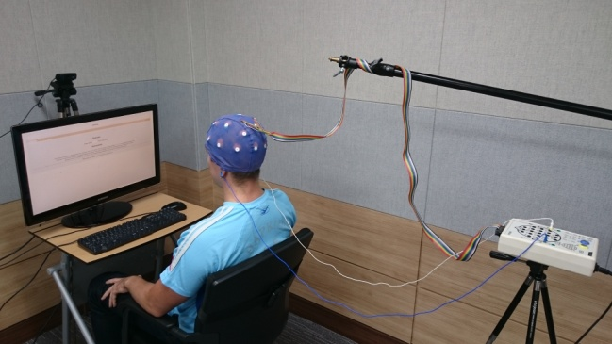

Figure 1 Experimental setup

**2.2 Testing procedure**

The recording session consisted of four stages: (a) resting, (b) the IQ test, (c) resting, (d) reading, and (e) the memory test. The testing software was developed in HTML and javascript (jQuery) in such a way that it does not required any interventions. The whole testing session took 1720 seconds, 5 minutes resting before the IQ, 540 seconds the IQ test, 5 minutes resting stage, 5 minutes reading and 280 seconds the memory test. The IQ test consisted of 14 questions. Before the memory test a resting stage and passage about Ethiopia was given. After reading the passage user was presented questions one by one. In the figure 2 an example of a memory test question is shown.

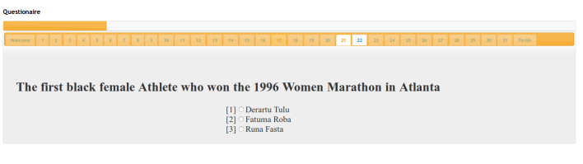

Figure 2 User interface

**2.3 Eye blinking detection procedure**

@TODO: for professor :)

**3.0 METHODS**

**4.0 CONCLUSIONS**

**Acknowledgments**

**References**

[1] The role of driver fatigue in commercial road transport crashes: European Transport Safety Council, 2001.

[2] L. Hartley, T. Horberry, and N. Mabbott, Review of fatigue detection and prediction technologies: Institute for Research in Safety and Transport, Murdoch University, Western Australia and Gerald Krueger - Krueger Ergonomics Consultants, Virginia, USA, 2000.

[3] Elaine Allen, Jeff Seaman, 2013. Changing Course: Ten Years of Tracking Online Education in the United States. Pearson.

[4] Stern, J.A., D. Boyer, and D.J. Schroeder, Blink Rate as a measure of fatigue: A Review. 1994.

[5] Nakayama, M., K. Takahashi, and Y. Shimizu. The act of task difficulty and eye-movement frequency for the 'Oculo-motor indices'. in Symposium on Eye tracking research & applications. 2002. New Orleans, Louisiana.

[6] Fukuda, K., et al., Cognition, Blinks, Eye-Movements, and Pupillary Movements During Performance of a Running Memory Task. Aviation, Space, and Environmental Medicine, 2005. 76: p. C75-C85.

[7] Yamada, F., Frontal midline theta rhythm and eyeblinking activity during a VDT task and a video game: useful tools for psychophysiology in ergonomics. Ergonomics, 1998. 41(5): p. 678-88.

[8] Orden, K.F.V., et al., Eye Activity Correlates of Workload during a Visuospatial Memory Task. HUMAN FACTORS, 2001. 43: p. 111-121.

[9] Caffier, P., U. Erdmann, and P. Ullsperger, Experimental evaluation of eye-blink parameters as a drowsiness measure. Eur J Appl Physiol, 2003. 89: p. 319-325.

[10] Paul Viola and Michael J. Jones. Rapid Object Detection using a Boosted Cascade of Simple Features. IEEE CVPR, 2001.

[11] Trelea, I. C. 2003. Particle Swarm Optimization Algorithm: convergence analysis and parameter selection.Information ProcessingLetters. 85: 317–325.

[12] [12] Chongshi Yue, EOG Signals in Drowsiness Research. LiTH-IMT/MASTER-EX—11/007—SE

[13] Dhaval Pimplaskar, Dr. M.S. Nagmode, Atul Borkar, Real Time Eye Blinking Detection and Tracking Using Opencv