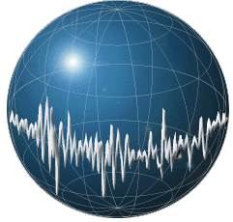MACHINE LEARNING APPLICATIONS IN DIGITAL PATHOLOGY

Leo Berman

Albert Bulik

Yuan Nghiem

We require no purchases for our project. Due to our project being primarily based on Python, a free and open-source software (FOSS), an existing dataset (Temple University Health Digital Pathology), compute server (Neuronix High Performance Cluster), and team of researchers to support us, there isn’t a need to purchase anything. We evaluated contributing to the existing compute server via hardware purchases, but after touching base with our advisor, Dr. Picone, he seconded that there is no need to purchase anything and that it would not significantly impact our productivity, or final result.

It is possible for us to purchase an enterprise version of our version control software (GitHub) which is not FOSS, but the benefit for large file support, workflow automation, and proprietary Continuous Integration/Continuous Delivery (CI/CD) pipeline weren’t significantly beneficial to our project due to having access to a large amount of reliable storage offered by the existing infrastructure.