Mirror Networking

Implemented basic code from a tutorial for the online versus component of the game. The work consists of having mirror integrated into the game loop as a simple test, a basic player movement script that will be rewritten by another coder and the start of a lobby/code for it.

The mirror integration was the simple act of adding the following scripts and components:

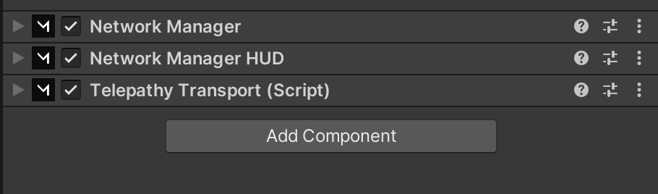

All components shown have auto generated default settings in which the only thing was I required to do is create a player prefab for the network to spawn. The Network Manager HUD is responsible for the creation of the host, client and server buttons that appear upon playing the game. All of which are generated from a premade template.

I created a very simple player prefab that housed a simple test script for the player. Contained in it was a jump script that required the script to send the command to the server host and back. After the round trip completed the player would jump. Once this prefab was made, I put it in the Network Manager script that housed a prefab specifically for the player.

Additionally, for the purpose of testing, I’ve added the parallel sync custom package that allowed me to test the host and client simultaneously. In the parallel sync tab, I was able to create a clone of the editor and scene. Once I’ve had both running, I’d set one as the host and the other as the client. It worked as intended with no complications.

The main menu required a lobby feature in which either you host the game or join one rather than the simple and basic way it currently is constructed as of writing. Nothing concrete has been established yet as I’m still going through the tutorials.