Financial Outcomes of Private Equity-Backed Portfolio Companies Post-IPO

Leonardo Straccia Spring 2023

**Contents**

1. Introduction 2
2. Related Literature 4
   1. Differences in Methodologies . . . . . . . . . . . . . . . . . . . . . . . . . . . 6
3. Data Overview 7
   1. Treatment - Portfolio Company Selection . . . . . . . . . . . . . . . . . . . . 8
   2. Control – Non-PE-Backed Company Selection 10
   3. Post-IPO Company Data 10
4. Analysis 1 11
   1. Methodology 1 12
      1. Propensity Scores 14
      2. Independent Two-Sample T-test 16
   2. Methodology 1 18
   3. Results 19
      1. Revenue Growth 19
      2. Net Income Growth 21
      3. EBITDA Growth 22
      4. Liquidity Growth 23
      5. ROE Growth 25
   4. Next Considerations **& Retesting**  17
   5. **Update to methodology**
   6. **Updated Results & Analysis**
5. **Analysis 2**
   1. **Company Selection**
   2. **Model Overview**
   3. **Generalizing Approach to other companies**
   4. Results of Findings & Aggregating the data
   5. Commentary on outliers
6. Robustness Testing
7. Conclusion 26
8. Appendix 27
   1. Growth Distributions 27
9. References 30

# Introduction

My analysis looks to investigate the long-term financial outcomes of companies that were formerly private equity (PE)-backed (strictly buyout-related private equity) in the US by comparing outcomes on a 1–5-year time horizon post-PE exit. The primary vehicle of exit will be an initial public offering (IPO). Through my investigation, I aim to analyze if companies outperform non-PE-back companies after IPO. In doing so, I hope to examine the long-term implications of private equity investment on the portfolio companies that they aim to grow. Since there has been a plethora of contrasting viewpoints surrounding the question of whether private equity involvement ultimately destroys or adds value to portfolio com- panies on a long-term time horizon, I aim to provide further discussion on how companies respond once they are no longer held by the PE firms. **Finally, I investigate the levels of growth post-IPO to see if the effects of private equity treatment are sustained after exit through the use of an event study.**

For this research, I define the “treated” group as portfolio companies with previous private equity backing, and the “control” group as all other companies that have previously not received backing from PE. Data for this project comes from IPOs of both treated and control IPO events that occurred from 2010 to 2018. My analysis first consists of regressing on propensity scores to assess the causal effect of PE treatment. Since the treatment im- posed on private equity firms is non-random, I must first eliminate the bias present in the targeted acquisitions by assigning each company a propensity score to assess their likelihood of being selected as a portfolio company. Some covariates I use include employee count, the number of years a given firm has been in business, and common deal and business multiples. To increase the heterogeneity of my control variables, I will look to target several different industries presently targeted by private equity firms. Companies will be split into their

respective industries in accordance with Pitchbook’s convention of classifying company sec- tors. Once companies are successfully matched, I construct a t-test for statistical significance within the treated and controlled populations to test for differences within mean financial metric growth of the two populations. Metrics tested include revenue, EBITDA, net income, liquidity, and ROE growth rates of PE-treated and non-treated companies at one-, three-, and five-years after IPO.

I leverage multiple confirmed sources to construct my analysis. To gain background information about companies, I use S&P Capital IQ. In addition, the source provides accu- rate valuation multiples, deal data, and company financial statements for public companies. IPO data will be pulled from a combination of both Pitchbook and Capital IQ. Pitchbook specializes in private equity transactions and keeps an extensive log of every pe-backed IPO exit dating back to the late 1800s. Capital IQ, on the other hand, provides extensive data on every IPO on both the NYSE and NASDAQ, as well as all worldwide public exchanges, and will be my primary source for looking at comparable non-PE-backed IPOs. Berkeley students have access to both Capital IQ and Pitchbook for free. The Security and Exchange Commission (SEC) requires all public companies to register IPOs through publicly available S-1 documents that can be found either on any publicly traded company’s website or directly through the SEC. S-1 documents will serve as the primary means of analyzing pe-backed performance pre-IPO as they are required to submit financial documentation prior to IPO. Annual 10-K filings are accessible publicly in the US through the same channels and will be used to analyze the financial performance of public companies post-IPO.

# Related Literature

Private equity firms raise funds to acquire and manage targeted companies before sell- ing them to create larger returns. Funds are raised from limited partners (LPs), managed by general partners (GPs), and have an average investment period of 7-10 years. Following the investment phase is a quick withdrawal and divestiture period to disburse profits back to LPs (Chen, 2022). Through the investment period, GPs “add value” to said portfolio companies to increase profitability and potentially increase exit valuation.

Since the emergence of the commercial private equity industry in the early 80s, there has been a plethora of contrasting arguments surrounding the economic impacts of private equity. An early study by Shleifer and Summers (1988) indicated that buyout investors in- creased their monetary returns by decreasing employee head count and slashing wages. In contrast, Kaplan (1989) argued that incentives like reducing wasteful expenditures and revenue-increasing business decisions **were** what led to increased operational performance rather than manage- rial exploitation. Nonetheless, arguments on both sides prevail. As recently as October 2021, Senator Elizabeth Warren claimed that private equity firms “destroy the long-term prospects of the businesses that they buy” (Warren) since they’re incentivized to capture short-term profit by ruthlessly cost-cutting and loading portfolio companies up with debt. This claim is further supported by research from Cressy et al. (2011) which found aggressive downsizing in portfolio company employment following post-PE backing. Recent contradictions to this claim, as evident from a meta-analysis by Verbouw et al. (2020) finds that there is a pos- itive effect on PE portfolio companies’ operational performance with little to no difference in employment gains.

Although much research has been done to investigate private equity investment impact on operational performance, much less evidence exists analyzing the long-term consequences of PE investments. Lerner et al. (2011) found through 472 leveraged buyout (LBOs) transac- tions that PE backing does not sacrifice long-term investments. Through patenting activity three and five years after initial investment, they find no significant differences in patenting data pre and during PE backing. This study, much like others mentioned, fails to provide any insight into the performance of portfolio companies post-PE exits. After all, most funds look to divest in a reasonable 7–10-year timeline, so assessing what happens to these port- folio companies, and if they can maintain similar levels of growth after PE “treatment”, is important to advance the literature surrounding the financial impacts of private equity. Research from Lavery et al. (2022) along with Melo (2014) suggests that the financial per- formance of PE-backed portfolio companies either did not fare better post-IPO than their non-PE-backed counterparts or underperformed in the long run. However, these studies were conducted using data from UK and Portugal-based companies respectively, and thus can- not be generalizable to the US. A recent study performed by Grønberg (2015) does indeed use US-based companies to investigate the question at hand and finds that non-PE-backed companies performed significantly better 36 months post-IPO on an operational basis. The biggest problem with the research, however, was presented in the matching process for non- PE-backed companies to compare against treated portfolio companies. Grønberg manually matched control companies with 50 undisclosed comparable features from PE-backed port- folio companies. There is no mention of any robust technique used to eliminate the effects of confounders such as Propensity scores or restriction besides this manual matching. In addition, the paper uses data from US IPOs from 2002 to 2010. After an extensive search **online**, I

was not able to find a similar study that used US IPOs from 2010 to 2018 and so will choose to do so. A study by Athar (2018) does make use of this existing data but proposes a slight variation on the question at hand by investigating the aftermarket performance of portfolio company stock prices post-IPO.

## Differences in Methodologies

Most of the studies that I have presented use some form of matching technique to address the exogenous impact that private equity investments have on portfolio companies. It is crucial to use techniques such as propensity scores or matching in this environment because the selection process of private equity targeted acquisitions is strictly nonrandom. Using existing financial documents on target companies, PE firms can select which firms to invest deemed on their confidence of being able to see a favorable return on investment (ROI). Instead of attempting to perform this match by hand, I leverage propensity scores using a logistic regression to get a probability score for how likely the private equity firm would invest in the control companies I select. Once I calculated the propensity scores for the individual companies, I regress on the propensity score estimates to get a causal interpretation on the effects PE treatment by setting it as a dummy variable. Unlike performing a 1-to-1 matching as in other studies investigated, regressing on PE treatment effects directly without matching companies beforehand allows me to use many more data points than previous research. **There were also inadequate matches within each respective industry to perform traditional propensity score matching.** For example, Grønberg (2015) loses nearly 87% of all portfolio company IPOs to use in their model because they could not find suitable matches for the portfolio companies. Further, the model throws out the vast majority of non-PE-backed IPOs that it was not able to find

matches more. From 2010 through 2018, there were roughly 6.8 non-PE-backed IPOs per PE-backed IPO. As I did not want to throw out these data points, I found matching to not be suitable in my model. Adding on to this methodology, I use performance and size metrics pre- IPO of both non-PE-backed and PE-backed companies to serve as covariates for calculating propensity scores. These include, but are not limited to, company age, EBITDA margin growth, liquidity ratios (assets to liability ratio and cash to liability ratio), profitability ratios (gross profit margins and return on equity), and total company employment.

The data set **of IPOs used**, US companies from 2010-2018 provides a more accurate depiction of US private equity when compared to the other research papers. The most recent paper to do so, Grønberg (2015), leverages data from US IPOs from 2002-2010. Through the two periods mentioned, there has been an increase from 409 transactions to 471 with an increase in the post-valuation median from $468.3M to $777.5M (Pitchbook). With a 15% increase in the number of PE-backed IPOs and a 66% increase in the post-valuation median, it’s necessary to use this new dataset to advance findings on the topic.

# Data Overview

I decided to only use companies from the US to study the impacts of private equity. More specifically, companies selected were either publicly listed on the Nasdaq or NYSE. The timeframe that I chose, company IPOs from 01/01/2010 until 01/01/2018 was selected for three reasons. Firstly, as mentioned, the most recent use of portfolio company IPOs for similar research as mine uses data from 01/01/2002 until 01/01/2010 (Grønberg, 2015). Sec- ondly, I have decided to set an upper cap at 01/01/2018 as to investigate portfolio company

IPOs by using at least five years of company performance data post-IPO. **Companies that IPO’d prior to 01/01/2018 have, in theory, at least five years of year end financials to reported (FY 2018 – FY 2022).** Lastly, the period specified saw no recessions in the US economy (recession defined in this paper as two succes- sive quarters of falling GDP). One issue with Grønberg’s design was that the data observed did not fully capture the period specified. This was largely due to the Great Recession, which saw virtually no PE-backed exits into the public sector from 2007-2009. Since both IPO and PE activity increased from 2010 through 2018 (Statistica; McKinsey), there is no shortage in data availability in this period.

Company data for my research will be split into different subgroups; private equity portfolio companies that have IPO’d (treatment), non-private-equity-backed private compa- nies with similar IPO dates as my treatment group (control 1), and public companies that were already traded on the market at time of treatment IPO. The timeframe I target only includes date of IPO. For example, multiple data points used go as recent as 12/2022.

## Treatment - Portfolio Company Selection

The selection process for the companies was done using Pitchbook. Pitchbook al- lows me to set certain flags to filter out companies between the specified dates and location that were involved in private equity-backed exits. Pitchbook also further specifies which companies were involved in VC-backed exits, and which ones were involved in traditional buyout-backed exits, thus saving me time by not having to search for private equity involve- ment for each portfolio company. This brought the total amount of exited companies to 699. By further specifying the IPO deal stage as “Completed”, I was able to narrow the list to 531. In addition, I can filter for transactions where private equity funds will not

have a controlling interest post-IPO, which brought the list down to 392. Next, I eliminated all companies in very niched industries that were not primary targets of private equity or considered as sectors. An example of this was my decision to eliminate Special Purpose Acquisition Companies, which do not have any business operations, and private equity firms that went public as they are inherently PE-backed. Adding additional flags to narrow down the companies to just those listed on Nasdaq or NYSE further decreases the total amount of companies to 261.

One initial problem with this dataset is that determining how long a company has been public for is nontrivial. For example, some companies since initial IPO have been ac- quired or merged with other companies within the observation period of five years. These companies need to be excluded as there is not enough observational data to be useful for my model. Pitchbook writes ticker symbols next to company names that are still publicly traded, so all I must do is look at those without ticker symbols. I am careful, however, to keep companies that went bankrupt within the five-year time horizon. After filtering to make sure that there were enough data entries to use for each portfolio company, the total amount of companies that I use in my model fell to 141. Filtering out companies at this level was simply done by manually googling their trading history and SEC filings. All public company activity must be published in 8-K forms as per SEC requirements, so although cumbersome, eliminating those without five years of public information is simple.

## Control – Non-PE-Backed Company Selection

I use non-PE-backed companies that IPO’d from 01/01/2010 to 01/01/2018 as my control. Pitchbook allows for a search of IPO deals to specify if the companies had no previous IPO involvement. With this flag on, I was able to find 1373 companies with similar search criteria. Public company data is also used to gauge the performance of both PE-backed and non-PE-backed companies to account for average industry growth within the verticals targeted. After eliminating companies that had no private equity involvement whatsoever, did not have the required five years of financials, or were categorized in niche industries such as SPACs, I was left with 953 control companies to work with. As mentioned, the large discrepancy in non-PE-backed and PE-backed IPOs was the reason why it’s to use matching. The population sizes of the two groups are drastically different, and therefore, I would have been left with several valuable but discarded data points.

## Post-IPO Company Data

The data used to analyze the difference between treatment control groups is trivial to find. As mandated by the SEC, and the main reason for choosing companies registered on either the Nasdaq or NYSE exchanges, publicly listed companies on NAS and NYSE exchanges are required to report financial reports quarterly with 10-Q forms and annually with 10-K forms (SEC). This information is also made public on the SEC database and, to my knowledge, never expires. Therefore, whether the companies are taken private after the initial IPO or file for bankruptcy, I was able to find financial information on the observed companies long after it is no longer useful. The metrics of interest, more specifically, are

included on balance sheet and income statement within the financial reports. Revenue, Income, and Net Income can be located on the income statement and are found on all 10-K forms that were compiled. Liquidity, measured as cash and cash equivalence at the end of the reported period, is located on the balance sheet. ROE is not genally found on the balance sheet, but is calculated as total liabilities over total equity. The two are required parts of any balance sheet calculation. Due to the time horizons of my study, I use annually-filed 10-K forms for the analysis. Five successive 10-K’s will be used after the IPO per each company observed to analyze performance trends.

# Analysis

**Hypothesis 1 (H1)** *Company growth rates of PE-Treated companies post-IPO are statistically significant*

Through my analysis I investigate differences in revenue, EBITDA, net income, liq- uidity, and ROE growth rates of PE-treated and non-treated companies at one-, three-, and five-years after IPO. I find no statistical significance in revenue growth, net income growth, and ROE growth. However, I do find statistical significance in both liquidity and EBITDA growth. These results go in hand with the business model of private equity firms. Firms raise as much debt as possible when acquiring businesses, and thus the cash at hand (liquidity) that these companies will have to pay off debt is directly impacted by the amount of debt they take on. For each growth measure of growth tested, I compile my results in the form of an attached table and violin plot to demonstrate the distribution of data between treated and control groups.

## Methodology 1

As previously stated, I rely on propensity score estimates for each company to com- pute their probability of treatment. My analysis relies on two data tables. The first of which is a deals table that maps companies to their dates of IPO. There were 141 IPO’s of PE-treatment firms with sufficient financials to compute a propensity score and 832 IPO’s of non-treated firms with the same criteria from 2010 through 2018. Along with these fields were relevant metrics that I used to calculate propensity scores. These metrics in- clude, but are not limited to, ratios such as Valuation/EBITDA, Valuation/Cash Flow, Deal Size/Revenue, Deal Size/Net Profit, and company-specific information such as total years of operation, employee count, and EBITDA margins. Companies were subdivided into seven industries to address industry-specific effects that could introduce bias in growth rates. These industries included B2C, B2B, Technology, Energy, Natural Resources, Healthcare, and Financial Services. Private equity activity is highly present in all these industries, as was made evident by deal information from Pitchbook. The second data set is a compiled list of all IPO’d company financials dating from 2010 to 2022. There were roughly 36,000 total company financial reports in the data set. Companies report four times a year, but since many reporting companies report the bulk of their financial metrics in December (Q4) of each year, I relied on end-of-year financial reports for my estimations. Both data sets were pulled from Pitchbook and required a substantial amount of cleaning before working with. For one, many entries in the data were null. To work around this, and not skew the analysis findings, I populate null values with the median of their respective columns and industry. Because I used Python instead of Stata to conduct my analysis, it was required to populated the graph with as many entries as possible. For example, Stata has features

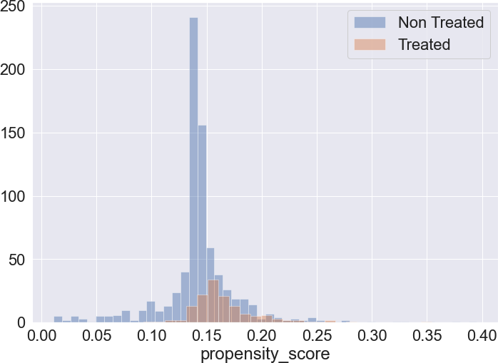in place that will automatically address null values in a data table whereas many Python packages don’t respond as gracefully. In addition, my main metrics of interest (revenue, EBITDA, net income, liquidity, and ROE growth rates) were left uncalculated in the dat aset. This required some light data manipulation to calculate. I also found it important to eliminate entries that had extreme outliers. Some companies in the data set experi- enced large negative decreases in growth rates much higher than other company values, which I suspected would have heavily skewed my analytical findings. All data manipula- tion directly relating to the format of the data sets was handled through excel. After the data was cleaned, I imported it into a Jupyter Notebook for the remainder of the EDA.

After importing the datasets, I ran a bal- anced logistic regression on the deal information to compute propensity scores for each respec- tive company, and then appended the propensity

Figure 1: Positivity Check for Propensity Score Overlap

scores to the company financial information by mapping propensity scores to company names. An initial positivity check confirmed that none

of the propensity scores were less than zero or greater than one, and that there is sufficient overlap to infer causal inference. To compute a two-sided t-test for statistical significance, I ran the calculated propensity scores with a PE-treatment binary indicator, *Di*, and ran an OLS regression of the form:

*Yit* = *β* + *a*0*Di* + *a*1*pi* + *εit*

In this model, *β*, the intercept, is interpreted as the expected growth estimate *Yit* given no

PE-treatment, *a*0*Di* represents the measured PE-treatment effect on *Yit* given the company was a PE portfolio company, and *a*1*pi* is included as an estimate interpreted as how *Yit* will change as company i’s likelihood of PE-treatment increases. This regression was calculated using the package *statsmodels.formula.api*, which also gave the option to compute the t-test given the null hypothesis (PE-treatment == 0) as an input. Next, violin plots were graphed to compare the log growth rates of different growth rate measures modeled. Each plot shows the distribution of log values at the one-, three-, and five-years post-IPO increments, and is further subdivided to show how the distributions of PE and non-PE treated companies compared side-by-side at the specified year. Because measures of growth were scattered across a wide range – some companies experiencing 10x growth in the span of one year – it is necessary to take log estimates to get a better view of the overall distribution. All growth distributions can be found in 6.1.

### Propensity Scores

The problem with directly investigating the difference between treated portfolio com- panies post-IPO and non-PE-backed companies post-IPO is that I must account for the exogenous treatment of private equity investment into a company. To address for the selec- tion bias of treatment, which are characteristic of observational studies, I must first attempt to assess the likelihood of both treated and non-treated groups being chosen as a portfo- lio company by using propensity scores. Propensity scores attempt to address the effect of treatment on a certain group by controlling for covariates that help to predict treatment of a group. By controlling for covariates that affect the probability of treatment, I’m able to control for the probability of treatment itself (Mostly Harmless Econometrics, 60). Once cal-

culating the probability of treatment (propensity score) for both treated and control groups, I can simply regress upon the scores themselves to control for variables I believe to impact company selection. The initial assumption of the propensity score method is that treated groups can be compared to non-treated counterparts once conditioned on observational co- variates (World Bank). The second is that there is a large enough data set within the two groups to run the propensity score estimates on. Prior to running the model, I subdivide treatment and control groups into the industry sector buckets mentioned. I will then further subdivide based on the year of IPO. By separating groups this way, I aim to eliminate any fixed time effects between treatment and control companies. During 2010-2018, there have been numerous regulations implemented which I expect to affect performance of the observed companies. For example, the Tax Cuts and Jobs Act (2017) substantially cut corporate tax- ation of several businesses, and as a result may have sparked artificial growth in company profits.

Due to metric availability, covariates that I will be regressing on include company age, mean management years of experience, liquidity ratios (assets to liability ratio and cash to liability ratio), profitability ratios, total company employment, low relative capital expen- ditures, and profit margins. These covariates were chosen because they are key areas of interest that PE funds look for when investing in a company (Consero) but are unlikely to affect my outcomes of interest. Although adding too little covariates to regress on could violate the unconfoundedness assumption, I will be careful to not include too many as it could lead to very low propensity score estimates (World Bank). The most common ap- proach for calculating propensity scores is a logistic regression. I use a dependent variable *D* = *{*1 if PE treatment; 0 if no PE treatment*}* to identify if the companies received PE-

backing or not and calculate my propensity score as:

*e*(*x*) = *P*ˆ*r*(*D* = 1 *| X* = *x*) = *σ*(*θx*)

where *x* is the vector of covariates used to match groups. The function *σ*(*θx*) is a sigmoidal function which commonly used in logistic regressions. Within the regression, *θ* is interpreted as a vector of coefficients where *θi* is the expected log odd of having the treatment variable *D* change due to a change in an additional *xi*.

### Independent Two-Sample T-test

Once companies scores are calculated, I run a two-sample t-test for statistical significance assess the difference in mean performance indicator growth between treated and control groups. Performance variables of interest, revenue growth, return on equity growth, EBITDA growth, net profit growth, and liquidity growth, are tested to check for statistical significance in my dummy treatment variable. These performance indicators were specifically chosen because they are commonly used in assessing the health of businesses (Twin, 2022). The same package that I use to run my OLS regression has a built-in *results.t test(’hypothesis’)* features, which I use for my analysis. The hypothesis in this case is simply the null hypothesis of my analysis. In this case, it would be that PE-treated companies do not differ from their non-treated counterparts when it comes to business growth. Simply put, the hypothesis in this model checks if the dummy variable PE treatment == 0.

In this model, I am investigating company i’s performance in year t. The outcome of interest of companies per variable then becomes:

*Yit* = *{Y*1*it* if *Di* == 1; *Y*0*it* if *Di* == 0*}*

Setting the average treatment effect to be *E*[*Y*1*it − Y*0*it | t*] = *λ*, I can further break down *Yit* = *λt* + *st* + *δDit* + *εit* where *E*[*εit | t*] = 0. I expect *λ* in my model to equal the mean causal effect in financial outcomes between private equity backing pre-IPO and non-PE-backing. Time-fixed effects (*λt*), are used to address time-specific effects that arise from changes in the economic environment from year-to-year. Industry-specific fixed effects (*st*) capture the differences in growth and regulations from one industry to another. After estimating the mean causal effect in treatment, I can plug my result into the t-test model to test for statistical significance.

## Next Considerations

**Covariates used for matching:** ”Valuation/EBITDA”,”Deal Size/Cash Flow”, ”Val- uation/EBIT”, ”Valuation/Revenue”, ”Valuation/Cash Flow”,”Deal Size/EBITDA”,”Deal Size/EBIT”,”Deal Size/Net Income”, ”Deal Size/Revenue”

* How do I check that the datapoints that I use to calculate the propensity scores are relevant? In my model, I merely choose some that I believe to be correlated.
  + Maybe I should be using some sort of regularization of my data. I know that ridge regressions are common to use to eliminate some of the multicollinearity present with the independent variables
  + It could be the case that my datapoints are actually not covariates at all to the propensity score
* Is there a better methodology of dealing with missing datapoints?
  + For the time being, missing datapoints are filled with the column median. At what level is it ok to do something like this?
* The model also does not match companies based on year that the company IPO’d.

Must the companies have IPO’d in the same years to see any impact on performance

* IQR ranges from .05 - .95 because traditional ranges removed too much of the data for each of the covariate columns

## Methodology 1

After analyzing the differences between both treatment and control groups. I would like to analyze my secondary topic to see if the growth of portfolio companies is sustained post-IPO. This will be done through an event study. The event that we are analyzing here is IPO exit after PE investment. Event studies are used primarily to determine how a certain event impacts the performance of a firm, and thus fit well for this analysis. As stated previously, S-1 documentation shows three years of available company finances before IPO, as mandated by the SEC. Because of this, the timeline of the event study will be from three years pre-exit until five years post-exit. This timeline is purely based on availability of data. Considering that many companies only report one year of company financials pre-IPO in S-1 filings, the true range of data will vary from one to three years pre-IPO. Five years of post- exit data will be taken from 10-K forms. Growth variables analyzed will be the exact same as the ones analyzed in significance testing above. These include revenue growth, return on equity growth, EBITDA growth, net profit growth, and liquidity growth. The model formula

is written as Y*it* =*i* +*st* +( *j* = *−*3)5*Ditj* +*i t*

*j*

where Y*itistheperformancegrowthvariablemeasuredf romcompanyi,i isthefirmfixedeffect,s tisthey industryfixedeffect,j isthecapturedeffectjyearspost−exit, Ditjisanindicatorfunction*1*ifj >* 0; *else*0*, a testisconductedtotestwhetherthegrowthsustainedduringprivateequitytreatmentstatisticallydiffersfro*

*IPO.Utilizingt−testsforeventstudydesignsisacommonpractice.Similarly, thet−testmodelleveragedwill*

*samplet−testforstatisticalsignificance, whichhasthesameassumptionsasstatedpreviously.Bytestingfo*

*exit, Icandetermineisgrowthwassustained, fell, orincreasedinrelationtowhentheportfoliocompanieswer*

*management.*

## Results

In this section I break down my analytical findings of differences in mean growth of the metrics measured and give high-level level descriptions of their distributions.

### Revenue Growth

From table 1 we can see that there is no significance between previous private equity backing and revenue growth at one-, three-, and five-year time horizons after IPO. At the one-year horizon, I report an estimated PE-treatment impact of -0.821% on total revenue growth with a standard error of 5.313 and t-statistic of -0.156, which is insignificant at the

0.1 level. The reported 95% Confidence interval of the estimates (-11.255 - 9.602) includes 0 and therefore it cannot be concluded that there is significance in revenue growth at the one-year level. The same is seen at three- and five- year time horizons for revenue growth. Three-year estimates found the impact of private equity treatment to be -4.9920% growth with a standard error of 4.981 and t-statistic of -1.002 which five-year estimates found an

|  |  |  |  |
| --- | --- | --- | --- |
|  |  | *Revenue Growth %* |  |
| (Year 1) | (Year 3) | (Year 5) |
| Intercept | 28.248∗∗∗ (4.653) | 15.641∗∗∗ (4.397) | 20.326∗∗∗ (4.931) |
| PE | -0.826 | -4.992 | -0.267 |
|  | (5.313) | (4.981) | (5.667) |
| Propensity Score | -19.081 | -7.829 | -25.633 |
|  | (27.742) | (26.391) | (29.441) |
| Observations | 796 | 709 | 619 |

*R*2 0.001 0.002 0.001

|  |  |  |  |
| --- | --- | --- | --- |
| Adjusted *R*2  Residual Std. Error F Statistic | -0.002  53.483(df = 793)  0.264 (df = 2.0; 793.0) | -0.001  46.902(df = 706)  0.594 (df = 2.0; 706.0) | -0.002  49.286(df = 616)  0.386 (df = 2.0; 616.0) |
| Test for PE Significance |  |  |  |
| PE | -0.8261 | -4.9920 | -0.2668 |
| std err | 5.313 | 4.981 | 5.667 |
| t | -0.156 | -1.002 | -0.047 |
| P*> |*t*|* | 0.876 | 0.317 | 0.962 |
| 0.025 | -11.255 | -14.770 | -11.395 |
| 0.975 | 9.602 | 4.786 | 10.862 |

∗p*<*0.1; ∗∗p*<*0.05; ∗∗∗p*<*0.01

Table 1: Test for PE Significance with Revenue Growth %

impact of -0.2668% growth with a standard error of 5.667 and t-statistic of -0.047. We fail to reject the null hypothesis of no statistical PE-treatment impact on all years measured. Although nothing can be statistically concluded with these estimates, it appears to be the case that portfolio companies could in fact be growing at a slower pace than their non- treated counterparts. This is made evident in Figure 2 where we can see that log growth rate distribution peaks appear to be slightly lower than non-treated counterparts at all years measured. Of note as well is the long upper bound tail of non-treated companies and long lower bound tail of portfolio companies. Through the tails we can see that there is greater concentration of very high growth measures in non-treated companies and vise versa for the portfolio group.

### Net Income Growth

|  |  |  |  |
| --- | --- | --- | --- |
|  |  | *Net Income Growth %* |  |
|  | (Year 1) | (Year 3) | (Year 5) |
| Intercept | 2.741 | 3.713 | 39.763 |
|  | (31.430) | (53.466) | (37.912) |
| PE | 21.676 | -73.491 | -48.050 |
|  | (36.631) | (59.385) | (44.697) |
| Propensity Score | -77.826 | -36.058 | -70.860 |
|  | (187.379) | (324.489) | (227.394) |
| Observations | 769 | 699 | 617 |

*R*2 0.001 0.002 0.002

|  |  |  |  |
| --- | --- | --- | --- |
| Adjusted *R*2  Residual Std. Error F Statistic | -0.002  358.925(df = 766)  0.238 (df = 2.0; 766.0) | -0.001  553.827(df = 696)  0.804 (df = 2.0; 696.0) | -0.001  381.191(df = 614)  0.661 (df = 2.0; 614.0) |
| Test for PE Significance |  |  |  |
| PE | 21.6757 | -73.4909 | -48.0504 |
| std err | 36.631 | 59.385 | 44.697 |
| t | 0.592 | -1.238 | -1.075 |
| P*> |*t*|* | 0.554 | 0.216 | 0.283 |
| 0.025 | -50.233 | -190.087 | -135.828 |
| 0.975 | 93.584 | 43.105 | 39.728 |

∗p*<*0.1; ∗∗p*<*0.05; ∗∗∗p*<*0.01

Table 2: Test for PE Significance with Net Income Growth %

In Figure 3 we see less evidence of a difference in overall distribution ranges for both groups. As was the case with revenue growth, there is no statistical significance in PE-treatment impact at any of the time horizons measured post-IPO. One year post IPO, non-PE-backed companies measured on average saw 2.74% growth in net income in the first year after their IPO. The estimated impact of PE-treatment was 21.68% increase in net income with a standard error of 36.631 and t-statistic of 0.592, which is well above the

0.1 significance threshold. At years three and five, we see a slightly different picture with insignificant findings. At year three, companies on average saw an increase of 3.71% in net income growth while PE-treated companies saw nearly 70% decreases in net income growth from the year prior. The standard error measured was 59.39 with an insignificant t-statistic

of -1.24. At year five, we see non-PE-backed companies on average seeing increases in net income of 39.76% while PE-treatment suggests a decrease in net income growth of 8.29% with a standard error of 44.697 and insignificant t-stat of -1.075. Since in all three 95% confidence intervals the value of 0 is present, I conclude my failing to reject the null hypothesis as well.

### EBITDA Growth

*EBITDA Growth %*

|  |  |  |  |
| --- | --- | --- | --- |
|  | (Year 1) | (Year 3) | (Year 5) |
| Intercept | -39.986∗∗∗ | -4.624 | 2.420 |
|  | (12.904) | (11.526) | (13.570) |
| PE | 52.809∗∗∗ | 11.185 | 38.303∗∗ |
|  | (14.894) | (13.180) | (15.870) |
| Propensity Score | 181.489∗∗ | 36.565 | 20.129 |
|  | (77.357) | (69.329) | (81.317) |
| Observations | 794 | 711 | 621 |

*R*2 0.025 0.002 0.010

|  |  |  |  |
| --- | --- | --- | --- |
| Adjusted *R*2  Residual Std. Error F Statistic | 0.023  148.766(df = 791)  10.156∗∗∗ (df = 2.0; 791.0) | -0.001  123.105(df = 708)  0.568 (df = 2.0; 708.0) | 0.006  136.787(df = 618)  3.014∗∗ (df = 2.0; 618.0) |
| Test for PE Significance |  |  |  |
| PE | 52.8093∗∗∗ | 11.1846 | 38.3031∗∗ |
| std err | 14.894 | 13.180 | 15.870 |
| t | 3.546 | 0.849 | 2.414 |
| P*> |*t*|* | 0.000 | 0.396 | 0.016 |
| 0.025 | 23.573 | -14.692 | 7.137 |
| 0.975 | 82.046 | 37.061 | 69.469 |

∗p*<*0.1; ∗∗p*<*0.05; ∗∗∗p*<*0.01

Table 3: Test for PE Significance with EBITDA Growth %

In contrast to a first look at the distribution in Figure 4, I find statistically significant results for EBITDA growth at one- and five-year time horizons. The distribution shows us that for both portfolio and non-treated companies within years one and three, most companies tested experienced high levels of growth (between 10-40%) with non-PE backed companies being slightly more skewed toward to upper bound. The mean EBITDA growth rate for non-treated companies one year after IPO was found to be -39.99% while PE-backed

companies saw increases of around 12.82% in EBITDA with a standard error of 14.89. The t-statistic of 3.546 is seen to be highly statistically significant at the 0.1, 0.05, and 0.01 p-values. One reason for this statistically significant increase could relate to the business model of portfolio companies pre-IPO. Private equity firms raise large amount of debt to fund transactions in order to see maximum internal rate of returns. An increase in EBITDA post-IPO could suggest an attempt for the companies to cut cost and raise liquidity so as to pay down the significant debt. At year three post-IPO, we find insignificant results. On average non-PE-backed companies see EBITDA growth rates of -4.62%, while PE-treated companies on average saw 6.56% increases in EBITDA with a standard error of 13.18 and t-statistic of 0.849. If my first claim of portfolio companies cutting costs to pay down debt at the first year holds, an insignificant result at year three could suggest that the majority of raised debt is paid off at three years post-exit and that portfolio companies no longer need to aggressively cut costs to pay back debt. Interestingly, I also find significant results at the five-year horizon. Non-treated companies saw increases of 2.42% on average which treated ones saw an additional 38.30% growth on average. Standard error was measured to be 15.87 and the t-statistic of 2.414 is statistically significant at p-values of 0.1 and 0.05. For years one and five post-IPO we reject the null and conclude that PE-treatment does cause statistically significant EBITDA growth at these horizons.

### Liquidity Growth

In table 4, I find statistically significant liquidity growth at year three post IPO for portfolio companies. At the first year after initial IPO, non-PE-backed companies on average saw liquidity growths of 101.42% while portfolio companies saw increases of 51.93%

|  |  |  |  |
| --- | --- | --- | --- |
|  |  | *Liquidity Growth %* |  |
| (Year 1) | (Year 3) | (Year 5) |
| Intercept | 101.415∗∗ | 297.336∗∗∗ | 111.414∗∗∗ |
|  | (43.578) | (72.788) | (42.626) |
| PE | -49.482 | -160.929∗∗ | -54.027 |
|  | (49.769) | (81.487) | (50.103) |
| Propensity Score | 184.530 | -429.127 | 10.175 |
|  | (259.695) | (442.528) | (255.370) |
| Observations | 784 | 705 | 618 |

*R*2 0.002 0.008 0.002

|  |  |  |  |
| --- | --- | --- | --- |
| Adjusted *R*2  Residual Std. Error F Statistic | -0.001  498.492(df = 781)  0.675 (df = 2.0; 781.0) | 0.005  757.153(df = 702)  2.730∗ (df = 2.0; 702.0) | -0.001  427.190(df = 615)  0.583 (df = 2.0; 615.0) |
| Test for PE Significance |  |  |  |
| PE | -49.4817 | -160.9290∗∗ | -54.0270 |
| std err | 49.769 | 81.487 | 50.103 |
| t | -0.994 | -1.975 | -1.078 |
| P*> |*t*|* | 0.320 | 0.049 | 0.281 |
| 0.025 | -147.179 | -320.917 | -152.420 |
| 0.975 | 48.216 | -0.941 | 44.366 |

∗p*<*0.1; ∗∗p*<*0.05; ∗∗∗p*<*0.01

Table 4: Test for PE Significance with Liquidity Growth %

in liquidity. The measured standard error of PE treatment was calculated to be 49.769 and the t-test showed insignificant results at a p-value of 0.1. At year three, we see a mean effect of private equity treatment to be 160.93% less liquidity growth compared to the estimated 297.34% increase in liquidity of non-treated companies. Standard error was measured to be 81.49 with a t-statistic significant t-stat of -1.975 at p-values of 0.1 and 0.05. Lastly, there is no statistical different between treated and non-treated companies at year five post- IPO, which suggests there being no impact on liquidity growth of PE-treatment on a longer timeline. Estimated growth of 111.41% was seen in non-treated companies while portfolio companies saw on average 53.38% increases in liquidity. Interestingly, portfolio companies were seen to have less liquidity growth on average than their non-treated counterparts. In theory, we would expect this to be due to portfolio companies paying off debt from initial

PE financing, but this cannot be inferred.

### ROE Growth

|  |  |  |  |
| --- | --- | --- | --- |
|  |  | *ROE Growth %* |  |
|  | (Year 1) | (Year 3) | (Year 5) |
| Intercept | -100.720∗∗ | -68.770 | -55.532 |
|  | (47.254) | (46.276) | (49.299) |
| PE | -55.781 | -29.781 | -13.531 |
|  | (54.922) | (53.241) | (57.936) |
| Propensity Score | 231.437 | 229.069 | 189.768 |
|  | (281.532) | (277.472) | (295.475) |
| Observations | 781 | 698 | 614 |

*R*2 0.002 0.001 0.001

|  |  |  |  |
| --- | --- | --- | --- |
| Adjusted *R*2  Residual Std. Error F Statistic | -0.001  544.309(df = 778)  0.770 (df = 2.0; 778.0) | -0.002  490.600(df = 695)  0.444 (df = 2.0; 695.0) | -0.003  493.970(df = 611)  0.222 (df = 2.0; 611.0) |
| Test for PE Significance |  |  |  |
| PE | -55.7806 | -29.7808 | -13.5306 |
| std err | 54.922 | 53.241 | 57.936 |
| t | -1.016 | -0.559 | -0.234 |
| P*> |*t*|* | 0.310 | 0.576 | 0.815 |
| 0.025 | -163.594 | -134.314 | -127.308 |
| 0.975 | 52.033 | 74.752 | 100.247 |

∗p*<*0.1; ∗∗p*<*0.05; ∗∗∗p*<*0.01

Table 5: Test for PE Significance with ROE Growth %

There was no measured significant changes in ROE growth between treated and non- treated companies at any of the years measured. At year one, non-treated companies saw 100.7% decreases in ROE while PE-treated companies saw an additional 55.78% decrease on average. The measured t-statistic of -1.016 was insignificant at any p-value. In years three and five we see something similar. Non-treated companies experienced 68.77% and 55.53% decreases in ROE respectively while portfolio companies saw additional decreases of 29.78% and 13.53% on average with insignificant t-stats of -0.559 and -0.234 respectively. Due to insignificance in the findings, we fail to reject the null hypothesis and conclude that there is no statistical significance between treated and non-treated companies.

# Conclusion

This analysis provides evidence that private equity involvement has had an impact on growth rates of portfolio companies that IPO’d from the beginning of 2010 to the beginning of 2018. When compared to the 953 non-PE-backed companies that IPO’d within the same time frame, the 141 analyzed portfolio companies showed insignificant differences in growth measures of revenue and net income, but do display highly significant differences in EBITDA and liquidity growth. Notably, portfolio companies are seen to have significantly lower levels of liquidity growth three years after private equity divestment and significantly higher levels of EBITDA growth at years one and five after exit. EBITDA growth was tested to be significantly higher at years one and three with growths rates on average being 53% and 38% additional percentage points higher than non-treated companies. Liquidity, on the other hand, is recorded to be 160% less additionally in mean growth of portfolio companies. Although my analysis does not dive into the root cause for this difference in estimates,

I suggest that it is due to the business model of private equity to leverage as much debt as possible to acquire these portfolio companies. This is partially controlled since I include total debt as a covariate to my propensity score regression, but missing company data around this parameter implies that I cannot infer any causality from it. Though the evidence I present cannot infer conclusively if portfolio companies end up *better off* than their non-backed counterparts, I do find significant differences in growth measures in support of the initial hypothesis.

# Appendix

## Growth Distributions

This section displays violin plots of all tested measures of growth and demonstrates the differences in distributions of data between portolio and non-treated companies.

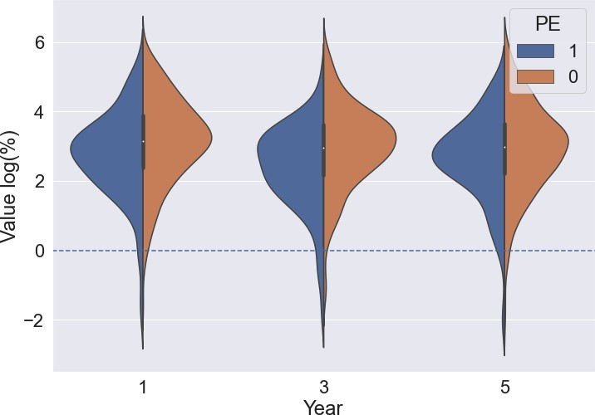

Figure 2: Log Growth Rate (%) of Revenue

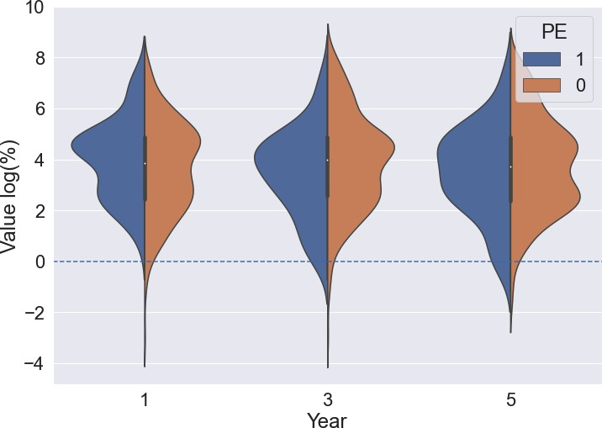

Figure 3: Log Growth Rate (%) of Net Income

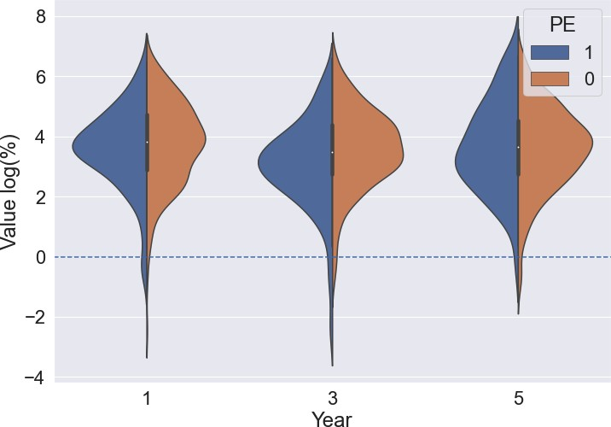

Figure 4: Log Growth Rate (%) of EBITDA

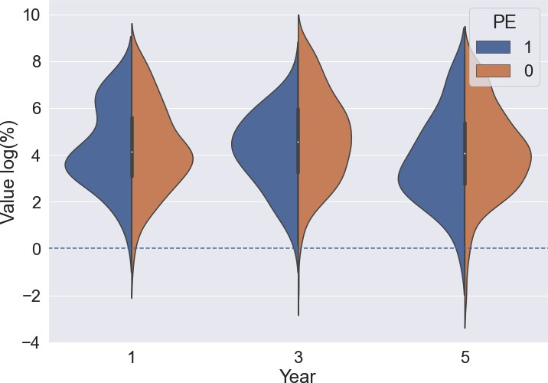

Figure 5: Log Growth Rate (%) of Liquidity

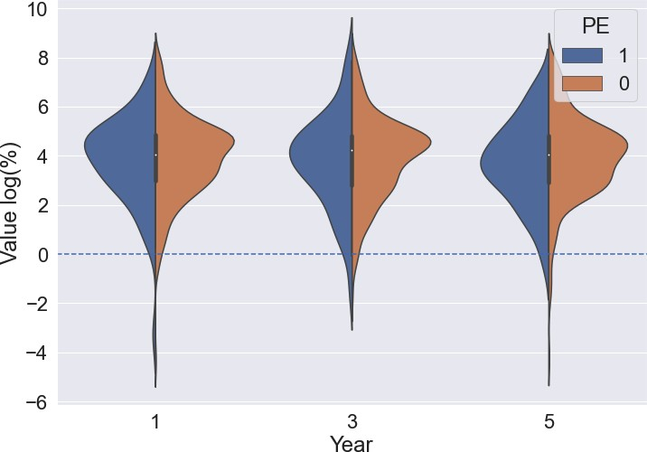

Figure 6: Log Growth Rate (%) of ROE

# References

Angrist, J. D., & Pischke J¨orn-Steffen. (2013). Mostly harmless econometrics: An empiri- cists companion. Content Technologies Inc.

Athar, F. (2018). Aftermarket Performance of Private Equity Backed Companies (Doctoral dissertation, Stern School of Business New York).

Chen, J. (2023, January 19). Private equity explained with examples and ways to invest, Investopedia.

Consero Global. (2021, February 11). 6 things private equity firms look for in companies.

Cressy, R., Munari, F., & Malipiero, A. (2011). Creative destruction? evidence that buyouts shed jobs to raise returns. Venture Capital, 13(1), 1–22.

Grønberg, N. G. Does Private Equity Affiliation Add Economic Value to Portfolio Firms Post-Exit?.

Kaplan, S. (1989). The effects of management buyouts on operating performance and value.

Journal of Financial Economics, 24(2), 217–254.

Lavery, P., & Wilson, N. (2022). Private equity buyouts and portfolio company Performance Post-exit. SSRN Electronic Journal.

Lerner, J., Sorensen, M. and Str¨omberg, P. (2011), Private Equity and Long-Run Investment: The Case of Innovation. The Journal of Finance, 66: 445-477.

McKinsey & Company. (2019). (rep.). Private Markets Come of Age.

Melo, D. (2014). The post-IPO operational effect of private equity past ownership: The secondary buyouts case (Order No. 29113765). Available from ProQuest Dissertations & Theses A&I; ProQuest Dissertations & Theses Global. (2689294546).

Mishra, P., Pandey, C. M., Singh, U., Gupta, A., Sahu, C., & Keshri, A. (2019). Descriptive statistics and normality tests for statistical data. Annals of cardiac anaesthesia, 22(1), 67–72.

Propensity Score Matching. (n.d.), Dime Wiki, World Bank.

Shleifer, A., & Summers, L. H. (1988). Breach of trust in hostile takeovers. In Corporate takeovers: Causes and consequences (pp. 33-68). University of Chicago Press.

Statista Research Department. (2023, February 3). Number of ipos in the U.S. 1999-2022, Statistica.

Text - H.R.1 - 115th Congress (2017-2018): An Act to provide for reconciliation pursuant to titles II and V of the concurrent resolution on the budget for fiscal year 2018. (2017, December 22).

Twin, A. (2023, January 12). Key performance indicator (KPI): Meaning, types, examples, Investopedia.

US. Securities and Exchange Commission. (2017, May 4). Exchange act reporting and registration, SEC.

US Gross Domestic Product. (2023, February 23), FRED, Federal Reserve Bank of St.

Louis.

Venture Capital, private equity and M&A Database. (n.d.), Pitchbook.

Verbouw, J., Meuleman, M., & Manigart, S. (2021). The Real Effects of Private Equity Buyouts: A Meta-Analysis. In Academy of Management Annual Meeting (Vol. 1, p. 14309).

Warren, E. (2021, October 20). Protecting companies and communities from private equity abuse: United States Senate Committee on Banking, Housing, and Urban Affairs.