Ruixuan’s LabNotes for HPVevo

NCBI Data download/format/clean [done, final cleaned dataset n=1398, including 245 DOCK8]
(1) Download all available genome/meta data from NCBI Virus database on Mar 13, 2025:
Virus/Taxonomy: Papillomaviridae, taxid:151340
Number of nucleotide sequences: 9,134 (including 40 RefSeq)
Host: Homo sapiens
Sequence length filter threshold: 7000
(2) Format the metadata:
(2.1) For those that are missing ‘Isolate’ values (n=75), extract the ‘strain’ from its ‘GenBank_Title’. After refining, 24 sequences are missing isolate/strain values (set to ‘unknown_strain’). Notes: Please note that in NCBI virus, if the strain name is not found in ‘Isolate’ column, try extracting it from the strain values in column ‘GenBank_Title’.
(2.2) Remove the columns that only have ‘NA’ values (‘Segment’ and ‘USA’ were removed).
(2.3) Set ‘Country’ to ‘unknown_country’ for those that are missing ‘Country’ values (n=591).
(2.4) Refine the 'Type' information. Add a new column ‘Type’. For those whose ‘Organism_Name’ are formatted as ‘(H)human papillomavirus (type) 11’, set its ‘Type’ into ‘HPV_11’ (438 records are missing standard ‘Organism_Name’, including 245 DOCK8 sequences).
(2.5) Add ‘Group’ column. Set records whose BioProject value is ‘PRJNA471898’ into ‘DOCK8’ while others were set into ‘Global’.
(3) Clean the public data, create standard sequence headers:
(3.1) Exclude GenBank ref strain (n=40, will use PaVE ref strain instead)
(3.2) Exclude ‘Global’ records that are missing ‘Type’ values (n=182)
(3.3) Exclude records that missing ‘Collection_Date’ (n=7456). Create another column named 'date', complete date missing month/day info into ‘yyyy-07-01/yyyy-mm-15’.
(3.4) Remove the duplicate (n=58) from metadata by strain name. Remove duplicates based on Isolate, Geo_Location and Collection_Date, keeping the largest Accession (please remember to exclude the unknown_strain first).
(3.5) Add sequence header column ‘strain’, replace ‘blank’, ‘.’, ‘(‘ and ‘)’ with ‘_’.
(4) Extract clean sequences and replace their headers

PaVE Ref Data download/format [done, plan to redo the NCBI data processing to include PaVE data]
(1) Download all available ref HPV GenBank/sequence data from PaVE database on Mar 14, 2025:
Database: Genomes
Number of nucleotide sequences: 224 (excluded DOCK8 sequences)
Host: Homo sapiens
(2) Extract the metadata from GenBank file (.gb format):
(2.1) Four metadata information were extracted (accession, definition, organism, length).
(2.2) To avoid duplicates, search the ‘Accession’ list of PaVE dataset in NCBI dataset. Only part of the PaVE data was found duplicated with NCBI data (final cleaned: 61, before cleaning: 116, the most likely reason for this partial match is that some of the ref sequences lack of ‘Host’ information which results in them to be excluded from filtering). Trouble shooting: Try downloading the NCBI dataset again without ‘Host’ filter and remove the sequences whose ‘host’ is neither ‘Homo sapiens’ or ‘(blank)‘ (n = 9977). All PaVE accession numbers were found! Use GenBank data to better unify the format!

NCBI Data re-process [done, final cleaned dataset n=9,058, including 245 DOCK8 and 224 REF]
(1) Download all available genome/meta data from NCBI Virus database on Mar 17, 2025:
Virus/Taxonomy: Papillomaviridae, taxid:151340
Number of nucleotide sequences: 10,761 (including all PaVE sequences)
Sequence length filter threshold: 7000
(2) Initially clean the public data:
(2.1) Remove the sequences whose ‘Host’ is neither ‘Homo sapiens’ or ‘(blank)‘, (left: n = 9,977).
(2.2) Remove the useless columns that only have ‘NA’ values (‘Segment’ and ‘USA’ were removed).
(2.3) Except for PaVE REF sequences, other records whose ‘Host’ is not ‘Homo sapiens’ were removed. This is because that some of the PaVE ref HPV sequences are lack of ‘Host’ information, (left: n = 9,358).
(3) Format the metadata:
(3.1) For those that are missing ‘Isolate’ values (n=182), extract the ‘strain’ from its ‘GenBank_Title’. After refining, 129 sequences are missing isolate/strain values (set to ‘unknown_strain’). Notes: Please note that in NCBI virus, if the strain name is not found in ‘Isolate’ column, try extracting it from the strain values in column ‘GenBank_Title’.
(3.2) Set ‘Country’ to ‘unknown_country’ for those that are missing ‘Country’ values (n=715).
(3.3) Refine the 'Type' information. Add a new column ‘Type’. For those whose ‘Organism_Name’ are formatted as ‘(H)human papillomavirus (type) 11’, set its ‘Type’ into ‘HPV_11’ (448 records are missing standard ‘Organism_Name’, including 245 DOCK8 sequences). After refining the ‘Type’ information by matching the ‘PaVE’ metadata, 429 records are missing standard ‘Organism_Name’ (including 245 DOCK8 sequences). Set all DOCK8 sequences into ‘HPV_new’, left 184 sequences with no ‘Type’ (deleted).
(3.4) Add ‘Group’ column. Set records whose BioProject value is ‘PRJNA471898’ into ‘DOCK8’, records that are PaVE ref set into ‘REF’, while others were set into ‘Global’.
(3.5) Keep only identical records in the dataset (left: n = 9058).

Nextstrain build
Before applying nextstrain run, create another column named 'date', completing ‘Collection_Date’ missing month/day info into ‘yyyy-07-01/yyyy-mm-15’. For those who are missing ‘Collection_Date’, make up their date column by using ‘Release_Date’ – 1734d. Add sequence header column ‘strain’, replace ‘blank’, ‘(‘ and ‘)’ with ‘_’. Extract the clean sequences (n = 9,058). Ref strain: HPV type 1 (GenBank: V01116.1).
(1) Nextstrain build for confirmed date data (n = 1,483).
The Nextstrain tree shape is weird, root-age is too old. Considering changing a ref strain or separate different subtype and run the Nextstrain separately.
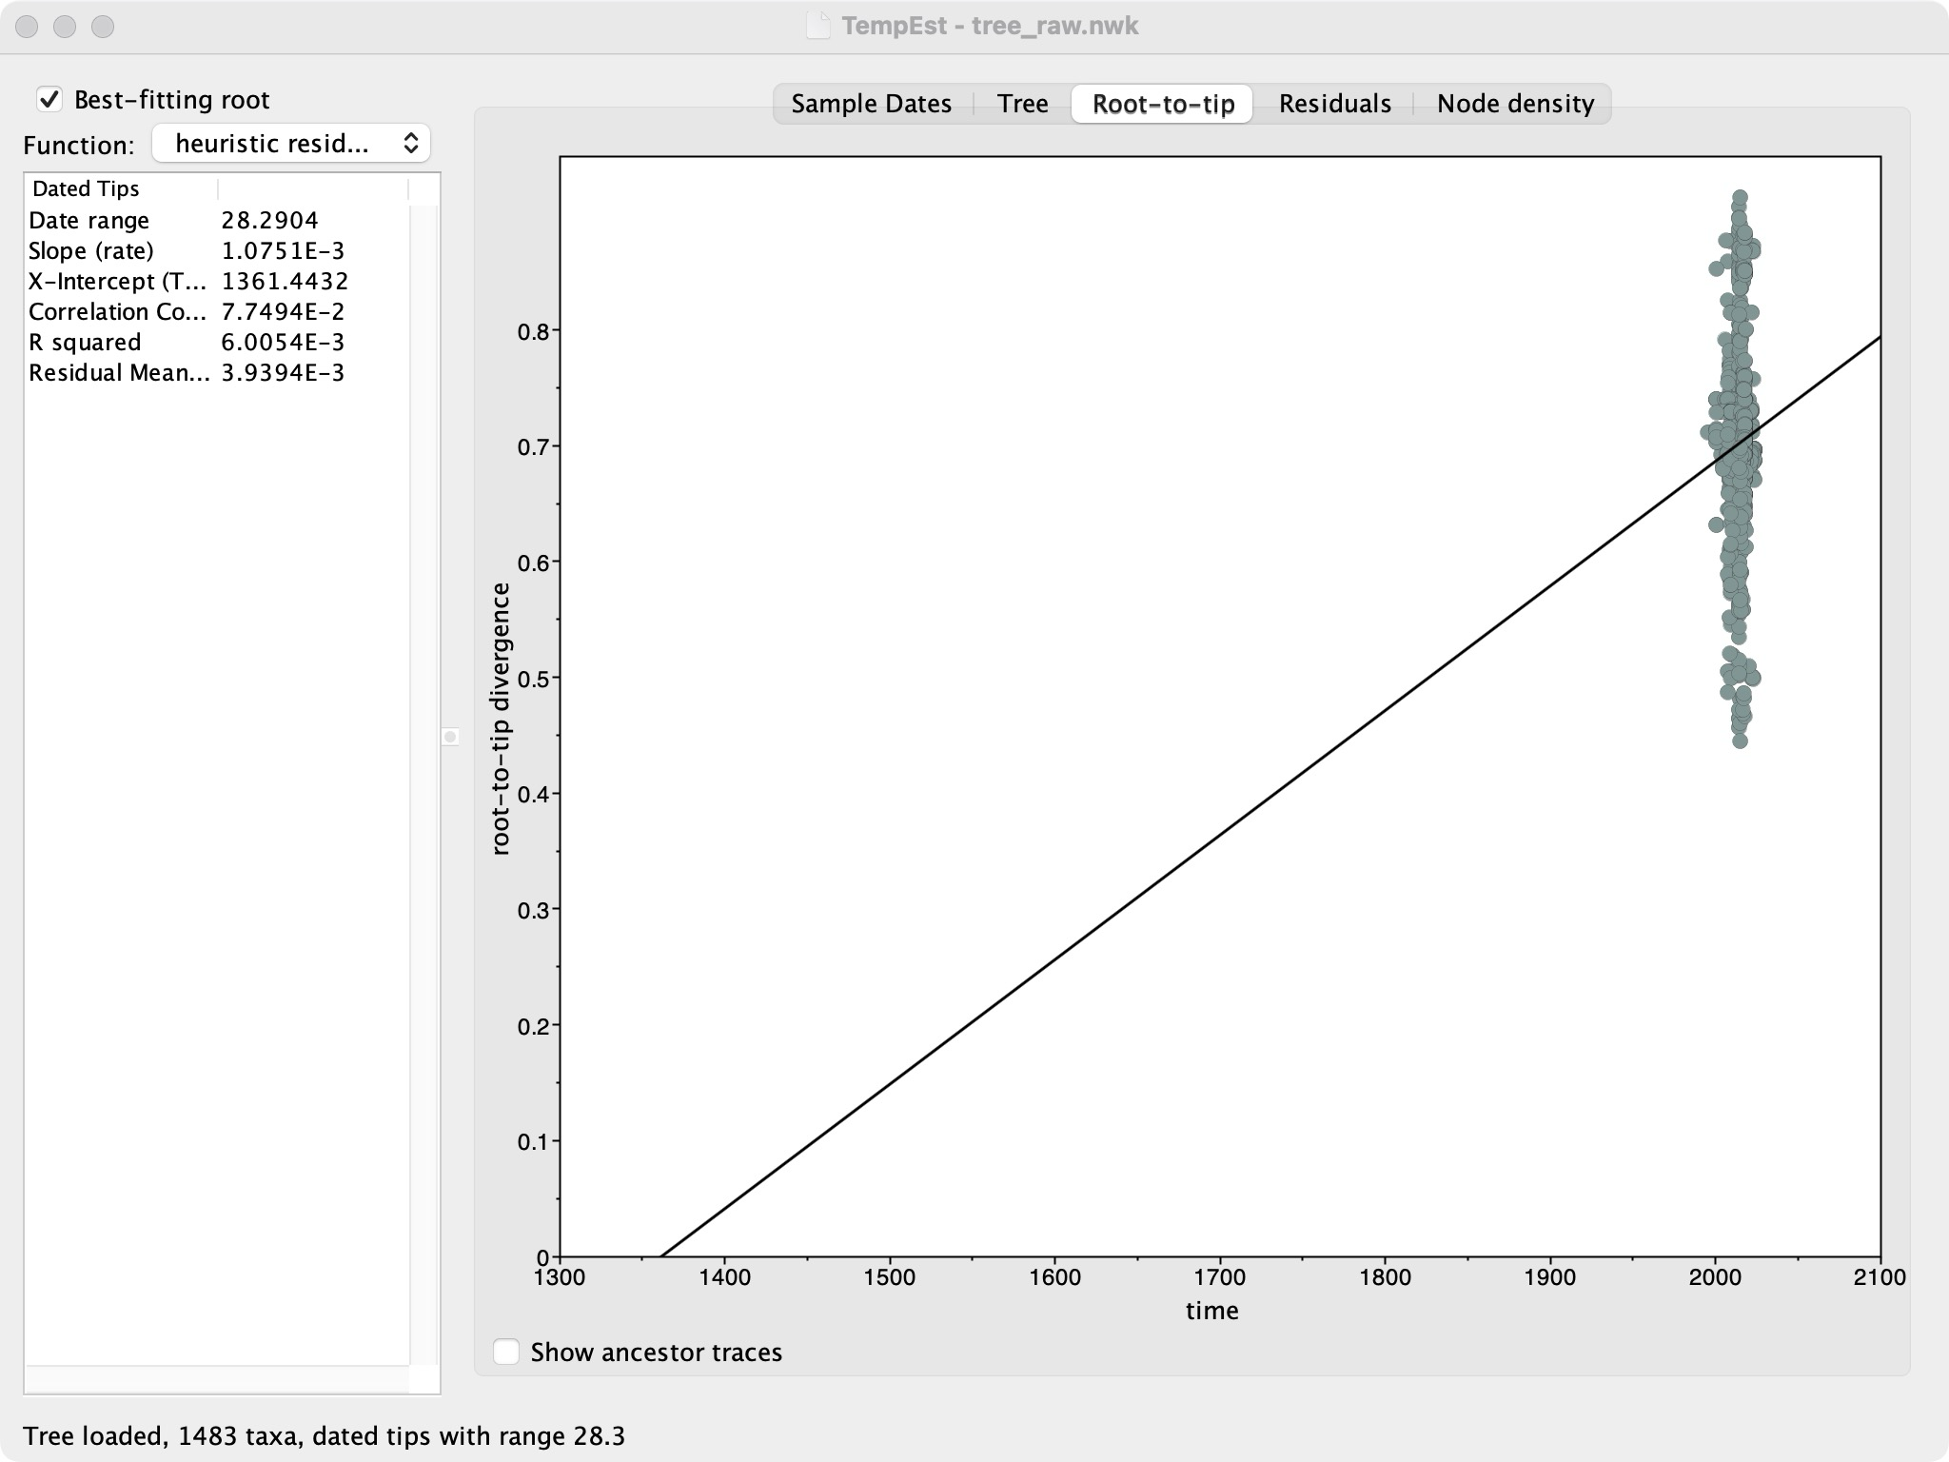
The temporal signal of HPV whole genome is really bad… Consider apply only L1 gene for analysis??? Also, for the alignment ref strain is also a question…

DOCK8 FASTQ file download [done, 545 SRR, 1090 FASTQ file total, <500GB]
(1) Use bash script to download (missed the first raw, failed few):
(2) Manually found out the missed/failed SRR, saved them into another csv file and re-try them.
(3) Retry missed/failed SRR downloads

FASTQ file processing by ‘KneadData’ [done, 545 samples]
(1) Install KneadData (https://github.com/biobakery/kneaddata)
(2) Download the human ref genome (to remove the host genome from the fastq files)
kneaddata_database --download human_genome bowtie2 /home/ubuntu/HPV_evo/human_ref (error)
cd /home/ubuntu/HPV_evo/human_ref (manually downloaded here first)
(3) Process the KneadData to paired reads fastq files (single sample & loop entire sample set)
(4) Check the overall process summary, re-process the failed samples

FASTQ reads combining before ‘SPAdes’ [done, 202 MET combined samples]
Assembling combined reads by using ‘SPAdes’ [ MET combined samples]
(1) Install SPAdes from source (https://github.com/ablab/spades)
tar -xzf SPAdes-4.2.0-Linux.tar.gz
cd SPAdes-4.2.0-Linux
python3 --version
echo 'export PATH="$PATH:$(pwd)/bin"' >> ~/.bashrc
source ~/.bashrc
spades.py --version
(2) Remove all \r characters from filenames (optional, applicable if happen)
for f in *; do
new_name=$(echo "$f" | tr -d '\r')
mv -v "$f" "$new_name"
done
(3) Run SPAdes (add ‘—meta’ to indicate the metagenomic data type)
cd /home/ubuntu/HPV_evo/spades
chmod +x run_spades.sh
nohup ./run_spades.sh > run_spades_script.out 2>&1 &
tail -f run_spades_script.out
(4) Check process (SPAdes may take more than a week to finish…)
(5) Stuck process kills and MET2051 separate re-run (stuck at MET2051)
Check the stuck process id: ps aux | grep 'spades.py'
Kill the stuck process: kill -9 548619 (pgrep -P 548619 # List child PIDs if any)
After killing the spades for the stuck sample, the script will automatically continue with the next sample. So, we only need to separate re-run the killed one (here is MET2051):
nohup /home/ubuntu/tool/SPAdes-4.2.0-Linux/bin/spades.py --meta \
-1 /home/ubuntu/HPV_evo/kneaddata/merged/MET2051_kneaddata_paired_1.fastq \
-2 /home/ubuntu/HPV_evo/kneaddata/merged/MET2051_kneaddata_paired_2.fastq \
-o /home/ubuntu/HPV_evo/spades/MET2051_SPAdes_output \
-t 24 > MET2051_spades_output.log 2>&1 &
tail -f MET2051_spades_output.log
(6) Check the un-finished sample list:
for dir in /home/ubuntu/HPV_evo/spades/*_SPAdes_output; do
if [[ ! -f "${dir}/scaffolds.fasta" ]]; then
sample_id=$(basename "$dir" "_SPAdes_output")
echo "$sample_id"
fi
done
(7) List Largest Files Recursively:
Trouble shooting: 4 samples (MET1739, MET1765, MET2039, MET2051) failed SPAdes run. However, not all of them belong to the top largest file size.
Separate re-run with ‘--only-assembler’ (take MET2051 as example):
nohup /home/ubuntu/tool/SPAdes-4.2.0-Linux/bin/spades.py --meta --only-assembler \
-1 /home/ubuntu/HPV_evo/kneaddata/merged/MET2051_kneaddata_paired_1.fastq \
-2 /home/ubuntu/HPV_evo/kneaddata/merged/MET2051_kneaddata_paired_2.fastq \
-o /home/ubuntu/HPV_evo/spades/MET2051_SPAdes_output \
-t 48 > MET2051_spades_output.log 2>&1 &
tail -f MET2051_spades_output.log
As we ran KneadData before SPAdes, skipping the error correction should be acceptable?
Or we can apply another read correction tool before running SPAdes, such as Musket v1.1?
Trouble shooting: 2 largest samples (MET1739, MET1765) exist with error 12 due to out-of-memory. Try re-running with memory limitation: failed
(8) Use ‘megahit’ to deal with the largest two samples (MET1739, MET1765):
Trouble shooting: MEGAHIT presented much less contig seqs than metaSPAdes, which is a limitation.

(5.5) Audit and Repair Paired-end Reads (CRITICAL STEP):
Problem Context: After running KneadData and merging the paired-end files, we discovered a critical issue: while the R1 and R2 files for each sample had the same number of reads, the read headers/IDs were mismatched across all 202 samples. This meant the reads were effectively unpaired, which would cause metaSPAdes to fail or produce incorrect results.
Solution: We used the repair.sh tool from the BBMap suite to re-sync the paired reads.
Execution Details:
1. Audit Check: A check script confirmed that 100% of samples (202/202) had mismatched read IDs in their merged files.
2. Repair Process: Ran repair.sh on all samples. The command used was:
repair.sh in1=sample_R1.fastq in2=sample_R2.fastq out1=fixed_R1.fastq out2=fixed_R2.fastq outs=singletons.fastq repair
3. Verification Results:
- All 202 samples were successfully repaired.
- 0 reads were lost (0.00% singletons generated), ensuring full data preservation.
- Random sampling audits (checking 10 random positions per file) confirmed perfect ID matching.
The repaired files are now stored in the repaired/ subdirectory and should be used for all downstream assembly steps (replacing the original merged files).

Last updated on 2026 Jan 30

Problems & Questions & Thinkings

(1) The model inputs include ‘collection date’ information, but most of the HPV sequences are lack of date of collection information (including most ref sequences in PaVE database). For the ref sequences in PaVE, can we use their ‘release date’ as their approximate ‘collection date’? Or would it be better to calculate an average time gap between the ‘collection date’ and ‘release date’ and set a ‘likely collection date’ to them?
(2) The model adjustments should be aligned with data features. So, comparing with influenza/rsv/mpox which were frequently used for MASCOT model application, how is HPV different with them? Sequence? Mutation pattern? Evolution rate? Collection date (consider adding a CI range for each sequences, there could be 3 initial group: global data with firm collection date information, global data without collection date information, DOCK8 data with blur collection date information). Before any clock rate estimation, we need to check if there is enough temporal signal in HPV evolution history.
(3) Whole genome or only partial genes? For example, only L1? If we are only focus on the LI gene, we might need to re-prepare our public dataset. It really depends on the genetic feature of HPV.
(4) Also, the evolution of HPV could be a long journey. For different patient, we might need to model their unique inner evolution history. If one patient’s all detected strains are found distributed in one or two certain lineage(s), consider extract the subtree to reconstruct the evolution history of this patient.
(5) The temporal signal of HPV whole genome is really bad. Consider only apply L1 gene for analysis. This needs to read some HPV evolution related paper to understand how other researchers deal with it.
(6) When doing alignment, what reference strain should be used? HPV type 1 sequence? Or others?
– It is a tricky problem. As HPVs are highly diverse, ref-aligning among whole genome range would be problematic. Consider applying phylogenetic analysis only on L1 gene for now.
(7) For transmission between groups, model would allow virus to transition between each pair of groups, which do not fit with the reality/our hypothesis (e.g., we might consider that there is no/little virus can transition into the global environment from the patients). A possible way to address this problem is to set up a ‘transmission predictor table’ and see if result changes (ref to air-traffic predictor table).

Last updated on 2025 July 21

Ruixuan’s Learning Notes

MASCOT vs. GLM-MASCOT
(1) Advantages of GLM-MASCOT over MASCOT
(1.1) Hypothesis Testing: Tests whether specific covariates (e.g., flight routes, climate) significantly influence migration rates or population structure. Example: "Does human travel volume between cities predict viral migration rates?"
(1.2) Reduced Overfitting: Instead of estimating separate migration rates for all pairs of demes (which can lead to overfitting), GLM-MASCOT ties rates to covariates, reducing the number of free parameters.
(1.3) Interpretability: Provides biological/epidemiological insights by quantifying how covariates affect parameters (e.g., "a 10% increase in trade volume increases migration rate by 15%").
(1.4) Handling Complex Systems: Useful for systems where migration is driven by measurable factors (e.g., pathogen spread influenced by host mobility, environmental suitability).
(2) When to Use Each?
(2.1) Use MASCOT if: You want to estimate migration rates/population sizes without modeling external drivers. Focus is on ancestral state reconstruction (e.g., Where did the viral ancestor originate).
(2.2) Use GLM-MASCOT if: You have covariates and test hypotheses about what drives migration or population dynamics. Need to model parameter heterogeneity (e.g., migration rates vary with distance).
(3) Example Workflow
(3.1) MASCOT: Input: Viral sequences from 10 cities + collection dates. Output: Migration rates between cities, ancestral locations of viral lineages.
(3.2) GLM-MASCOT: Input: Same sequences + covariates (e.g., flight passenger counts between cities, geographic distances). Output: Coefficients showing that migration rates increase with flight traffic, even after accounting for distance.
(4) Key Takeaway
GLM-MASCOT adds an explanatory layer to MASCOT, linking phylogeographic parameters to covariates via GLMs. It answers not just "How do populations migrate?" but also "Why do they migrate this way?". Both methods are implemented in BEAST2, making them accessible for empirical studies.

What is De Novo Assembly?
De novo assembly refers to reconstructing genome sequences from scratch, without using a reference genome. It stitches together overlapping sequencing reads to form longer contiguous sequences (contigs).
(1) Characteristics:
- Reference-free: No prior genome is needed.
- Useful for discovery: Ideal for identifying novel organisms or viral strains.
- Sensitive to coverage and complexity: Can struggle with similar strains or low-abundance variants.
(2) Example Applications:
- Metagenomic studies: Discovering unknown viruses in environmental or clinical samples.
- Rare disease genomics: Assembling genomes where no reference exists.
- Previous DOCK8 study: Used de novo assembly to uncover hundreds of novel HPV genomes.

What is Phasing?
Phasing refers to reconstructing the haplotypes (i.e., strain-level sequences) by determining which variants co-occur on the same molecule or read. It’s about linking mutations together to infer the actual viral strains present.
(1) Characteristics:
- Reference-guided or read-based: Often uses a reference genome or read linkage.
- Preserves mutation context: Maintains the co-occurrence of mutations across the genome.
- Ideal for evolutionary analysis: Enables tracking of strain dynamics, recombination, and within-host evolution.
(2) Example Applications:
- Intra-host viral evolution: Understanding how viruses mutate and adapt within a host.
- Drug resistance tracking: Identifying linked mutations that confer resistance.
- This study: Uses phasing to evaluate whether novel HPVs in DOCK8 patients arose from environmental acquisition or within-host evolution.

Last updated on 2025 July 21

