**RADAR\_GUIS Matlab Package**

**Graphical User Interface Scripts to be used with HFR\_Progs Toolbox**

Developed by Teresa Updyke

Old Dominion University

Version 3.2

December 2012

**Overview**

Here are some of the new graphics interfaces developed for use with the HFR Progs toolbox.

There are 4 main Guis:

**hfr\_setup\_gui.m**

creates a setup file with information used by the other GUIS, including paths to data, site names and grids

**radar\_display\_gui.m**

plots radials and/or totals on any number of user specified grids, calls to other guis

**maketotal\_gui.m**

(the "Process Totals" button in radar\_display)

compute totals (individually or in batch mode) for a list of specifically chosen radials for any number of user specified grids

**autoedit\_gui.m**

(the "Auto Edit" button in radar\_display)

run a script that will edit radial files (i.e. I have a couple examples of editing scripts, and a template for users to create their own)

Features:

* Flip through radial or total plots and change scales easily.
* Overlay plots of radials and/or total vectors in different colors.
* Option to plot radials with a red/blue pattern: red going away from antenna, blue heading towards antenna.
* Option to check a total vector by clicking on it to see (graphically) what radials went into computing that total.  (For this to work, the radial files need to be saved in the same MAT file as totals, e.g. create a total with maketotal\_gui and use the option to save radials with the totals.)
* Query a thredds database to display total vectors.
* Easily process totals with different options/sites/grids. For example, create a grid with locations of ADCPs only or with grid points only along shipping channels.
* Run a set of radial data through an editing script.
* Compare two radial files – this feature shows vector maps of differences, highlights areas of large differences and vectors that have opposite signs.

**Directory Structure**

RADAR\_GUIS/

Documentation/

RADAR\_GUIS\_documentation.docx

GridFiles/ (contains setup information and maps for displays)

OriginalDataFiles (I put my files with raw lon, lat info for grids here)

Images/ (default place to save images of gui figures)

TestTotals/

Gridname1 (default output path for maketotals\_gui)

Gridname2 (default output path for maketotals\_gui)

…

Scripts/

GUIS (the main gui Matlab scripts)

MyEditScripts (scripts created by user for autoedit\_gui)

Support (supporting Matlab scripts for main guis)

Toolboxes (HFR Progs 2.1.2 plus several external packages)

RadialEdits/

Sitename1 (default output path for radialedit & autoedit)

Sitename2 (default output path for radialedit & autoedit)

…

**Getting Started**

1) The GUI programs use the HFR Progs toolbox and the m\_map toolbox, which are already included in the full version of RADAR\_GUIS\_3\_0.zip so nothing else needs to be downloaded separately.

RADAR GUIS “lite” version is much smaller in size because it does not include m\_map toolbox. So if you already have m\_map you may want to download this version.

The “lite” version also does not include a java tool used for pulling data from a thredds server. (a version of toolsUI.jar from <http://www.unidata.ucar.edu/software/netcdf-java/documentation.htm> )

2) Make sure the RADAR\_GUIS subfolders and the necessary toolboxes are included in your Matlab path.

3) Run hfr\_setup\_gui.m

**Note about HFR Progs and latest MATLAB releases**

The latest versions of Matlab produce some errors with HFR progs, which are easy to fix. I think I’ve done the fixes already in the version that comes with GUIS but here they for reference:

1) finite() must be changed to isfinite()

2) the function calls have to be exact (case sensitive) This was a warning in previous versions of Matlab and is now a fatal error, e.g. call tuvLS.m instead of tuvls.m

**I. hfr\_setup\_gui.m**

**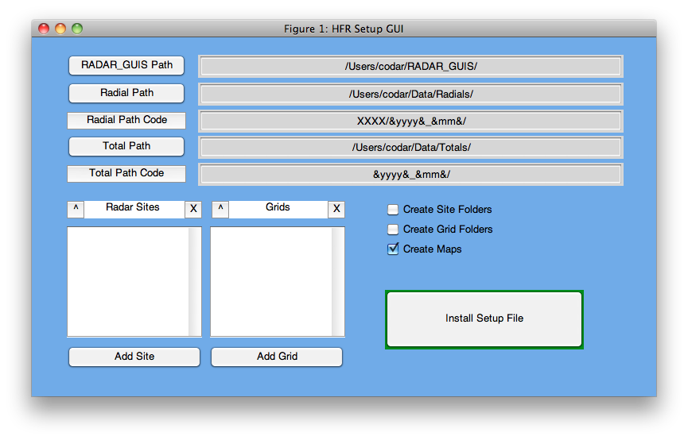**

Use this GUI to define default paths to data, site names and grids.

There are tips/instructions included in the gui. For example, click on path code or on checkboxes for more information. Hover the mouse over the ^ and X button for info.

The program installs a file called HFR\_INFO.mat in RADAR\_GUIS/GridFiles/

folder. Save a copy of your custom setup at any time during the setup process by clicking install. Rerun the gui at any time to complete/modify your setup.

IMPORTANT FOR ADDING GRIDS

When adding a grid, you will be prompted to load a MAT or text file containing the positions of the grid points. In the MAT file case, the file must contain a variable named "LONLAT" in which the first column is longitude and the second column latitude. In the text file case, the file must contain only numeric values and have two columns, the first being longitude and the second latitude.**II.** **radar\_display\_gui.m**

Overview of custom menus and toolbar icons

full_displaygui_menu.png

**GUI Menu**

|  |  |
| --- | --- |
| Compute Totals | Calls maketotal\_gui.m |
| Edit Radials | Calls autoedit\_gui.m |
| Edit Radials (Manual) | Allows user to handpick radials to remove |
| Compare Radials | Compute differences between 2 radial files |
| Check Total | View radials that contributed to a singe total vector |

**Grid Menu**

A listing of all user defined grids. Select one and then clear the plot to redraw the map. The last entry is “Custom Zoom” and it represents an area defined by the user under the “Extras” menu with “Define Custom Zoom”.

**Site Menu**

A listing of all user defined RADAR sites. Select one. You will not see your newly selected site until you add another plot with the plot button on the toolbar.

**Plot Menu**

|  |  |
| --- | --- |
| Set Date | Change date for the plot |
| Set Time Interval | For stepping through files. Default is 1 hour. |
| Set Path | Change default path to radials or totals for this viewer session. |
| Set Path Code\*\* | A code to explain file organization. See additional note below. |
| Set File Prefix | Set the radial prefix if you are not using the standard RDLm or RDLi |
| Use Standard File Prefix | If you have changed the radial prefix, revert back to standard RDLm and RDLi convention |
| Set Maximum Velocity for Colorbar | Used with mvec arrow style plots |
| Set GDOP Threshold for Display | Default for masking UWLS total vectors in display is 1.25 |
| Set OI Threshold for Display | Default for masking OI total vectors in display is 0.6 |

\*\*Note on Path Codes: Use this field to define your directory organization. For time-related folder names, use datestr codes surrounded by square brackets [] and use [XXXX] in place of the 4 letter site code.

Path codes only work if your data is organized in a consistent way for all sites under a single base path. Also if you use the name of the site in your organization scheme, you must use the four letter site name (case sensitive).

Let's say you keep all your data in /Users/codar/path/Radials/. Under this base folder you have a folder for each site and then under each site folder, there is a folder for every year and month. It looks like this: /Users/codar/path/Radials/

CBBT/

2012\_Jan

2012\_Feb

VIEW/

2012\_Jan

2012\_Feb

For this example the path code would be [XXXX]/[yyyy]\_[mmm]/

**Extras Menu**

|  |  |
| --- | --- |
| Range Ring | Plot a range ring around a total vector |
| Define Custom Zoom | Define area of interest that can be selected under “Grids” menu |
| Create Plot List | Use to Plot Sets of Files |

**Toolbar Icons**

icon_bar.png

Move the mouse over an icon to see its description.

The icons are by default in the “Off” position and are toggled “On” and “Off” when clicked. The default settings plot all measured radials with mvec type arrows.

|  |  |
| --- | --- |
| image_icon.png Save Image | Saves PNG image of plot in RADAR\_GUIS/Images/ |
| arrowtype.png Arrow Type | On (mvec arrows) Off (quiver arrows) |
| arrowdensity.png Arrow Density | On (fewer arrows) Off (all arrows) |
| rb.png Red/Blue Color Scheme | On (radials away from antenna in red, radials towards antenna in blue) |
| color.png Change Plot Colors  (Quiver arrows only) | Enter # of plot to change and select color. |
| scaleup.png Scale Up  (Quiver arrows only) | Increase scale ( quiver type arrows only ) |
| scaledown.png Scale Down  (Quiver arrows only) | Decrease scale ( quiver type arrows only ) |
| scale_value.png Set Scale | Allows user to type in value for scale (mvec or quiver arrows) |
| totals.png Plot Totals | On (plot totals) Off (plot radials) |
| radial_type.png Radial Type | On (ideal radials) Off (measured radials) |
| choosefile.png Choose Data File | Hit Plot button while this is set to On position to open any radial or total file for plotting |
| oi.png Plot Rutgers OI Totals | Retrieves Opendap Rutger OI totals for selected grid area |
| back.png Previous Time | Moves date back by 1 hour & recreates plot. |
| fwd.png Next Time | Moves date forward by 1 hour & recreates plot. |
| clear_plot.png Clear Plot | Clears vectors from plot. |
| plot.png Plot | Plot based on current settings (adds to previous plots unless map is cleared first). |

You can call the program with or without a date.

***radar\_display\_gui([2009 1 2 12 0 0])***

For example, to specify Jan 2 2009 12:00 UTC call the program with the datevec form of the date.

***radar\_display\_gui***

If you do not specify a date the program starts with your computer’s current time.

To Plot Radials:

Note: A default path for radials was specified in the set up program hfr\_gui\_setup.m. Based on your date, site, and radial type settings in the viewer, the programs will build the name of the radial file and look for it in the default path. If you want to set another default path, go to “Set Path” under the “Plot” menu. Alternatively you can use the choosefile.png button and then hit plot.png which allows you to open any radial file on the system no matter what the path or name.

1. Select a grid from the “Grid” pulldown menu and click the “Clear Plot” clear_plot.png button to plot the basemap.

2. Choose the time. If you did not already specify a date the program starts with your computer’s current time. If you want to change the date after you’ve started the program, use the time arrow back.png fwd.png buttons. Or click on the “Plot” menu and choose “Set Date”. Follow the form yyyy\_mm\_dd\_HHMM, e.g. Jan 2 2009 12:00 is 2009\_01\_02\_1200.

2. Choose a site from the “Site” pulldown menu. If no site is chosen the program uses the first site in the list.

3. Choose the type of radial.

Measured (RDLm) is the default.

Press the radial type button radial_type.png for ideal (RDLi) radials.

Or you can specify another 4 letter prefix by selecting “Set File Prefix” under the “Plot” menu. To revert back to a standard prefix later, select “Use Standard File Prefix” under the “Plot” menu.

4. Click “Plot” button. plot.png

5. Use the forward fwd.png and back back.png buttons to scroll through the files hour by hour using the current settings. The map is cleared and replotted each time.

6. Use other toolbar icons to change appearance of the plot. Change the type of arrow arrowtype.png, density of arrowsarrowdensity.png, colorsrb.png color.png, and scales scaleup.png scaledown.png. After each change (except for scale which automatically resets the plot), click clear_plot.png if you want to clear the plot first and then plot.png.

To specify a particular color for a set of quiver type vectors, click on the Colorcolor.png button. The program asks for a plot number and gives a range. 1 represents the data that was plotted first, etc. After entering a number, a color chart appears. Select a color for that data.

To Plot Totals

Note: A default path for totals was specified in the set up program hfr\_gui\_setup.m. Based on your date and radial type settings in the viewer, the programs will build the name of the total file and look for it in the default path. If you want to set another default path, go to “Set Path” under the “Plot” menu. Alternatively you can use the choosefile.png button and then hit plot.png which allows you to open any totals file on the system no matter what the path or name.

1. Select date, grid and radial type (as described in plot radials section above). If radial type is ideal, the program looks for a “TOTi” file. If radial type is measured it looks for “TOTm”. Or if you “Set the File Prefix” under the “Plot” menu, it looks for the prefix you entered.

2. Click the totals.png button and hit Plotplot.png.

3. Masking: The program masks total vectors with a GDOP cutoff value. The default is to not display vectors with a GDOP value > 1.25. To change the cutoff value, go to the “Plot” menu and select

“Set GDOP Mask Value”. The new cutoff value will be used the next time the “Plot” plot.png button is pressed.

4. To plot Rutgers optimal interpolated total vectors from the Thredds server, click the oi.png button. In this case, the program masks total vectors using an OI Err cutoff value. The default is to not display vectors with a Uerr or Verr value > 0.6. Set a new cutoff value by going to the “Extras” menu and selecting “Apply Mask to Rutgers OI Totals”. The new cutoff value will be used the next time the “Plot” plot.png button is pressed.

GUI Menu Options

“Compute Totals” calls maketotal\_gui.m This program calls the makeTotals\_for\_gui routine, a slightly modified version of the HFR Progs toolbox makeTotals.m routine, which processes totals using the least squares technique. See other detailed instructions for maketotal\_gui.m in this document.

“Edit Radials” calls autoedit\_gui.m. Use this to run one or more radial files through a custom-written script. There are two programs already provided or you can write your own script using the template “RADAR\_GUIS/Scripts/MyEditScripts/radial\_template.m. See other detailed instructions for autoedit\_gui.m in this document.

“Edit Radial (Manual)” Use this to “hand” edit the currently selected radial file by clicking on individual radial vectors to remove.

Plot the radial file that you want to edit. Then choose this option from the “GUI Menu”. A new figure window appears showing the radial in the red/blue color scheme (red for current away from antenna and blue for current towards the antenna).

Follow the directions in the Matlab command window. In order to click on specific vectors for removal, it is easier to zoom in a little on the section of interest. Hit enter. Click again on the map figure window (outside of the map itself if you want to avoid selecting the vector on your first click) and then click next to the *base* end of a vector to erase it. The radial map will be redrawn. Two new zoom buttons appear on the bottom of the figure in case the zoom needs to be readjusted. Hit enter when ready to select the next vector. Repeat and when finished, type 0 in the command window to exit.

The program asks if you want to save. If yes, type “1” and then enter the prefix for the filename (limit to 4 characters such as RDLi). The radial will be saved at RADAR\_GUIS/RadialEdits/XXXX/pppp\_XXXX\_yyyy\_mm\_dd\_HH.mat and contain one variable:

RADIAL (the standard HFR\_Progs radial structure)

Extra Options

“Range Ring” Draw a range ring on the map. Enter the desired range in the input box, and then click anywhere on the map to draw the ring.

III. **autoedit\_gui.m**

1. Run from the MATLAB command line with a date in the following form:

***autoedit\_gui([2009 1 2 12 0 0])***

OR

From radar\_display\_gui window, select “Edit Radials” from the “GUI Menu”.

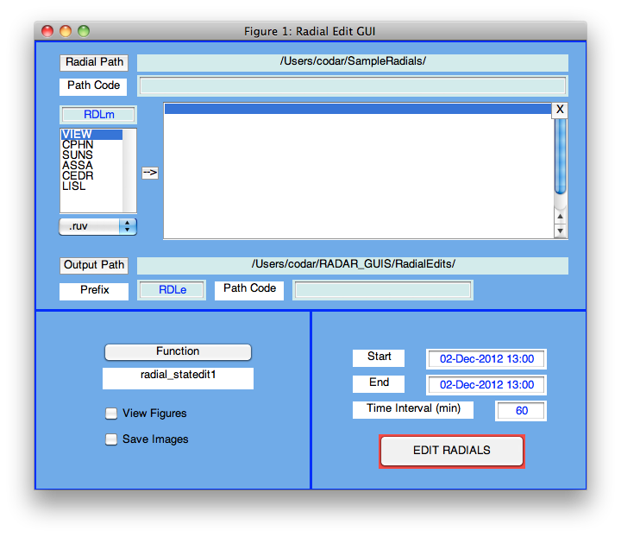

2. Create a list of radials. Choose paths, site names and radial type, then push the “->” button. Sites can be added individually or in groups.

3. Use the “Function” button to select the editing program. It will open a standard file browser window. The default path is RADAR\_GUIS/Scripts/MyEditScripts but it is possible to navigate to any path to choose a script. The chosen function appears in the box below the “Function” button.

IV. **maketotals\_gui.m**

This GUI compute totals (individually or in batch mode) for a list of specifically chosen radials on a grid selected by the user. This program calls the HFR Progs toolbox makeTotals.m routine, which processes totals using the least squares technique or makeTotalsOI.m to process with optimal interpolation technique\*.

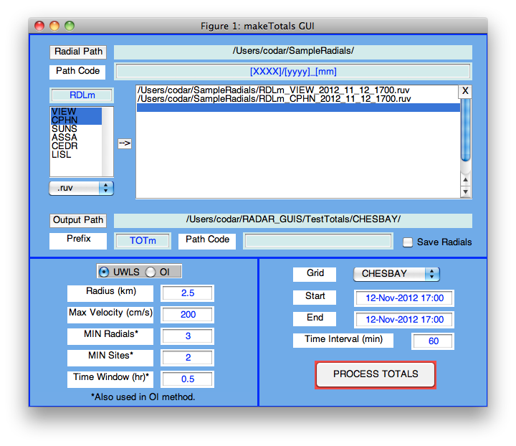

Create a list of radials. Choose paths, site names and radial type, then push the “->” button. Sites can be added individually or in groups.

Check the box beside “Save Radials” to save radial structures along with the totals structure in the output MAT file.

Edit settings and then “Process Totals”.

\*NOTE: Optimal interpolation requires detailed examination of covariance matrix for region of interest to be optimal so this does not automatically work for any local region.