 

Software Documentation

*for*

*Website for the counting system from the AI Development Team*

**Development team:** Bermeo Mike, Brito Juan Diego, Macancela Carlos, Ramos Leo.

**Client:** Eugenio Morocho Cía. Ltda.

### 2021

**Software Documentation for a Website for the counting system from the AI Development Team**

|  |  |
| --- | --- |
| Table of Contents |  |
| 1 Software Requirements Specification | 3 |
| 1.1 Preface | 3 |
| 1.2 Introduction | 3 |
| 1.2.1 Purpose | 3 |
| 1.2 Project Scope | 3 |
| 1.3 Product Features | 3 |
| 2. Glossary | 3 |
| 3. User and system requirements | 4 |
| 3.1 User requirements | 4 |
| 3.2 System requirements | 5 |
| 4. Functional and non-functional requirements | 5 |
| 4.1 Functional requirements | 5 |
| 4.2 Non-functional requirements | 5 |
| 5. Form-based structured requirements specification | 5 |
| 6. System Modeling (UML) | 9 |
| 6.1 Activity model | 9 |
| 6.2 Use case model | 10 |
| 6.3 Sequence model | 12 |
| 6.4 Class model | 13 |
| 6.5 State model | 13 |
| 7. Architectural design | 15 |
| 7.1 Layered design | 15 |

1. **Software Requirements Specification**
   1. **Preface**

The aim of this project is to build a web interface for an AI model detection system. This AI model shall detect and count roses as elements. Then, the website should show the image with bounded boxes and collected information such as accuracy, number of the detected roses, the coordinates of the roses found by the model. Furthermore, there will be two different options to store the results; it could be as an image or a pdf report.

## Introduction

* + 1. **Purpose**

The purpose of this document is to provide the software requirements specifications for the “Website for the counting system from the AI Development Team” project, aimed at the development team and end users.

## Project Scope

The software will provide a user-friendly interface and easy-to-use functionalities for the user to interact with and use an AI-based object counting system that can detect and count one type of roses in an image embedded in it. The software also allows the user to visualize and store the results of applying the AI model, either as an image or as a detailed report.

## Product Features

A web site, which allows the analysis of images from the computer storage or in real time video. The analysis will be accomplished by an IA, which recognizes and counts roses from images or frames. Furthermore, the website will be stored locally. In addition, the website will be able to adapt to different screen sizes in order to be accessed by more users.

# Glossary

### Table 1

*Glossary Terms*

|  |  |
| --- | --- |
| **Input** | Data that is uploaded into a machine or system. |

|  |  |
| --- | --- |
| **Output** | Data provided by computer after processing information. |
| **AI model** | A program or algorithm utilizes a set of data that enables it to recognize certain patterns. |
| **User session Id** | It is a unique number that a Web site’s server assigns to identify a specific user. |
| **Image with bounded boxes** | It is the process of partitioning a digital image into multiple segments. |
| **PDF** | A file format that provides an electronic image of text or text and graphics that looks like a printed document and can be viewed, printed, and electronically transmitted. |
| **Runtime** | The length of time a program takes to run |
| **Accuracy** | The quality or state of being correct or precise. |
| **Local storage** | Local Storage includes physical hardware such as external hard drives, flash drives, and CDs |
| **Embedded** | Incorporate within the body of a web page or other document. |

# User and system requirements

## User requirements

Build a website that runs the counting system from the AI Development Team. The website should allow the user to load a photo from the local computer, or to open the webcam to do the inference locally. The website needs to ask permissions to access both the device storage system and the webcam.

## System requirements

* + 1. The website must have a friendly interface so that the user can interact with its functionalities in an easy and pleasant way.
    2. The website shall be able to upload an image from local storage and process that image through an AI-based object counting system that can detect and count one type of roses in an image; in the same way, the website shall be able to process an image in real time.
    3. The website must require user permissions to access his storage and camera, through a modal window, in order to process the image.

# Functional and non-functional requirements

## Functional requirements

* + 1. The website must show the user a text box with the number of roses and the accuracy of the model resulting from processing an image through the AI model mentioned.
    2. The user shall be able to download the image with bounded boxes processed by the model or the report.
    3. The website must be able to show the user a report in a PDF document, which can be printed, with the information that has been obtained through the AI model, showing the image with bounded boxes, the number of roses that have been identified, the coordinates of each roses that was identified and their accuracy.
    4. The website must have a “Cancel button” in order to cancel the image processing if necessary.

## Non-functional requirements

* + 1. Display error messages in case of AI model failure.
    2. Ability to adapt to different screen sizes.
    3. The website must not store any image uploaded and other information about the user.
    4. The website must recognize the user session so that it does not request permissions of camera and storage again within a period.

# Form-based structured requirements specification

### Table 2

*Website for the counting system from the AI Development Team.*

Request camera and storage permissions

**Function**

|  |  |
| --- | --- |
| **Description** | The website should ask for camera and storage access permissions, as long as the user has not previously authorized within a time range |
| **Input** | User session Id |
| **Source** | Current session ID |
| **Output** | None |
| **Destination** | Nowhere |
| **Action** | Click the button to allow permissions. |
| **Requirements** | The user visits the website for the first time or after a long time. |
| **Pre-condition** | None |
| **Post-condition** | The website accesses the user camera and storage, and saves the Id session for a period. |
| **Side effects** | Modal windows requesting permissions |

### Table 3

*Website for the counting system from the AI Development Team.*

|  |  |
| --- | --- |
| **Function** | Deliver image with bounded boxes |
| **Description** | Computes an image with bounded boxes with elements recognized (roses). |
| **Input** | An image |
| **Source** | Computer storage or camera |
| **Output** | Image with bounded boxes, the number of roses that have been identified, and the accuracy of the model applied to an image. |
| **Destination** | It can be displayed on screen, or sent to a function to save the image with bounded boxes on the user's device. |

|  |  |
| --- | --- |
| **Action** | Click the button to run the inference |
| **Requirements** | An available image that is uploaded by the user or in real time obtained by the webcam. |
| **Pre-condition** | A correctly formatted and sized image. |
| **Post-condition** | It is up the user to save the image or not |
| **Side effects** | None |

### Table 4

*Website for the counting system from the AI Development Team.*

|  |  |
| --- | --- |
| **Function** | Deliver a report. |
| **Description** | Computes a PDF report with the outputs from the AI model. |
| **Input** | An image with bounded boxes, the number of roses that have been identified, and the accuracy of the model applied to an image and the coordinates of each rose found. |
| **Source** | Deliver Image with bounded boxes Function. |
| **Output** | PDF report. |
| **Destination** | It can be displayed on screen, or sent to a function to save the report on the user's device. |
| **Action** | Click the button to download the PDF report. |
| **Requirements** | The IA model should already process the image. |
| **Pre-condition** | There should be no errors. |
| **Post-condition** | It is up the user to print the report or not. |
| **Side effects** | None. |

### Table 5

*Website for the counting system from the AI Development Team.*

|  |  |
| --- | --- |
| **Function** | Display results from the AI model. |
| **Description** | Display the information as text on screen, resulting from applying the AI model to an image. |
| **Input** | Results from the image with bounded boxes. |
| **Source** | Deliver image with bounded boxes Function. |
| **Output** | A screen with the results from the image with bounded boxes. |
| **Destination** | Function that shows the results in the main screen. |
| **Action** | Click the button to run the inference. |
| **Requirements** | Results of applying the delivered image with bounded boxes function. |
| **Pre-condition** | There should be no errors. |
| **Post-condition** | None. |
| **Side effects** | The website shows the results. |

### Table 6

*Website for the counting system from the AI Development Team.*

|  |  |
| --- | --- |
| **Function** | Pre-process the Input. |
| **Description** | Pre-process the input image to adapt it to the size and format requirements. |
| **Input** | Image from camera or form local storage. |
| **Source** | User uploaded image. |
| **Output** | Image with correct size and format. |
| **Destination** | Function of AI model. |
| **Action** | Upload an image or take it from the camera. |

|  |  |
| --- | --- |
| **Requirements** | The input image shall be in one of these 3 formats:  .jpg .png. jpeg. |
| **Pre-condition** | None. |
| **Post-condition** | There should be no errors. |
| **Side effects** | IA model process the Image. |

### Table 7

*Website for the counting system from the AI model Development Team.*

|  |  |
| --- | --- |
| **Function** | Cancel Button. |
| **Description** | Cancel the inference process from AI model. |
| **Input** | Click event. |
| **Source** | User uploaded image. |
| **Output** | None. |
| **Destination** | None. |
| **Action** | Click the button to cancel the image processing/inference. |
| **Requirements** | None. |
| **Pre-condition** | The deliver image with bounded boxes function is running. |
| **Post-condition** | There should be no errors. |
| **Side effects** | No output is generated. |

# System Modeling (UML)

## Activity model

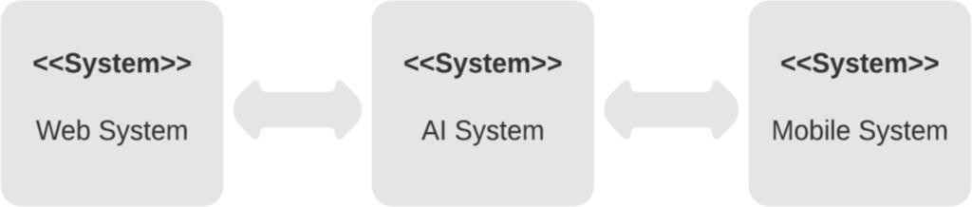

Figure 1: Activity model, website for the counting system from the AI Development Team.

## Use case model

### Table 8

*Use case model #1, website for the counting system from the AI Development Team.*

|  |  |
| --- | --- |
| **UPLOAD IMAGE** | |
| **Actors** | Users, counter system, website. |
| **Description** | The users could upload their images for analysis.  The counter system will receive the image. |
| **Data** | Users’ images. |
| **Stimulus** | None. |
| **Response** | Confirmation from the website, that the image is well uploaded. |
| **Comments** | The users may allow the access to their computer storage or camera. |

### Table 9

*Use case model #2, website for the counting system from the AI Development Team*

|  |  |
| --- | --- |
| **COUNTER SYSTEM** | |
| **Actors** | AI model system, website. |
| **Description** | After the user selects an image, the AI model receives it to detect and count specific objects (roses). |
| **Data** | An users’ image. |
| **Stimulus** | Command issued by the user. |
| **Response** | Question: what do the users want to do with the image and results? |
| **Comments** | The used image should meet the parameters as format. |

### Table 10

*Use case model #3, website for the counting system from the AI Development Team.*

|  |  |
| --- | --- |
| **SAVE RESULTS** | |
| **Actors** | Website users, website interface. |

|  |  |
| --- | --- |
| **Description** | When the counter system has finished the analysis of the image, the users are allowed to save the bonding boxed image or a pdf report with all the results. |
| **Data** | Path where the image or report will be stored. |
| **Stimulus** | Command issued by the user. |
| **Response** | Confirmation that the image or report has been downloaded. |
| **Comments** | The website must have the permissions to access the users’ computer storage |

## Sequence model

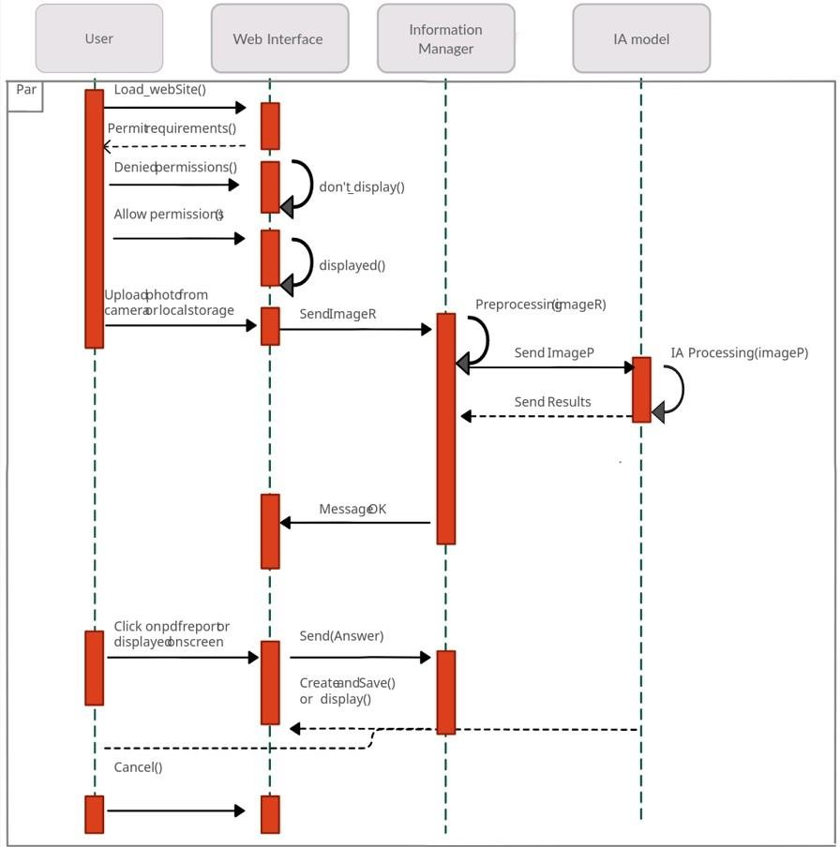

Figure 2: Use case model #1, website for counting system from the AI Development Team.

## Class model

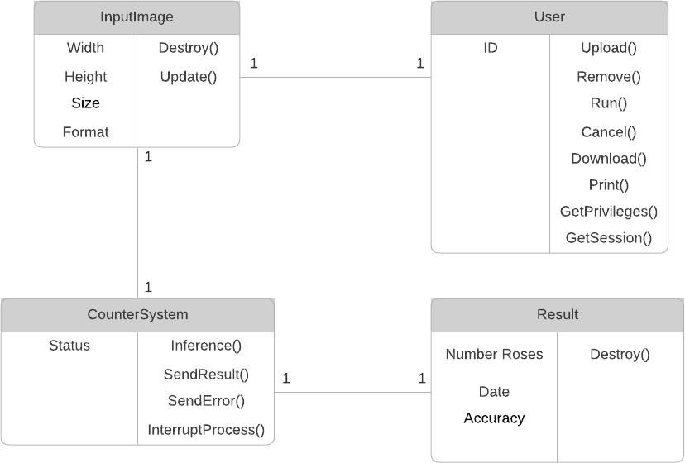

Figure 3: Class model, website for counting system from the AI Development Team

## State model

### Table 11

*Description of the states of the state diagram.*

|  |  |
| --- | --- |
| **STATE DESCRIPTION** | |
| **Permission** | The page starts asking for permission to access camera and local storage. Display a window. |
| **Waiting** | The webpage is shown. Display the website with the functionalities. |
| **Upload** | The page asks for uploading images. Display a window. |
| **Inference** | The page processes the images using the Ai model.  Display a message when it is done. |
| **Camera** | The page opens the webcam and asks to take a picture.  Displays the webcam interface. |

|  |  |
| --- | --- |
| **Results** | The page shows the results from the inference. |
| **Image** | The page downloads the resulting image from the inference. |
| **Report** | The page creates a PDF report with the info from the inference. |

### Table 12

*Description of the stimulus of the state diagram.*

|  |  |
| --- | --- |
| **STIMULUS DESCRIPTION** | |
| **Allow** | The user allows access to the camera and local storage. |
| **Not allow** | The user does not allow access to the camera and local storage. |
| **Cancel** | The user has pushed the bottom “Cancel”. |
| **Upload** | The user has pushed the bottom “Upload”. |
| **Take photo** | The user has pushed the bottom “Take photo”. |
| **Start** | The user has pushed the bottom “Start”. |
| **Error** | The inference from the AI model has an error. |
| **Show result** | The AI model was successful. |
| **PDF** | The user has pushed the bottom “PDF”. |
| **Image** | The user has pushed the bottom “Image”. |
| **New** | The user has pushed the bottom “New”. |

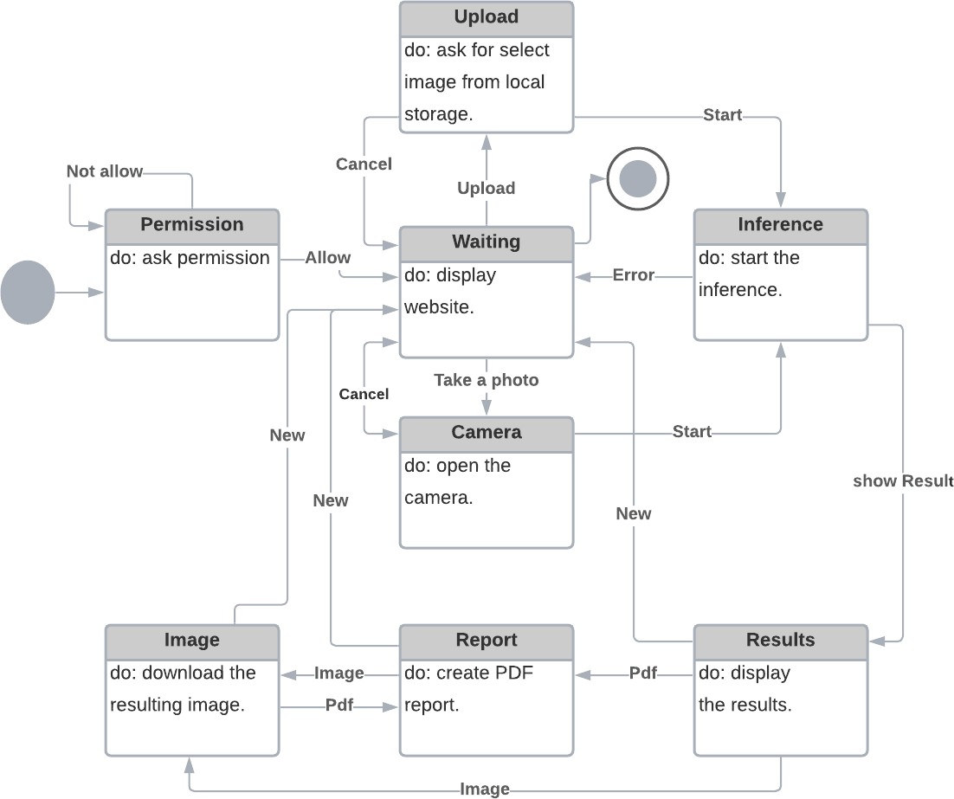

Figure 4: State model, website for counting system from the AI Development.

## 7.1 Layered design

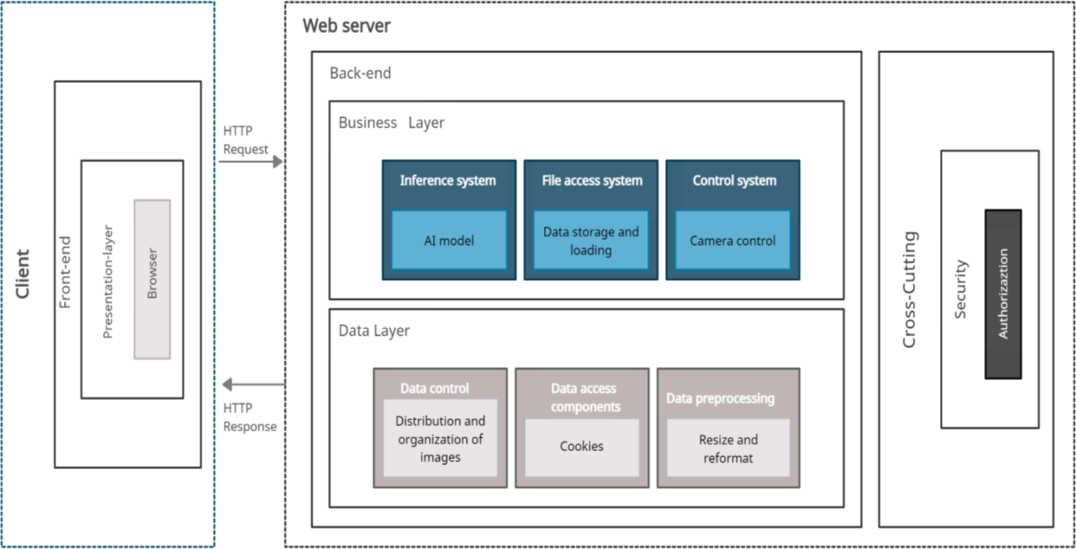

Figure 5: Layered design, website for the counting system from the AI Development Team

|  |  |
| --- | --- |
| Firmado electrónicamente por:  1M**M**I**I**K**K**E**E**  C**C**H**H**R**R**I**ISTOPHER**  .B**B**E**E**R**R**M**MEO BADILLO**  BERMEO BADILLO CHRISTOPHER MIKE ID. No. 1751374156  DEVELOPER | BRITO MEDINA JUAN DIEGO ID. No. 1723097521 DEVELOPER |
|  | Firmado electrónicamente por:  L**L**E**E**O**O THOMAS**  *•m* fi. . **RAMOS GRANDA** |
| MACANCELA BOJORQUE CARLOS JULIO | RAMOS GRANDE LEO THOMAS |
| ID. No. 0105619498 | ID. No. 1805311923 |
| DEVELOPER | DEVELOPER |



