Climate Mesh
A decentralised, explainable climate early-warning mesh on a Raspberry Pi 5
Luis Yu and Leo Zhang · Years 12–13
PA Raspberry Pi Competition 2026/27 · Theme: Building a Positive Human Future (Safer Societies & Sustainable World)
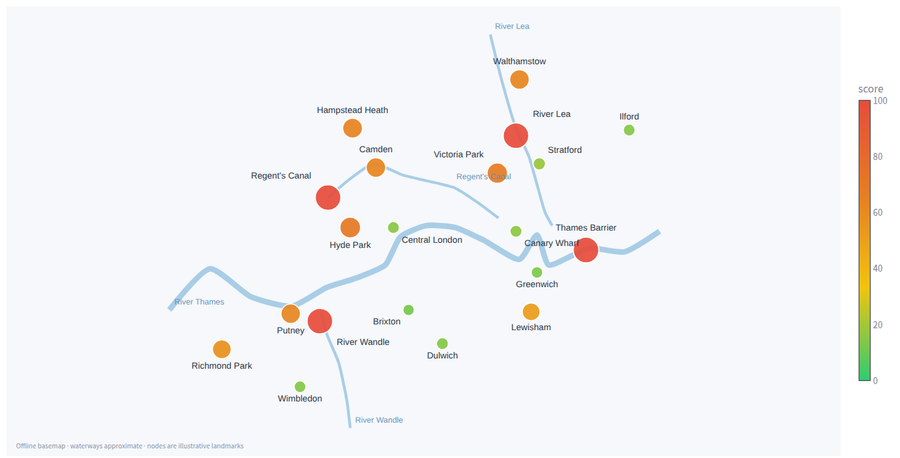

1. The problem
The official river gauge nearest to a school or an estate can be kilometres away from the stream, drain or underpass that actually floods. By the time an official warning reaches a community, the water is already rising. The World Meteorological Organization reports that countries with limited early-warning coverage suffer nearly six times the disaster mortality of countries with substantial coverage (4.05 versus 0.71 deaths per 100,000 people; WMO/UNDRR, Global Status of Multi-Hazard Early Warning Systems, 2023). There is a gap between where climate events happen and where they are measured.
We picked this because it is the rare climate problem two students can actually build something about. Reading about early-warning systems, what struck us was that the hard part is not the science but the last mile: the forecast exists, and nobody is watching the particular street. A watcher for one street is software and an £85 computer, which is exactly what we had.
We wanted a low-cost way for a school or a community to watch its own streets, and to be told in plain English what to do.

2. What we built
Climate Mesh is a network of 20 environmental “nodes” across Greater London, simulated or fed by live weather data, that runs on a single Raspberry Pi 5, fully offline, with no cloud account and no API key. Every two seconds each node reports eight channels: temperature, humidity, air quality, water level, wind speed, wind chill, heat index and barometric pressure. A risk engine scores every location from 0 to 100, an explainable AI model flags unusual combinations of readings, neighbouring nodes have to agree before a risk is escalated, and plain-English alerts with community action playbooks appear on a seven-tab dashboard.

3. How it works
One reading shape for every source. Whether a value comes from a physical sensor, the live Open-Meteo weather service or our simulator, it is turned into the same canonical reading: the eight channels plus a source label (hardware / api / demo / simulation) and a quality_flag (ok / estimated / stale / missing). Everything downstream (the risk engine, the AI, the database, the dashboard and the evidence export) only ever sees that shape. A real sensor joins the mesh by adding one adapter; nothing else changes.
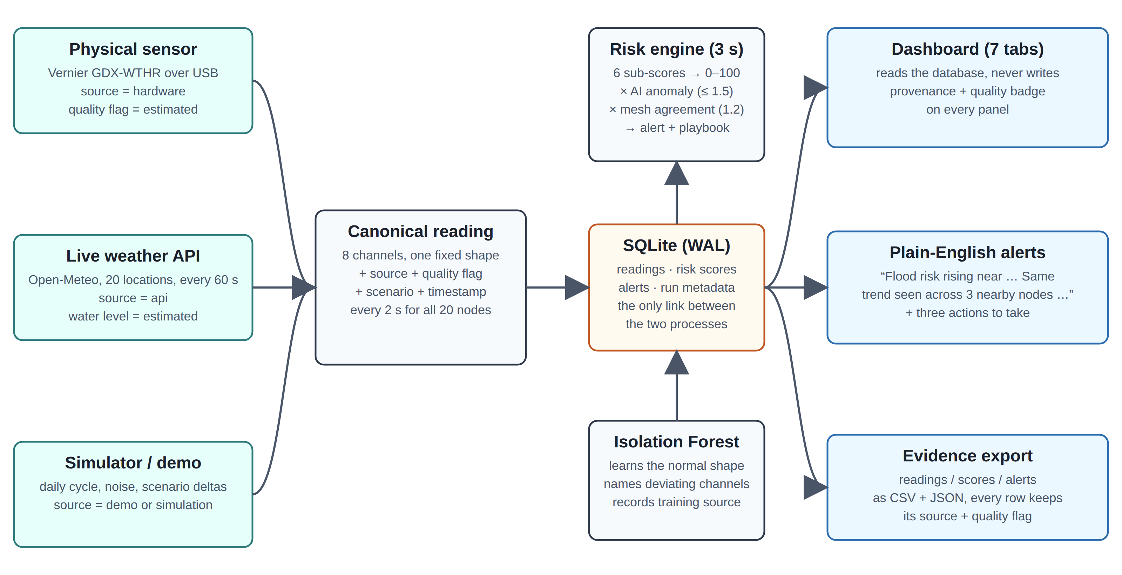
Figure 1 — The data path. Every source emits the same canonical reading (eight channels plus source and quality flag), so a real sensor is a drop-in and nothing downstream changes; one small database file is the only link between the engine and the dashboard.
An explainable risk score. For each node the engine computes six hazard sub-scores on a 0–100 scale (temperature, humidity, air quality, water level, wind, pressure); wind chill and heat index are derived comfort values (NOAA/Steadman) shown to the user, not scored twice. The sub-scores are combined as worst hazard plus 20 % of the rest, so one severe hazard alone can reach CRITICAL while several moderate ones also escalate. The bands are SAFE (under 30), MODERATE (30–60), WARNING (60–80) and CRITICAL (80–100). Temperature and humidity are two-sided: a frosty morning is filed as a cold hazard with its own advice, never as a “heatwave”.
AI that explains itself. An Isolation Forest learns the normal shape of the data and flags readings that are easy to isolate (a bit like spotting the odd one out in a crowd: a reading that can be separated from all the others in a few cuts is unusual), so an unusual combination of values is caught while each channel is still only moderately elevated. A confirmed anomaly multiplies the node’s graded risk by up to 1.5×, and the model reports which channels deviate most from the learned baseline, so every alert says why. Deliberately, the AI can amplify risk but never create it: 1.5× a SAFE score of 5 is still SAFE, so even the roughly 5 % of ordinary readings an Isolation Forest is expected to mis-flag cannot turn a SAFE node into an alert. Offline it trains on 2,000 deterministic synthetic samples; when online it can instead train on about 30 days of real hourly ERA5 weather and air quality for a representative central-London point from the Open-Meteo archive (cached after the first fetch), and it records which path it used. Every number in this write-up was produced with the synthetic path; training on the archive is a one-flag change (--ai-training historical).
Neighbours have to agree. Two nodes within 6 km are neighbours. The 1.2× mesh multiplier fires only when a node and at least two of its neighbours are elevated for the same hazard. A single glitching sensor cannot cry wolf; a correlated regional event is escalated. A worked example from the flood frame: Hyde Park’s own sub-scores give a base of 58.0 (MODERATE). Four of its neighbours are elevated for the same flood hazard, so the mesh multiplier applies: 58.0 × 1.2 = 69.6, WARNING, and an alert is raised. Regent’s Canal, by contrast, saturates on its own: water 83.5 + 20 % of (humidity 67.8 + pressure 37.3) = 104.5, capped at 100, before any multiplier. In the heatwave frame Lewisham shows both layers at once: base 65.8 (WARNING) × AI 1.26 × mesh 1.2 = 99.5, CRITICAL.
Alerts people can act on. WARNING and CRITICAL results raise an alert containing the plain-English explanation and a playbook of practical, low-risk actions for that hazard (flood, heatwave, smog, storm, cold). Alerts are rate-limited so the log never fills with duplicates.
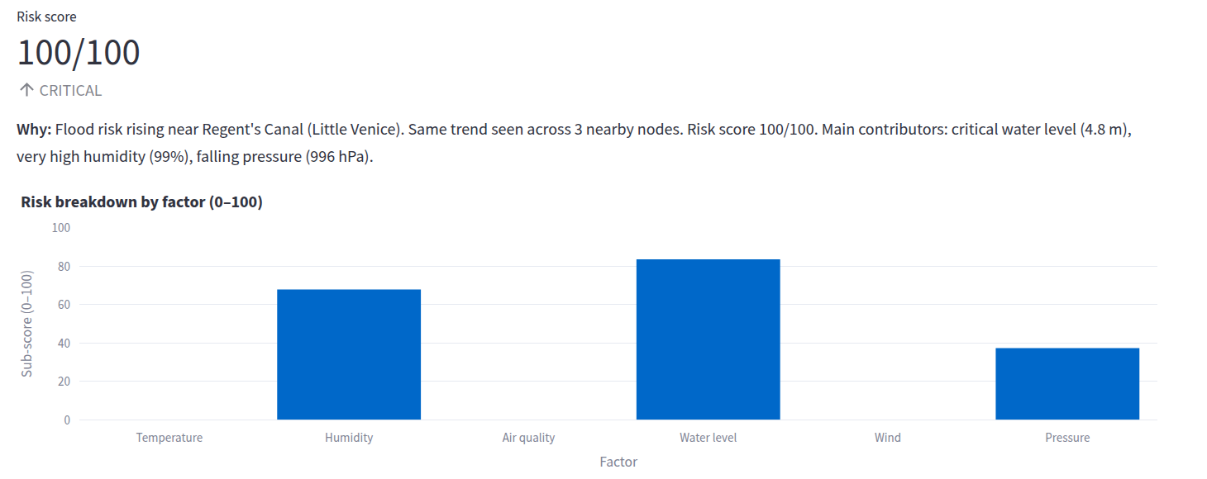
Figure 2 — Node Detail, Regent’s Canal, flood scenario, demo data: the “Why:” sentence and the six sub-scores behind a 100/100 score (this node saturates on its base score; see the Hyde Park example above for the mesh layer at work).
How the parts talk. The engine writes every reading and score into one small database file on the Pi; the dashboard only ever reads that file, so it can never alter the data, and either half can be restarted without losing anything. The sensor loop reads all 20 nodes every 2 seconds (every 60 seconds in api mode, to respect Open-Meteo’s free service) and the risk engine scores them every 3 seconds. A one-command export writes every reading, score and alert to CSV and JSON, each row still carrying its source and quality flag, plus a table of how many readings came from each source.

4. What we think is new
Not any single part, but the combination:
- Neighbours as a trust signal. A cheap node’s risk is escalated only when it and at least two neighbours within 6 km are elevated for the same hazard, so a network of £85 nodes is harder to fool than one expensive sensor.
- A bounded, explainable AI layer. The Isolation Forest names the channels responsible and can only amplify graded risk (up to 1.5×), never create it.
- Provenance enforced in code, not by convention. Every reading, panel, alert and exported row carries its source and quality flag; is_simulated is derived from source so the two can never disagree; a reading with an unknown source or flag is rejected at construction; a missing or non-numeric channel scores 0 rather than falling through to CRITICAL; each score is rounded once so the stored number, its band and the alert text always agree; and the dashboard can only show a “Physical Sensor” badge when a reading really came from a device.
- Reproducible by a stranger. The whole pipeline, model included, runs offline on one Pi 5, and one command reruns our entire evidence chain.

5. What is real and what is simulated
We label exactly what this is and is not.
Mode | Data | Internet | Sensors
simulation | Realistic generated data (default) | No | No
demo | Deterministic, screenshot-stable data | No | No
api | Live Open-Meteo weather and air quality for all 20 locations | Yes, falls back to simulation | No
hardware | One physical Vernier weather sensor, simulated mesh for the rest | No | Yes, falls back if absent
auto | Hardware, else API, else simulation | Optional | Optional
Figure 3 — Live Map, flood scenario, demo (simulated) data, on the dashboard’s offline basemap. Each circle is one of the 20 nodes; colour and size show risk 0–100; the blue lines are the Thames, the Lea, the Wandle and Regent’s Canal. The river and canal nodes are the ones in red.
- The 20 nodes sit at well-known London landmarks chosen to exercise the environment types (river, residential, urban, park). They are illustrative, not deployment sites.
- The hardware path (a Vernier Go Direct Weather sensor, GDX-WTHR, over USB) is implemented and tested end to end with a stand-in device object that mimics Vernier’s helper library (it opens, answers, answers badly or refuses to open, and the adapter is checked for each), but it has not yet been validated against a physical device. A node is labelled hardware only after a device actually opens and returns a reading.
- The GDX-WTHR senses temperature, humidity, wind and pressure only. In hardware mode the air-quality and water-level channels are conservative placeholders, so a hardware reading is always flagged estimated, never ok: a hardware/ok label can never cover a channel that was not measured.
- In api mode the water level is derived from precipitation, not read from a river gauge, so it is flagged estimated; it is an indicator, not a measurement.
- The flood, heatwave, smog and storm scenarios are simulated so that judging never depends on a real emergency. In api and hardware modes live values are shown unmodified.
- The AI is decision support for a community, not an accredited warning system. Alerts always defer to official guidance.

6. Evidence that it works
- 180 automated tests pass on Python 3.11, 3.12 and 3.13, including a test that executes all seven dashboard tabs in Streamlit’s headless test harness and tests that pin the exact numbers quoted below. Continuous integration runs the suite on every push to main and every pull request, on x86-64 (Python 3.11 and 3.13) and on a 64-bit Arm Linux runner (Python 3.11), the Pi’s architecture; 3.12 was checked by hand.
- python scripts/judge_validate.py runs the smoke test, all 180 tests, a normal and a flood demo cycle and the evidence export → PASS (5/5 steps passed). Its full output is docs/screenshots/terminal-judge_validate.png in the repository.
- python scripts/demo_tour.py runs one deterministic cycle of all five scenarios in a few seconds. Repeated runs print identical numbers; its full output is reproduced in the Appendix.
The demo tour, one row per scenario:
Scenario | Average risk | Worst node | Level | Alerts
normal | 3.9 | Greenwich | SAFE | 0
flood | 50.8 | Regent’s Canal (Little Venice) | CRITICAL | 10
heatwave | 78.8 | Brixton | CRITICAL | 12
smog | 82.7 | Brixton | CRITICAL | 15
storm | 98.1 | Brixton | CRITICAL | 20
What the AI and mesh layers add, on the same deterministic frames (number of nodes in each band):
Scenario | Sub-scores only | With AI and mesh | What changed
normal | 20 SAFE | 20 SAFE | Nothing: no node is flagged anomalous, no false alarm.
flood | 4 CRITICAL, 8 MODERATE, 8 SAFE | 4 CRITICAL, 6 WARNING, 2 MODERATE, 8 SAFE | Neighbour agreement lifts six residential and park nodes to WARNING; alerts 4 → 10.
heatwave | 8 CRITICAL, 4 WARNING, 8 MODERATE | 11 CRITICAL, 1 WARNING, 8 MODERATE | The AI flags 11 nodes as anomalous (eight urban, three residential); the three residential nodes move from WARNING to CRITICAL.
smog | 12 CRITICAL, 8 MODERATE | 12 CRITICAL, 3 WARNING, 5 MODERATE | Neighbour agreement lifts three river and park nodes; alerts 12 → 15.
storm | 5 CRITICAL, 15 WARNING | 19 CRITICAL, 1 WARNING | 18 AI anomalies plus agreement across 19 nodes.
The layers only ever amplify a hazard the sub-scores already see; they cannot invent one. These counts are pinned by a test, like the other numbers in this section.
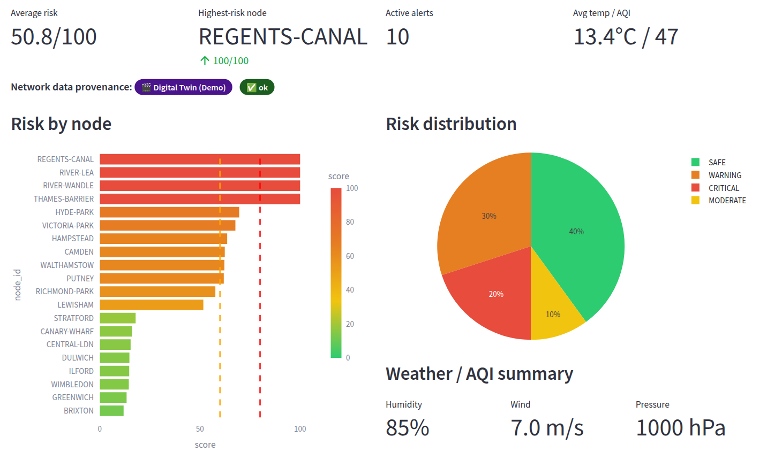
Figure 4 — Network Overview, flood scenario, demo data: the four river nodes go CRITICAL while inland nodes such as Brixton and Greenwich stay SAFE. The hazard lands where it should, and the purple badge says every value is simulated.

7. The Raspberry Pi 5
The Pi 5 is the whole product: it runs the simulator or the live data source, the scikit-learn model, the risk engine, the database and the web dashboard at the same time, headless, at the site.
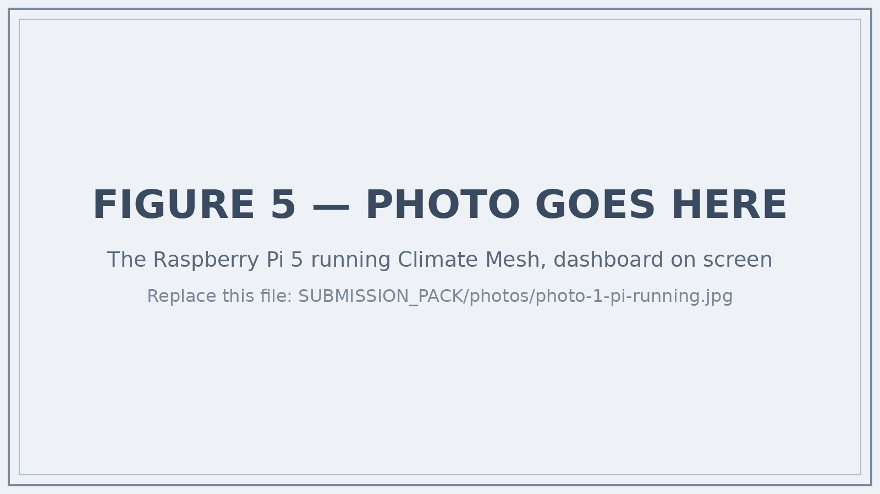
Figure 5 — ► PLACEHOLDER: replace photos/photo-1-pi-running.jpg with a photo of the Raspberry Pi 5 running Climate Mesh, and change the picture in WRITEUP.docx. Caption to use: “The Raspberry Pi 5 running Climate Mesh.”
Bill of materials for one node (approximate UK prices, September 2026):
Item | Purpose | Approx. cost
Raspberry Pi 5 (4 GB) | Runs everything | £55
27 W USB-C power supply | Power | £12
32 GB microSD card | OS and software | £8
Case with fan | Protection | £10
Core node total |  | £85
Vernier Go Direct Weather (GDX-WTHR), optional | Physical temperature, humidity, wind and pressure | ~£130
A community node therefore costs less than a hundred pounds before sensors; the software costs nothing and needs no subscription. Our own Pi 5 and sensor came free in the competition’s starter kit, so those are replacement prices for anyone else building a node, not what we spent: the barrier to a school copying this is a spare afternoon, not a budget.
Speed. The per-cycle cost is small: the 20 nodes are scored by the Isolation Forest in one batch rather than one at a time, which cut a full cycle from about 425 ms to about 23 ms on the x86-64 Linux machine used for the final review (four cores, 16 GB, Python 3.11), where the model trains in 0.2 s and the engine peaks at about 200 MB of memory.
On Arm. The same suite and benchmark run in our continuous integration on a real 64-bit Arm Linux machine (GitHub’s Arm runner: four Neoverse-N2 cores, 16 GB, Python 3.11 as the Bookworm release of Raspberry Pi OS ships). Every dependency installed from a prebuilt Arm wheel with compilation forbidden, all 180 tests passed in 9 s, the model trained in 0.1 s, a full 20-node cycle took 13 ms and the engine peaked at 199 MB.
On the Pi. It runs on our own Pi 5; we have not put a stopwatch on it there, so for the board we give a bound rather than a number: its Cortex-A76 cores are slower than those server cores, but even if the Pi were eight times slower (two to three times is more likely) a cycle would take about 100 ms, 5 % of the 2-second read interval, and the 200 MB footprint sits comfortably inside the 4 GB board with the dashboard alongside. python scripts/pi_benchmark.py prints the measured sentence for whatever machine it runs on.
Installation. Every dependency ships a prebuilt 64-bit Arm wheel (the Arm job in our CI installs with compilation forbidden, to prove it), so installation on Raspberry Pi OS is one script (setup_pi.sh): it creates a Python environment, installs the requirements (no compiler or special tools needed) and runs the smoke test. The dashboard is only reachable from the Pi itself, or from a laptop connected to it securely over SSH, so nothing is opened up on the school network. The map has an offline basemap option, so even the Live Map works with no internet.

8. Impact
What it looks like on the day. It is a wet November morning. The water-level channel at the Regent’s Canal node climbs. Three neighbouring nodes report the same trend, so this is not one stuck sensor, and the site manager’s screen reads: “Flood risk rising near Regent’s Canal (Little Venice). Same trend seen across 3 nearby nodes. Risk score 100/100. Main contributors: critical water level (4.8 m), very high humidity (99%), falling pressure (996 hPa).” Under it are three things to do now: check and clear the nearby drains and gullies, inspect low-lying paths and entrances for standing water, and move valuables off the ground floor. The official area warning may follow later; the point is that someone on site had a reason to act before it did. (The quoted alert is the actual output of python scripts/demo_tour.py for the flood scenario, on simulated data.)
Climate Mesh is aimed at the people who actually respond first: a school site manager, a receptionist, a residents’ association. For the streets that official gauges do not cover, it gives them a risk score they can read at a glance, the reason it is rising, and three practical things to do. It stores only environmental measurements, never personal data, and runs entirely locally, so a school can adopt it without a data-protection review or a cloud bill. Because every node is cheap and every reading carries its provenance, a network of schools could pool their nodes into a genuine neighbourhood early-warning mesh.

9. Teamwork and what we learned
We are a team of two, Luis Yu and Leo Zhang. The first version of Climate Mesh went into our repository in early August 2026; by the end of that month it carried 144 automated tests, and the final review before submission brought that to 180. We worked on it together throughout, and we would both be able to explain any part of it to a judge.
The first thing that worked was the simulator: twenty nodes with a daily cycle and some noise, and a risk score that went red when we typed in a flood. That took an afternoon and felt like most of the project. It was not. Almost everything after it was about trust: deciding what the system is allowed to claim. We argued about whether the demo could show a “sensor” reading for a sensor we did not have, and decided it could not. That decision is now enforced in code: a node can only be labelled hardware after a real device opens, and a badge saying “Physical Sensor” can only appear when a reading actually came from one. It cost us the easy screenshot and gave us the project’s spine.
The worst week was the one where we made the demo deterministic. Every screenshot and every number in this document had to be reproducible by a stranger, which meant fixed seeds, a frozen clock in judge mode, and tests that pin the published figures. We broke the numbers several times while “improving” the risk engine, and each time a test told us before a judge could. We also learned to test the dashboard itself, not just the maths: an automated run of all seven tabs found that one tab crashed whenever real data was present, which we had never noticed because we always looked at the first few tabs.
If we were starting again, or advising a Year 10 team: build the honest version first, make one command that proves it works, and only then make it look good.
What was hardest. The three things above: deciding what the system is allowed to claim (a reading is “hardware” only after a device physically opens; a water level derived from rainfall is flagged estimated; the AI records whether it trained on real or synthetic data), making every published number reproducible by a stranger, and testing the dashboard itself rather than just the maths. The crash the tab test caught was a whole column of data-source labels being tested as if it were a single yes/no value, which broke the Hardware Readiness tab whenever live data was present and blanked the Competition Pitch tab after it.
What we learned. The big one: an honest system is more work than an impressive one, and the work is mostly saying no to yourself. Technically: that anomaly detection finds odd combinations that thresholds miss; that a test which pins a number you have published is the best guard against quietly breaking your own claims; and that a whole machine-learning pipeline really does fit on a £55 computer (199 MB and 13 ms a cycle on Arm).
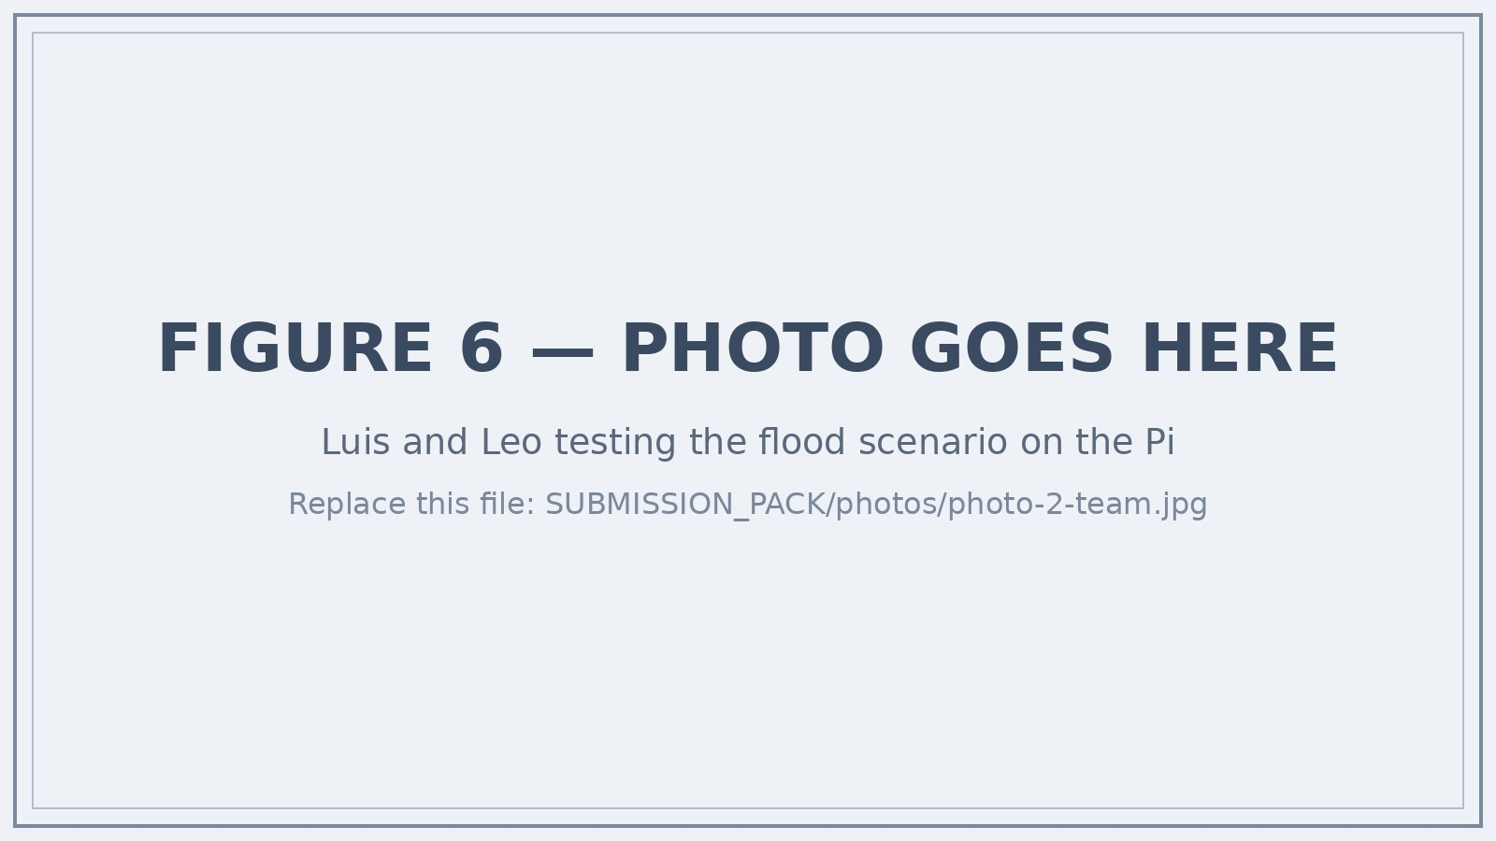
Figure 6 — ► PLACEHOLDER: replace photos/photo-2-team.jpg with a photo of the two of you at the Pi, and change the picture in WRITEUP.docx. Caption to use: “Luis and Leo testing the flood scenario on the Pi.”

10. What we would do next
- Validate one physical node. Read a real Vernier GDX-WTHR through the existing adapter and compare it against the digital twin for the same location.
- Calibrate against history. Use the evidence export to compare risk scores with recorded local flood and heat events, and tune thresholds from data instead of by hand.
- Physical mesh links. Two or more real Pi nodes exchanging readings (Wi-Fi first, LoRa later) so neighbour agreement runs across actual devices.
- Node cost pack. A priced, tested bill of materials for a minimal community node, published once we have built one from it and run it.

11. Safety, privacy and responsible use
No personal data is stored: no names, accounts, cameras, microphones or tracking of people. The only optional outbound calls fetch public Open-Meteo weather data. Emergency scenarios are simulated and labelled as such, so judging never depends on or misrepresents a real emergency. Alerts are decision support and always defer to official emergency guidance. The hardware is low-voltage and USB-powered.

12. Acknowledgements and help received
Built in Python with Streamlit (dashboard), scikit-learn (Isolation Forest), pandas, NumPy, Plotly and SQLite. Live and archive weather data come from the free Open-Meteo service. The hardware path uses Vernier’s godirect driver and gdx helper. Early-warning statistics are from the World Meteorological Organization and UNDRR. The heat index follows the NOAA/Steadman formulation.
Help received. We declare this whether or not the entry form asks, because the whole point of the project is saying where things come from. During the final review of this entry (September 2026) we used an AI coding assistant (Anthropic’s Claude), working under our direction: it reviewed the code and fixed the bugs it found; added tests (the suite grew from 144 to 180); batched the anomaly scoring and wrote the benchmark script and the Arm CI job behind the figures in §7; added the offline basemap; captured the screenshots; replaced the licence text at our request; and drafted this document, the entry-form answers and the Word/PDF build from the repository’s history and our notes, which we then read and corrected. The repository’s September 2026 commits record that work. No teacher, mentor or other adult wrote any part of the code or of this document. The concept, the design and the original codebase are our own work.

Appendix — Running it yourself
python3 -m venv .venv && source .venv/bin/activate # Windows: .venv\Scripts\activate
pip install -r requirements.txt
python scripts/judge_validate.py # smoke test + 180 tests + 2 demo cycles + export
python scripts/demo_tour.py # all five scenarios in a few seconds
python run.py --mode demo --scenario flood --judge-mode # terminal 1
python -m streamlit run dashboard/app.py # terminal 2 → http://localhost:8501
The repository’s README.md has the full file map, run modes and troubleshooting; docs/screenshots/ holds every dashboard tab and the terminal evidence.
The demo tour’s output, exactly as printed (the numbers quoted in §6):
==============================================================================
Climate Mesh - Demo Tour (deterministic, synthetic data, no hardware)
==============================================================================
Scenario Avg Max Worst node Level Alerts
------------------------------------------------------------------------------
normal 3.9 11.4 Greenwich SAFE 0
flood 50.8 100.0 Regent's Canal (Little Venice) CRITICAL 10
heatwave 78.8 100.0 Brixton CRITICAL 12
smog 82.7 100.0 Brixton CRITICAL 15
storm 98.1 100.0 Brixton CRITICAL 20
------------------------------------------------------------------------------
Risk is 0-100. Every reading above is source=demo, is_simulated=True.
==============================================================================
Sample explanation (flood, Regent's Canal (Little Venice)):
Flood risk rising near Regent's Canal (Little Venice). Same trend seen across 3 nearby nodes. Risk score 100/100. Main contributors: critical water level (4.8 m), very high humidity (99%), falling pressure (996 hPa).
RESULT: PASS (5/5 scenarios, deterministic, offline)

