学号 P21714001 专业 计算机英才班 姓名 刘峰

实验日期 **2019.11.18**  教师签字 成绩

实验报告

【实验名称】  数字图像处理 实验一

【实验内容】

一、

a) In Matlab workspace, generate an image with the size of 512 × 512 pixels, 8-bit

grayscale, black background, the center having a 40 pixels width and 20 pixels height

white rectangle. As shown in the following figure:

clc

clear all

close all

a=zeros(512,512);

b=uint8(a);

b(246:266,236:276)=255;

imshow(b);

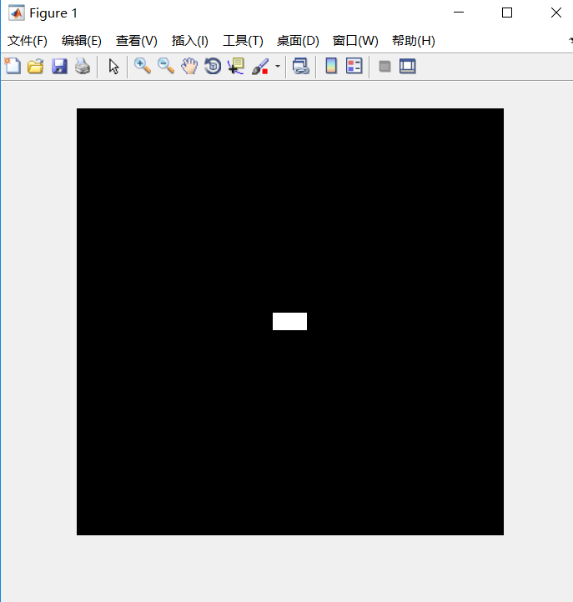

b) Save this image as a file “test.bmp”

imwrite(b,'test.bmp');

c) Read out the image from the file test.bmp to the variable I

I=imread('test.bmp');

d) Display the image represented by the variable I in Matlab graphical interface

figure

imshow(I);

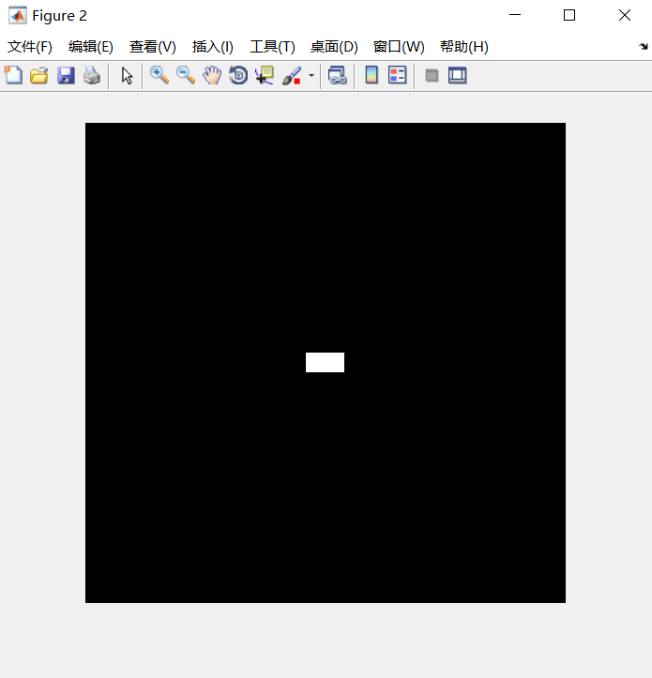

e) Convert the obtained image format into "*. tif", "*. jpg” format, check the data size of

the volume of the documents with different formats.

imwrite(I,'test.jpg');

imwrite(I,'test.tif');

imfinfo test.bmp

imfinfo test.jpg

imfinfo test.tif

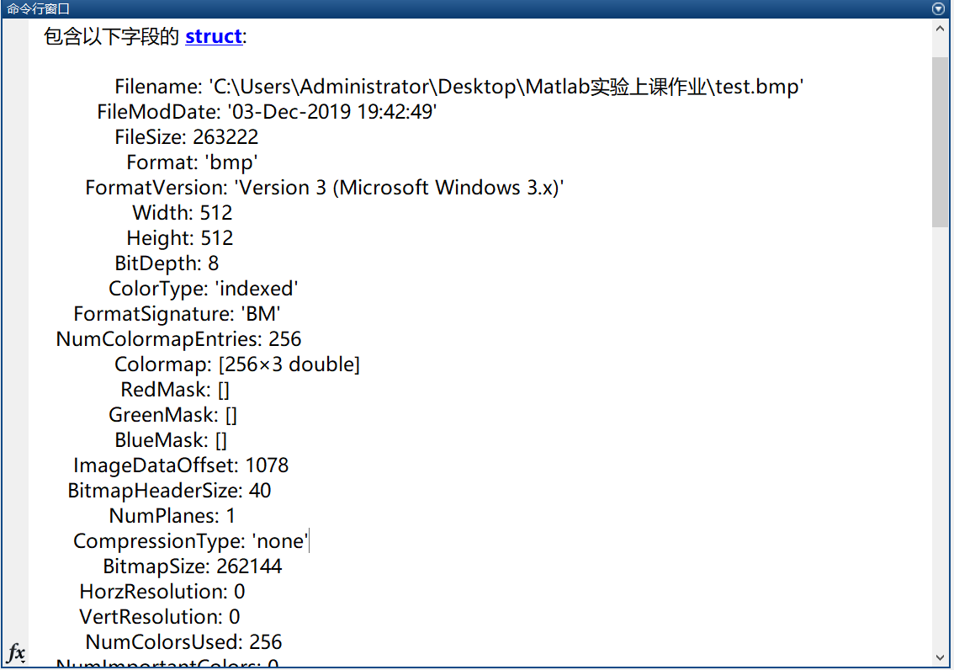

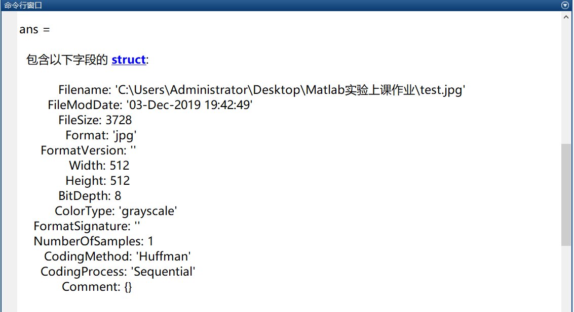

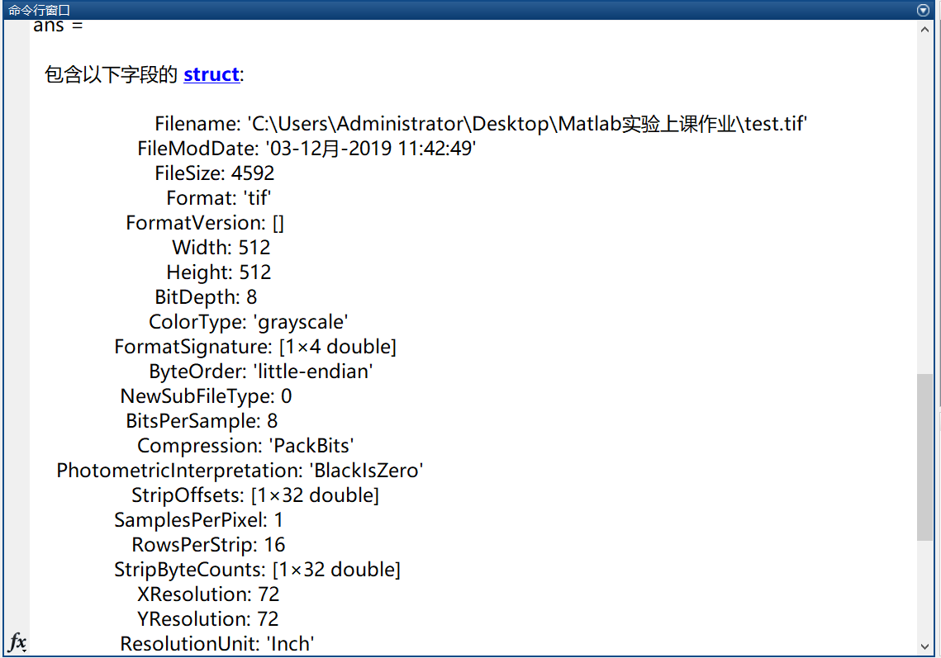

f) Save or copy the image to the root directory of MATLAB program "work" folder for later

experimental use.

mkdir work;

I2=imread('test.jpg');

I3=imread('test.tif');

imwrite(I,'work\test.bmp');

imwrite(I2,'work\test.jpg');

imwrite(I3,'work\test.tif');



二、

Write a computer program capable of producing the negative images (logic operation NOT) on

“Fig_blurry_moon.tif” as well as the images used in the previous sections.

I=imread('Fig_blurry_moon.tif');

Z=255-I;

imshow(Z);

imwrite(Z,'Negtive.jpg');

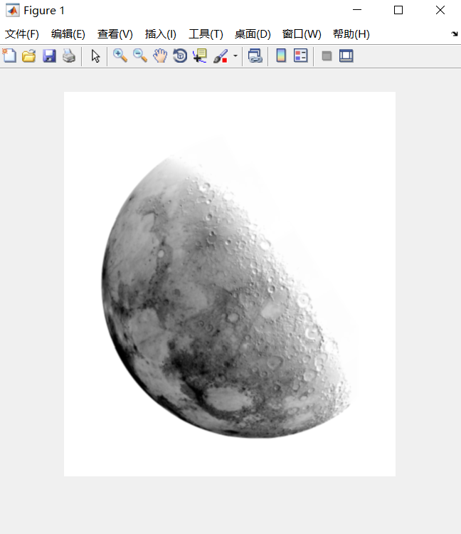

三、

PROJECT 02-03

Zooming and Shrinking Images by Pixel Replication

(a) Write a computer program capable of zooming and shrinking an image by pixel replication.

Assume that the desired zoom/shrink factors are integers.

(b) Use your program to shrink the image “Fig_rose.tif” by a factor of 16.

(c) Use your program to zoom the image in (b) back to the resolution of the original. Explain

the reasons for their differences.

%%

clear all;

clc;

close all;

%原图

img = imread('Fig_rose.tif');

%缩小图像

img1 = imresize(img,0.16);

figure(1)

imshow(img);

title('原图');

figure(2)

imshow(img1);

title('缩小0.16倍的图像');

imwrite(img1,'zoomedto2_imag.jpg');

img_name = 'zoomedto2_imag.jpg'

img2 = imread(img_name);

img3 = imresize(img1, 6.25);

figure(3)

imshow(img3);

title('缩小图像再次还原的图像');

imwrite(img3,'6.25zoomed.jpg')

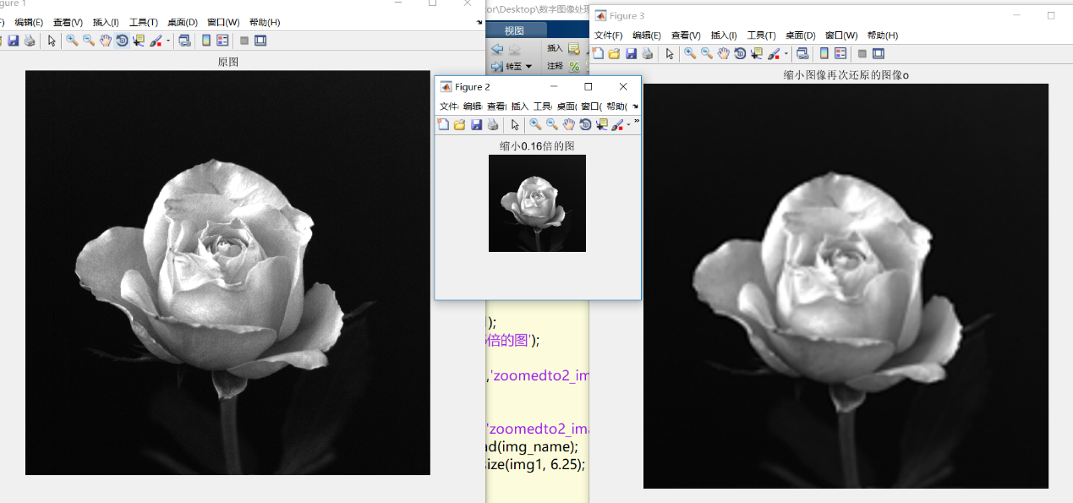

三、

PROJECT 02-04

Reducing the Number of Intensity Levels in an Image

(a) Write a computer program capable of reducing the number of intensity levels in an image

from 256 to 2, in integer powers of 2. The desired number of intensity levels needs to be a

variable input to your program.

(b) Perform the program on the following image “Fig_ctskull-256.tif” from the textbook

L1=imread('Fig_ctskull-256.tif');

imag1=reduceIntLevel(L1,128);

imag2=reduceIntLevel(L1,64);

imag3=reduceIntLevel(L1,32);

imag4=reduceIntLevel(L1,16);

imag5=reduceIntLevel(L1,8);

imag6=reduceIntLevel(L1,4);

imag7=reduceIntLevel(L1,2);

subplot(2,4,1),imshow(L1);

subplot(2,4,2),imshow(imag1);

subplot(2,4,3),imshow(imag2);

subplot(2,4,4),imshow(imag3);

subplot(2,4,5),imshow(imag4);

subplot(2,4,6),imshow(imag5);

subplot(2,4,7),imshow(imag6);

subplot(2,4,8),imshow(imag7);

function img = reduceIntLevel(L1, level)

imageSize = size(L1);

num = 256 / level;

img = uint8(zeros(imageSize(1), imageSize(2)));

for r = 1:1:imageSize(1)

for c = 1:1:imageSize(2)

img(r, c) = fix(double(L1(r, c)) / num) * 255 / (level-1);

end

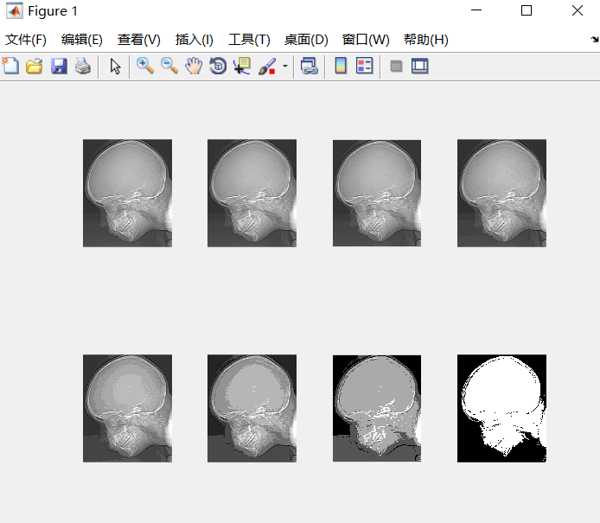

五、PROJECT 02-05

Zooming and Shrinking Images by Bilinear Interpolation

(a) Write a computer program capable of zooming and shrinking an image by bilinear

interpolation. The input to your program is the desired resolution (in dpi) of the resulting

image.

(b) Use your program to shrink the same image as shown in PROJECT 02-03 from 1250

dpi t0 100 dpi.

%%

clear all;

clc;

close all;

%%

%Ô­Í¼

img = imread('Fig_rose.tif');

%ËõÐ¡Í¼

img1 = imresize(img,[1250,1250]);

figure(1)

imshow(img);

title('Ô­Í¼');

figure(2)

imshow(img1);

title('1250*1250');

imwrite(img1,'1250dpi.jpg');

% ¸´Ô­Í¼

img_name = 'zoomedto2_imag.jpg'

img2 = imread(img_name);

img3 = imresize(img1, [100,100]);

figure(3)

imshow(img3);

title('100*100');

imwrite(img3,'100dpi.jpg')

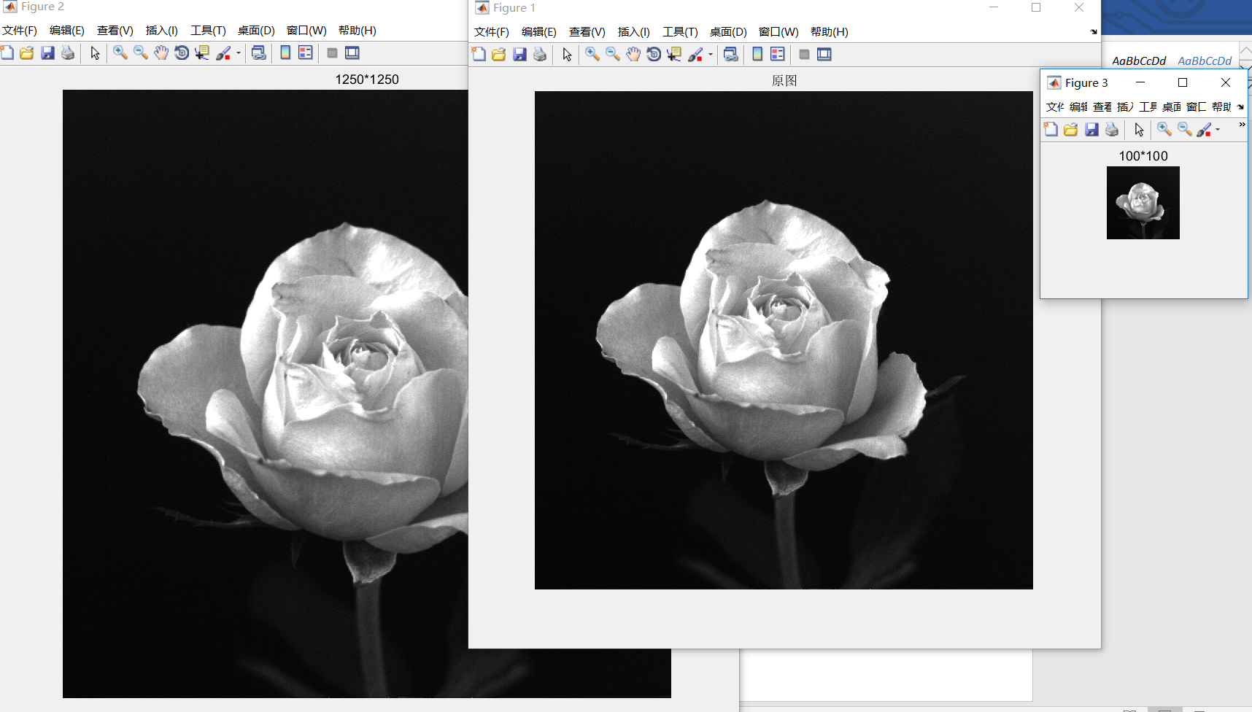

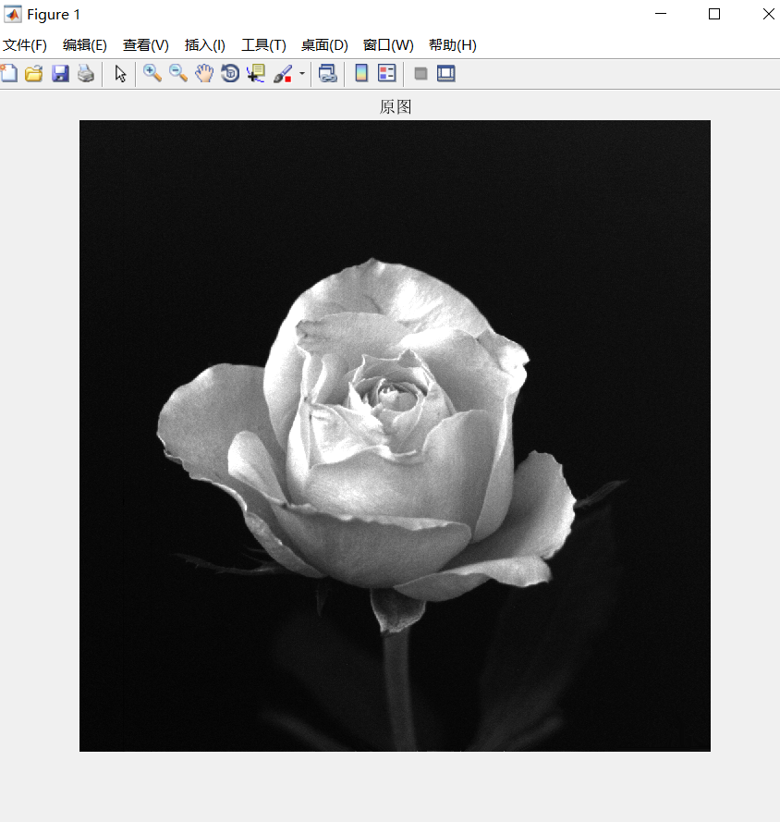

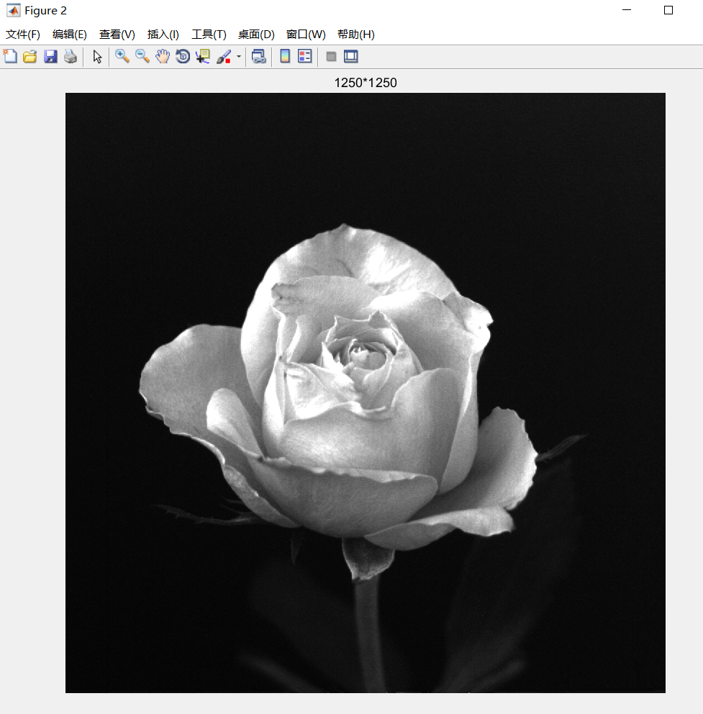

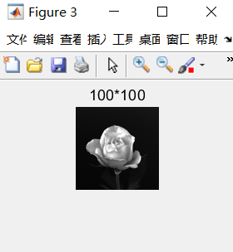

(c) Use your program to zoom the image in (b) back to 1250 dpi. Explain the reasons for their

differences.

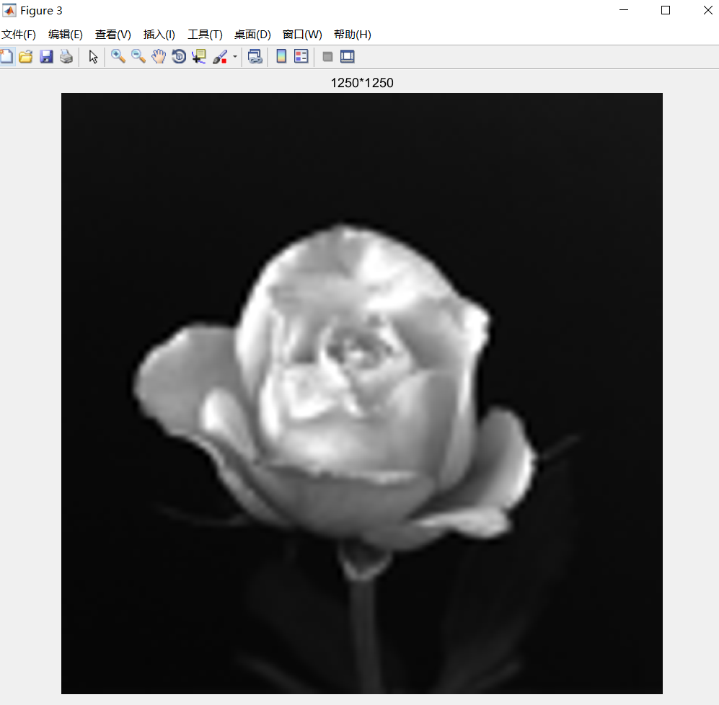

图像先缩小后放大过程中，损失像素，图像会变模糊。

【实验总结】

本次是数字图像处理实验的第一次，通过第一次图像处理实验，了解了利用命令创建文件以及保存文件，对图像的缩放以及对不同图像缩放，图像发生的一系列变化的原因。