学号 P21714001 专业 计算机英才班 姓名 刘峰

实验日期 **2019.12.6**  教师签字 成绩

实验报告

【实验名称】  数字图像处理实验三

【实验目的】

熟悉并掌握直方图均衡化、图像翻转、直方图统计像素点灰度等技术

【实验原理】

Matlab与数字图像处理技术。

【实验内容】

PROJECT 03-04 Image Flipping

Write a MATLAB function flipImage which flips an image either vertically or horizontally. The function should take two parameters – the matrix storing the image data and a flag to indicate

whether the image should be flipped vertically or horizontally. Use this function from the command line to flip the image woman.bmp both vertically and horizontally which should give the following results.

function flipImage()

%% 初始化

clc

clear all

close all

%% 读入图片

I=imread('woman.tif');

subplot(1,3,1);

imshow(I);

title('原图');

%I2=imrotate(I,180);

I2=fliplr(I)

subplot(1,3,2);

imshow(I2)

title('左右翻转图片');

I3=flipud(I);

subplot(1,3,3);

imshow(I3)

title('上下翻转图片');

end

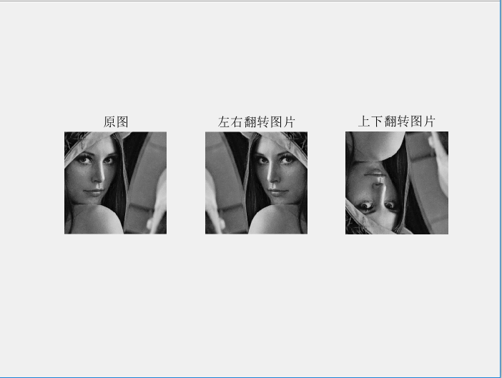

PROJECT 03-05 Image Histogram

Write a MATLAB function, generateHistogram, which generates the histogram of an image. The function should take an image data array (with pixel values in the range 0 – 255) as its only parameter and return an array containing the histogram of the image. The histogram can be displayed using the built in MATLAB function hist. For example:

A = generateHistogram(Image); hist(A);

Use this new function to generate and display histograms for the following images (darkPollen.jpg, lightPollen.jpg, lowContrastPollen.jpg and pollen.jpg).

function histogram()

%%

clc

clear all

close all

I=imread('darkPollen.jpg');

[row,column]=size(I);

array=zeros(1,256);

for i=1:row

for j=1:column

array(1+I(i,j)+1)=array(1+I(i,j)+1)+1; %统计各像素点的灰度值

end

end

i=1:256;

figure

subplot(1,2,1)

imshow(I);

title('待统计图像');

subplot(1,2,2);

bar(i,array(1,i));

title('自定义统计灰度值');

end

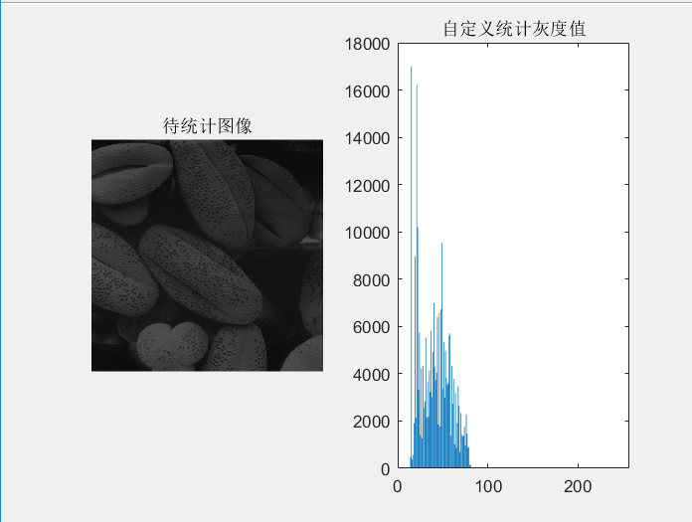

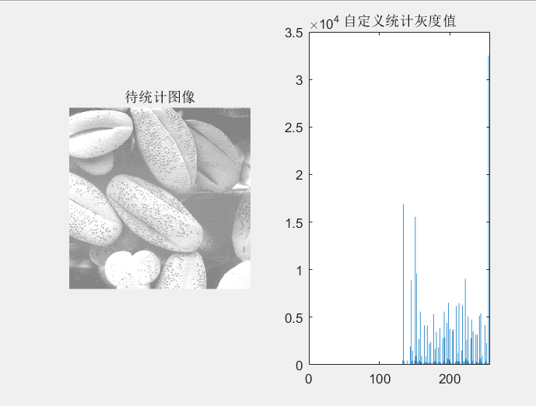

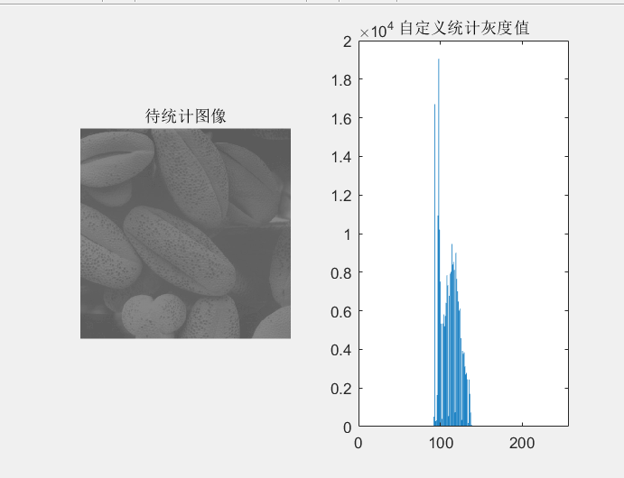

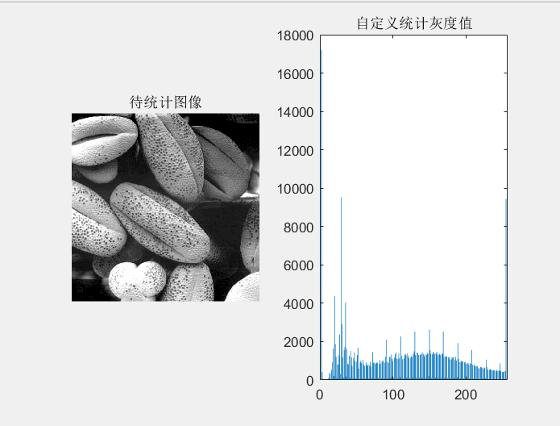

PROJECT 03-06 Histogram Equalization

a) Implement the histogram equalization using the function in MATLAB. Perform histogram

equalization on the above 4 images.

function histogramEqualization()

%% 初始化

clc

clear all

close all

%% 读入图片

r1=imread('darkPollen.jpg');

r2=imread('lightPollen.jpg');

r3=imread('lowContrastPollen.jpg');

r4=imread('pollen.jpg');

%% 显示以上四幅图片的直方图均衡化

figure

subplot(2,2,1);

histeq(r1);

title('darkPollen的直方图均衡化');

subplot(2,2,2);

histeq(r2);

title('lightPollen的直方图均衡化');

subplot(2,2,3);

histeq(r3);

title('lowContrastPollen的直方图均衡化');

subplot(2,2,4);

histeq(r4);

title('pollen原图的直方图均衡化');

end

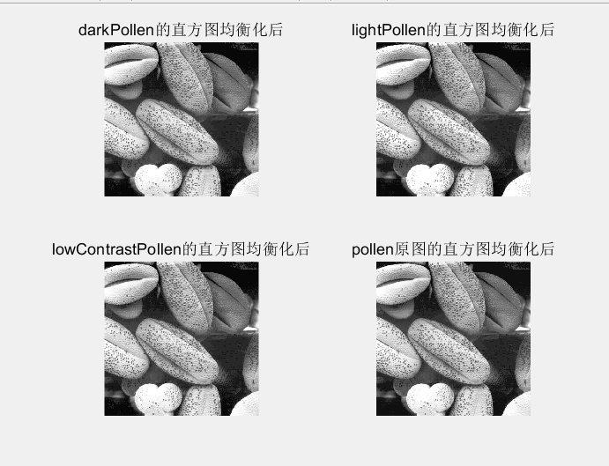

b) Plot the histogram of the original images and the histogram-equalization enhanced images.

As a minimum, your report should include the original image, a plot of its histogram, the enhanced .

%% 绘制原始图片和均衡化后的图片

figure

subplot(2,2,1);

imhist(r1);

title('darkPollen直方图图');

subplot(2,2,2);

imhist(r2);

title('lightPollen的直方图');

subplot(2,2,3);

imhist(r3);

title('lowContrastPollen的直方图');

subplot(2,2,4);

imhist(r4);

title('pollen原图的直方图');

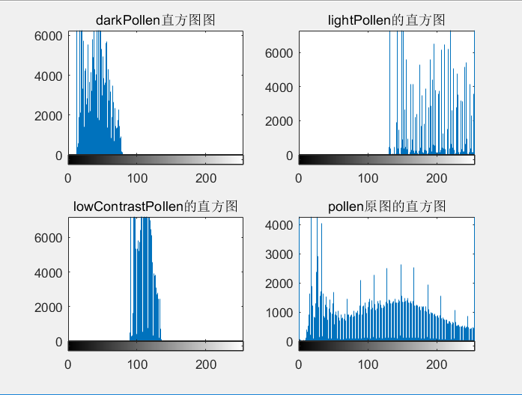

image, and a plot of its histogram. Use this information to explain why the resulting image was enhanced as it was. 显而易见的是，darkPollen，lightPollen，lowContrastPollen，pollen原图的初始直方图统计如上图所示，darkPollen灰度值较低的占大多数，因此图片较暗，lightPollen灰度值较高的占大多数，因此图片比较明亮，lowCountPollen其灰度值相对比较集中的分布再100-150这个范围内，高对比度没发挥出其对比优势，因此在均衡化之前，其图片比较泛白，色差不够明显。但是四副图片经过直方图均衡化之后，均有比较明显的对比度提升.

Histeq 具有将原来色彩不够光鲜的图片提升对比度的作用。

【实验总结】

本次实验通过做以上三个项目实验，我们熟悉了利用直方图均衡化对图像进行增强，还学会了利用工具箱所带的直方图函数对图像的像素点进行统计以及图像基本的上下、左右翻转。