学号 P21714001 专业 计算机英才班 姓名 刘峰

实验日期 **2019.12.04**  教师签字 成绩

实验报告

【实验名称】  **数字图像处理实验二——图像增强**

【实验内容】

PROJECT 03-01

Image Enhancement Using Log Transformations The focus of this project is to experiment with intensity transformations to enhance an image.

Enhance the image “Fig_DFT_no_log.tif” by the log transformation of Eq.: s = clog (1 + r).

Change the only free parameter c until (according to your **judgment) you have the best visual**

**result for the transformation**

%% 初始化

clc

clear all

close all

%% 读入图像

img1=imread('Fig_DFT_no_log.tif');

figure;

subplot(1,2,1);

imshow(img1);

imwrite(img1,'original.bmp');

title('original');

%% the log transformation of Eq.: s = clog (1 + r)

c=input('input c is：');

t1=c*log(1+double(img1));

t2=mat2gray(t1); %矩阵归一化

t3=im2uint8(t2);

subplot(1,2,2);

imshow(t3);

title('log transformation');

**input c is: 1**

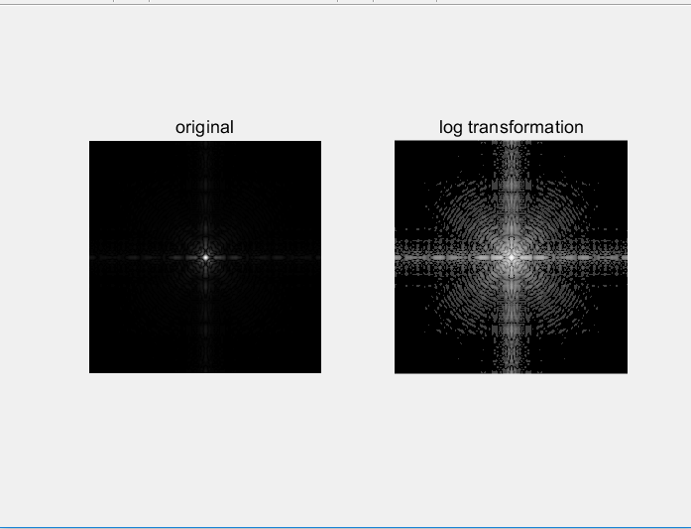

**input c is: -1**

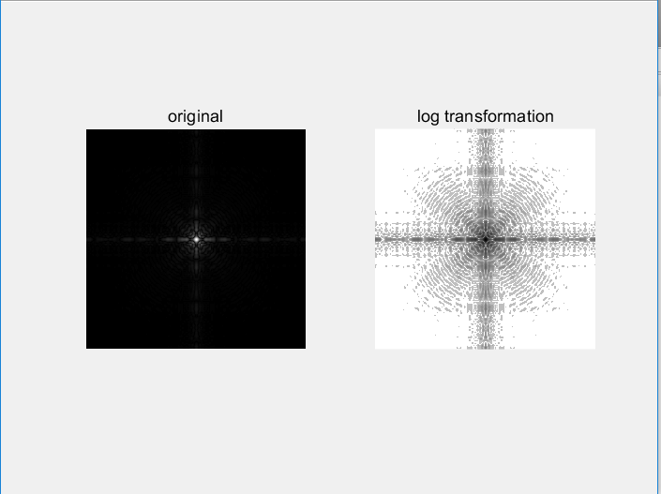

PROJECT 03-02

Image Enhancement Using Power-law Transformations

Enhance the image “Fig_fractured_spine.tif” by a power-law transformation of the form

shown in Eq.: . Change the two parameters, c and r until (according to your

judgment) you have the best visual result for the transformation.

%% 初始化

clc;

clear all;

close all;

%% 读入图像数据

img_gray=imread('Fig_fractured_spine.tif');

figure;

subplot(3,3,1);

imshow(img_gray);

title('original');

%% 幂律变换

img_t1=double(img_gray);

c=1;

pow=0.1;

for pow =0.1:0.1:0.8

img_t2=im2uint8(mat2gray(img_t1.^pow));

c=c+1;

subplot(3,3,c);

imshow(img_t2);

gamma=sprintf('power-law:gamma=%.1f',pow);

title(gamma);

end

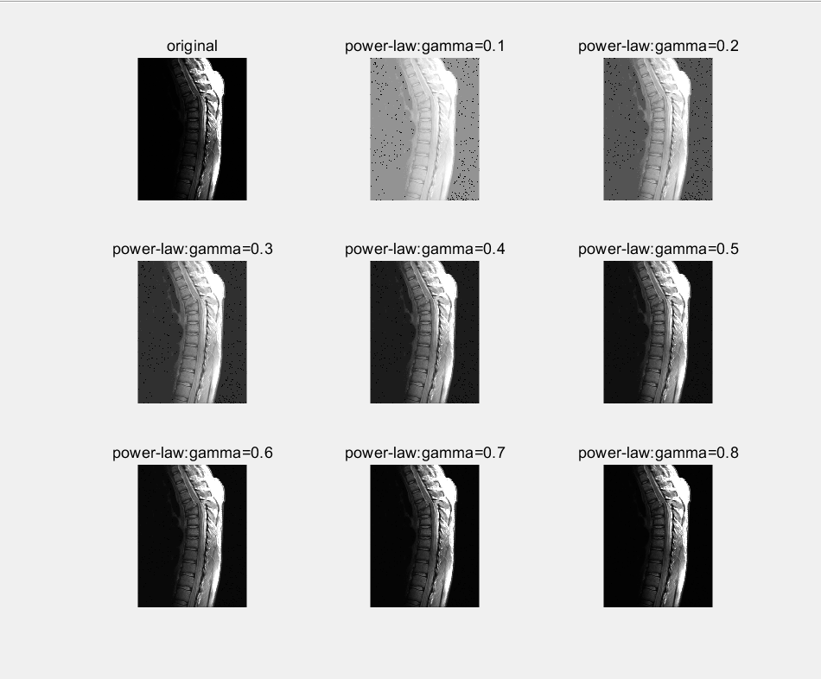

PROJECT 03-03

Image Enhancement Using Thresholding

a) Write a MATLAB function averageIntensity which calculates the average intensity level of an

image. From the command line use this function on the image “Fig_blurry_moon.tif”.

(Hint: To calculate the average intensity of the pixels in an image simply iterate through every

pixel in the image, summing all of their values and finally divide this sum by the total number

of pixels.)

function ans=averageIntensity()

Img=imread('Fig_blurry_moon.tif');

ans=sum(Img(:))/length(Img(:));

end

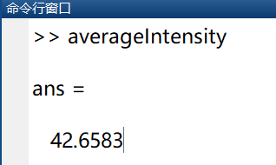

b) Write a MATLAB function thresholdImage which thresholds an image based on a threshold

level given as a parameter to the function. The function should take two parameters – the image

to be thresholded and the threshold level. The result of the function should be a new

thresholded image. This function would be called as follows:

ThresholdedMoon = thresholdImage(Moon, ave);

Use this new function from the command line on the image to give images similar to the

following:

function The_moon=thresholdImage()

ave_bw=ave/256;

bw_moon=im2bw(gray_moon,ave_bw);

end

%% 初始化

clc

clear all

close all

%% 读入图片

Img_moon=imread('Fig_blurry_moon.tif');

gray_moon=mat2gray(Img_moon);

%% 得到平均值

ave=averageIntensity();

%% 阈值变换

ave_bw=ave/256;

bw_moon=im2bw(gray_moon,ave_bw);

%% 画图

imshow(bw_moon);

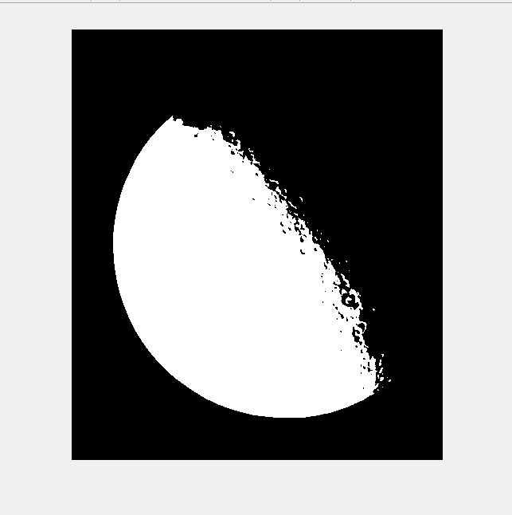

【实验总结】

数字图像处理实验让我们学习到了如何应用Log Transformations Power-law Transformations Thresholding

等技术对图像进行变换，让图像增强，给人以更方便的获取想获得的图像。