学号 P21714001 专业 计算机英才班 姓名 刘峰

实验日期 **2019.12.19**  教师签字 成绩

实验报告

【实验名称】  数字图像处理实验五

【实验目的】

1. 掌握彩色图像与灰度图像之间的相互转化

2. 掌握彩色图像的基本组成，通过调整彩色图像的组成改变图像的外观

3. 理解彩色图像的成分对图像的影响

【实验内容】

PROJECT 04-01

Image Filtering in Frequency Domain

(a) Implement the Gaussian lowpass filter function. You must be able to specify the size, M x N, of the resulting 2D function.

(b) Conduct the Guassian lowpass filter on “Fig_characters_test_pattern.tif” with cutoff

frequencies at radii values of 5,15,30,80 and 230 respectively.

(c) Compare the results with the original image.

%%

clc

close all;

clear all;

%%

img1 = imread('Fig_characters_test_pattern.tif');

img1 = mat2gray(img1);

figure;

subplot(1,3,1);

imshow(img1);

title('原图像');

%% 产生滤波函数

[M, N] = size(img1);

P = 2 * M;

Q = 2 * N;

alf = 100;

Glow = zeros(P, Q);

for i = 1:P

for j = 1:Q

Glow(i, j) = exp(-((i-P/2)^2 + (j-Q/2)^2) / (2 * alf^2));

end

end

% H = ones(P, Q);

subplot(1,3,2);

imshow(Glow);

title('高斯低通滤波函数图像');

%

%% 图像填充

[M, N] = size(img1);

P = 2 * M;

Q = 2 * N;

img_fp = zeros(P, Q);

img_fp(1:M, 1:N) = img1(1:M, 1:N);

img_f = zeros(P, Q);

for x = 1:P

for y = 1:Q

img_f(x, y) = img_fp(x, y) .* (-1)^(x+y);

end

end

img_F = fft2(img_f);

img_G = img_F .* Glow;

img_g = real(ifft2(img_G));

for x = 1:P

for y = 1:Q

img_g(x, y) = img_g(x, y) .* (-1)^(x+y);

end

end

img2 = img_g(1:M, 1:N);

subplot(1,3,3);

imshow(img2, []);

title('高斯低通滤波后的图像');

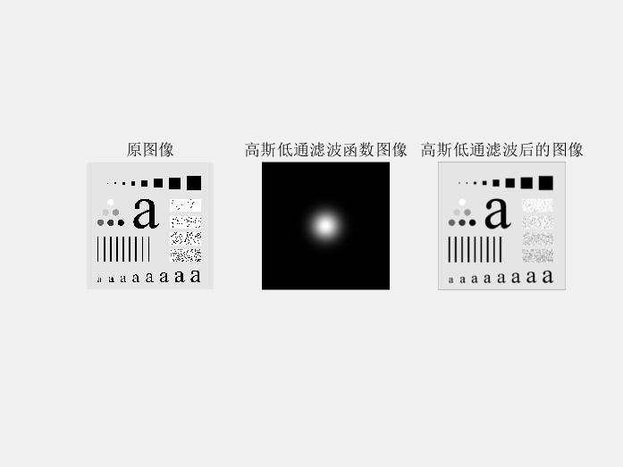

PROJECT 04-02

(a) Based on the PROJECT 04-01, implement the Ideal lowpass filter and Butterworth lowpass

filter (n=2 for Butterworth).

clear all;

I1=imread('Fig_characters_test_pattern.tif');

figure,imshow(I1,[]);

f=double(I1);

g=fft2(f);

%傅立叶变换

g=fftshift(g);

%转换数据矩阵

[N1,N2]=size(g);

n=2;

d0=50;

n1=fix(N1/2);

n2=fix(N2/2);

for i=1:N1

for j=1:N2

d=sqrt((i-n1)^2+(j-n2)^2);

h=1/(1+0.414*(d/d0)^(2*n));

%计算Butterworth低通转换函数

result(i,j)=h*g(i,j);

end

end

result=ifftshift(result);

X2=ifft2(result);

X3=uint8(real(X2));

figure,imshow(X3)

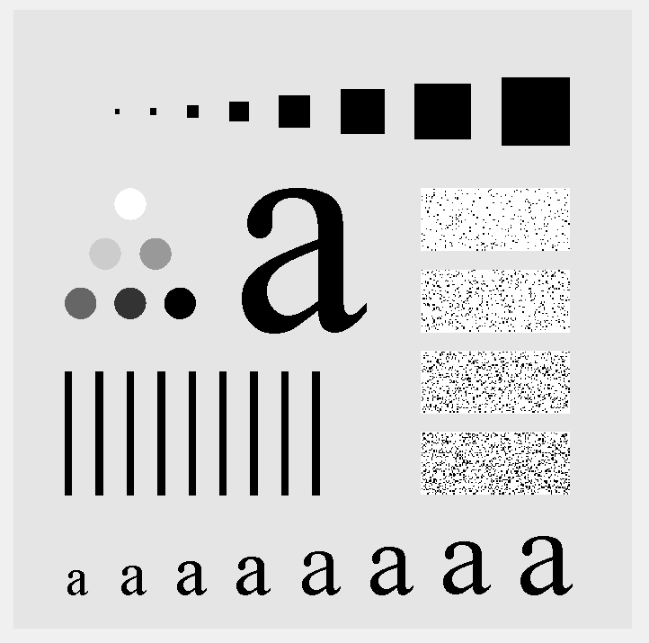

(b) Conduct these two filters on “Fig_characters_test_pattern.tif” with cutoff frequencies at radii

values of 5,15,30,80 and 230 respectively.

原图：

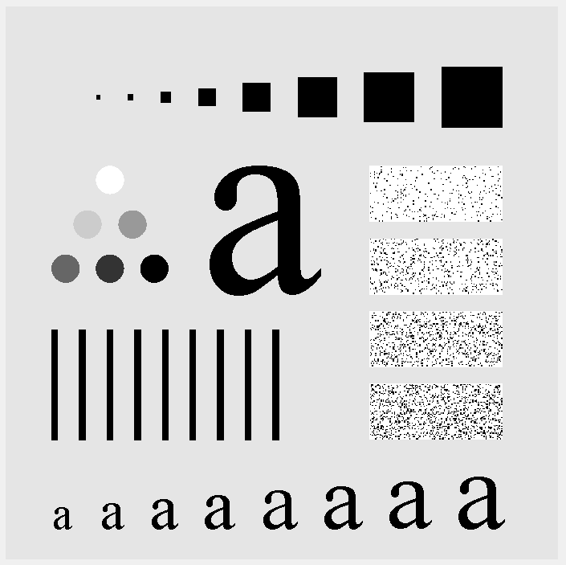

截至频率=5



截至频率=15



截至频率=30



截至频率=80

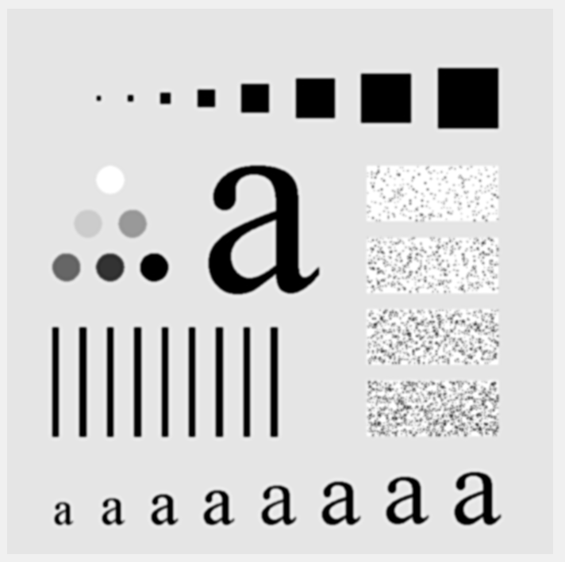

截至频率=230

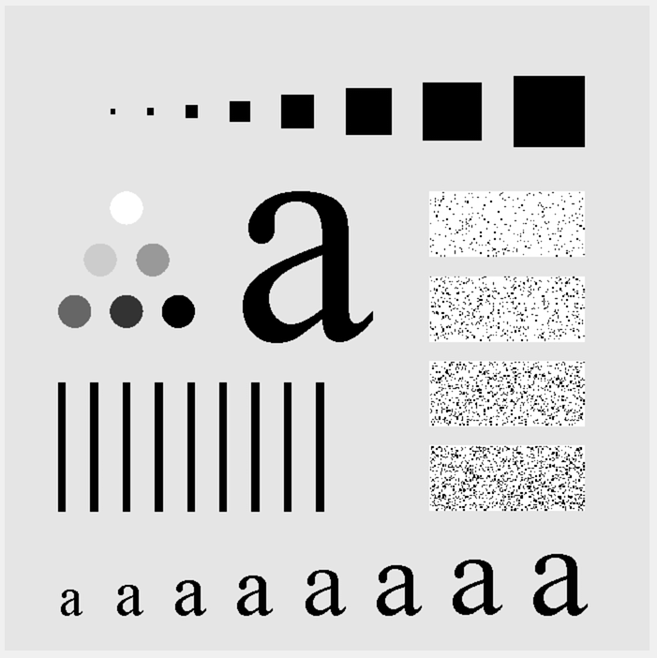

(c) Compare the results with the original image.

PROJECT 04-03

Implement the Ideal, Gaussian and Butterworth highpass filter (n=2 for Butterworth).

clc

close all;

clear all;

I1=imread('Fig_characters_test_pattern.tif');

figure,imshow(I1,[]);

f=double(I1);

g=fft2(f);

g=fftshift(g);

[N1,N2]=size(g);

n=2;

d0=5;

n1=fix(N1/2);

n2=fix(N2/2);

for i=1:N1

for j=1:N2

d=sqrt((i-n1)^2+(j-n2)^2);

if d==0

h=0;

else

h=1/(1+(d0/d)^(2*n));

end

result(i,j)=h*g(i,j);

end

end

result=ifftshift(result);

X2=ifft2(result);

X3=uint8(real(X2));

figure,imshow(X3)

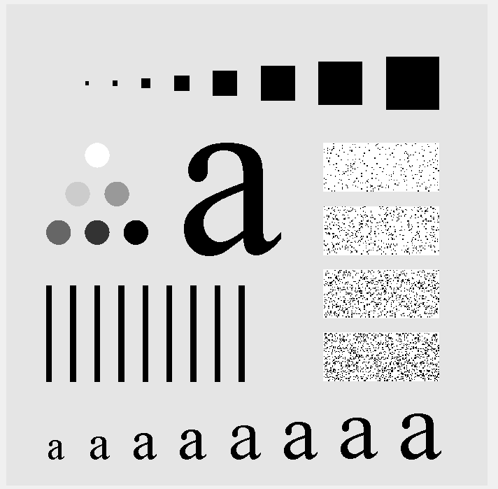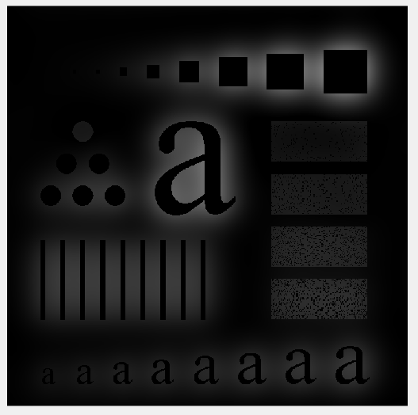

(b) Conduct these three filters on “Fig_characters_test_pattern.tif” with cutoff frequencies at

radii values of 15,30 and 80 respectively.

截止频率15

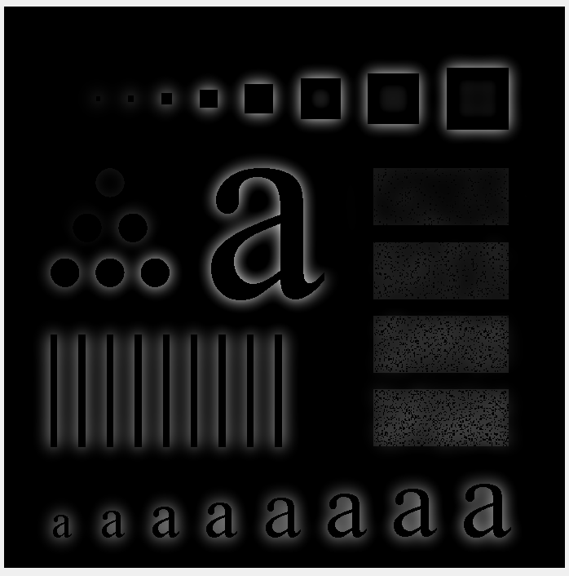

截止频率30

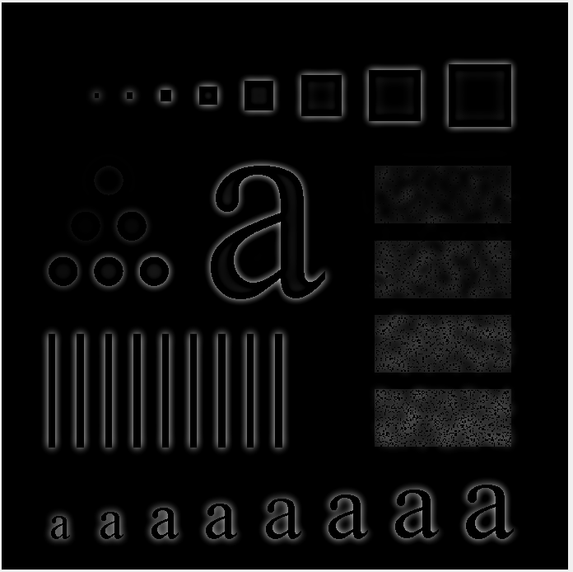

截止频率80

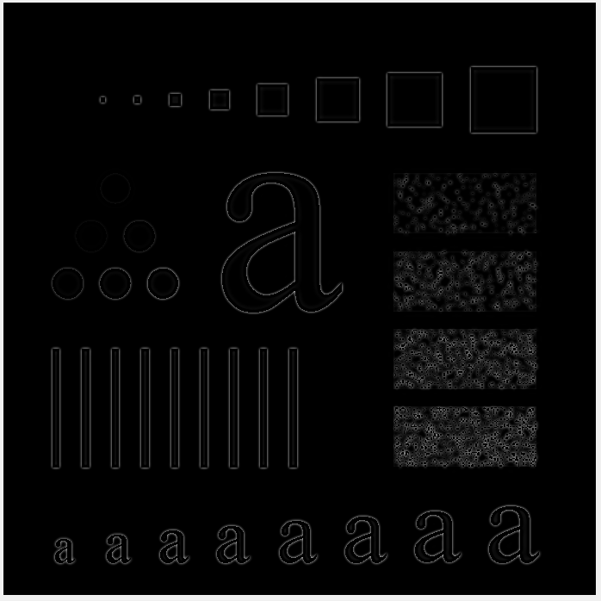

(c) Compare the results with the original image.

PROJECT 05-01

Noise Generators

This is a generic project, in the sense that the programs developed here are used in several of the

projects that follow. See Fig. 5.2 for the shapes and parameters of the following noise probability

density functions.

(a) Find (or develop) a program to add Gaussian noise to an image. You must be able to

specify the noise mean and variance.

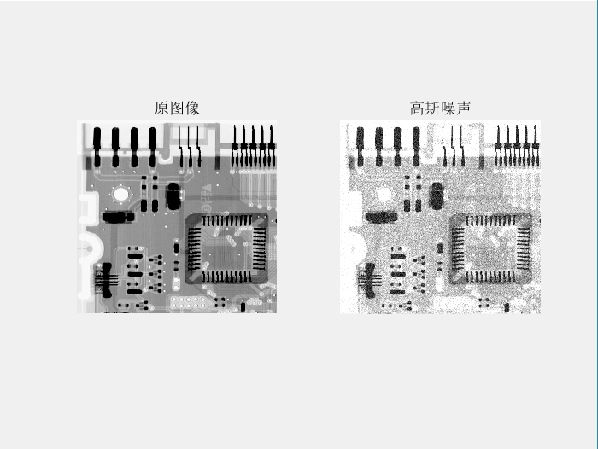

(b) Find (or develop) a program to add salt-and-pepper (impulse) noise to an image. You

must be able to specify the probabilities of each of the two noise components.

Note: Your program must be capable also of generating random numbers organized as a 1-D array

of specified size (including a single random number), as you will need it later in Chapter 12 to add

noise to elements of a vector.

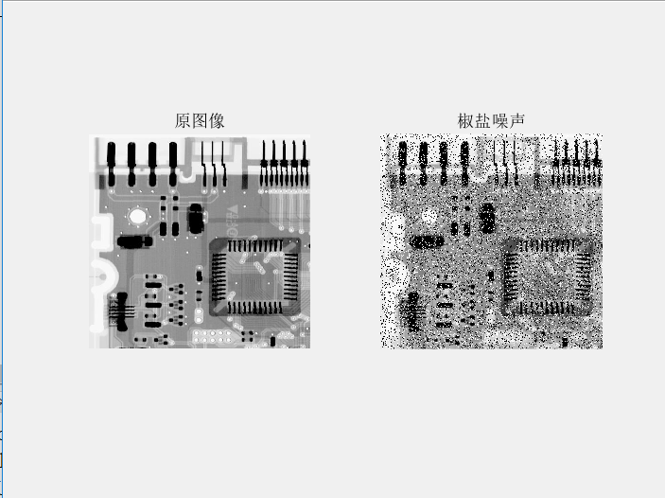

PROJECT 05-02

Noise Reduction Using a Median Filter

Implement program to perform 3 x 3 median filtering.

%%

medianFilter=medfilt2(I);

subplot(2,2,2);

imshow(medianFilter);

title('中值滤波器-对原图像');

Add salt-and-pepper noise to ‘ckt-board-orig.tif’, with Pa = Pb = 0.2.

noiseI=imnoise(I, 'salt & pepper',0.02);

subplot(2,2,3);

imshow(noiseI);

title('椒盐噪声');

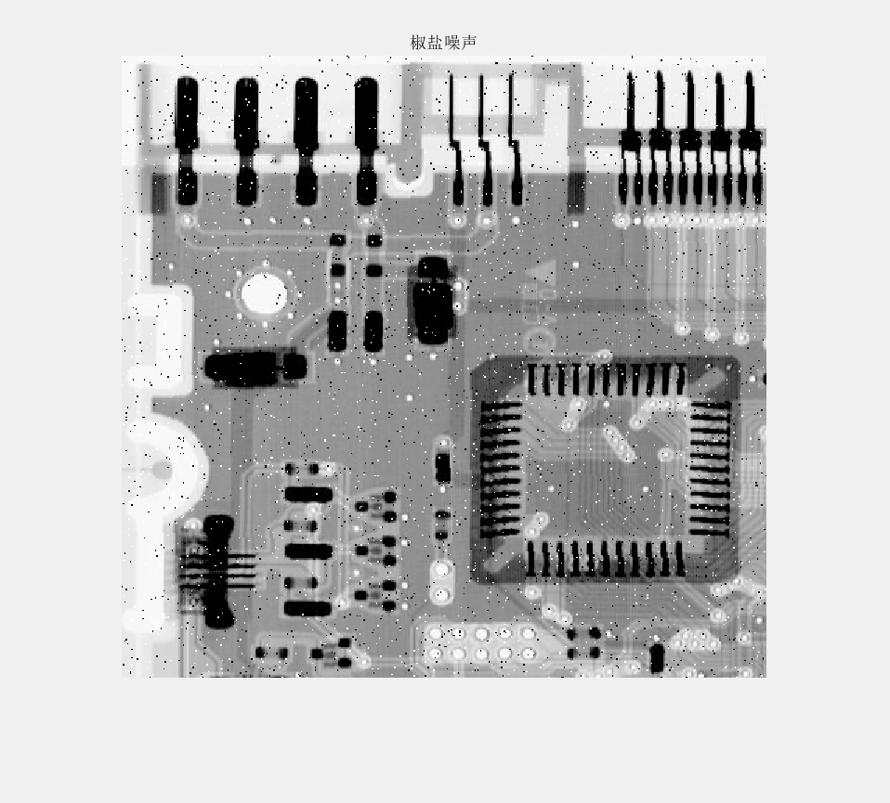

(c) Apply median filtering. Explain differences between your result and Fig. 5.10(b).

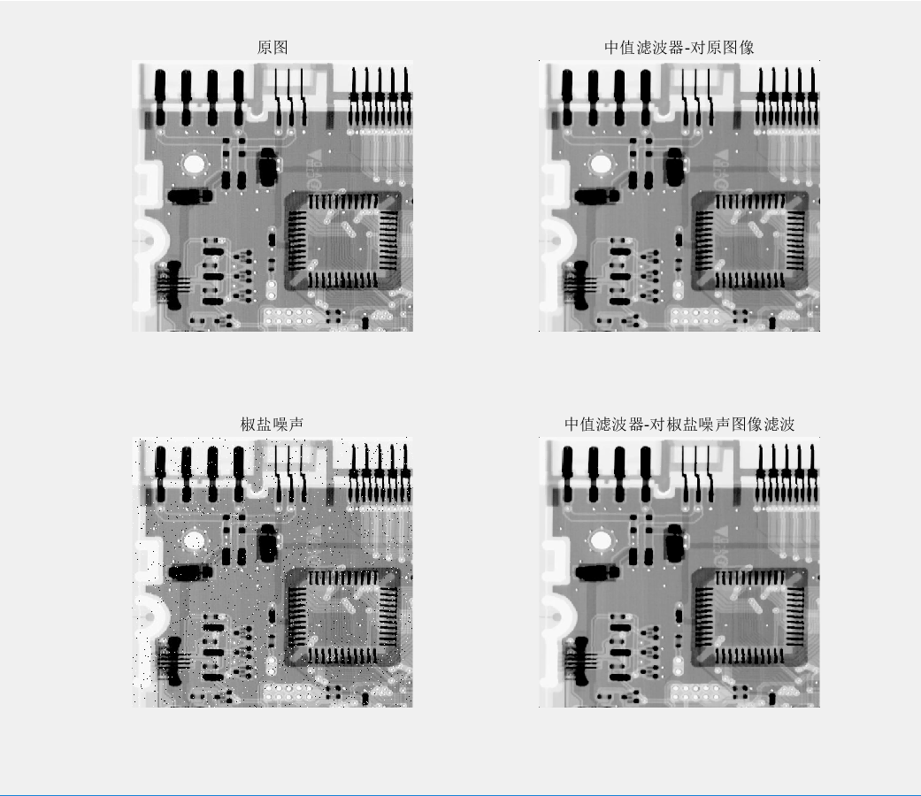

%%

clc

clear all

close all

%%

I=imread('ckt-board-orig.tif')

figure;

subplot(2,2,1);

imshow(I);

title('原图');

%%

noiseI=imnoise(I, 'salt & pepper',0.02);

subplot(2,2,3);

imshow(noiseI);

title('椒盐噪声');

%%

medianFilter=medfilt2(I);

subplot(2,2,2);

imshow(medianFilter);

title('中值滤波器-对原图像');

%%

medianFilter2=medfilt2(noiseI);

subplot(2,2,4);

imshow(medianFilter2);

title('中值滤波器-对椒盐噪声图像滤波')

【实验总结】

实现了对常用滤波器，比如高斯滤波器，巴特沃斯滤波器，理想滤波器，还了解了对噪声的添加，