学号 P21714001 专业 计算机英才班 姓名 刘峰

实验日期 **2019.12.25**  教师签字 成绩

实验报告

【实验名称】  数字图像处理实验六

【实验目的】

1. 掌握彩色图像与灰度图像之间的相互转化

2. 掌握彩色图像的基本组成，通过调整彩色图像的组成改变图像的外观

3. 理解彩色图像的成分对图像的影响

【实验内容】

PROJECT 06-01

Convert the RGB color image into gray image

(a) Read the color image” top_ left_flower.tif” in Matlab, you will obtain a 3-D array which

denote the Red, Green and Blue component respectively.

(b) Use the equation I=(R+G+B)/3 to calculate the intensity. This is actually a simple way

to convert the RGB color image into a gray image.

(c) Display the gray image.

%% 初始化

clc

clear all;

close all;

%%

Img=imread('top_ left_flower.tif');

%I=(Img(:,:,1)+Img(:,:,2)+Img(:,:,3))/3.0;

I2=rgb2gray(I);

imshow(I2);

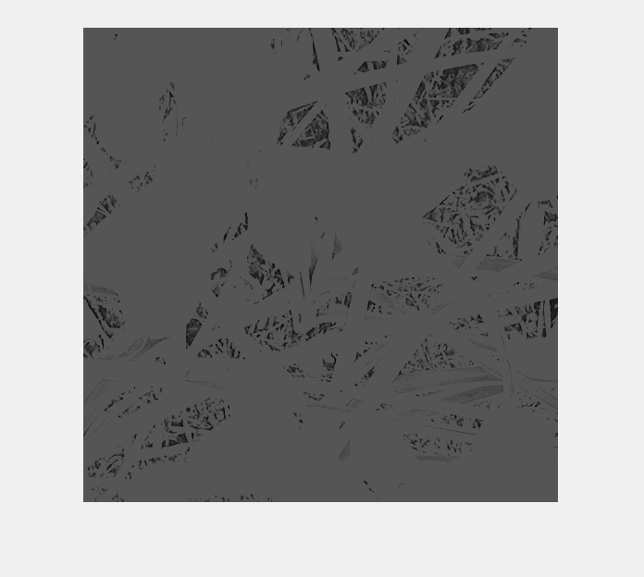

PROJECT 06-02

Intensity Slicing

(a) Implement intensity slicing, with the characteristic that you can specify different ranges

of gray-level values for the input image and your program will output an RGB image

whose pixels have a specified color. You can set the colors in color palette.

(b) Process the above images with your program with different ranges (8 for (1), 3 for (2),

6 for (3)).

%%

clc

clear all

close all;

%%

I=imread('picker_phantom.tif');

slice=[60 80 100 130 150 170 210 230];

Q=grayslice(I,slice);

figure;

mymap=[0 0 0;

0 0 1; %蓝色

0 1 0;

1 0 0;

0 1 1;

1 1 0;

1 0 1;

1 1 1;]

imshow(Q,colormap(mymap));

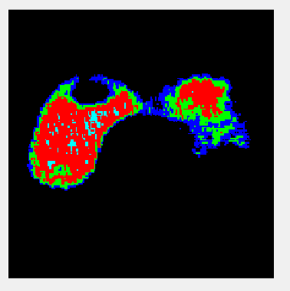

%%

clc

clear all

close all;

%%

I=imread('weld-original.tif');

slice=[100 150 200];

Q=grayslice(I,slice);

figure;

mymap=[0 0 0;

0 0 1; %蓝色

0 1 0;

1 0 0;

0 1 1;

1 1 0;

1 0 1;

1 1 1;]

imshow(Q,colormap(mymap));

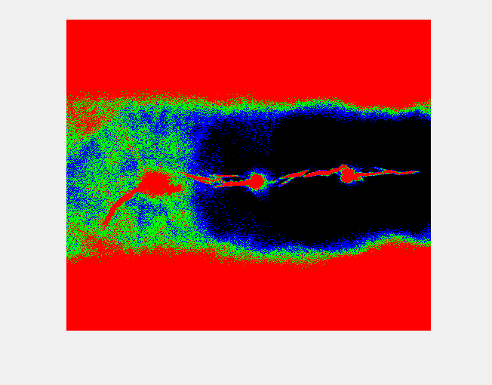

%%

clc

clear all

close all;

%%

I=imread('tropical_rain_grayscale.tif');

slice=[32 64 96 128 160 192];

Q=grayslice(I,slice);

figure;

mymap=[0 0 0;

0 0 1; %蓝色

0 1 0;

1 0 0;

0 1 1;

1 1 0;

1 0 1;

1 1 1;]

imshow(Q,colormap(mymap));

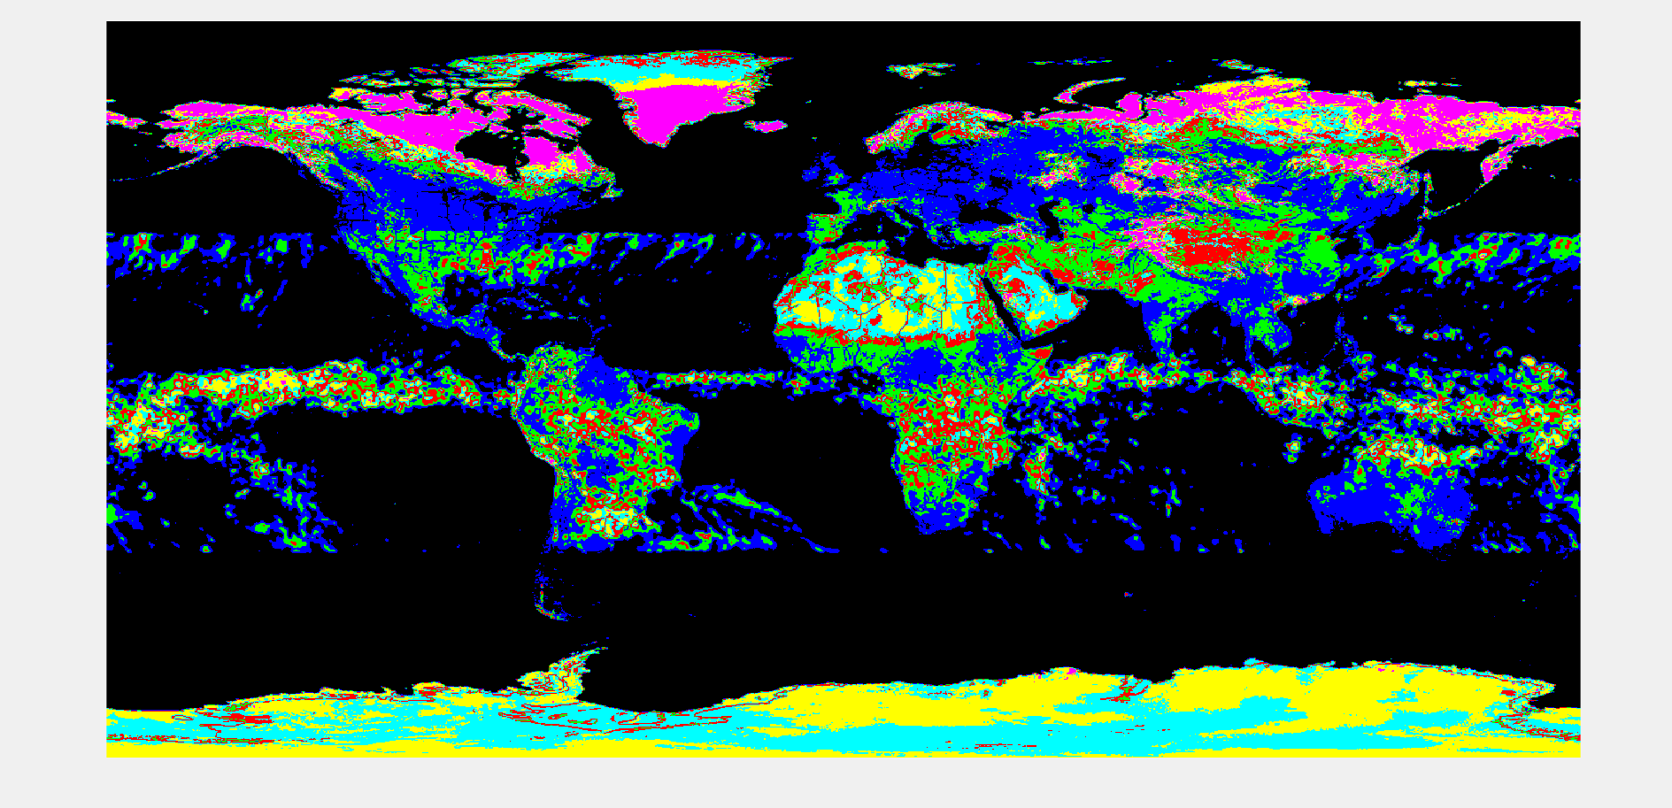

图像处理实验六 自己的脸部图像处理

FINAL PROJECT

1. Take an image of you, and resize to 1024x1024. Save it as yourID.tif。

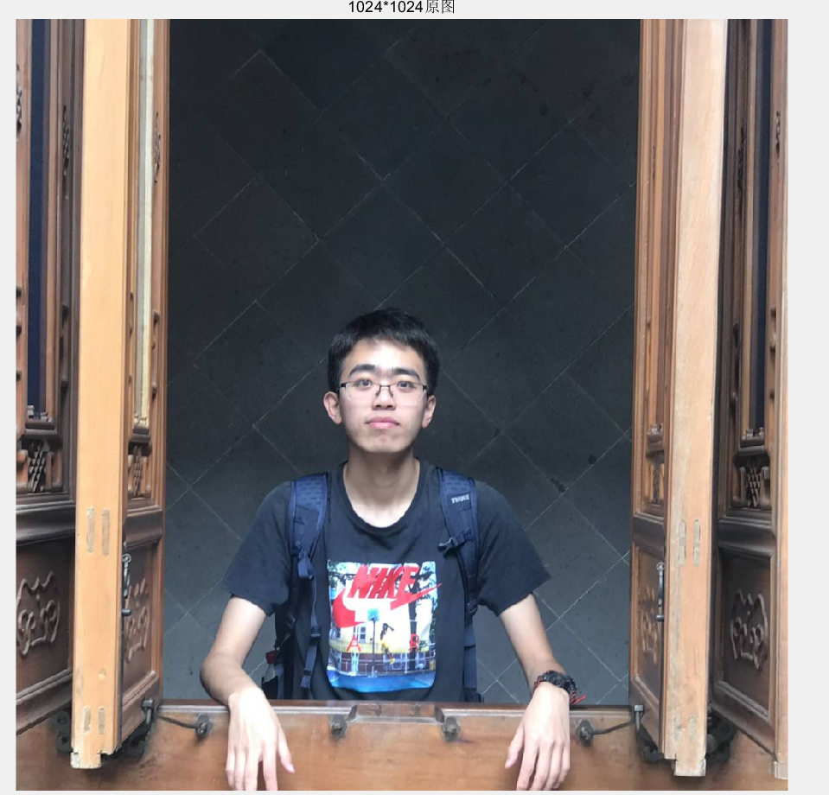



1. Convert the color image ‘yourID.tif’ into gray level Use the equation Use the equation I=0.3*R+0.59*G+ 0.11*B to calculate the intensity. Display it as the gray level image.

(20 marks).

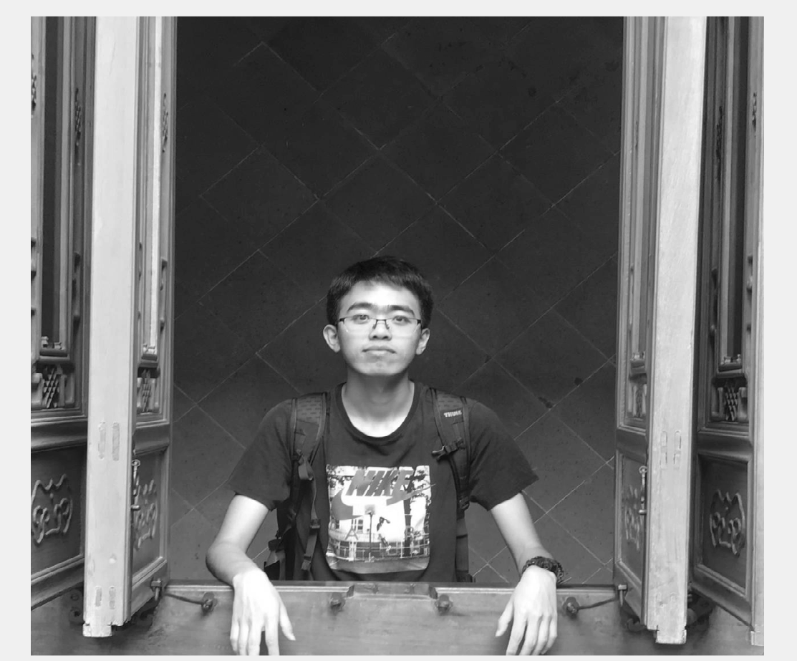



1. Write your own codes to add additional salt-and-pepper noise with probabilities Pa = Pb = 0.1 to the gray image and display the noised image. Obviously, you can use the library function imnoise to test your result .

(20 marks)

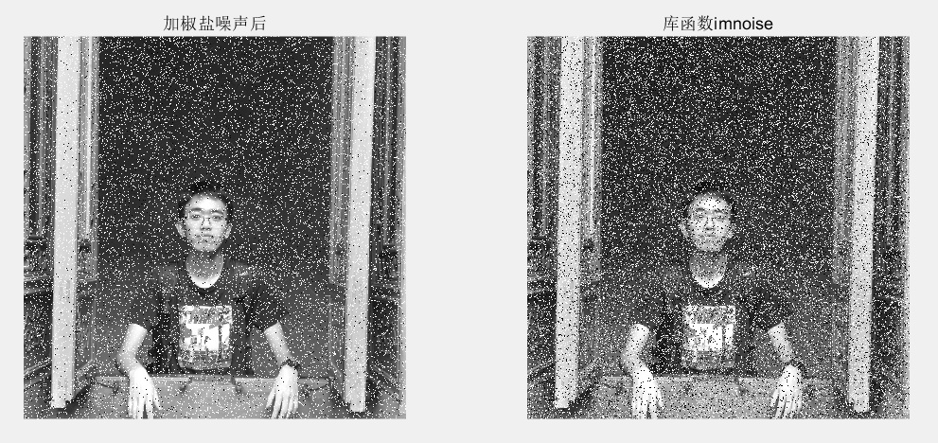

1. Write your own function(s) to implement the noise reduction using a 5*5: 1) arithmetic filter 2) geometric mean filter 3) Median Filter 4) alpha-trimmed mean filter with d = 5. Display the results.

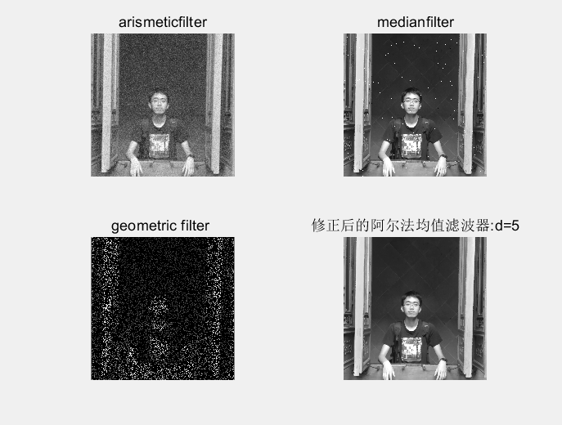

【实验总结】

本次实验了解了基本的RGD图像转灰度图像以及灰度图像利用伪彩色技术实现灰度图像转RGB图像和其中的强度切片方法，除此之外，作为本学期最后一次实验，老师鼓励我们用自己的照片进行数字图像处理其中包括改变照片尺寸、将照片转换成灰度图片、给照片添加噪声以及自己用滤波器将这些照片滤除。给实验作业增加了趣味性。

总而言之，本学期数字图像处理实验收获颇丰，认识了讲课很棒的老师以及乐观探讨的同学，自己也学了不少数字图像处理的基础知识，提供了一个自己以后感兴趣的科研方向，很有意义！