Project 1

Student name: 謝元碩

Student ID: 311512015

1. Source code

* Import cv2 to do image processing, and I always do a Gaussian blurring with kernel size 7 before doing Laplacian and Sobel gradient.
* For some processing, I use CV2_64F data structure and “convertScaleAbs” to make the result more accurate.
* Save every image in 200 dpi by using PIL library.
* Use cv2.calcHist to make the histograms.
* Import openpyxl to write data into an excel file.
* I separate python codes into two versions to do different image processing as below.

1. kid.py

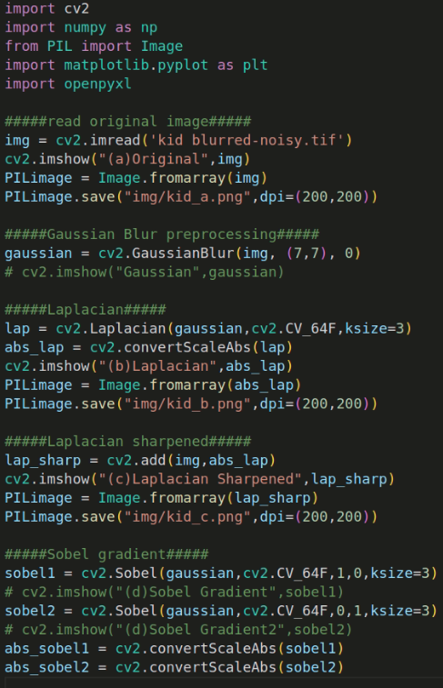

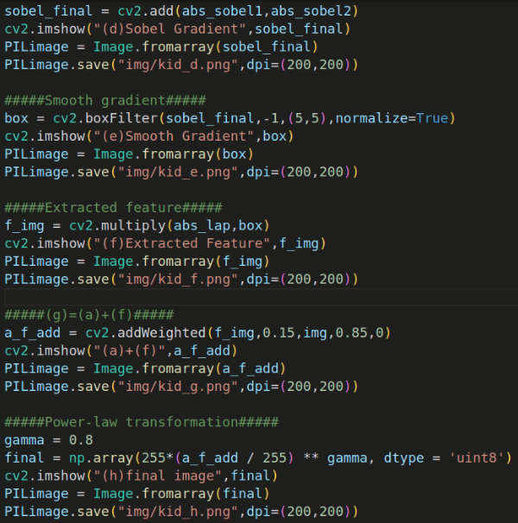

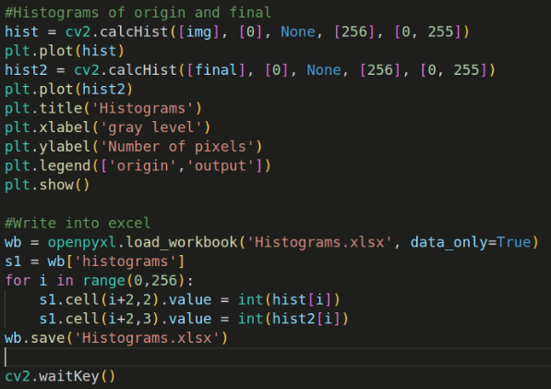

1. fruit.py

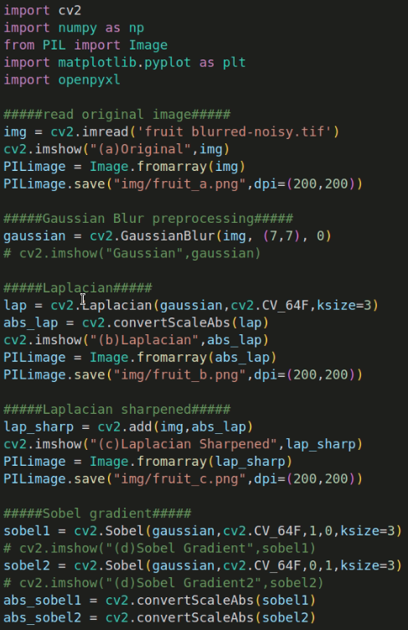

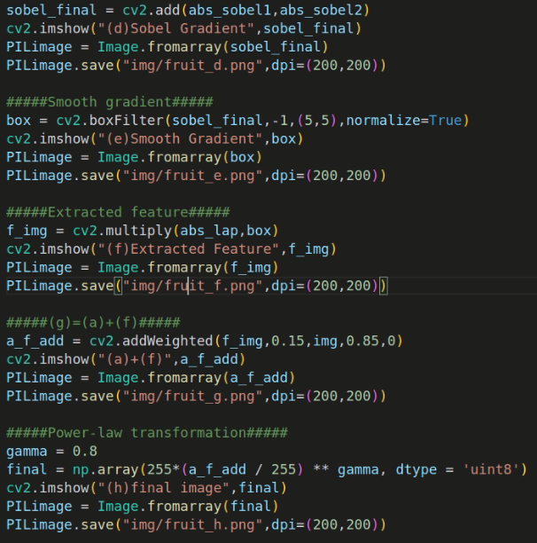

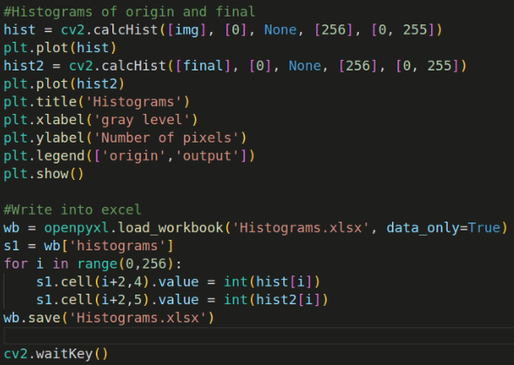

1. 16 images with 200 dpi
2. kid



1. original (b) laplacian (c) laplacian-sharpened

 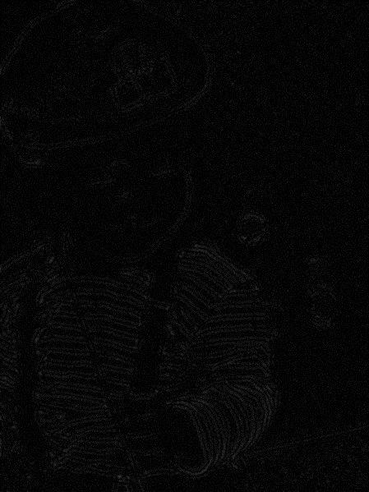 

(d) Sobel-gradient (e) smooth gradient (f) extracted feature

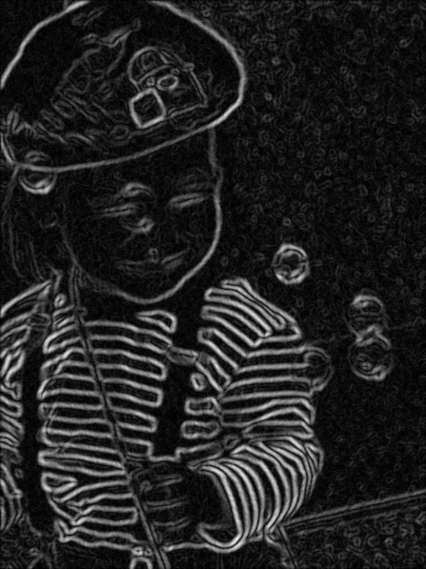 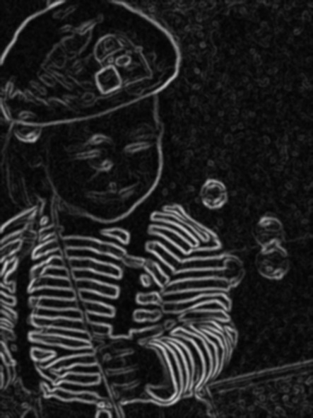 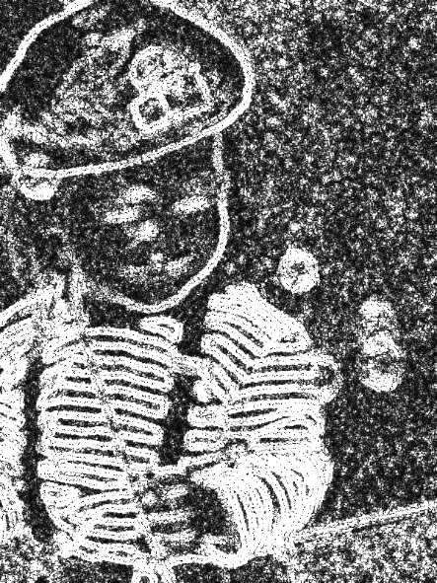

(g) image(a)+(f) (h) final image

 

1. fruit



1. original (b) laplacian (c) laplacian-sharpened

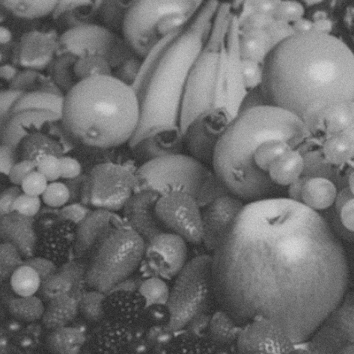  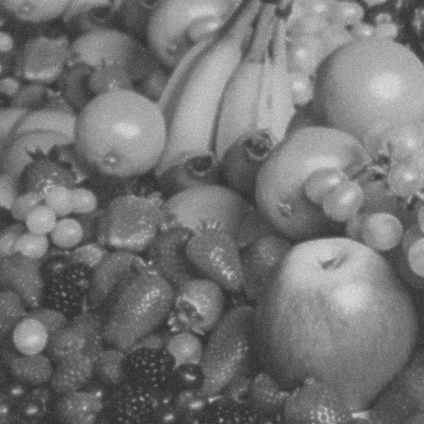

(d) Sobel-gradient (e) smooth gradient (f) extracted feature 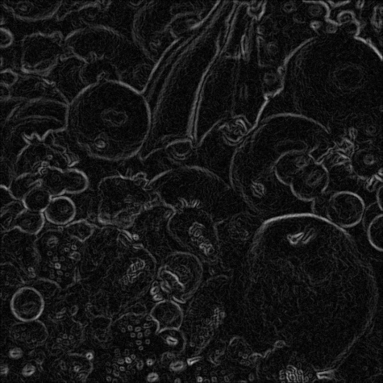 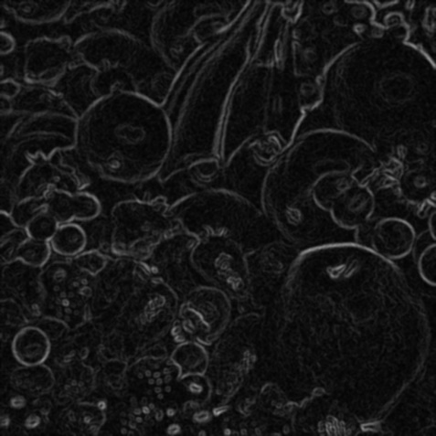 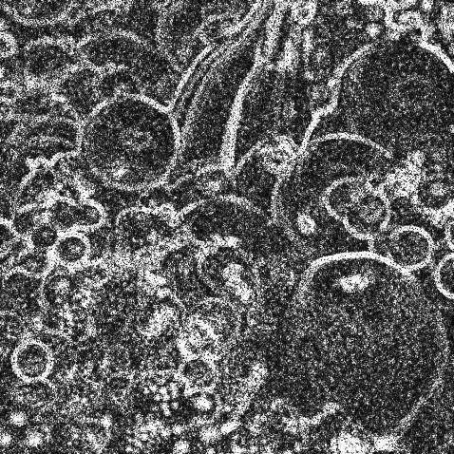

(g) image(a)+(f) (h) final image

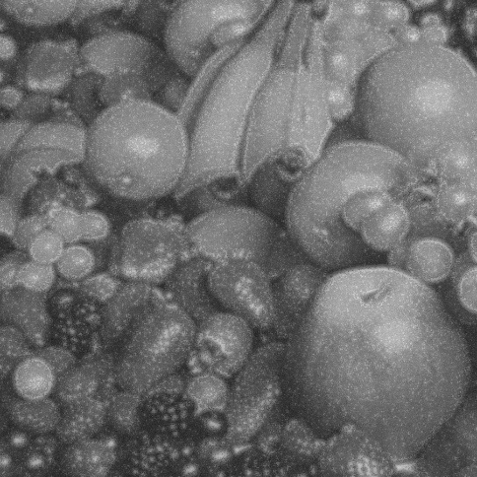 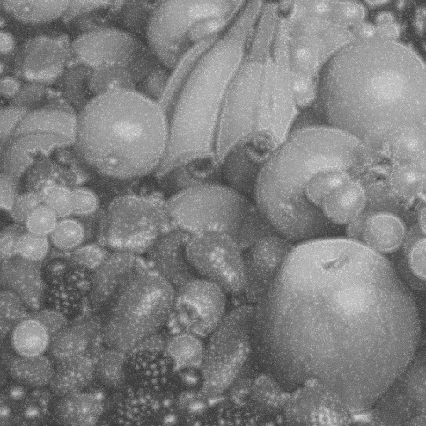

1. Figures of original and final histograms

* From the histograms shown below, we can differentiate properties between original and final images. The histogram of original image is very smooth (smooth gray level), and that of final image is very sharp (some gray levels are enhanced).

1. kid

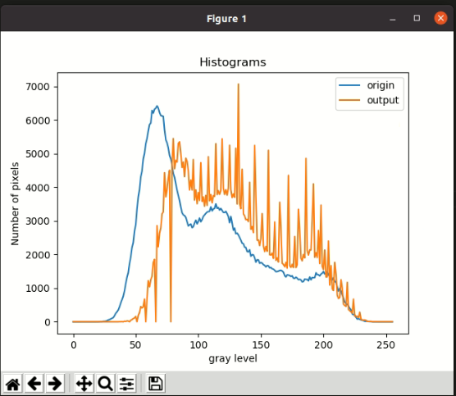

1. fruit

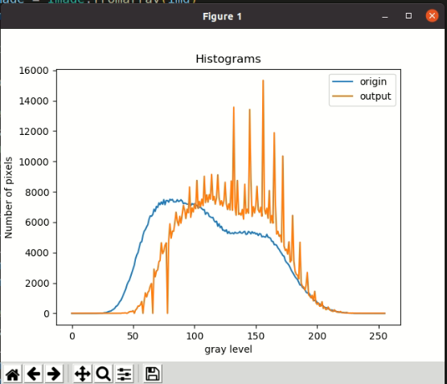

1. Excel tables of original and final histograms

|  |  |  |  |  |
| --- | --- | --- | --- | --- |
| *r* | p(r)  (kid original) | p(r)  (kid output) | p(r)  (fruit original) | p(r)  (fruit output) |
| 0 | 0 | 0 | 0 | 0 |
| 1 | 0 | 0 | 0 | 0 |
| 2 | 0 | 0 | 0 | 0 |
| 3 | 0 | 0 | 0 | 0 |
| 4 | 0 | 0 | 0 | 0 |
| 5 | 0 | 0 | 0 | 0 |
| 6 | 0 | 0 | 0 | 0 |
| 7 | 0 | 0 | 0 | 0 |
| 8 | 0 | 0 | 0 | 0 |
| 9 | 0 | 0 | 0 | 0 |
| 10 | 0 | 0 | 0 | 0 |
| 11 | 0 | 0 | 0 | 0 |
| 12 | 0 | 0 | 0 | 0 |
| 13 | 0 | 0 | 0 | 0 |
| 14 | 0 | 0 | 0 | 0 |
| 15 | 0 | 0 | 0 | 0 |
| 16 | 1 | 0 | 0 | 0 |
| 17 | 0 | 0 | 2 | 0 |
| 18 | 0 | 0 | 3 | 0 |
| 19 | 1 | 0 | 1 | 0 |
| 20 | 1 | 0 | 2 | 0 |
| 21 | 4 | 0 | 6 | 0 |
| 22 | 6 | 0 | 8 | 0 |
| 23 | 5 | 0 | 12 | 0 |
| 24 | 13 | 0 | 12 | 0 |
| 25 | 14 | 0 | 11 | 0 |
| 26 | 19 | 0 | 30 | 0 |
| 27 | 32 | 0 | 45 | 0 |
| 28 | 54 | 0 | 46 | 0 |
| 29 | 65 | 0 | 81 | 0 |
| 30 | 85 | 0 | 112 | 0 |
| 31 | 107 | 0 | 138 | 1 |
| 32 | 124 | 0 | 156 | 0 |
| 33 | 179 | 1 | 218 | 2 |
| 34 | 252 | 0 | 265 | 2 |
| 35 | 295 | 0 | 328 | 0 |
| 36 | 349 | 0 | 452 | 0 |
| 37 | 444 | 3 | 500 | 3 |
| 38 | 557 | 2 | 610 | 4 |
| 39 | 652 | 5 | 758 | 7 |
| 40 | 759 | 0 | 850 | 0 |
| 41 | 922 | 17 | 1021 | 23 |
| 42 | 1130 | 9 | 1208 | 18 |
| 43 | 1320 | 26 | 1387 | 30 |
| 44 | 1458 | 22 | 1594 | 28 |
| 45 | 1731 | 0 | 1879 | 0 |
| 46 | 1926 | 47 | 2061 | 52 |
| 47 | 2205 | 66 | 2186 | 100 |
| 48 | 2354 | 95 | 2437 | 118 |
| 49 | 2700 | 115 | 2703 | 120 |
| 50 | 2886 | 159 | 2923 | 171 |
| 51 | 3344 | 0 | 3180 | 0 |
| 52 | 3706 | 185 | 3600 | 213 |
| 53 | 3933 | 277 | 3843 | 307 |
| 54 | 4310 | 452 | 4002 | 477 |
| 55 | 4478 | 414 | 4326 | 475 |
| 56 | 4838 | 442 | 4664 | 560 |
| 57 | 5013 | 675 | 4711 | 779 |
| 58 | 5295 | 0 | 5134 | 0 |
| 59 | 5447 | 681 | 5399 | 783 |
| 60 | 5670 | 1223 | 5510 | 1348 |
| 61 | 5867 | 1040 | 5692 | 1078 |
| 62 | 5910 | 1253 | 5840 | 1372 |
| 63 | 6286 | 1350 | 6200 | 1486 |
| 64 | 6205 | 1759 | 6416 | 1800 |
| 65 | 6322 | 1855 | 6391 | 1959 |
| 66 | 6351 | 0 | 6501 | 0 |
| 67 | 6422 | 2861 | 6850 | 2908 |
| 68 | 6359 | 2231 | 6705 | 2401 |
| 69 | 6225 | 2631 | 7037 | 2780 |
| 70 | 6133 | 2795 | 6965 | 2861 |
| 71 | 6123 | 3208 | 7267 | 3391 |
| 72 | 6112 | 3264 | 7151 | 3483 |
| 73 | 5709 | 4432 | 7330 | 4638 |
| 74 | 5411 | 3714 | 7170 | 3923 |
| 75 | 5325 | 3921 | 7484 | 4088 |
| 76 | 5176 | 4276 | 7147 | 4468 |
| 77 | 4948 | 4505 | 7424 | 4633 |
| 78 | 4844 | 0 | 7423 | 0 |
| 79 | 4663 | 4701 | 7313 | 4795 |
| 80 | 4414 | 5450 | 7503 | 5889 |
| 81 | 4296 | 4553 | 7450 | 4948 |
| 82 | 4102 | 4802 | 7496 | 5412 |
| 83 | 3914 | 4750 | 7336 | 5401 |
| 84 | 3761 | 5304 | 7337 | 5946 |
| 85 | 3608 | 5351 | 7338 | 6654 |
| 86 | 3411 | 4999 | 7474 | 6063 |
| 87 | 3242 | 4589 | 7359 | 5780 |
| 88 | 3182 | 4751 | 7391 | 6385 |
| 89 | 3159 | 4316 | 7473 | 5931 |
| 90 | 3104 | 4867 | 7386 | 6520 |
| 91 | 2980 | 4775 | 7205 | 7105 |
| 92 | 2851 | 4492 | 7261 | 6797 |
| 93 | 2885 | 3922 | 7224 | 6237 |
| 94 | 2906 | 4216 | 7184 | 6851 |
| 95 | 2798 | 3919 | 7176 | 6615 |
| 96 | 2828 | 4826 | 7306 | 8317 |
| 97 | 2935 | 3619 | 7084 | 6318 |
| 98 | 3022 | 3924 | 7219 | 6938 |
| 99 | 2912 | 3511 | 7160 | 6668 |
| 100 | 2982 | 3844 | 7218 | 7180 |
| 101 | 3086 | 3609 | 7079 | 6888 |
| 102 | 2976 | 4732 | 7121 | 8743 |
| 103 | 3041 | 3579 | 6930 | 6903 |
| 104 | 3134 | 3712 | 6992 | 7366 |
| 105 | 3178 | 3438 | 6971 | 7011 |
| 106 | 3224 | 3761 | 6885 | 7516 |
| 107 | 3262 | 3461 | 6812 | 7094 |
| 108 | 3278 | 4909 | 6823 | 9019 |
| 109 | 3285 | 3598 | 6511 | 7283 |
| 110 | 3415 | 3784 | 6627 | 7793 |
| 111 | 3299 | 3536 | 6599 | 7317 |
| 112 | 3355 | 3755 | 6387 | 7809 |
| 113 | 3371 | 3728 | 6347 | 7509 |
| 114 | 3506 | 5297 | 6298 | 9134 |
| 115 | 3375 | 3785 | 6311 | 7448 |
| 116 | 3398 | 3902 | 6097 | 7696 |
| 117 | 3323 | 3789 | 6004 | 7179 |
| 118 | 3369 | 3904 | 6065 | 7602 |
| 119 | 3310 | 5443 | 5732 | 9110 |
| 120 | 3252 | 3977 | 5895 | 7625 |
| 121 | 3248 | 3786 | 5639 | 7135 |
| 122 | 3284 | 3929 | 5725 | 7408 |
| 123 | 3214 | 3768 | 5473 | 7057 |
| 124 | 3126 | 3978 | 5468 | 7440 |
| 125 | 2945 | 5250 | 5396 | 8626 |
| 126 | 3134 | 3929 | 5495 | 7207 |
| 127 | 2940 | 3696 | 5258 | 6830 |
| 128 | 2726 | 3805 | 5387 | 7208 |
| 129 | 2786 | 3700 | 5252 | 6805 |
| 130 | 2617 | 5163 | 5260 | 8712 |
| 131 | 2636 | 3505 | 5294 | 6783 |
| 132 | 2583 | 7070 | 5232 | 13563 |
| 133 | 2509 | 3517 | 5339 | 7019 |
| 134 | 2430 | 3364 | 5281 | 6459 |
| 135 | 2336 | 4536 | 5274 | 8739 |
| 136 | 2321 | 3210 | 5300 | 6503 |
| 137 | 2219 | 3152 | 5384 | 6588 |
| 138 | 2211 | 3035 | 5282 | 6457 |
| 139 | 2092 | 3048 | 5275 | 6831 |
| 140 | 2081 | 2981 | 5358 | 6197 |
| 141 | 2143 | 4148 | 5394 | 8493 |
| 142 | 1951 | 2754 | 5189 | 6569 |
| 143 | 1996 | 2833 | 5216 | 6853 |
| 144 | 1989 | 2651 | 5389 | 6589 |
| 145 | 1905 | 5245 | 5332 | 13414 |
| 146 | 1773 | 3763 | 5227 | 8902 |
| 147 | 1843 | 2428 | 5371 | 6378 |
| 148 | 1840 | 2432 | 5270 | 7021 |
| 149 | 1739 | 2267 | 5319 | 6603 |
| 150 | 1764 | 2463 | 5212 | 7105 |
| 151 | 1745 | 3217 | 5260 | 8361 |
| 152 | 1698 | 2254 | 5124 | 6801 |
| 153 | 1679 | 2090 | 5245 | 6639 |
| 154 | 1632 | 2244 | 5217 | 6982 |
| 155 | 1671 | 2097 | 5033 | 6393 |
| 156 | 1664 | 5100 | 5068 | 15329 |
| 157 | 1604 | 1994 | 5032 | 6870 |
| 158 | 1617 | 1987 | 5014 | 6533 |
| 159 | 1576 | 2043 | 5196 | 6919 |
| 160 | 1565 | 1887 | 5005 | 6255 |
| 161 | 1531 | 2970 | 4991 | 8079 |
| 162 | 1490 | 1827 | 4931 | 5950 |
| 163 | 1496 | 1899 | 4743 | 6434 |
| 164 | 1506 | 1781 | 4729 | 5934 |
| 165 | 1525 | 3556 | 4514 | 11884 |
| 166 | 1530 | 2831 | 4524 | 7125 |
| 167 | 1511 | 1740 | 4475 | 5211 |
| 168 | 1475 | 1707 | 4307 | 5397 |
| 169 | 1372 | 1638 | 4205 | 5075 |
| 170 | 1333 | 1770 | 4065 | 5152 |
| 171 | 1397 | 1596 | 3947 | 4687 |
| 172 | 1388 | 4355 | 3808 | 10351 |
| 173 | 1376 | 1668 | 3757 | 4429 |
| 174 | 1347 | 1618 | 3479 | 4138 |
| 175 | 1369 | 1711 | 3352 | 4214 |
| 176 | 1298 | 1616 | 3280 | 3891 |
| 177 | 1291 | 2539 | 3161 | 4707 |
| 178 | 1329 | 1614 | 3004 | 3373 |
| 179 | 1297 | 1694 | 2826 | 3488 |
| 180 | 1252 | 3347 | 2694 | 6440 |
| 181 | 1264 | 2695 | 2551 | 3434 |
| 182 | 1243 | 1887 | 2407 | 2764 |
| 183 | 1188 | 1813 | 2307 | 2561 |
| 184 | 1199 | 2000 | 2221 | 2510 |
| 185 | 1271 | 1901 | 2046 | 2262 |
| 186 | 1258 | 4862 | 1862 | 4679 |
| 187 | 1261 | 2125 | 1865 | 2004 |
| 188 | 1218 | 1985 | 1712 | 1789 |
| 189 | 1334 | 2138 | 1642 | 1724 |
| 190 | 1247 | 2136 | 1562 | 1524 |
| 191 | 1319 | 3046 | 1399 | 1860 |
| 192 | 1310 | 4103 | 1332 | 2692 |
| 193 | 1315 | 1921 | 1364 | 1231 |
| 194 | 1459 | 2056 | 1238 | 1125 |
| 195 | 1401 | 1912 | 1048 | 1018 |
| 196 | 1399 | 2716 | 1013 | 1193 |
| 197 | 1366 | 1732 | 885 | 815 |
| 198 | 1418 | 3473 | 831 | 1446 |
| 199 | 1445 | 1646 | 831 | 708 |
| 200 | 1497 | 1552 | 718 | 587 |
| 201 | 1420 | 2133 | 658 | 691 |
| 202 | 1441 | 1332 | 621 | 470 |
| 203 | 1494 | 1338 | 541 | 477 |
| 204 | 1382 | 2404 | 518 | 765 |
| 205 | 1465 | 1091 | 481 | 327 |
| 206 | 1268 | 1669 | 383 | 415 |
| 207 | 1234 | 978 | 383 | 247 |
| 208 | 1313 | 928 | 360 | 264 |
| 209 | 1201 | 1768 | 296 | 416 |
| 210 | 1173 | 1412 | 266 | 251 |
| 211 | 1038 | 791 | 214 | 180 |
| 212 | 908 | 694 | 222 | 157 |
| 213 | 996 | 723 | 193 | 123 |
| 214 | 912 | 1249 | 149 | 227 |
| 215 | 791 | 1000 | 156 | 138 |
| 216 | 713 | 523 | 101 | 89 |
| 217 | 583 | 485 | 108 | 80 |
| 218 | 551 | 458 | 76 | 67 |
| 219 | 515 | 1174 | 73 | 123 |
| 220 | 469 | 365 | 57 | 46 |
| 221 | 403 | 330 | 61 | 44 |
| 222 | 351 | 294 | 42 | 41 |
| 223 | 232 | 264 | 33 | 32 |
| 224 | 209 | 676 | 23 | 60 |
| 225 | 205 | 166 | 22 | 27 |
| 226 | 131 | 164 | 14 | 17 |
| 227 | 80 | 161 | 21 | 10 |
| 228 | 92 | 125 | 7 | 18 |
| 229 | 75 | 287 | 8 | 22 |
| 230 | 55 | 75 | 5 | 5 |
| 231 | 45 | 56 | 2 | 5 |
| 232 | 36 | 52 | 2 | 4 |
| 233 | 14 | 55 | 1 | 4 |
| 234 | 13 | 43 | 4 | 6 |
| 235 | 17 | 11 | 1 | 5 |
| 236 | 7 | 11 | 1 | 0 |
| 237 | 5 | 9 | 0 | 0 |
| 238 | 2 | 13 | 0 | 1 |
| 239 | 0 | 1 | 0 | 0 |
| 240 | 0 | 2 | 0 | 0 |
| 241 | 0 | 2 | 0 | 0 |
| 242 | 0 | 2 | 0 | 0 |
| 243 | 0 | 0 | 0 | 0 |
| 244 | 0 | 0 | 0 | 0 |
| 245 | 0 | 0 | 0 | 0 |
| 246 | 0 | 0 | 0 | 0 |
| 247 | 0 | 0 | 0 | 0 |
| 248 | 0 | 0 | 0 | 0 |
| 249 | 0 | 0 | 0 | 0 |
| 250 | 0 | 0 | 0 | 0 |
| 251 | 0 | 0 | 0 | 0 |
| 252 | 0 | 0 | 0 | 0 |
| 253 | 0 | 0 | 0 | 0 |
| 254 | 0 | 0 | 0 | 0 |
| 255 | 0 | 0 | 0 | 0 |