Project 2

ID：311512015 name：謝元碩

(a)code

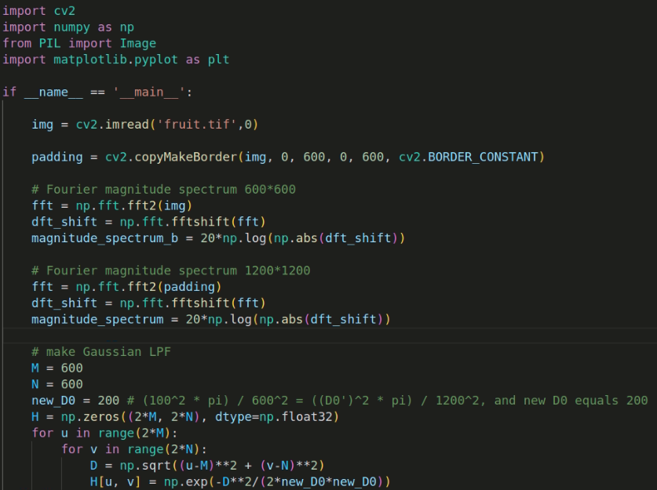

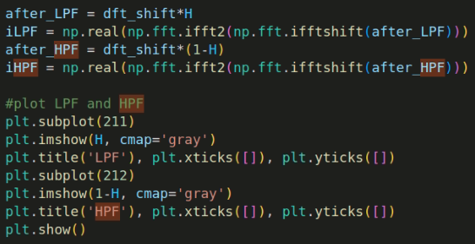

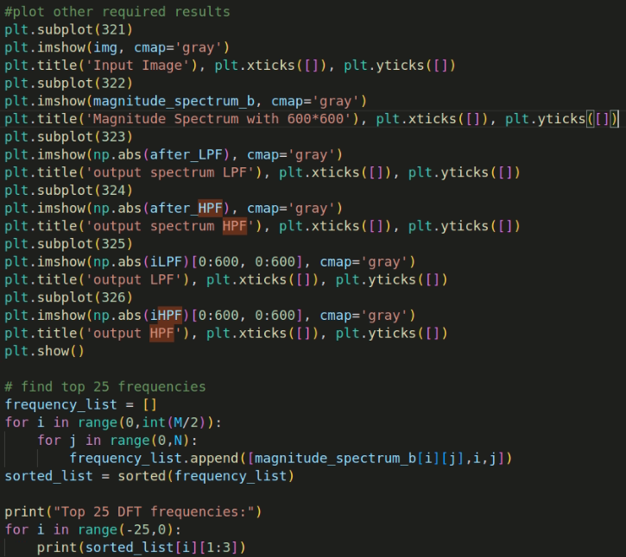

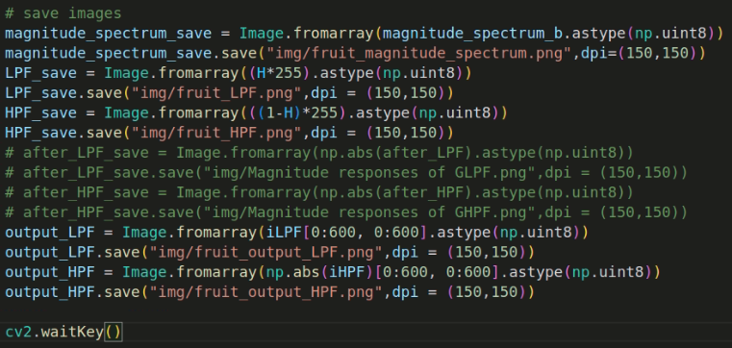

(b) Fourier magnitude spectra (in Log scale) of kid and fruit

|  |  |
| --- | --- |
| kid | fruit |

c) Magnitude responses of Gaussian LPF and HPF

|  |  |
| --- | --- |
| LPF | HPF |

(d) 4 output images

Kid LPF, HPF

|  |  |
| --- | --- |
|  |  |

Fruit LPF, HPF

|  |  |
| --- | --- |
|  |  |

(e) start from left top

※由上至下，頻率由低到高

Kid Fruit

[296, 298]

[298, 305]

[299, 297]

[297, 296]

[294, 301]

[296, 296]

[299, 296]

[297, 302]

[299, 298]

[296, 294]

[297, 301]

[296, 301]

[298, 301]

[298, 299]

[296, 300]

[299, 306]

[297, 298]

[298, 303]

[295, 299]

[299, 299]

[297, 303]

[296, 299]

[299, 303]

[298, 300]

[299, 300]

[297, 296]

[298, 292]

[283, 300]

[284, 303]

[296, 298]

[296, 296]

[283, 302]

[299, 304]

[299, 294]

[297, 300]

[284, 302]

[296, 302]

[299, 298]

[298, 304]

[298, 301]

[298, 294]

[298, 298]

[298, 302]

[299, 297]

[297, 299]

[298, 300]

[298, 299]

[299, 299]

[299, 300]

[299, 301]