Project 2

ID：311512015 name：謝元碩

1. Source codes:

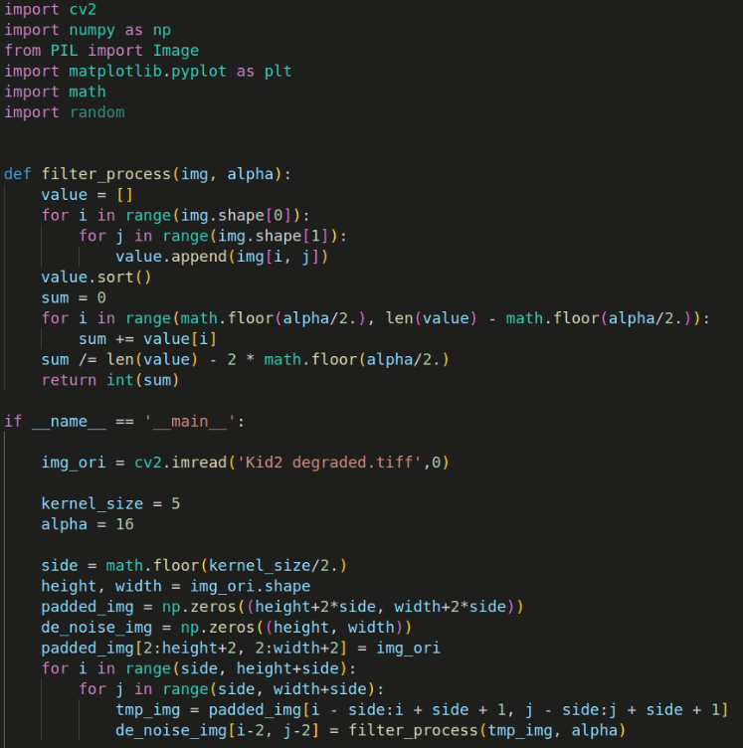

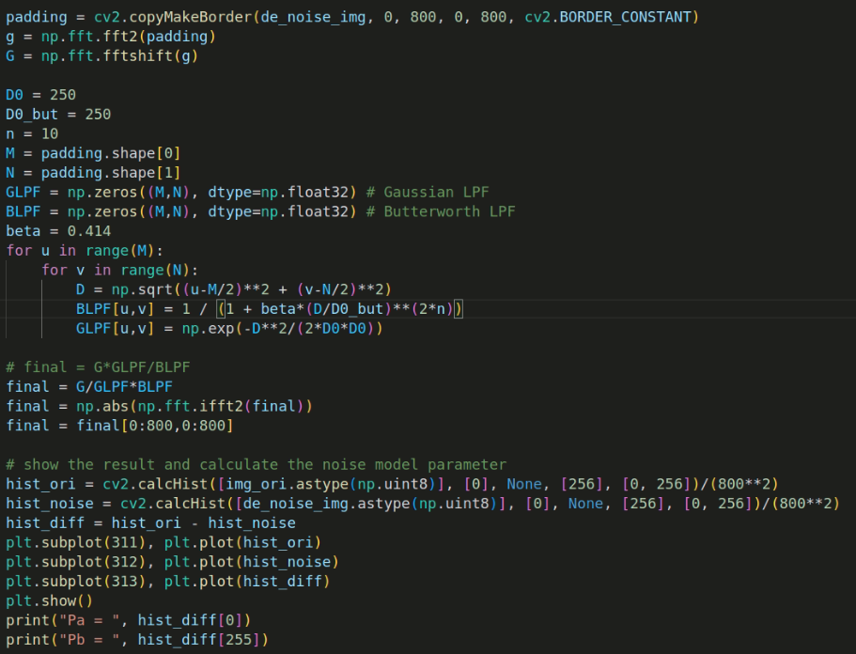

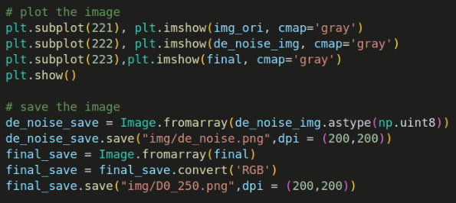

(b) Results of noise model and model parameters:

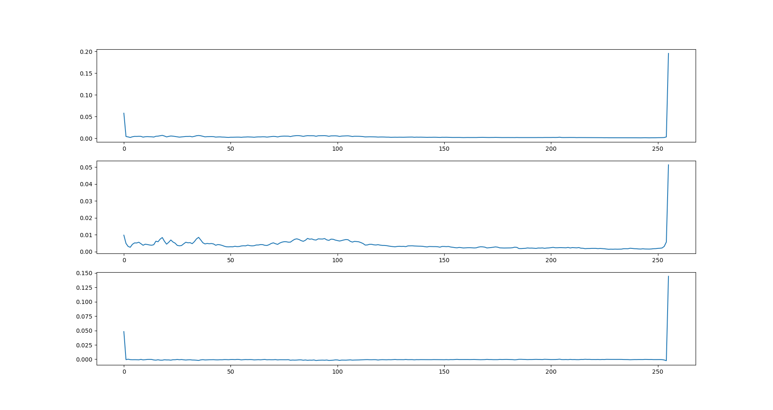

Subtraction of original image and de-noise image

De-noise

Original

* Compare the original and de-noise histograms, and calculate the probability difference between them to find Pa, Pb. The results show that there are more different in the salt part.



(c) De-noised image by alpha-trimmed mean filter:

|  |
| --- |
|  |

(d) Output image、parameters:

|  |  |
| --- | --- |
| D0 = 100 (因處理後為白色，故圖片不明顯) | D0 = 150 |
| D0 = 200 | D0 = 250 |

* The purpose of the Butterworth LPF is to confine the region of applying inverse filtering scheme. That is, to let the Gaussian LPF deblurring more visible and observable, we need to modify the D0 and power n of Butterworth LPF. The smaller the D0 is, the fewer frequencies are kept to do the deblurring, and that means the image will become blurrier before blurring, so I set D0 to be 250. Next, change of n will influence the quality of images. When n is much smaller, some white noises generate unexpectedly, so I set it to be 10.
* D0 of Gaussian LPF will affect sharpness as well as blurring directly. The picture above showed that when D0 becomes larger, the image becomes a little blurrier. A special situation is that D0=100 makes the image not visible. It’s all white. I think this is because the frequency of too few ranges appears in the range limited by Butterworth LPF, resulting in the loss of the deblur function, which will make the picture change.