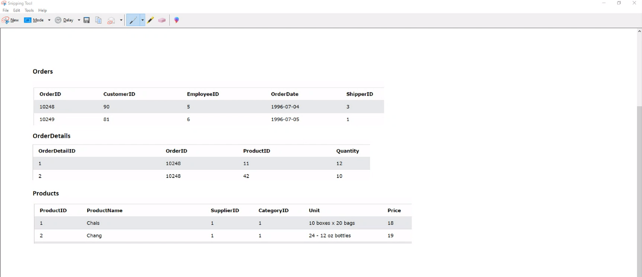

Order Id, Customer ID, Product Name, Product ID and Quantity - quantity is greater than 10, EmployeeID is 5 and sort by quantity in descending order

Select from orders o, orderdetails od, products p

where o.orderid = od.orderid and od.productid = p.productid