IERG1000 LAB REPORT 2

NAME : YU MU QUAN, SID : 1155191596, Email：ym022@ie.cuhk.edu.hk

### Task 3.1

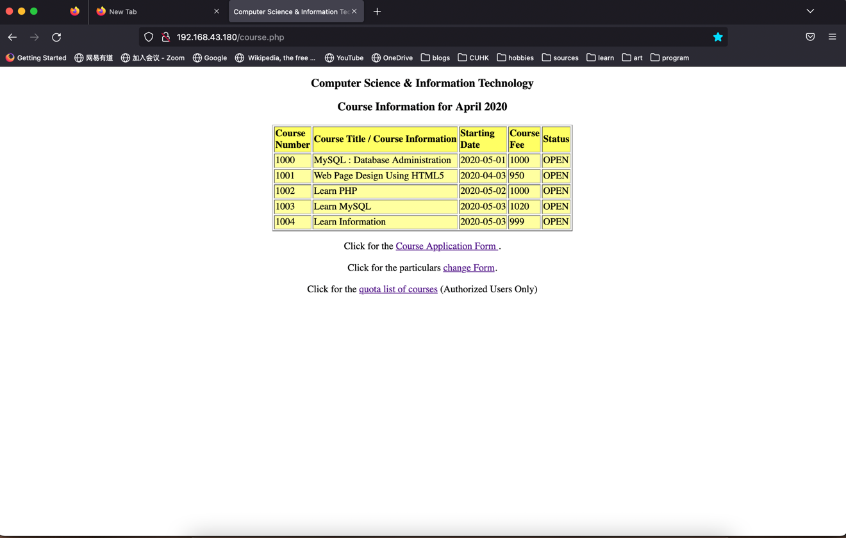

### Task 3.2

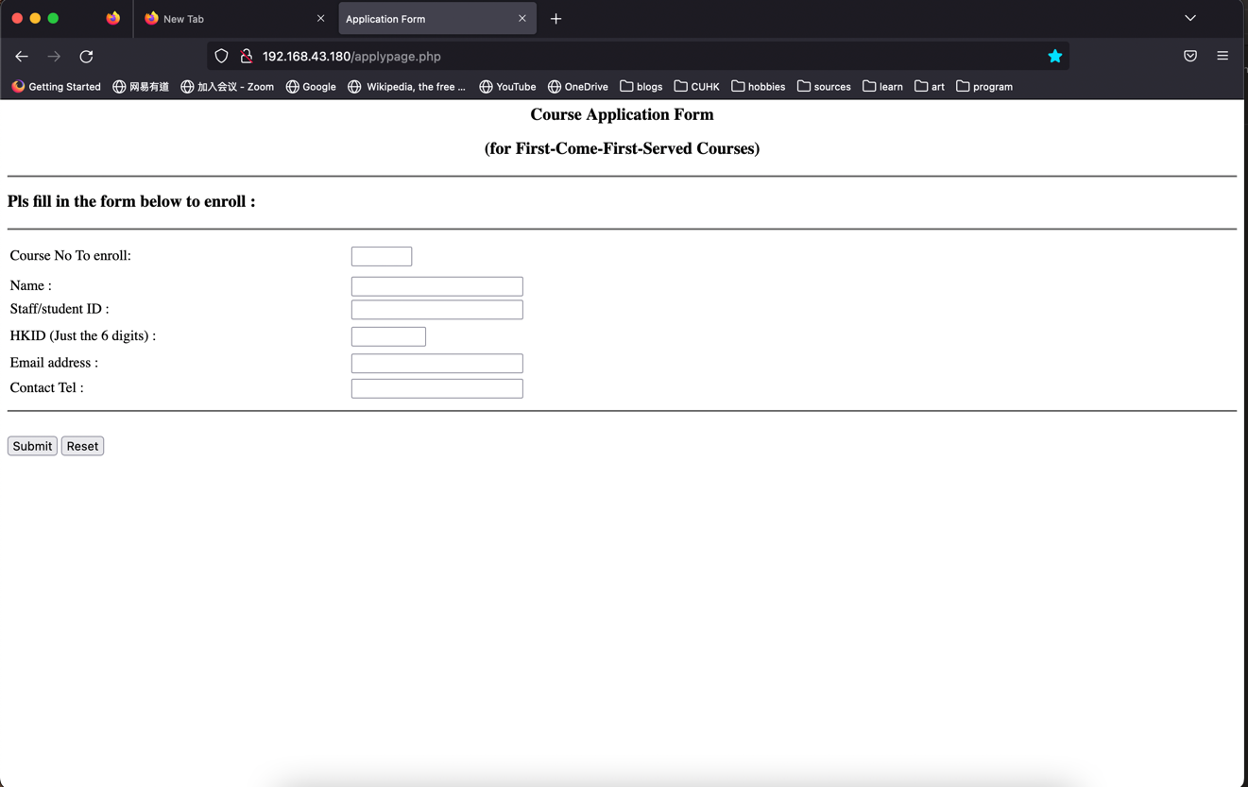

### Task 3.3

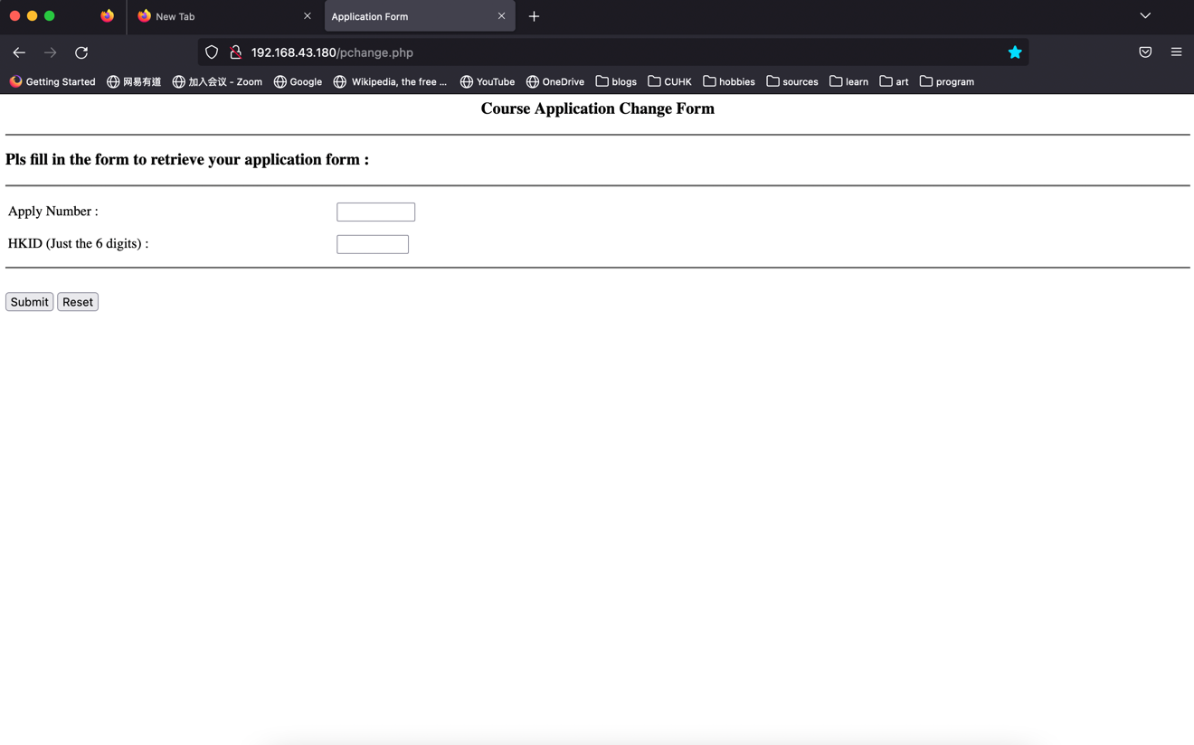

### Task 3.4

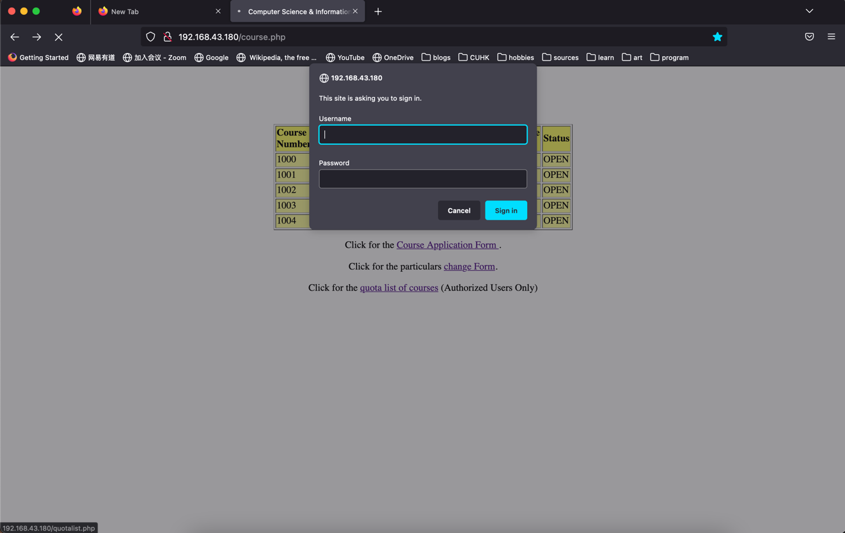

|  |
| --- |
| Put apply.php source code below :  Apply.php:  <?php  /* connect to database */  **define**('DBSERVER',"172.16.180.2");  **define**('DBUSER',"coursedb");  **define**('DBPASS',"mypass");  **define**('DATABASE',"coursedb");  if (!$**connection** = **mysqli_connect**(DBSERVER, DBUSER, DBPASS))  die("Cannot connect");  @**mysqli_select_db**($**connection**,DATABASE) or die( "Unable to select database");  /* validate the input */  if (!**ctype_digit**($**_POST**["hkid"])) {  echo "invalid hkid:should contain not only numbers";  } else { //check if has the same hkid  $**cdoub_sql** = "SELECT courseno, hkid FROM applytbl";  $**cdoub_result** = **mysqli_query**($**connection**, $**cdoub_sql**);  while($**cdoub_row** = **mysqli_fetch_assoc**($**cdoub_result**)) {  if($**cdoub_row**["courseno"] == $**_POST**["courseno"] && $**cdoub_row**["hkid"] == $**_POST**["hkid"]){  die("already applied");  }  }  /* find applyno */  $**to_find** = $**_POST**["courseno"];  $**get_sql** = "SELECT courseno, quotaused FROM coursetbl";  $**quota_result** = **mysqli_query**($**connection**, $**get_sql**);  while($**row** = **mysqli_fetch_assoc**($**quota_result**)) {  //echo "courseno is " . $row["courseno"] . "<br>";  if( $**row**["courseno"] == $**to_find**){  //echo "to find is " . $to_find ." <br>";  //echo "course no is " . $row["courseno"] ." <br>";  /* add to database and return applyno */  //echo "quta used is: " . $row["quotaused"] . "<br>";  $**courseno** = $**_POST**["courseno"];  $**applyno** = $**_POST**["courseno"] * 1000 + $**row**["quotaused"] + 1;  $**name** = $**_POST**["name"];  $**stid** = $**_POST**["stid"];  $**hkid** = $**_POST**["hkid"];  $**email** = $**_POST**["email"];  $**tel** = $**_POST**["tel"];  $**sql** = "INSERT INTO applytbl (applyno, name, studentid, hkid, email, tel, courseno) VALUES ($**applyno**, '$**name**', '$**stid**', $**hkid**, '$**email**', '$**tel**', $**courseno**)";  if (**mysqli_query**($**connection**, $**sql**)) {  echo "New record created successfully! <br> ";  echo "your apply number is " . $**applyno** . "<br>";  } else {  echo "Error: " . $**sql** . "<br>" . **mysqli_error**($**connection**);  }  /* qutoa user plus 1 */  $**tmp** = $**row**["quotaused"]+1;  //echo "tmp is " . $tmp . "<br>";  $**update_sql** = "UPDATE coursetbl SET quotaused=$**tmp** WHERE courseno=$**to_find**";  if (**mysqli_query**($**connection**, $**update_sql**)) {  echo "Record updated successfully";  } else {  echo "Error updating record: " . **mysqli_error**($**connection**);  }  } //end if  } //end while  /* close db */  } //end else in hkid check  $**connection**->close();  ?>  Applypage.php:  **<**html**><**head**>**  **<**title**>**Application Form**</**title**>**  **<**metahttp-equiv**=**"Content-Type"content**=**"text/html; charset=iso-8859-1"**>**  **</**head**>**  **<**bodybgcolor**=**"#FFFFFF"**>**  **<**h3align**=**"center"**>**Course Application Form**</**h3**>**  **<**divalign**=**"center"**>**  **<**h3**>**(for First-Come-First-Served Courses) **</**h3**>**  **</**div**>**  **<**hr**>**  **<**h3**>**Pls fill in the form below to enroll :**</**h3**>**  **<**hr**>**  **<**formmethod**=**"post"action**=**"apply.php"**>**  **<**tablewidth**=**"75%"border**=**"0"**>**  **<**tbody**><**tr**>**  **<**tdwidth**=**"37%"height**=**"39"**>**Course No To enroll:**</**td**>**  **<**tdwidth**=**"63%"height**=**"39"**>**  **<**inputtype**=**"text"name**=**"courseno"size**=**"4"maxlength**=**"4"**>**  **</**td**>**  **</**tr**>**  **<**tr**>**  **<**tdwidth**=**"37%"**>**Name :**</**td**>**  **<**tdwidth**=**"63%"**>**  **<**inputtype**=**"text"name**=**"name"**>**  **</**td**>**  **</**tr**>**  **<**tr**>**  **<**tdwidth**=**"37%"**>**Staff/student ID :**</**td**>**  **<**tdwidth**=**"63%"**>**  **<**inputtype**=**"text"name**=**"stid"**>**  **</**td**>**  **</**tr**>**  **<**tr**>**  **<**tdwidth**=**"37%"height**=**"32"**>**  **<**p**>**HKID (Just the 6 digits) :**</**p**>**  **</**td**>**  **<**tdwidth**=**"63%"height**=**"32"**>**  **<**inputtype**=**"text"name**=**"hkid"size**=**"6"maxlength**=**"6"**>**  **</**td**>**  **</**tr**>**  **<**tr**>**  **<**tdwidth**=**"37%"**>**Email address : **</**td**>**  **<**tdwidth**=**"63%"**>**  **<**inputtype**=**"text"name**=**"email"**>**  **</**td**>**  **</**tr**>**  **<**tr**>**  **<**tdwidth**=**"37%"height**=**"28"**>**Contact Tel : **</**td**>**  **<**tdwidth**=**"63%"height**=**"28"**>**  **<**inputtype**=**"text"name**=**"tel"**>**  **</**td**>**  **</**tr**>**  **</**tbody**></**table**>**  **<**hr**>**  **<**br**>**  **<**inputtype**=**"submit"name**=**"Submit"value**=**"Submit"**>**  **<**inputtype**=**"reset"name**=**"reset"value**=**"Reset"**>**  **</**form**>**  **<**p**>**&nbsp;**</**p**>**  **</**body**></**html**>**  ~ |
| Put change.php source code below:  change.php: (page for authentification):  **<**html**>**  <?php  /* connect to database */  **define**('DBSERVER',"172.16.180.2");  **define**('DBUSER',"coursedb");  **define**('DBPASS',"mypass");  **define**('DATABASE',"coursedb");  if (!$**connection** = **mysqli_connect**(DBSERVER, DBUSER, DBPASS))  die("Cannot connect");  @**mysqli_select_db**($**connection**,DATABASE) or die( "Unable to select database");  /* validate if yes go to change2.php not not */  $**ip_applyno** = $**_POST**["applyno"];  $**ip_hkid** = $**_POST**["hkid"];  if(!$**cmp_sql** = "SELECT applyno, hkid FROM applytbl"){  echo "error in sql <br>";  }  if(!$**cmp_result** = **mysqli_query**($**connection**, $**cmp_sql**)){  echo "error in result <br>";  }  /* go to the right row */  $**flag** = 0;  while($**cmp_row** = **mysqli_fetch_assoc**($**cmp_result**)) {  if( $**cmp_row**["applyno"] == $**ip_applyno**){  $**flag** = 1;  break;  }  }  if($**flag** == 1 && $**ip_applyno** == $**cmp_row**["applyno"] && $**ip_hkid** == $**cmp_row**["hkid"]){  echo '<form method="post" action="change2.php">';  echo '<table width="75%" border="0">';  echo '<tbody><tr>';  echo '<td width="37%" height="39">input apply number:</td>';  echo '<td width="63%" height="39">';  echo ' <input type="text" name="applyno" size="7" maxlength="7">';  echo '</td>';  echo '</tr>';  echo '<tbody><tr>';  echo '<td width="37%" height="39">Reset telephone number (input nothing to not reset):</td>';  echo '<td width="63%" height="39">';  echo ' <input type="text" name="new_tel">';  echo '</td>';  echo '</tr>';  echo '<tr>';  echo '<td width="37%" height="32">';  echo '<p>Reset email(input nothing to not reset) :</p>';  echo '</td>';  echo '<td width="63%" height="32">';  echo '<input type="text" name="new_email">';  echo '</td>';  echo '</tr>';  echo '</tbody></table>';  echo '<hr>';  echo '<br>';  echo '<input type="submit" name="Submit" value="Submit">';  echo '<input type="reset" name="reset" value="Reset">';  echo '</form>';  } else{  die("wrong hkid or apply number");  //echo "flag is {$flag}";  }  /*  echo "input applyno is: " . $ip_applyno . "<br>";  echo "correct applyno is: " . $cmp_row["applyno"] . "<br>";  echo "input hkid is " . $ip_hkid . "<br>";  echo "correct hkid is " . $cmp_row["hkid"] . "<br>";  */  /* close db */  $**connection**->close();  ?>  Change2.php ( page for changing information):  <?php  /* connect to database */  **define**('DBSERVER',"172.16.180.2");  **define**('DBUSER',"coursedb");  **define**('DBPASS',"mypass");  **define**('DATABASE',"coursedb");  if (!$**connection** = **mysqli_connect**(DBSERVER, DBUSER, DBPASS))  die("Cannot connect");  @**mysqli_select_db**($**connection**,DATABASE) or die( "Unable to select database");  /* get applyno */  $**applyno** = $**_POST**["applyno"];  /* change email */  if ($**_POST**["new_email"] != null){  $**new_email** = $**_POST**["new_email"];  $**email_sql** = "UPDATE applytbl SET email='$**new_email**' WHERE applyno=$**applyno**";  if (**mysqli_query**($**connection**, $**email_sql**)) {  echo "email updated successfully";  } else {  echo "email Error updating record: " . **mysqli_error**($**connection**);  }  }  /* change tel */  if ($**_POST**["new_tel"] != null){  $**new_tel** = $**_POST**["new_tel"];  $**tel_sql** = "UPDATE applytbl SET tel='$**new_tel**' WHERE applyno=$**applyno**";  if (**mysqli_query**($**connection**, $**tel_sql**)) {  echo "phone number updated successfully";  } else {  echo "phone number Error updating record: " . **mysqli_error**($**connection**);  }  }  ?>  ~ |