IERG1000 LAB REPORT 1

NAME : CHAN TAI MAN, SID : 110011000, Email : [ctm122@ie.cuhk.edu.hk](mailto:ctm122@ie.cuhk.edu.hk)

### Task 1.1

Run at server VM

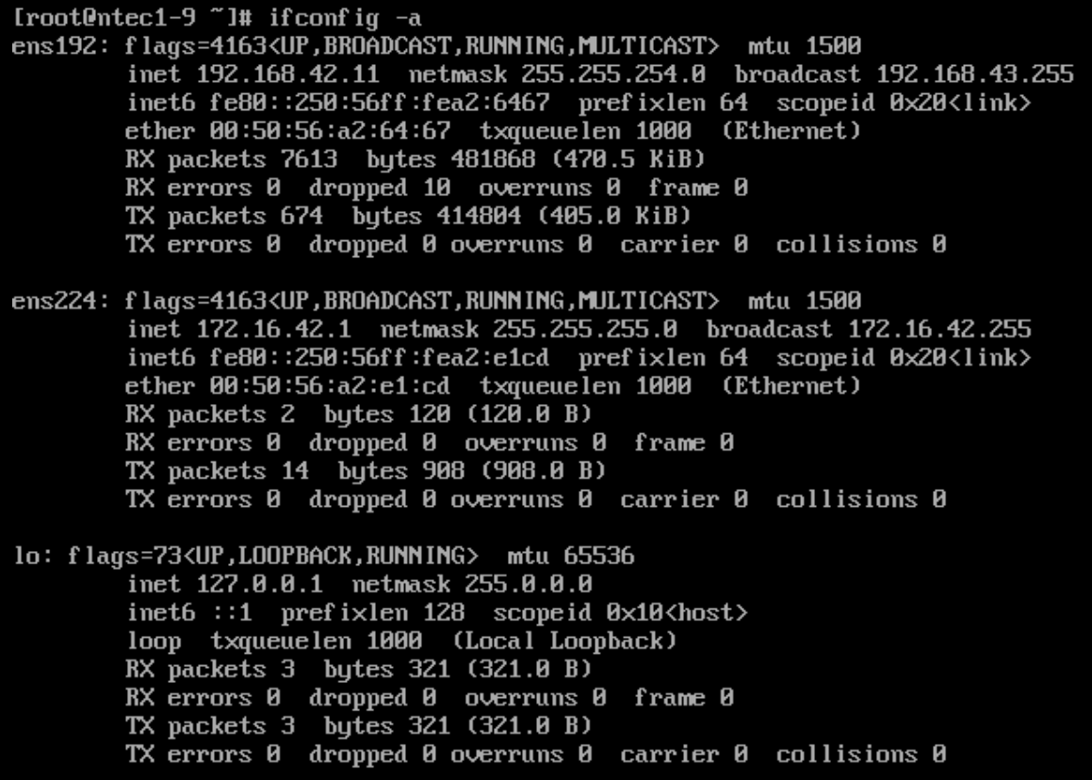

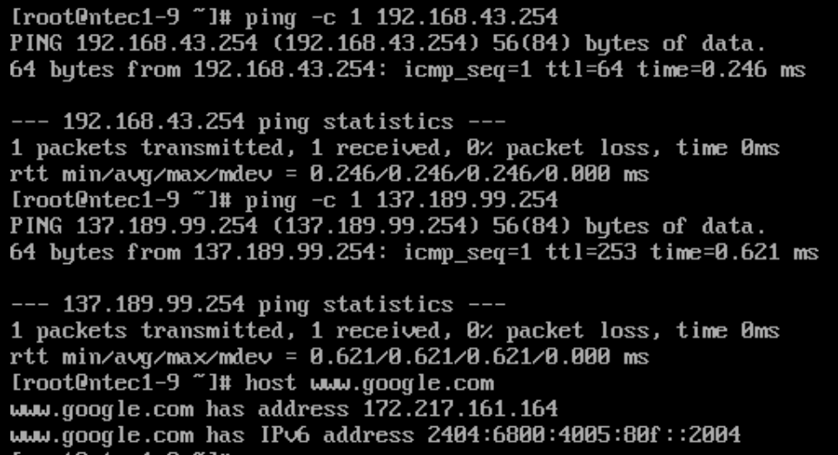

### Task 1.2

Run at client VM

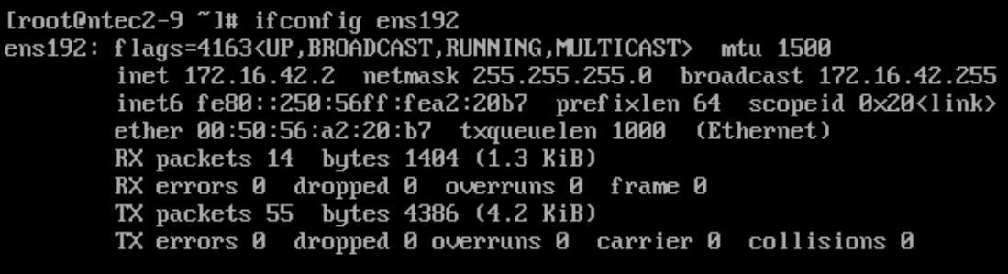

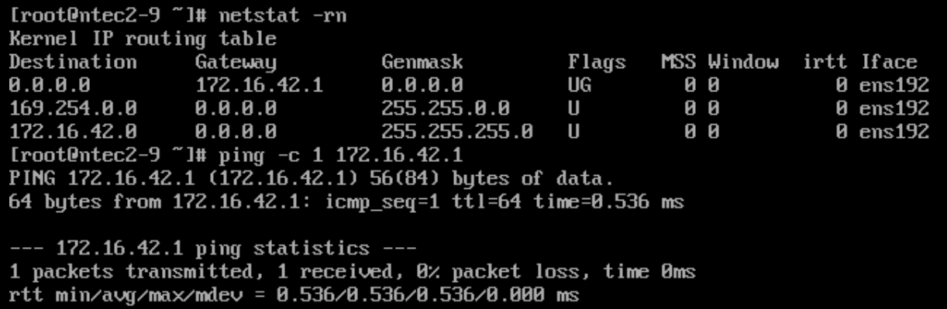

Run at Server vm

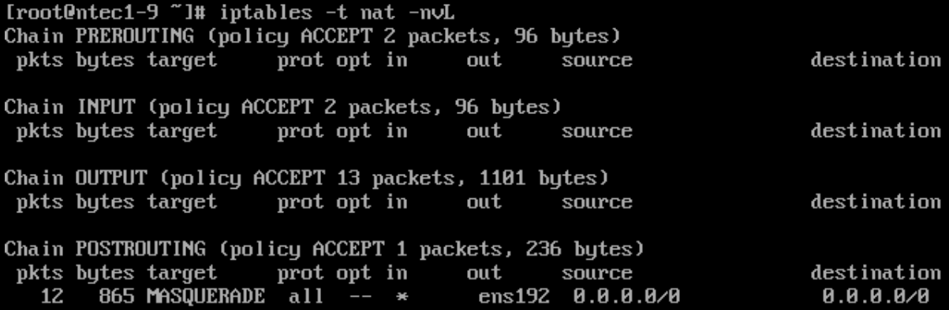

Run at Client VM

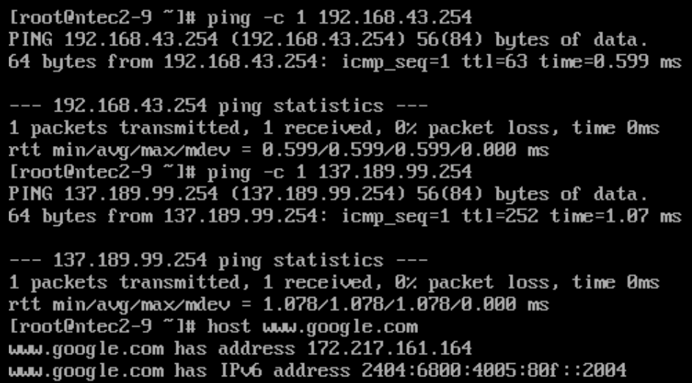

### Task 2.2

At the Client VM, show the content of ~/.ssh/authorized_keys

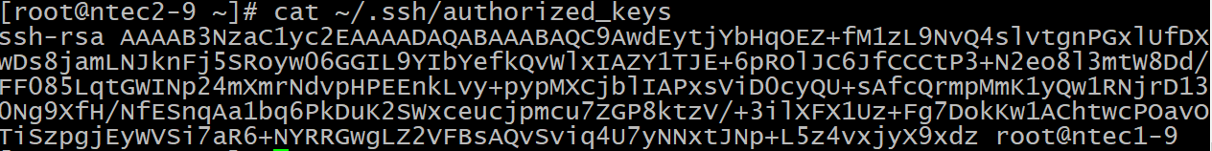

### Task 2.3

### 

### Task 2.4

At Client VM

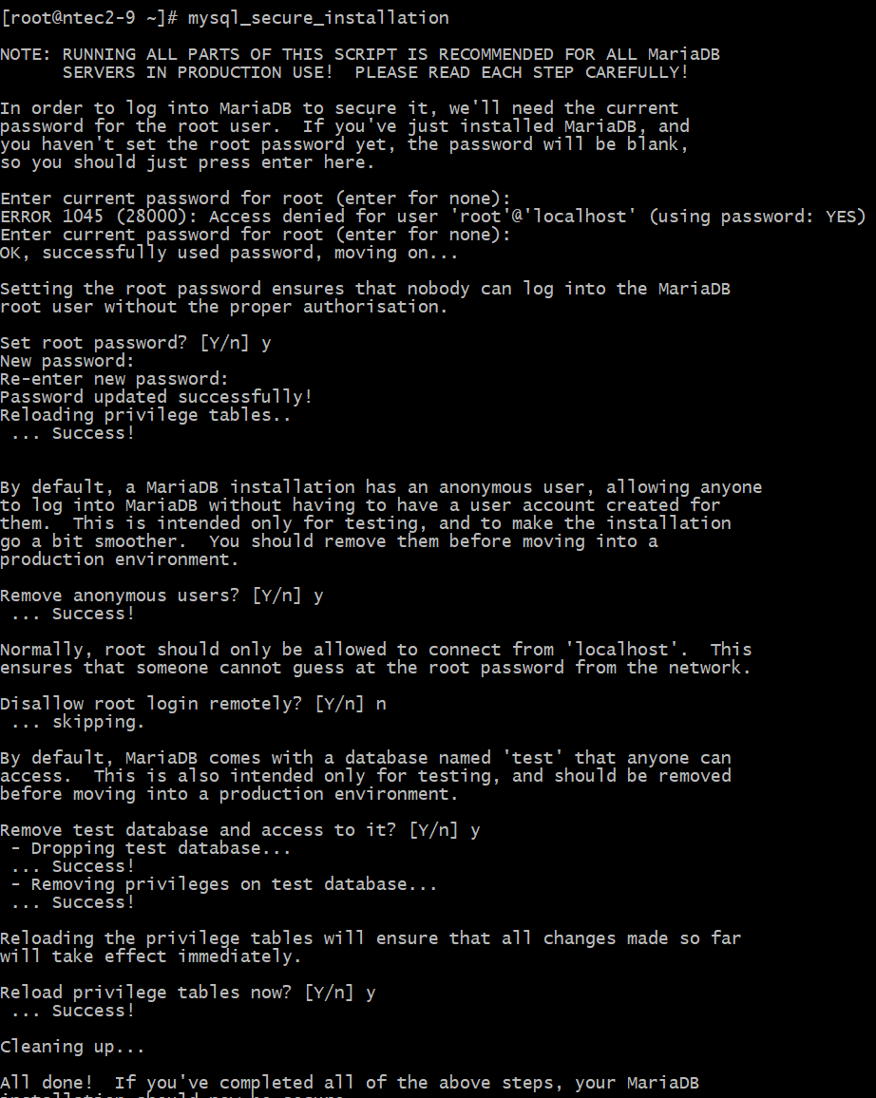

At Server VM

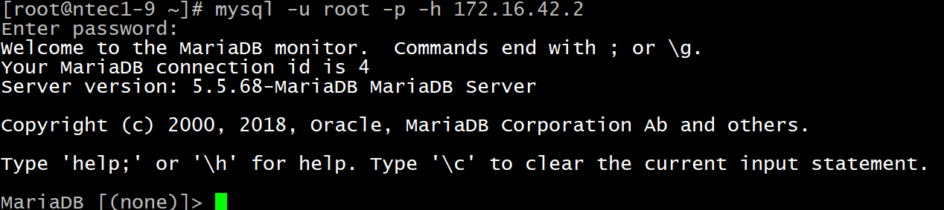

### Task 2.5

Login : root, password : my-pasword

