CSCI2100 Data Structure

Report on Project: Memory Manager
Based on Dynamic Hash Table
And Anchor Point Array

Name: Muquan YU
SID: 1155191596
Submission Date: 20 Dec 2023

- DESIGN
- Data structures used for implementing the algorithm
- Memory Map by linked list
- Description
The Memory Map (memMap) as shown in Figure 1 is a linked list that contains information on both free and allocated memory blocks in the memory. Each node in memMap contains parameters (1) the physical starting address of this block; (2) the size of this block; (3) the occupation status (whether free or occupied); (4) reference to the previous node; (5) reference to the next node. In real-world memory maps, there should also be information like ownership and protection, but it is omitted in this project. (NOTE: The forward and back pointers are NOT used for linear search of the whole memory space, but for a quicker access to the information about the previous or succeeding memory blocks.)
- Supported Operations
- insert(MemMapNode prev, MemMapNode curr) : Given the reference of the node before the to insert node (prev) and the node to be inserted (curr), node curr can be inserted into memMap. By operating on a linked list, it could be done in O(1) time.
- delete(MemMapNode curr): Given the reference to memMap node (curr) to be deleted, this node can be deleted from memMap. By operating on linked list, it is done in O(1) time.
- Anchor point array
- Description
The memory block where certain addresses (anchor points, as shown in figure 2) belong is always being tracked. The information is stored in an array where the index is the order of the anchor points, and the value is a reference to the memMap node.
The addresses of each anchor point are evenly distributed in the memory address space (with distance anchorDist between them), and the number of anchors should be O(n). Maintaining the anchor point array is efficient since we only need to update the anchor points covered by certain memory block in its insertion process.
- Hash table pointing to memMap
- Description
There are 2 Hash tables (as shown in figure 3) referencing to the memMap indexed on the starting Address of the memMap Node (htOfAddr) and the size (htOfFreeSize) of the free memMap nodes respectively.
Since the number of free and allocated nodes will change in the memory managing process, the hash table are designed to expand and shrink automatically.
For htOfAddr, key is the starting address of each memMap blocks, for htOfFreeSize, the key is the size of free memory blocks, and the value of both hash tables are the reference to memMap.
- Supported Operations
- put(BigInteger key, MemMapNode memMapNode): insert a key value pair.
- getMinAddr(BigInteger key): Given the key, it will loop through the whole bucket of the corresponding key and find the key value pair with the minimum value. It is used in htOfFreeSize to find the block of required size with the smallest address.
- getPredKey(BigInteger key): Given the key (an arbitrary address), return the reference to the memory block where the address belongs to. This is done by first finding the biggest anchor point that is less than the address, and checking whether the address is inside the block. If yes, just return the block; if no, we can get the starting address of next memory block by the starting address and the size of the current block, and search in the succeeding blocks in the hash table until finding the address.
- getSuccKeyMinAddr(BigInteger key): Similar to the searching method in getPredKey() except that it starts from address 0. It will get the key value pair with successor of the key of smallest address.
- remove (BigInteger key, MemMapNode memMapNode): remove the hash table element with the given key and value.
- Explanation of the algorithm
- Request
- Validation
In the validation process, if the request has a target address, then we only need to locate the memory block of the address by htOfAddr.getPredKey(), and validate if there is enough space to allocate.
If the request has no target address, then we have 3 different kinds of strategies.
For FIRST_FIT, we know that address 0 must be in the htOfAddr, and check whether the memory block meets the standard. If yes, return this block; if no, we can get the starting address of next memory block by the starting address and the size of the current block, and search in the succeeding blocks in the hash table until finding the target block.
For BEST_FIT, we can directly use the method htOfFreeSize.getSuccKeyMinAddr() to search for the target memory block.
For WORST_FIT, maintain an extra variable maxFreeBlockSize that stores the max free memory block size. maxFreeBlockSize is initialized to be the total memory size in the beginning, and only needs to be updated when a free block with size maxFreeBlockSize is deleted. During validation, use htOfFreeSize. getMinAddr(maxFreeBlockSize) to search for the free memory block with the max free block size.
In the three kinds of operations, if we successfully find a target memory block, then it means that the operation is valid and we can go to the allocation process. Otherwise, it is an invalid request.
- Allocation
In the allocation process, up to 3 new memory blocks will be generated: the newly allocated block N2, the free block N1 before N2 (if exists) and the free block N3 after N2 (if exists). We update the memMap and htOfAddr by inserting N1, N2, N3 and deleting the original memory block from them. And for the hash table of free size, we only need to delete the original block and insert N2. The update of max free block size is only performed when the original block is the biggest free block. The anchor point array is updated whenever a memMap insertion is performed.
- Release
- Validation
Locate the memory block of the address by htOfAddr.getPredKey(), and use htOfAddr to check whether all the spaces in the release request are allocated. If not, the release operation is invalid and terminated.
- Release
Loop through all the memory blocks by the way similar to getPredKey(), in the range of the release request. The new free memory blocks are updated in memMap, htOfAddr, and htOfFreeSize. Old memory blocks are deleted in memMap and htOfAddr. If the total size of the new free block size is bigger than maxFreeBlockSize, maxFreeBlockSize is updated.

- Evaluation
- Tradeoffs and modification on the given structure
- Dynamic hash table
In my algorithm, I merged the 2 hash tables of addresses into 1 and made it dynamic.
The benefit of merging is that (1) it can save place and make the algorithm and data structure simpler to understand and implement (2) if the starting address of all blocks are placed in one hash table, then for any memory block B, the key B.startingAddr + B.size (which is the starting address of the next memory block) is definitely in the hash table, this makes methods involving search the hash table of address like getPredKey() and getSuccKeyMinAddr() quicker. But one disadvantage is that for the FIRST_FIT, we are unable to only search for the starting address of free memory blocks, which is a drawback of this modification.
Making the hash table dynamic will make the size of the hash table proportion to the total number of blocks instead of the total memory block (which is usually a lot smaller size one block is often of a big size in real life), while ensuring that the time complexity of insertion and deletion is still O(1) after amortization. In terms of parameter, I set the expand and shrink factor to 2 and 0.5 respectively. I didn’t choose the load factor 0.75 which is commonly used because when I print out the hash table, I think that to expanding when there is 75% filled is too scarce, and in the scenario where memory blocks are frequently released and allocated, we have to do too many shrinks and expansions. When setting the parameter to 2 and 0.5, the hash table will double or half exactly making the number of hash table elements equal to the length of hash table array length. So that on average 1 element in each hash table bucket, at the same time decreasing the frequency shrinks and expansions need to be performed.
- Anchor Point Array
The anchor point array is really efficient in finding the block where a certain address belongs to. As long as we make sure that the anchor points are evenly distributed in the memory space and are of number O(n) (where n is the total size of the memory space), we can assure that there only O(1) address and thus O(1) memory blocks between each anchor point. So when we need to find out the block where a certain address belongs to, we only need to loop through O(1) memory blocks, and making the time complexity of the operation O(1). This data structure realizes the role of the hierarchical hash table and is a lot more easily implemented.
As for the total number of anchor points, although it is O(n), we still need to figure out the detailed implementation. If there is too many anchor points, it would take up too much space and are hard to initialize and update. But if there is too little, the efficiency of finding the block where a certain address belongs to will be low. So in my algorithm, I set the total number of anchor points to be n/1000, which is not too tedious for initializing and updating, and is efficient in searching. Also, when n < 1000, I simply set the number of anchor points to 1000. In both situations, the number of anchor points is O(n).
- Adding an extra memory map
The memory map is designed to be a linked list, so that form each memory block we can get information about its previous and next memory block in O(1) time. If we don’t have this data structure, it would be a lot harder to store information such as the allocation status (since I merged the 2 hash table of size into 1, I need to store the allocation status to indicate if a block is free or allocated) and access information of neighbor blocks.
Although there might be an increase in space consumption, the change trivial (still O(n)).
- Space complexity analysis
Among the data structures created, the anchor point array has O(n) elements and is thus of space complexity O(n).
The other data structures (memory map, dynamic hash tables) have number of elements proportional to the total number of memory blocks. Although the number of memory blocks is still O(n), in practice, this number will be smaller than the total number of addresses.
So In conclusion, when the total size of memory is n, the space complexity of my algorithm is O(n) and but are slightly smaller than the proposed one.
- Time complexity analysis
- Amortized performance relative to the case of hash table of one entry
I chose my shrink and expansion factor of the hash table to be 0.5 and 2, which means that if the elements in the hash table is less than half of the length of hash table array, the length will shrink by half, and if the elements in the hash table is two times more than the length of hash table array, the length will double.
Each time the length of the hash table array changes, a new array is created, and all elements in the original hash table are copied to the new hash table. Let n be the number of elements in the hash table. Each expansion and shrink takes O(n) time. However, we can charge the cost on O(n) newly inserted or deleted elements (since we need to insert/delete O(n) elements to make the number of elements to be double/half of the length of the hash table array). Each insertion and deletion takes only O(1) time, so the amortized insertion and deletion time complexity for htOfSize and htOfAddr is O(1).
- Request
- Validation
For the request with address, first we need to find the memory block containing the target address. This is done by htOfAddr. getPredKey(target_address) with the help of anchor point arrays and thus the total time complexity is O(1). Checking the if all of the request space is free involves validating O(1) number of blocks thus the complexity is also O(1).
For FIRST_FIT, it involves looping through the memory blocks with address from small to. In worst case, there is no such block, so the complexity is the same as the number of elements in htOfAddr so it is O(n).
For BEST_FIT, we can use htOfAddr.getSuccKeyMinAddr(target_size) to get the best fit memory block with the smallest address. The process also involves looping through the whole hash table so time complexity is O(n).
For WORST_FIT, we first need to get the max free block size. This requires only O(1) time to search in htOfFreeSize since the variable maxFreeBlockSize is maintained throughout the algorithm.
- Allocation
For the allocation process, we need to insert and delete O(1) number of elements in memMap and in 2 hash tables. Since we already know the reference to the node in the Memory Map and hash table is dynamic, so each insertion and deletion also takes only O(1) time.
But for WORST_FIT, if the maxFreeBlockSize is updated in the process, we need to update it by looping through the hash table of free size, so the complexity goes back to O(n). However, since we do not need to update the maxFreeBlockSize every time in real practice (actually in a very low frequency: only when a very big free block exists), it stills has a high efficiency.
- Combined
Combining validation and allocation, it takes O(1) time for allocation with address, and O(n) time for allocation without address.
- Release
When first finding the Memory Map block the target releasing starting address is in by htOfAddr.getPredKey(), the time complexity is O(1).
Looping through all the memory blocks in range, new blocks are updated in memMap, htOfAddr and htOfFreeSize, and original memory blocks are deleted in memMap and htOfAddr. As a reversed process of allocation, it also takes O(1) time. So the time complexity for release is O(1).
- Summary of the amortized performance
In conclusion, request and release with address can be handle in O(1) time by anchor point arrays, but request without address need O(n) time. So the total amortized time should be O(n), however, a lot better than the naïve algorithm.
- Possible improvements
- A new hash function of size to improve the complexity to O(1)
In my original program, my BEST_FIT and WORST_FIT are slow since we have to loop through all the memory blocks by hash table to find the suitable address. However, by changing the hash function we can improve it to O(1). Originally the hash function is done by doing modules calculation, so that the elements in each bucket have unordered keys. However, if we modify it to be done by rounding off, the elements in each bucket of the hash table will fall in certain range.
For example, we fix the length of hash table array to be k. Then the hash function can be hash(x) = ceiling(size / m), where m = floor(total_size / k). By this hash function, all blocks with size [0, m-1] will fall in bucket[1]; all blocks with size [m, 2m-1] will fall in bucket[2]; all blocks with size [2m, 3m-1] will fall in bucket[3] …
By this method, if we want to search for a memory block with certain size, we can first use the hash function to tell which bucket the element must be in, then linearly search inside the bucket.
For BEST_FIT, we first search bucket[hash(size)], then search bucket[hash(size)+1]. bucket[hash(size)+2] … until finding the target result. For BEST_FIT, we first search inside the bucket[hash(max_size)], then bucket[hash(max_size) – 1], then bucket[hash(max_size)-2], until finding the suitable target.
Let n be the total address size. It is reasonable to assume that the size of memory blocks distribute randomly between 1 and n. Thus, if we let k be a number of O(n), then the elements in each bucket will be n / O(n) which is O(1), so linearly searching in each element will only take O(1) time. As a result, the efficiency validation of BEST_FIT and WORST_FIT search can be improved to O(1).
Since the validation process with address, the allocation process and the release process is already O(1), the total time to handle n cases of requests and releases in BEST_FIT and WORST_FIT approach is O(n), and the amortized time complexity becomes O(1), while the space complexity remains O(n) (Only adding a new hash table with size O(n)).

Appendix

- Figures
- Figure 1: graph representation of Memory Map
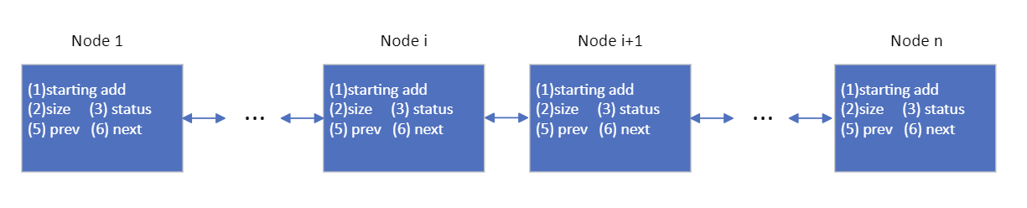
- Figure 2: graph representation of anchor point array
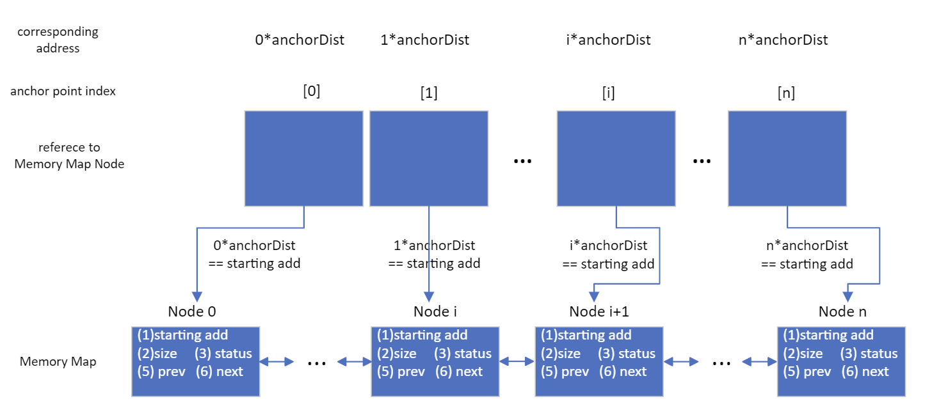

- Figure 3: graph representation of hash table
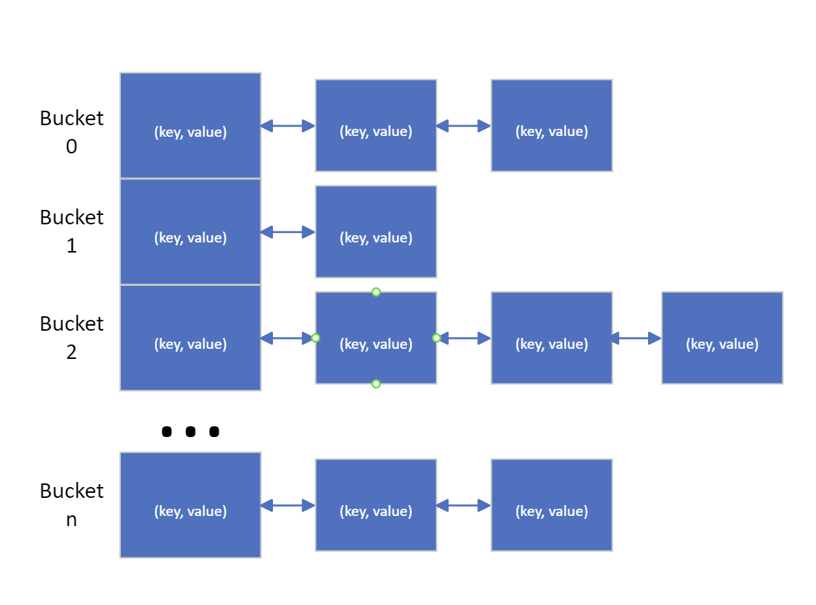

- References
- The implementation of dynamic hash table is modified from https://stackoverflow.com/questions/2127377/how-can-i-implement-extendible-hashing-in-java.

