# Terminology

1. Distillation：

a technique used in machine learning to transfer knowledge from a large, complex model (teacher model) to a smaller, more lightweight model (student model). The primary goal of knowledge distillation is to distill the knowledge or information learned by the teacher model into a more compact and computationally efficient student model.

1. Dense features

"Dense features" typically refer to high-dimensional feature representations in machine learning and deep learning models. These features are dense in the sense that they are represented by a large number of values, often in the form of continuous or real numbers, as opposed to sparse features that are represented by a smaller set of non-zero values.

1. Contrastive learning

is a type of self-supervised learning technique that aims to learn useful mnjbhgytvfr5555555555555555555554ed3f epresentations by maximizing the similarity between similar pairs of data points while minimizing the similarity between dissimilar pairs. In contrastive learning, the model learns by comparing and contrasting pairs of data points in a way that similar data points are brought closer together in the learned representation space, while dissimilar data points are pushed farther apart.

1. UMAP

UMAP (Uniform Manifold Approximation and Projection) is a dimensionality reduction technique that is widely used for visualizing high-dimensional data in a lower-dimensional space. UMAP is particularly effective for preserving the local and global structure of the data, making it a popular choice for exploratory data analysis, clustering, visualization, and feature engineering tasks.

1. In-context learning (ICL)

Learns a new task from a small set of examples presented within the context (the prompt) at inference time. LLMs trained on sufficient data exhibit ICL, even though they are trained only with the objective of next token prediction. Much of the interest in LLMs is due to the prompting with examples as it enables applications on novel tasks without the need for fine-tuning the LLM.

1. Readout: just the last layer of the network to change internal representations to meaningful format (eg. probability)

A readout in deep learning refers to the final layer or mechanism that converts the learned representations into the desired output format. It's essentially the interface between the internal network representations and the final prediction or output.

1. Noise ceiling

estimate how much stimulus-related variance you have in the data, (and the rest is noise)

assumption underlying this is that stimulus responses are fixed, and differ only in noise

for instance, if you have a correlation between data and model of 0.3 but your noise ceiling estimate is 0.4, you obtain a 'corrected' correlation of 0.3/0.4=0.75

1. Normalization

(<https://medium.com/@sachinsoni600517/layer-normalization-in-transformer-1a2efbff8b85>)

I. def: normalization in deep learning refers to the process of transforming data to conform to specific statistical properties.

II. place to use: Input Data / Hidden Layer Activations (layer norm: stabilize and accelerate training, especially in deep networks)

II. common types (in a statistical wahy)

1. standardization: each data adjusted by - mean of its column then / standard deviation

2. min-max normalization: data is scaled to fit within a given range.

III. common types (in terms of dimension doing norm)

1. Batch Norm / Layer Norm / Instance Norm / Group Norm definition

<https://blog.csdn.net/qq_36560894/article/details/115017087>

Batch norm: in this batch, every channel has the same distr

Layer Norm: every sample has the same distr

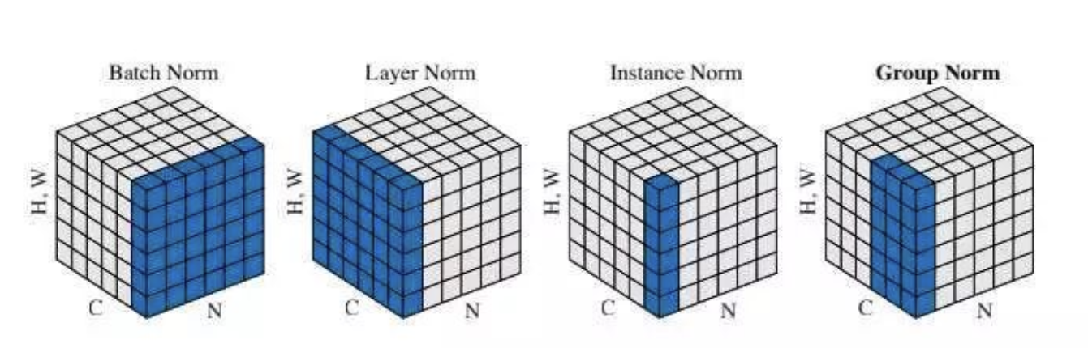

(note: for the graph, in vision, C is the channel, H,W are pixels; in NLP, C is the words in a sentence, H,W is the embedding for a single word)

So batch norm in cv: means in a batch, for each channels, all the images together N(0, 1) distr

So layer norm in NLP: for each sentence, the embeddings among all words together N(0, 1)

1. reasoning:

key idea, if some distributions are normed separately, the data inside a single distribution is still comparable, but data across distributions are no longer comparable

<https://blog.csdn.net/Little_White_9/article/details/123345062>