2. Materials and Methods

2.1. Phenotypic, Genotypic Data, and Pedigree Data

Phenotypic information was used from 108,819 Avileña-Negra Ibérica cattle born between 1,899 and 2,023, provided by Real Asociación de Raza Avileña-Negra Ibérica (RAEANI). The traits under analysis were weaning weight (recorded in 64,519 individuals), age at first calving (34,512 individuals), and interval between the first and second calving (16,726 individuals).

Genotypic information was collected using different types of panels. In total, 2,894 individuals were genotyped with the Axiom Bovine Genotyping version 3 chip from Thermofisher, a medium-density chip with 63,000 markers (50K). Additionally, 284 individuals were genotyped using the BovineHD BeadChip from Illumina with 777,000 markers (HD). The genotypic data obtained with the Axiom Bovine Genotyping chip were aligned and analyzed using the ARS-UCD1.2 bovine genome assembly, while the data obtained with the BovineHD BeadChip were based on the UMD3.1 assembly.

Before proceeding with imputation, each chip was subjected to quality control separately, where SNPs with a minor allele frequency (MAF) lower than 0.01 and Hardy-Weinberg equilibrium with a p-value lower than 0.00001 were removed, although for samples genotyped on the second chip (BovineHD BeadChip), the MAF threshold was set at 0.05. Markers and individuals with a call rate lower than 0.9 were also excluded, and markers not located on autosomal chromosomes were removed from the analysis. Quality control was performed using the Plink software (Purcell et al., 2007).

Given that one of the objectives of this study was to compare markers of different densities with the medium-density chip (the most widely used for genomic prediction in cattle), the imputation in both panels was based on the 50K map, corresponding to the ARS-UCD1.2 bovine genome assembly. During imputation, the samples genotyped at 50K were imputed to the post-quality control density of HD, thus generating a combined density genotype set. Similarly, the samples genotyped at HD were imputed to the post-quality control density of 50K. All this was done using the Beagle version 5.4 program (Browning et al., 2018). The figure below shows the markers and individuals shared between both densities at the time of imputation.

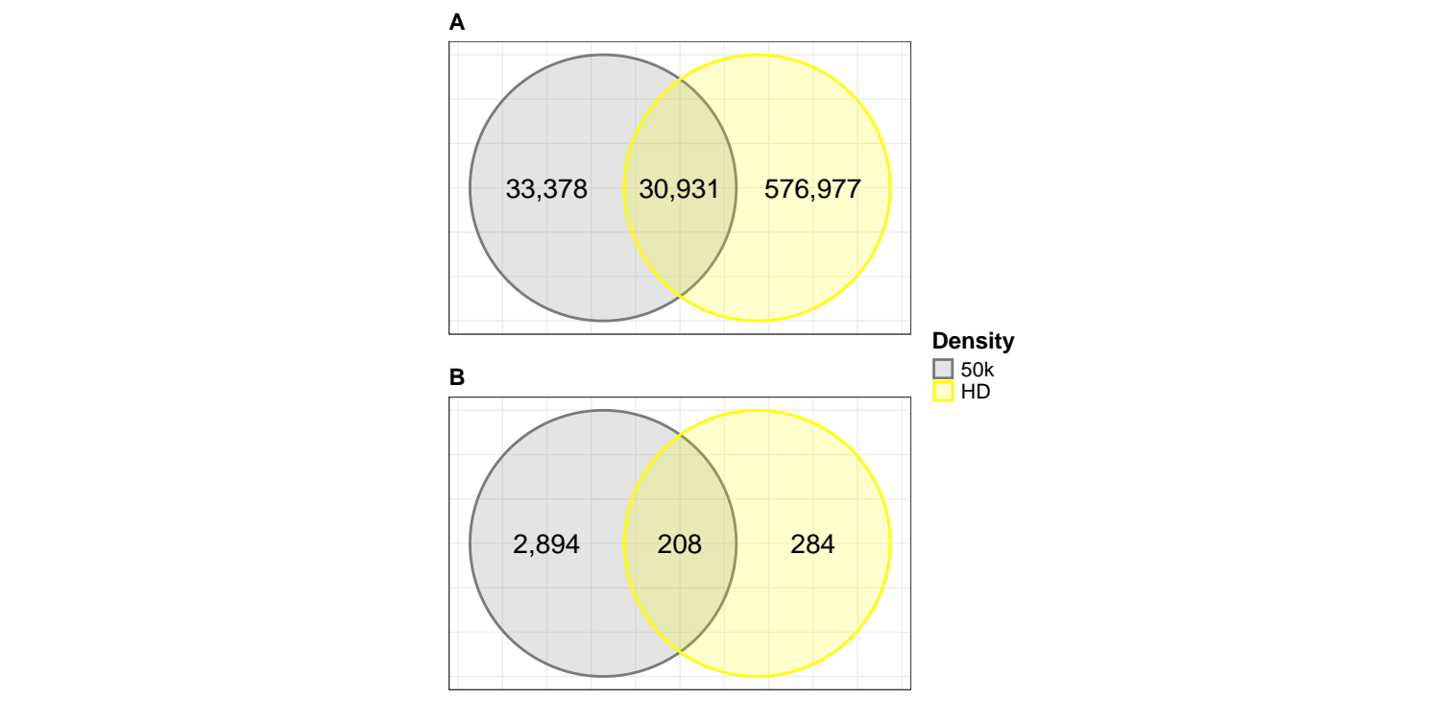
Figure 1. Venn diagram showing unique and shared markers (A) and individuals (B) between different marker panels after quality control. Markers were identified as shared between genotype sets if the marker position within the chromosome, the reference allele, and the alternate allele were identical.

The accuracy of imputation was assessed using the Imputation Quality Score (IQS) (Lin et al., 2010). The IQS is a randomly adjusted concordance rate with a maximum score of 1 and without theoretical minimum, designed to evaluate the accuracy of imputation for each marker separately. For this purpose, repeated k-fold cross-validation was performed. For the first chip, the genotyped individuals were randomly divided into eight data subsets without repetition. Then, to enable direct comparison between true and imputed genotypes, markers with complete genotypes were masked. For the second chip, imputation accuracy was assessed using the same methodology, which involved masking and subsequently predicting the genotypes in a cross-validation setting where four data subsets were randomly formed without repetition. The imputation accuracy, measured by IQS, ranged from 0.90 to 0.98, which was considered accurate imputation.

Based on these procedures and quality control measures, data from 43,421 markers and 579,424 markers, in 2970 individuals, were available for further analysis.

On the other hand, using the BovineHD BeadChip and the FastIndep program (Abraham and Díaz, 2014), a set of tag-SNPs and a set of singletons were derived. Tag-SNPs were defined as those with a linkage disequilibrium (r2) greater than or equal to 0.8 between markers, while singletons were those with an r2 less than 0.2. From this analysis, a total of 103,080 tag-SNPs and 128,660 singletons were derived. This analysis is described by Díaz et al. (2016).

2.2. Scenarios for the Estimation

A total of nine scenarios using markers of different densities were evaluated. In scenarios one and two (referred to as E1 and E2), the genotypic information consisted of 43,421 and 579,424 markers, respectively. E1 is considered the desirable scenario, as genomic prediction in cattle is mainly performed using a medium density of markers. Based on the tag-SNPs and singletons mentioned earlier, four additional scenarios were formed: E3, E4, E5, and E6. In E3, the genotypic information comprised the tag-SNPs present in E1, while in E4 the genotypes consisted of the tag-SNPs present in E2, resulting in densities of 5,534 and 97,779 markers in E3 and E4, respectively. In scenarios E5 and E6, the genotypic information included both tag-SNPs and singletons, resulting in densities of 13,961 and 203,612 markers in E5 and E6, respectively. Scenarios E3, E4, E5, and E6 were implemented with the aim of evaluating genomic prediction in contexts where the genotypic information consists of informative (tag-SNPs) and independent (singletons) markers. Additionally, using the genotypes in E1, two sets of markers were selected based on two criteria: SNPs uniformly distributed and informative (with MAF equal to 0.5), following a methodology similar to that of Rodriguez-Neira et al. (2022). This selection was performed using the R package selectSNPs (Wu et al., 2020), resulting in two additional scenarios: E7 with a density of 5,000 markers and E8 with a density of 13,999 markers. Finally, to compare genomic prediction by including genomic information, scenario E0 was established without genotypes.

2.3. Prediction Models

Two different models were used. In the first model, the trait weaning weight was treated as a variable determined not only by the genotype and environmental conditions of the individual but also by those of its mother (animal model with maternal effect). It is described below.

$$y=Xb+Z_{1}a+Z_{2}m+Z_{3}c+e$$

where y is a vector of observations for the trait, b, a, m, and c are the vectors of fixed effects, direct genetic effects, maternal genetic effects, and permanent maternal environmental effects, respectively. The matrices X, Z₁, Z₂, and Z₃ are the incidence matrices that relate these effects to the observation vector, and e is the vector of residual effects.

In the second model, the traits age at first calving and interval between the first and second calving were treated as correlated traits using a bi-trait animal model described below.

$$y=Xb+Z_{1}a+Z_{4}s+e$$

where y is the vector of observations for the two traits, b, a, and s are the vectors of fixed effects, direct genetic effects, and permanent environmental effects of the bull, respectively. The matrices X, Z₁, and Z₄ are the incidence matrices that relate these effects to the observation vector, respectively, and e is the vector of residual effects.

The single-step Genomic Best Linear Unbiased Predictor (ssGBLUP) implemented in the BLUPF90 software (Aguilar et al., 2018) was used for all scenarios described in the previous section to obtain the genomic estimated breeding values (GEBV). In ssGBLUP, the inverse of the pedigree-based relationship matrix (A⁻¹) is replaced by the inverse of the combined relationship matrix (H⁻¹), which is a function of A⁻¹ and the inverse of the genomic relationship matrix (G⁻¹) (Misztal, Legarra, and Aguilar, 2009), and is defined as follows.

$$H^{−1}=A^{−1}+\left[\begin{matrix}0 & 0 \\ 0 & G^{−1}−A_{22}^{−1}\end{matrix}\right]$$

where A⁻¹₂₂ is the inverse of the matrix containing the genomic relationships among genotyped individuals. The matrix G was obtained according to the VanRaden method (2008), that is, $G=\frac{MM'}{2\sum_{j=1}^{m}{p_{i}}\left(1−p_{i}\right)}$ , where M is a matrix with n rows and m columns containing the genotypes, p_{i} is the frequency of the i-th marker, n is the number of genotyped individuals, and m represents the total number of markers.

In the BLUP (best linear unbiased predictor) model adjusted for scenario E0, H⁻¹ is replaced by the matrix A⁻¹ of the same dimension as the first matrix.

The GEBV were estimated using Gibbs sampling, which comprised 200,000 rounds where samples was saved every 50 iterations of the Gibbs algorithm. After discarding the first 50,000 samples as burn-in, posterior statistics were calculated.

2.4. Scenario Comparison

Scenarios were compared using the bias ($\hat{Δ_{w,p}}$), dispersion ($\hat{b_{w,p}}$), and accuracy ($\hat{{acc}_{w,p}}$) estimators from the linear regression (LR) method proposed by Legarra and Reverter (2018). For each scenario, two subsets of data and a subset of focal or validation individuals were used. A complete data subset (w), which contained all phenotypes, and a partial data subset (p), where phenotypes of focal individuals were masked. Focal individuals, defined as a group of individuals of interest who could potentially be selected at a given time, consisted of individuals born between 2017 and 2023, of which 220, 189, and 131 individuals were genotyped according to the evaluated trait (weaning weight, age at first calving, and interval between the first and second calving, respectively).

Let $\overline{\hat{µ_{p}}}$ be the average GEBV in the partial data subset and $\overline{\hat{µ_{w}}}$ be the average GEBV in the complete data subset. The estimators of the LR method were calculated using the following expressions:

$$\hat{Δ_{w,p}}=\frac{\overline{\hat{µ_{p}}}−\overline{\hat{µ_{w}}}}{\hat{σ_{u}}}$$

$$\hat{b_{w,p}}=\frac{cov\left(\hat{µ_{p}},\hat{µ_{w}}\right)}{var\left(\hat{µ_{p}}\right)}$$

$$\hat{{acc}_{w,p}}=\sqrt{\frac{cov\left(\hat{µ_{p}},\hat{µ_{w}}\right)}{\left(1−\bar{F}\right)\hat{σ_{u}^{2}}}}$$

where $\hat{σ_{u}}$ is the square root of the additive genetic variance of the trait, $\bar{F}$ is the average inbreeding coefficient, and $\hat{σ_{u}^{2}}$ is the additive genetic variance of the trait. The calculation of these estimators was carried out using the function compute_LR_stats available in the TuttiFrutty GitHub repository, developed by Bonifazi (2023). A 95% confidence interval for the accuracy estimate was also obtained using bootstrap, generating 10,000 datasets by sampling with replacement from the focal or validation individuals.

3. Results

3.1. Accuracy, Bias, and Dispersion (NOTA: no se si sea necesario incluir un titulo de resultado al ser solo un titulo)

Figure 2 shows the accuracy in each of the evaluated scenarios for the trait age at first calving. In general, as expected, the accuracy of genomic prediction was higher in scenarios where pedigree and genomic information (ssGBLUP) were combined compared to scenario E0, which was based solely on pedigree information (BLUP). Specifically, scenarios E1 to E8 showed an improvement in accuracy, with scenario E7 standing out with the highest accuracy (0.47796), closely followed by E3 (0.47168). The confidence intervals provide a measure of the uncertainty associated with each estimate, being smaller in E0. This highlights that the integration of genomic data can increase the accuracy of GEBV but may also increase the variability of these estimates.

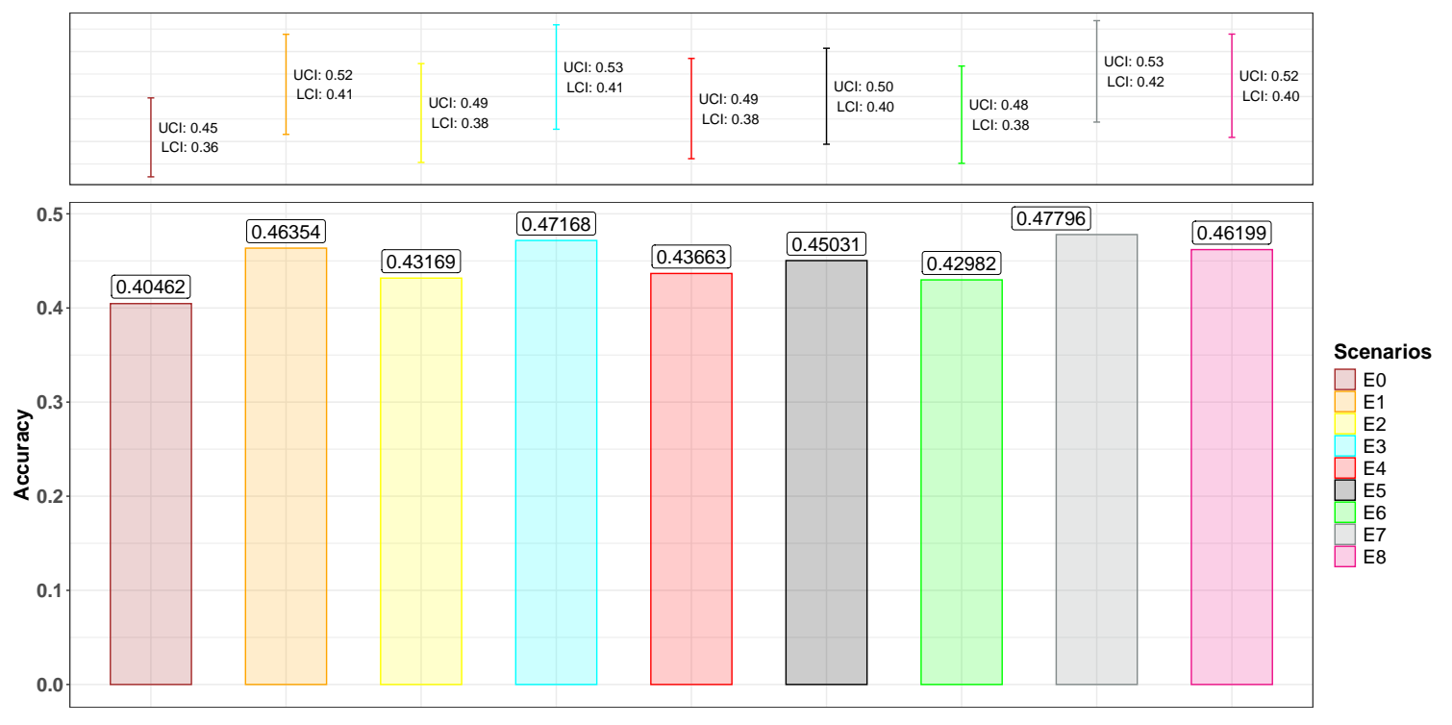
Figure 2. Estimates of accuracy for the trait age at first calving. The bar chart (bottom part of the graph) shows the accuracy estimate, while the error bars (top part of the graph) indicate the 95% confidence interval (UCI, Upper Confidence Interval; LCI, Lower Confidence Interval).

The bias and dispersion estimates for the trait of age at first calving can be seen in Table 1. Generally, across all scenarios, undesirable results were observed according to the expected measures (bias equal to 0 in the absence of bias and dispersion equal to 1 in the absence of dispersion). Comparing bias across scenarios, it was higher in E0, while in E7, the GEBV showed the least overestimation (0.08977). Regarding dispersion, there was apparent overdispersion of the GEBV, which was higher in scenarios E6 (1.11394) and E0 (1.10880), and lower in E7 (1.00012).

Table 1. Estimates of bias and dispersion for the trait age at first calving.

Scenarios | Bias | Dispersion
E0 | 0.11016 | 1.10880
E1 | 0.10359 | 1.04775
E2 | 0.10513 | 1.09873
E3 | 0.09566 | 1.02279
E4 | 0.10318 | 1.09684
E5 | 0.10350 | 1.06101
E6 | 0.10520 | 1.11394
E7 | 0.08977 | 1.00012
E8 | 0.09655 | 1.03032
E0, without genotype information; E1, genotypes with a density of 43,421 markers; E2, genotypes with a density of 579,424 markers; E3, genotypes with a density of 5,534 markers; E4, genotypes with a density of 97,779 markers; E5, genotypes with a density of 13,961 markers; E6, genotypes with a density of 203,612 markers; E7, genotypes with a density of 5,000 markers; E8, genotypes with a density of 13,999 markers.

For the trait of the interval between the first and second calving (Figure 3), a generally similar pattern was observed as previously presented for the age at first calving. The accuracy of the GEBV was higher in scenario E7, and overall, this accuracy was greater in scenarios where ssGBLUP was used, with values ranging from 0.39320 to 0.41911, compared to BLUP (0.34921). However, the uncertainty associated with the estimation of the GEBV was lower in scenario E0.

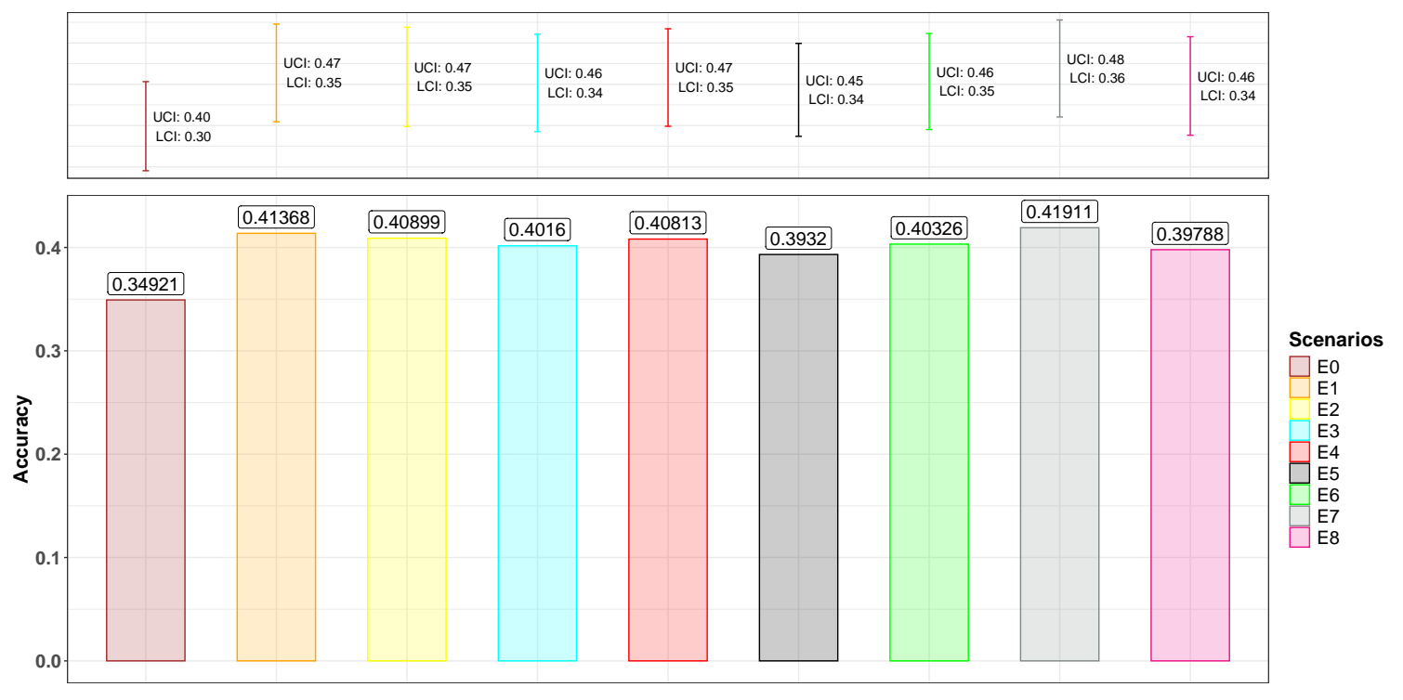
Figure 3. Estimates of accuracy for the trait interval between the first and second calving. The bar chart (bottom part of the graph) shows the accuracy estimate, while the error bars (top part of the graph) indicate the 95% confidence interval (UCI, Upper Confidence Interval; LCI, Lower Confidence Interval).

Regarding the bias estimates for the trait of the interval between the first and second calving (Table 2), all scenarios produced biased GEBV, with the least bias (closest to 0) observed in scenarios E2, E3, and E4. Additionally, the GEBV for this trait showed excessive dispersion, which was higher (further from 1) in scenario E0, where BLUP was used, with a value of 1.56294.

Table 2. Estimates of bias and dispersion for the trait interval between the first and second calving.

Scenarios | Bias | Dispersion
E0 | 0.06765 | 1.56294
E1 | 0.07395 | 1.45721
E2 | 0.05830 | 1.46762
E3 | 0.07242 | 1.43608
E4 | 0.05800 | 1.46456
E5 | 0.06926 | 1.45914
E6 | 0.05612 | 1.46343
E7 | 0.06809 | 1.42884
E8 | 0.07108 | 1.43433
E0, without genotype information; E1, genotypes with a density of 43,421 markers; E2, genotypes with a density of 579,424 markers; E3, genotypes with a density of 5,534 markers; E4, genotypes with a density of 97,779 markers; E5, genotypes with a density of 13,961 markers; E6, genotypes with a density of 203,612 markers; E7, genotypes with a density of 5,000 markers; E8, genotypes with a density of 13,999 markers.

The accuracy of GEBV for the trait of weaning weight derived from scenarios with markers of varying density is presented in Figure 4. For direct and maternal effects, the estimates ranged from 0.30376 (E0) to 0.40019 (E5) and from 0.30513 (E0) to 0.38741 (E3), respectively. Interestingly, the scenario with the highest accuracy was not the same for both direct and maternal effects, which could indicate that the accuracy of these estimates is dependent on the specific trait. Additionally, the uncertainty associated with the accuracy estimate was lower in scenario E0 compared to scenarios E1 to E8, indicating greater variability in the accuracy estimates when genomic information was used.

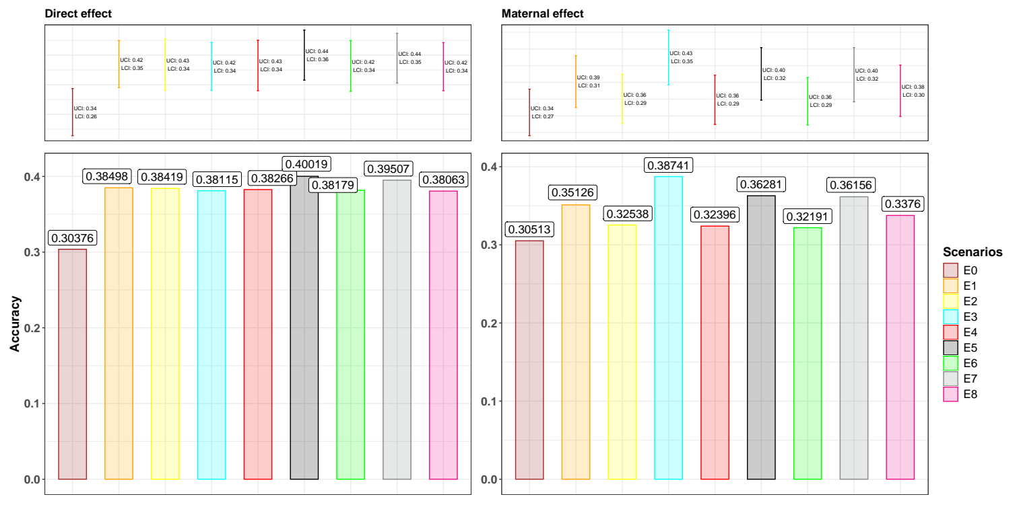
Figure 4. Estimates of accuracy for the trait weaning weight (direct and maternal effects). The bar chart (bottom part of the graph) shows the accuracy estimate, while the error bars (top part of the graph) indicate the 95% confidence interval (UCI, Upper Confidence Interval; LCI, Lower Confidence Interval).

The bias and dispersion estimators for direct and maternal effects of weaning weight can be seen in Table 3. For the direct effect, bias ranged from 0.04949 (E5) to 0.07085 (E7), while dispersion varied from 0.81701 (E0) to 0.99295 (E5). These results suggest that, although some scenarios presented lower biases, dispersion close to the optimal value of 1 was more common in scenarios with genomic information (E1 to E8), with E5 being the best-performing scenario in terms of bias and dispersion. Regarding the maternal effect, bias ranged from -0.04060 (E5) to 0.01641 (E0), and dispersion fluctuated from 0.75496 (E0) to 0.91915 (E5). Once again, scenarios that included genomic information tended to show dispersion closer to 1, although they also presented more pronounced negative biases.

Table 3. Estimates of bias and dispersion for the trait weaning weight.

Scenarios | Direct effect |  | Maternal effect
 | Bias | Dispersion | Bias | Dispersion
E0 | 0.05584 | 0.81701 | 0.01641 | 0.75496
E1 | 0.05908 | 0.92092 | -0.03365 | 0.90304
E2 | 0.06447 | 0.97738 | -0.03582 | 0.87405
E3 | 0.04949 | 0.99295 | -0.04060 | 0.91915
E4 | 0.06578 | 0.99099 | -0.03811 | 0.87307
E5 | 0.05422 | 0.92224 | -0.02332 | 0.82856
E6 | 0.06047 | 0.98355 | -0.03267 | 0.87436
E7 | 0.07085 | 0.87008 | -0.04046 | 0.85174
E8 | 0.05749 | 0.90903 | -0.03584 | 0.87986
E0, without genotype information; E1, genotypes with a density of 43,421 markers; E2, genotypes with a density of 579,424 markers; E3, genotypes with a density of 5,534 markers; E4, genotypes with a density of 97,779 markers; E5, genotypes with a density of 13,961 markers; E6, genotypes with a density of 203,612 markers; E7, genotypes with a density of 5,000 markers; E8, genotypes with a density of 13,999 markers.

5. References

Abraham, K. J. y Díaz, C. 2014. Identifying large sets of unrelated individuals and unrelated markers. Source Code for biology and Medicine 9 (6). https://doi.org/10.1186/1751-0473-9-6.

Aguilar, I. Tsuruta, S. Masuda, Y. Lourenco, D. A. L. Legarra, A. y Misztal, I. 2018. BLUPF90 Suite of Programs for Animal Breeding. 11th World Congr. Genet. Appl. Livest. Prod. 11, 751.

Bonifazi R. 2023. TuttiFrutti: A Collection of Miscellaneous R Functions and R Scripts. GitHub Repository. DOI: 10.5281/zenodo.11185709. Available on line: https://github.com/bonifazi/TuttiFrutti.
Browning, B. L. Zhou, Y. y Browning S. R. 2018. A one-penny imputed genome from next generation reference panels. Am J Hum Genet 103(3):338-348. doi:10.1016/j.ajhg.2018.07.015.

Díaz, C. Varona, L. Carabaño, M. J. Nicolazzi, E. Bichard, M. Baro, J. Molina, A. Piedrafita, J. Rossoni, A. Schwarzenbacher, H. Seyfried, F. Solberg T. R. Vicario, D. Altarriba, J y Abraham K. J. 2016. Using LD structure of several populations to optimize an SNP panel for conservation and selection. Journal of Animal Science 94: 168-169. https://doi.org/10.2527/jam2016-0350.

Legarra A. y Reverter A. 2018. Semi-parametric estimates of population accuracy and bias of predictions of breeding values and future phenotypes using the LR method. Genet Sel Evol 50(1):53. https://doi.org/10.1186/s12711-018-0426-6.

Lin, P., S. M. Hartz, Z. Zhang, S. F. Saccone, J. Wang, J. A. Tischfield, H. J. Edenberg, et al. 2010. A new statistic to evaluate imputation reliability. PLoS One 5 (3): e9697. https://doi.org/10.1371/journal.pone.0009697.

Misztal, I., A. Legarra, y I. Aguilar. 2009. Computing procedures for genetic evaluation including phenotypic, full pedigree, and genomic information. Journal of Dairy Science 92: 4648-55. https://doi.org/10.3168/ jds.2009-2064.

Purcell, S., B. Neale, K. Todd-Brown, L. Thomas, M. A. R. Ferreira, D. Bender, J. Maller, et al. 2007. Plink: a toolset for whole-genome association and population-based linkage analysis. American Journal of Human Genetics 81: 981-94. http://pngu.mgh.harvard.edu/purcell/plink/.

Rodriguez-Neira J., Peripolli E., de Negreiros M., Espigolan R., López-Correa R., Aguilar I., Lobo R. B. y Baldi F. 2022. Prediction ability for growth and maternal traits using SNP arrays based on different marker densities in Nellore cattle using the ssGBLUP. Journal of Applied Gnetics 63: 389-400. https://doi.org/10.1007/s13353-022-00685-0.

Wu X. L., Li H., Ferretti R., Simpson B., Walker J., Parham J., Mastro L., Qiu J., Schultz T., Tait jr R. G. y Bauck S. 2020. A unified local objective function for optimally selecting SNPs on arrays for agricultural genomics applications. Animal Genetics 51 (2): 306-310. https://doi.org/10.1111/age.12916.

