Oppgave 1 -> user stor stories

Case 1:

As an administrator I want to be able to save the template of the exam so that I can use it another time.

Case 2:

As a Administrator I want four multiple choices where only one is correct so that the participants has to choose between one.

Case 3:

As a participant I want to see my progress of the exam so that I know how many questions I have done and how many I have left.

Case 4:

As a participant I want to have my user profile so that I can download my approved certificates.

Case 5:

As a participant I want to see my score so that I know if I passed the test, or failed the test.

Oppgave 2:

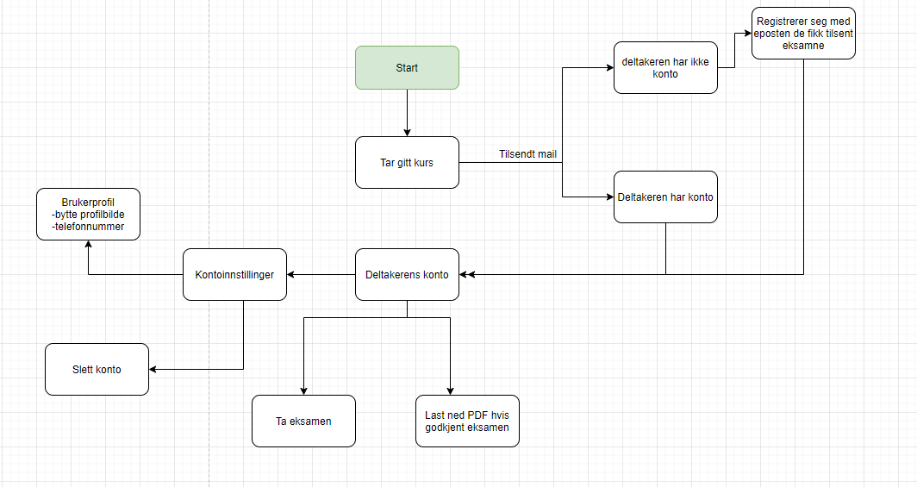

Oppgave 3

Ble litt usikker på hvor mange Wireframes vi skulle lage med tanke på at det sto vi skulle lage «en» enkel wireframe, men ble nesten umulig med å mange krav, så jeg prøvde å lage 4 som forklarer delvis hvordan det ville sett ut.

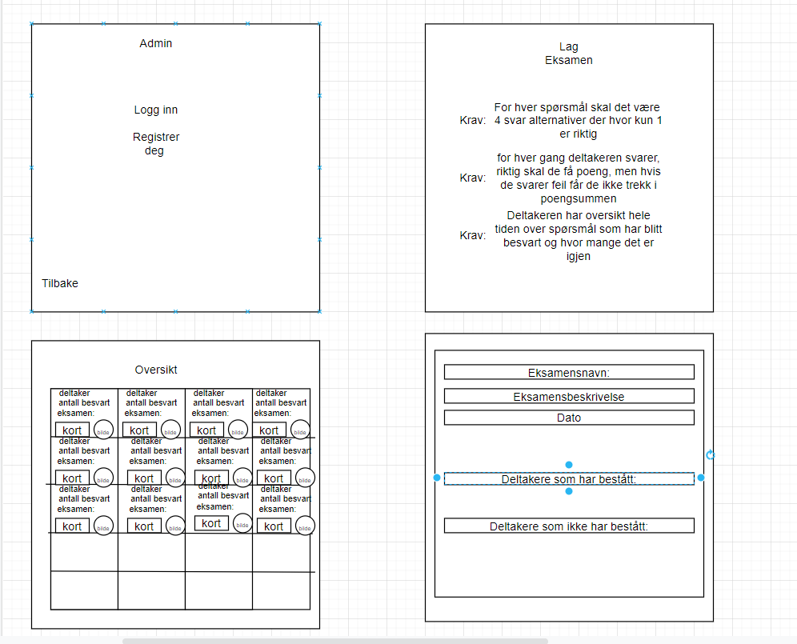

Oppgave 4:

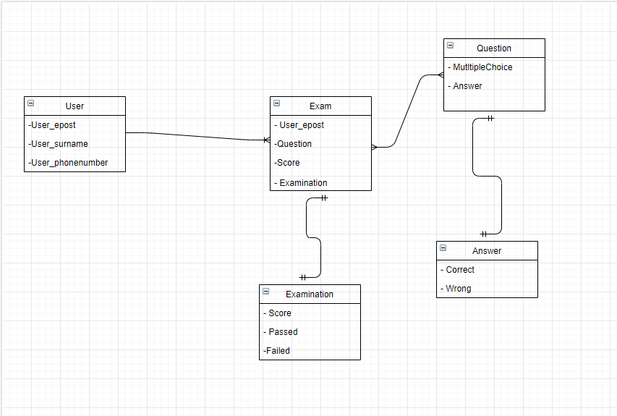

Oppgave 5:

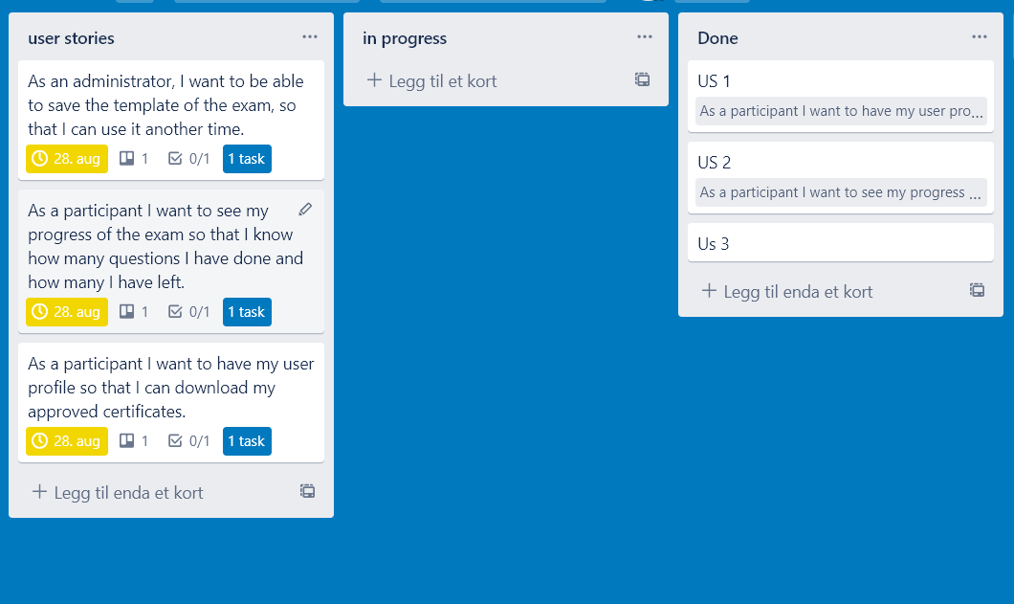

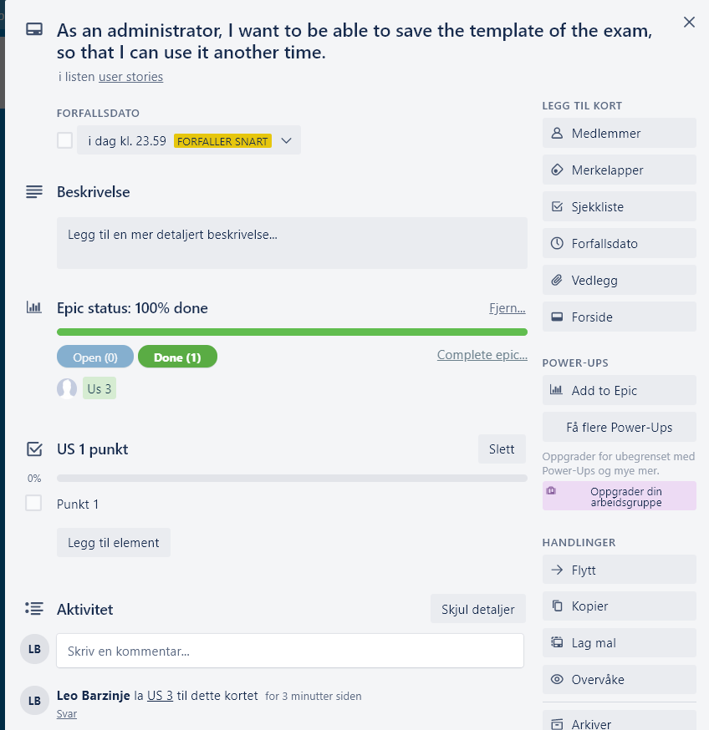

Oppgave 6