 |  |  |  | SOS-UG-001-II  EDIT. : 01 REV. : 00  DATE : 02/06/2010
 | Réf. CSSI/111-1/SOS/OSDMU-V5.0 du : 02/06/2010
Successive Order of Scattering
radiative transfer code
(version 5.0)
User Guide

Prepared by Bruno LAFRANCE (CS SI)
CS SI
Parc de la Plaine
5 Rue Brindejonc des Moulinais
BP 15 872
31506 Toulouse Cedex 5 - France

mail: bruno.lafrance@c-s.fr
tel: (33) 5 61 17 63 93

Software distribution by Olivier HAGOLLE (CNES / CESBIO)
CNES (DCT/SI/MO) and CESBIO
BPI 811
18 avenue Edouard Belin
31401 Toulouse Cedex 9- France

mail: olivier.hagolle@cnes.fr
tel : (33) 5 61 28 21 35

MODIFICATION

Edition | Revision | Date | Evolution cause
01 | 00 | 02/06/2010 | Document created

REFERENCE DOCUMENTS

DR1 : Bodhaine B., N. Wood, E. Dutton, and J. Slusser « oOn Rayleigh Optical Depth Calculations », J. Atmos. And Oceanic Technology, vol. 16, pp. 1854-1861, 1999.

DR2 : Bréon F.M., D. Tanré, P. Lecomte, and M. Herman« Polarized reflectance of bare soils and vegetation : Measurements and models », IEEE Trans. Geosci. Remote Sensing.., vol. 33, pp. 487-499, 1995.

DR3 : Cox C. and W. H. Munk, « Measurements of the Roughness of the Sea Surface from Photographs of the Sun’s Glitter », J. Optical Soc. America, Vol. 44, No. 11, 1954.

DR4 : Deuzé J.L, « Etude de la polarisation du rayonnement par les milieux diffusants, application à la polarisation localisée de Vénus », rapport de thèse, Université des Sciences et Techniques de Lille, 1974.

DR5 : Deuzé J.L, M. Herman, and R. Santer, « Fourier series expansion of the transfer equation in the atmosphere-ocean system », J. Quant. Spectrosc. Radiat. Transfer, vol. 41, no. 6, pp. 483-494, 1989.

DR6 : Dubovik O., Holben B., Eck T. F., Smirnov A., Kaufman Y. J., King M. D., Tanré D. and Slutsker I. « Variability of Absorption and Optical Properties of Key Aerosol Types Observed in Worlwide Locations », J. Atmos. Sciences, vol. 59, pp. 590-608, february 2002.

DR7 : Dubovik, O.et al., Application of spheroid models to account for aerosol particle nonsphericity in remote sensing of desert dust, J. Geophys. Res., 111, D11208, doi:10.1029/2005JD006619, 2006.

DR8 : Hansen J. and Travis L., “Light scattering in planetary atmospheres”, Space Sci. Rev., Vol. 16., pp. 527-610, 1974..

DR9 : Herman M and J.L. Deuzé, « Observation de la terre en lumière polarisée. Simulations numériques par le code des ordres successifs de diffusion. Notice scientifique », Laboratoire d’Optique Atmosphérique, Lille, 2002.

DR10 : Kuscer I. and M. Ribaric, « Matrix formalism in the theory of diffusion of light », Optica Acta, vol. 6, no. 42, 1959.

DR11 : Lenoble, J. et al., A successive order of scattering code for solving the vector equation of transfer in the earth's atmosphere with aerosols, J. Quantitative Spectroscopy & radiative transfer, vol. 107, n°3, pp. 479-507, 2007.

DR12 : Nadal F., « Analyse de la polarisation pour la télédétection de l’atmosphère et des surfaces grâce aux mesures spatiales POLDER», rapport de thèse, Université Paris VII, 1999.

DR13 : Rondeaux G. and M. Herman, « Polarization of light reflected by crop canopies », Remote Sens. Env., no. 38, pp. 63-75, 1991.

DR14 : Roujean J.L., M. Leroy, and P.Y. Deschamps, « A bidirectional reflectance model of the Earth surface for the correction of remote sensing data », J. Geophys. Res., no. 97, pp. 20455-20468, 1992.

DR15 : Shettle Eric P. and Fenn Robert W., « Models for the Aerosols of the Lower Atmosphere and the Effects of Humidity Variations on Their Optical Properties », Air Force Geophysics Laboratory. September 1979, AFGL-TR-79-0214, Environnemental Research papers, No. 676.

DR16 : Siewert C. E., « On the equation of transfer relevant to the scattering of polarized light », The Astrophysical J., vol. 245, no. 3, part 1, pp. 1080-1086, 1981.

DR17 : Stratton J.A., Electromagnetic theory, McGraw Hill Book, New York, USA, 615 pp., 1941.

DR18 : Vermote et al., Manuel – « Second Simulation of the Satellite Signal in the Solar Spectrum. 6S User Guide Version 1 », 15/09/97.

DR19 : World Climate Research Programme, « A preliminary cloudless standard atmosphere for radiation computation », WCP-112, WMO/TD Report No 24, Geneva, Switzerland , March 1986

TABLE OF CONTENTS

I- Introduction 6
II- Installation 8
II-1 Software and hardware environment 8
II-2 SOS Arborescence 8
II-3 Compiling 10
III- Operating mode 11
III-1 Defining the environment variables 12
III-2 Defining simulation parameters 12
III-2.1 Parameter list 13
III-2.2 Definition of angular conditions 25
III.2.2.a radiance field simulation parameters 25
III.2.2.b phase function parameters 27
III-2.3 Surface conditions 29
III.2.3.a Sea surfaces 29
III.2.3.b Land surfaces 29
III.2.3.c Files for surface reflection matrices 30
III-2.4 Atmospheric conditions 33
III.2.4.a Molecular diffusion 33
III.2.4.b Aerosol diffusion and absorption 34
III.2.4.c File format of the external phase functions 39
III.2.4.d Content and format of a file of type AEROSOLS for the SOS code 41
III-2.5 Type of output 42
III-2.6 Output files 46
III-2.7 Example of launch file : Simulation over the ocean 47
III-3 Constant parameters of the simulation 48
III-3.1 List of constant parameters included in SOS.h 48
III-3.2 Modification of the number of profile layers 52
IV- Software description 53

Introduction
The Successive Order of Scattering code simulates the scattered and polarized radiance of the system {surface – atmosphere}, under a clear sky and without gaseous absorption.

The concentration profile of particles (aerosols and molecules) is modelled through the division of the atmosphere in layers of optical thickness. For each level, considering the particle mixture, a phase matrix characterizes the scattering properties of the layer right above.
τ = τ∗
τ = 0
LayerNT
Layer 2
Layer 1
Level 0 : TOA
Level 1
Level NT
Level 2
Atmospheric profile

Light propagation through the atmosphere is described by the Equation of Radiative Transfer (ETR). At each level, the SOS code starts by computing the radiance field caused by the single-scattering of the direct solar beam (the solar irradiance is set equal to π in order to compute normalized radiance values). From these first radiation fields, one may derive the global field of single-scattering: by integrating the ETR for the upward field (considering the surface reflection of the direct solar beam) or for the downward field, the SOS code computes iteratively (layer after layer) the single scattering radiance emerging at TOA or illuminating the ground. The polarized radiance is computed as well.
This radiance field of order 1 induces the 2nd surface reflection and the source function of the 2nd scattering at each level of the atmospheric profile. The global radiation field of order 2 is then obtained by the same type of solution as for the single-scattering. By computing iteratively the successive terms of interaction and by adding them, we obtain the global field of radiance for each layer.

The complexity of the method lies on the expansion into Fourier series of the azimuth in order to separate zenith-dependent terms from azimuth-dependent terms in the expression of the radiance. This mathematical formalism is used to speed up the processing by a significant amount.

The complexity of the method lies on the use of Fourier series expansion in order to separate zenith-dependent terms from azimuth-dependent terms in the expression of the radiance. This mathematical formalism is used to speed up the processing by a significant amount.

The SOS code was first implemented by M. Deuzé during his PhD studies, which were dealing with the polarization of light by scattering media [Laboratoire d’Optique Atmosphérique, 1974, DR4]. The code was then extended to enable simulation of the sunglint reflection by the sea [1989, DR5].
The current version of the SOS code integrates the initial functions with new and improved methods of simulation:
- The aerosol data base has been widened : it is now possible to simulate mono-modal particle size distribution model (log or Junge function) as well as more complex models such as bimodal distributions [DR6] or predefined models from WMO [DR19] and Shettle & Fenn [DR15] (continental, urban, maritime or coastal models which consider relative air humidity). It is also possible to import phase functions from an external source which can be used to simulate scattering effects of non-spherical aerosols (with a random orientation). The position of the aerosol layer may be modified in the atmospheric profile definition.
- The use of new surface conditions is made possible: reflection model by Roujean [DR14], reflection model with polarisation by Rondeaux [DR13] for vegetation or by Bréon [DR2] for bare ground, semi-empirical model by Nadal [DR12].
The software code has gone through a refactoring phase, which included corrections of anomalies, adding of comments, reorganisation and optimization. The computation time has significantly decreased. The use of the software has been simplified: processing parameters are defined by “-Keyword Value”; the angles for Gauss quadrature and the associated values for limit orders of expansion are defined by the code.

This document is the user manual of the version 5.0 of the Successive Order of Scattering code.
It contains the description of the installation procedure and operating modes.

Installation

Software and hardware environment
The SOS software runs on a :
- SUN machine with SOLARIS operating system,
- PC with RedHat LINUX.
using a Fortran compiler (g77 or f77).

Note: The application outputs binary files (Mie calculations and surface reflection matrices) which formats are not compatible between SUN and PC architectures (data are recorded with different endianess : Most Significant Bit First against Least Significant Bit First).

SOS Arborescence
The SOS arborescence must first be copied on the user account.

The file structure is composed of the following sub-directories :
-src : contains the sources
SOS_ANGLES.F : manages angles and expansion orders.
SOS_AEROSOLS.F : computes aerosol radiative parameters.
SOS_MIE.F : generates MIE files
SOS_PROFIL.F : defines the atmospheric profiles
SOS_SURFACE.F : generates surface BRDF / BPDF files
SOS_GLITTER.F : computes reflection matrices for sun glint
SOS_ROUJEAN.F : computes Roujean’s BRDF matrices
SOS_RONDEAUX_BREON.F : generates BPDF matrices from Rondeaux or Bréon models
SOS_NADAL.F : generates BPDF matrices from Nadal model.
SOS_NOM_FIC_SURFACE.F : manages file names of surface reflection matrices
SOS.F : main program for successive scattering computations.
SOS_OS.F : computes the scattered and polarised radiance field (I, Q, U) for a diffuse atmosphere.
SOS_TRPHI.F : outputs result files for Stokes parameters I, Q, U.

-obj : folder for compiled files.

-exe : contains all executables and a KSH launch script
5 executables :
SOS_ANGLES.exe generates the files for the angles
SOS_AEROSOLS.exe generates the aerosol files,
SOS_PROFIL.exe generates the atmospheric profiles
SOS_SURFACE.exe generates the surface reflection matrices
SOS.exe computes the successive order of scattering.
2 ksh files (KornShell) :
runOS.ksh allows to select simulation parameters and feeds the main script main_SOS.ksh with arguments,
main_SOS.ksh supervises the workflow and calls the different executables.
1 text file:
config.txt is a copy of the file « SOS.h » (cf. §III-3). It contains the values of all constant parameters which were used for the compilation.

-inc : contains the file « SOS.h » which lists all constant parameters (cf. §III-3). All programs share this file. It specifies the size of 2D-arrays, names of data files issued from WMO and Shettle & Fenn aerosol models, as well as required thresholds.

-gen : contains Makefiles used for compilation and link.

-fic : contains data files required for the processing :
Aerosol data files from WMO and Shettle & Fenn models: DataWMO, DataSF, IRefrac_LR, IRefrac_LU, IRefrac_OM, IRefrac_SR, IRefrac_SU.

-doc : contains 5 text files :
Install.txt : installation from the SOS code.
Fichier.txt : description of file contents used by the SOS code.
Manuel.txt : execution of SOS code.
SOS-MU-001-II-E3-R0 : user guide (French version) in Microsoft Word format (.doc) and PDF format (.pdf).
SOS-UG-001-II-E1-R0: user guide (English version) in Microsoft Word format (.doc) and PDF format (.pdf).

Compiling
a) As a precaution, suppress all object files .o (rm *.o) in the directory obj.
b) assign the environment variable RACINE to the SOS main folder’s path.
Example : export RACINE=/users/username/SOS.
Type “ls $RACINE” to display all sub-directories described in section II-2.
It is recommended to define the variable $RACINE in a « .profile » or « .khsrc » file of the user account so as to avoid redefining it every time.
c) change directory to gen (cd $RACINE/gen).
d) run the makefile :
make -f Makefile.xxx
with xxx=g77 if the compiler g77 is available,
avec xxx=f77 if the compiler f77 is available.
Upon completion, one can find :
- In $RACINE/obj : object files output by the compiler,
- In $RACINE/exe :
5 executables SOS.exe, SOS_AEROSOLS.exe, SOS_ANGLES.exe, SOS_PROFIL.exe and SOS_SURFACE.exe in addition to the KSH scripts.

Operating mode
This chapter describes the procedure required in order to execute a simulation.
The processing parameters are divided in two sets :
- parameters specific to the simulation, specified in runOS.ksh,
- dimensioning parameters and threshold values defined in the include file SOS.h.

The parameters are interactively entered by the user when calling the main script main_SOS.ksh. It is also possible to define the parameters directly in the script runOS.ksh (under $RACINE/exe) which sets the required environment variables and executes main_SOS.ksh. The script runOS.ksh specifies all simulation parameters : physical parameters describing surface properties (albedo, BRDF, BPDF) and atmosphere content (molecules, aerosols), as well as the solar angle. runOS.ksh also allows to specify the type of desired output (viewing for a given plan of azimuth or global field of view, profile level, maximum order of interactions, switching off polarisation) as well as required angles (number of Gauss angles for spatial integrations, and list of user-defined angles). The user may also define the names of the output files, log files, and the arborescence for storing Mie and BRDF or BPDF files.

The include file SOS.h (under $RACINE/inc) contains all simulation constant parameters. It defines all dimensioning parameters which values are taken into account at compilation time.
Any change made to a constant parameter must be followed
by software recompilation to become effective.
The SOS.h file specifies 6 types of constant parameters:
- Constant values common to all programs such as length of character arrays.
- Constant values specific to SOS_AEROSOLS methods.
- Constant values specific to atmospheric profile definition.
- Constant values specific to computation of surface reflection matrices.
- Constant values specific to SOS methods, including threshold values in particular for testing whether the end of the processing has been reached.
- Constant values specific to angle definition and orders for the Fourier series and Legendre polynomials expansions.

Modification of the include file SOS.h is rarely necessary. Any change to its content requires a detailed knowledge of the software.

Defining the environment variables
All paths to executables, input and output files are defined by the environment variables which are set by runOS.ksh.

runOS.ksh requires 3 environment variables :
- $sos_racine is set to the $racine variable which itself points to the root directory of the software (refer to II-3).
- $sos_result specifies the output directory.
- $sos_racine_fic specifies the directory for predefined aerosol data files (WMO and Shettle&Fenn models).

Environment varaibles | runOS.ksh
Nom | Description
SOS_RACINE | Path to the SOS arborescence
SOS_RESULT | Path to the output files
SOS_RACINE_FIC | Path to predefined aerosols files (WMO and Shettle & Fenn models)

Defining simulation parameters
There are 5 sets of parameters:
- Parameters for required angles.
- Base parameters for radiation field.
- Parameters for surface conditions.
- Parameters for the atmospheric profile (optical thickness).
- Parameters for aerosols.

These parameters are defined by « -Keyword Value » during the call to main_SOS.ksh.
Chapter III-2.1 lists all simulation parameters.
Chapter III-2.2(p. 25) defines parameters for angular conditions.
Chapter III-2.3 (p. 30) defines parameters relative to surface conditions.
Chapter III-2.4 (p. 34) defines the atmospheric parameters.
Chapter III-2.5 (p. 43) defines the output type.
Chapter III-2.6 (p. 47) defines available output files
Finally, Chapter III-2.7 (p. 48) illustrates a simulation.

Parameter list
The following sketches indicate the input parameters (Keyword) to main_SOS.ksh.
Table 1 further describes all parameters.

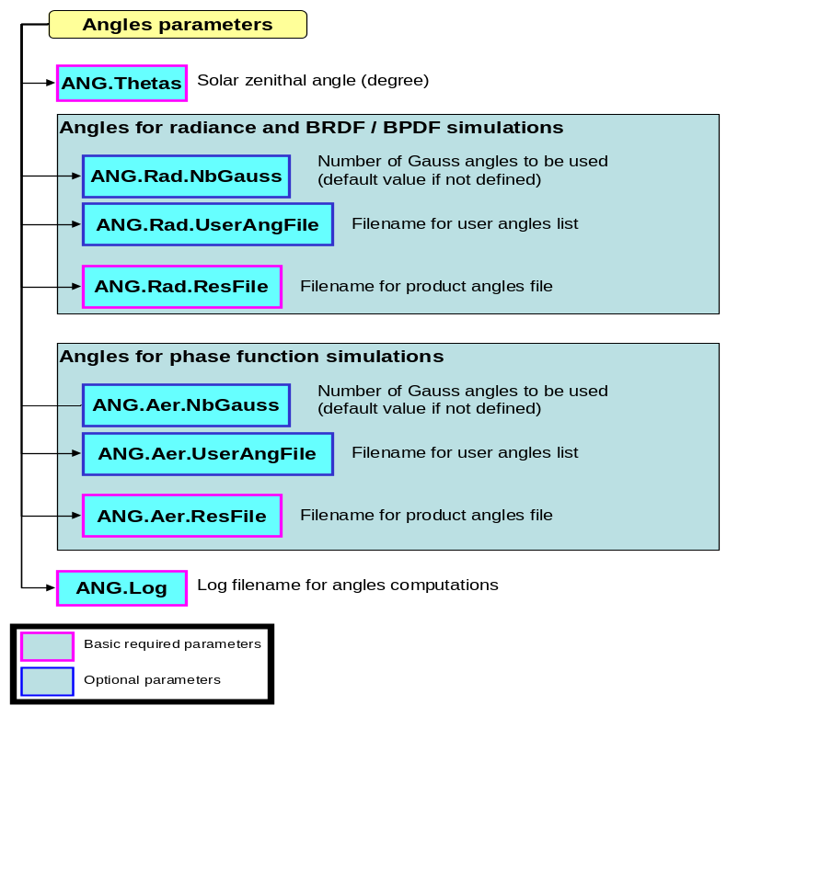
Figure 1 : main_SOS.ksh parameters for angle definition

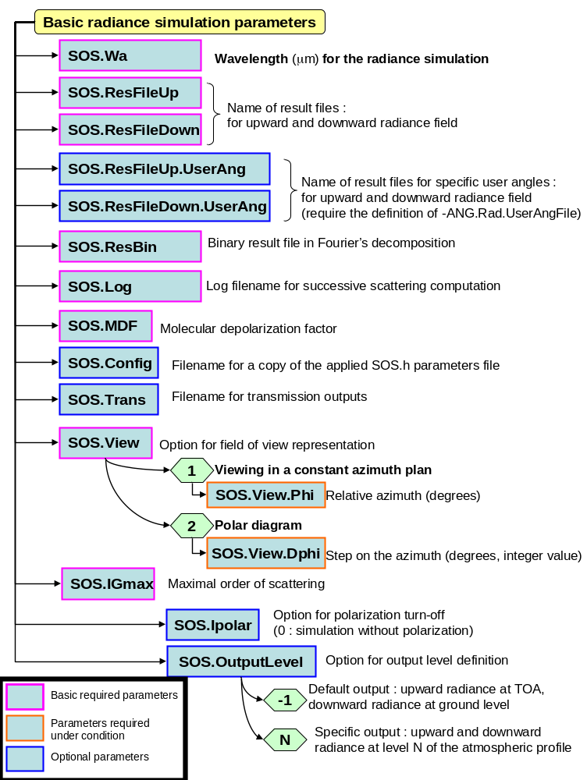
Figure 2 : main_SOS.ksh base parameters for radiation field simulation

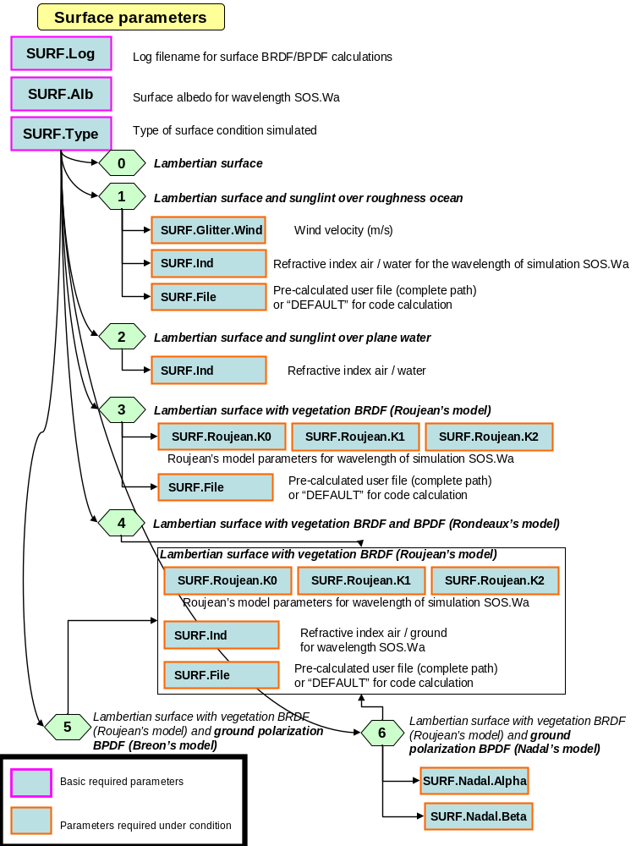
Figure 3 : main_SOS.ksh parameters for surface conditions

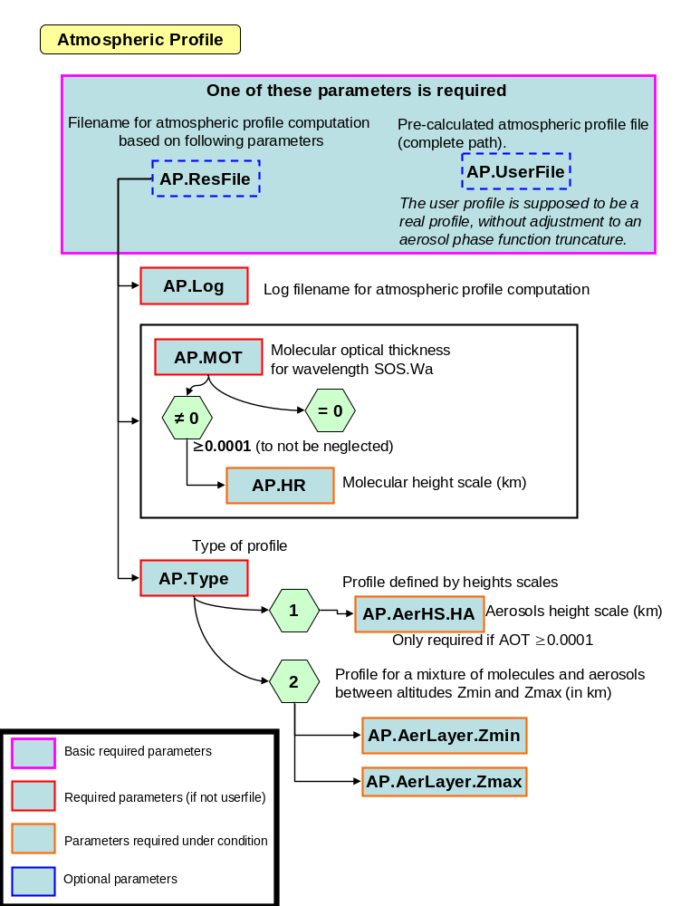
Figure 4 : main_SOS.ksh parameters for atmospheric profiles

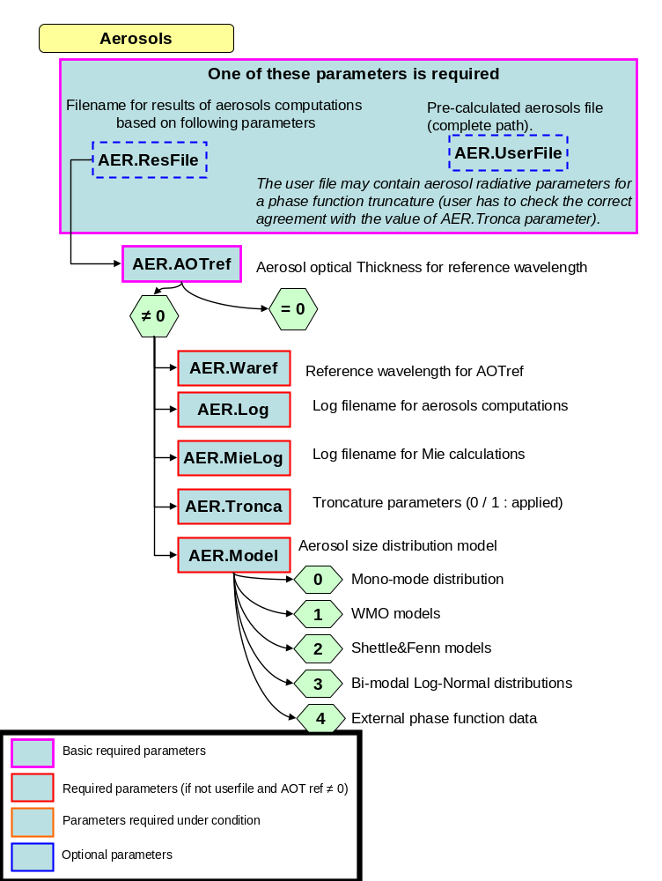
Figure 5 : main_SOS.ksh parameters for aerosols (1/2)

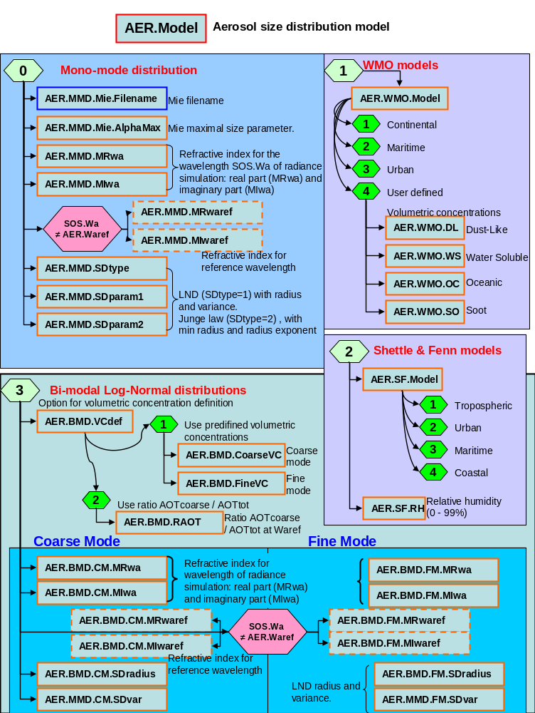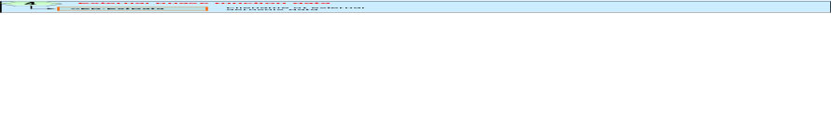
Figure 6 : main_SOS.ksh parameters for aerosols (detailed options) (2/2)

Tableau 1 : Simulation parameters
Simulation parameters :
Description of inputs, outputs, physical parameters, and processing options
Directories for surface reflection files, Mie files, Log files and output files.
dirSUNGLINT | Directory for sun glint model reflection files
dirROUJ | Directory for Roujean model reflection files
dirRH | Directory for Rondeaux – Herman model reflection files
dirBREON | Directory for Bréon model reflection files
dirNADAL | Directory for Nadal model reflection files
dirMIE | Directory for Mie files
dirLOG | Directory for log files
dirRESULTS | Directory for output files
Solar incidence parameters and definition of angles
ANG.Thetas |  | Solar zenith angle in degrees (0 < thetas < 90°)
ANG.Rad.NbGauss |  | Number of Gauss angles for radiance and BRDF/BPDF simulations
ANG.Rad.UserAngFile |  | File name of additional user-defined angles for radiance computations.
ANG.Rad.ResFile |  | Output file name of angles and maximum orders of series expansion to be used for radiance computations.
ANG.Aer.NbGauss |  | Number of Gauss angles for phase functions
ANG.Aer.UserAngFile |  | File name of additional user-defined angles for phase functions.
ANG.Aer.ResFile |  | Output file name of angles and maximum orders of series expansion to be used for phase functions.
ANG.Log |  | Log filename for the ANGLES function  Enter 0 for no log file
Wavelength for radiance simulation
SOS.Wa |  | Wavelength for radiance simulation (μm)
Atmospheric profile parameters
AP.Log |  | Log file name of the executable named PROFIL  Enter 0 for no log file
AP.ResFile |  | PROFIL file name: Used if no User file  Note : File overwritten by each run
AP.userFile |  | File name for user-precomputed atmospheric profile (full path)  Note :the user profile is assumed to be a real profile which has not undergone adjustment with respect to the truncation of the aerosol phase function.
Molecules
AP.MOT |  | Rayleigh optical thickness
If AP.MOT ≥ 0.0001
AP.HR |  | Height scale of the molecular profile (km)
Profile type
AP.Type |  | Type of the output profile :  1 : profile only defined by height scales  2 : profile defined with 3 distinct layers : molecules, molecules + aerosols, molecules
If AP.Type = 1 and AOT ≥ 0.0001
AP.AerHS.HA |  | Height scale of the aerosol profile (km)
If AP.Type = 2
AP.AerLayer.Zmin |  | Minimum layer altitude of the mixture molecules + aerosols (km)  Note : 0 altitude is possible for the two-layer case : molecules + aerosols, molecules
AP.AerLayer.Zmax |  | Maximum layer altitude of the mixture molecules + aerosols (km)

Aerosols parameters
AER.MieLog | Log filename of Mie calculations  Enter 0 for no log file
AER.Log | Log filename of the AEROSOLS executable  Enter 0 for no log file
AER.ResFile | Default file name for AEROSOLS output  File overwritten by each run
AER.UserFile | File name for user-precomputed Aerosols radiative properties (full path).  Note : The file Aerosols includes the information relative to truncation if has occurred. It can only be used if processing is performed on the same wavelength as for the simulation (reference wavelength identical to the wavelength for simulation of the radiation field).
AER.Waref | Reference wavelength (μm) for simulation of aerosol radiative properties
AER.AOTref | Aerosol optical thickness for the reference wavelength
AER.Tronca | Phase function truncation 0 : no  1 : yes
Aerosols : size distribution model
AER.Model | Type of aerosol models  0 : mono-modal  1 : WMO multi-modal  2 : Shettle & Fenn bi-modal  3 : Log-Normal bi-modal  4 : phase functions from an external source
If AER.Model = 0 : Mie parameters (mono-modal particle model)
AER.MMD.Mie.Filename | Mie filename written to dirMIE  User name or DEFAULT for a default name
AER.MMD.Mie.AlphaMax | Maximum value for size parameter
AER.MMD.MRwa | Real part of the refractive index for the simulation wavelength
AER.MMD.MIwa | Imaginary part of the refractive index (negative value) for the simulation wavelength
If AER.Waref ≠ SOS.Wa
AER.MMD.MRwaref | Real part of the refractive index for the reference wavelength
AER.MMD.MIwaref | Imaginary part of the refractive index for the reference wavelength
If AER.Model = 0 : parameters of mono-modal size distributions
AER.MMD.SDtype | Model index  1 : Log-Normal size distribution  2 : Junge law
AER.MMD.SDparam1 | Parameter of size distribution  If LND : modal radius (μm)  If Junge : minimal radius (μm)
AER.MMD.SDparam2 | Parameter of size distribution  If LND : log10 of variance  If Junge : radius exponent
If AER.Model = 1 WMO model
AER.WMO.Model | WMO model 1 : Continental 2 : Maritime  3 : Urban 4 : User-defined
If AER.WMO.Model = 4 : user concentrations (sum=1)
AER.WMO.DL | Volumetric concentration of « Dust-Like » components  (value between 0 and 1)
AER.WMO.WS | Volumetric concentration of « Water Soluble » components  (value between 0 and 1)
AER.WMO.OC | Volumetric concentration of « Oceanic » components  (value between 0 and 1)
AER.WMO.SO | Volumetric concentration of « Soot » components  (value between 0 and 1)
If AER.Model = 2 : Shettle & Fenn
AER.SF.Model | Shettle & Fenn model 1 : Tropospheric 2 : Urban  3 : Maritime 4 : Coastal
AER.SF.RH | Percentage of relative humidity (from 0 to 99%)
If AER.Model = 3 :bi-modal LND
AER.BMD.CVdef | Choice of mixture description type  1 : Use of predefined volumetric concentrations  2 : Use of the ratio of optical thickness of coarse mode over total optical thickness
If AER.BMD.Option= 1 : user-defined volumetric concentrations
AER.BMD.CoarseVC | volumetric concentration of the coarse mode
AER.BMD.FineVC | volumetric concentration of the fine mode
SIf AER.BMD.Option= 2 :
Use of ratio coarse mode optical thickness over total AOT
AER.BMD.RAOT | ratio of coarse mode optical thickness over total one for the reference wavelength.
Coarse mode LND parameters
AER.BMD.CM.MRwa | Real part of the refractive index for the coarse mode particles at simulation wavelength
AER.BMD.CM.MIwa | Imaginary part of the refractive index for the coarse mode particles at simulation wavelength
AER.BMD.CM.SDradius | Modal radius of LND size distribution for the coarse mode (μm)
AER.BMD.CM.SDvar | Log10 variance of LND size distribution for the coarse mode
If AER.Waref ≠ SOS.Wa
AER.BMD.CM.MRwaref | Real part of the refractive index for the coarse mode particles at reference wavelength
AER.BMD.CM.MIwaref | Imaginary part of the refractive index for the coarse mode particles at reference wavelength
Fine mode LND parameters
AER.BMD.FM.MRwa | Real part of the refractive index for the fine mode particles at simulation wavelength
AER.BMD.FM.MIwa | Imaginary part of the refractive index for the fine mode particles at simulation wavelength
AER.BMD.FM.SDradius | Modal radius of LND size distribution for the fine mode (μm)
AER.BMD.FM.SDvar | Log10 variance of LND size distribution for the fine mode
If AER.Waref ≠ SOS.Wa
AER.BMD.FM.MRwaref | Real part of the refractive index for the fine mode particles at reference wavelength
AER.BMD.FM.MIwaref | Imaginary part of the refractive index for the fine mode particles at reference wavelength
If AER.Model = 4 : phase functions from an external source
AER.ExtData | Filename of external phase function data (full path)

surface Conditions
SURF.Log | Log file name for SURFACE executable  Enter 0 for no log file
SURF.Alb | Surface albedo
SURF.Type | Surface type index  0 : lambertian surface of albedo SURF.Alb  1 : lambertian surface + sunglint (rough sea)  2 : lambertian surface + Fresnel reflection (calm, flat sea)  3 : lambertian surface + Roujean BRDF  4 : lambertian surface + Roujean BRDF + Rondeaux BPDF  5 : lambertian surface + Roujean BRDF + Bréon BPDF  6 : lambertian surface + Roujean BRDF + Nadal BPDF
If SURF.Type = 1 or ≥ 3
SURF.File | Surface reflection file name  - File name for user-precomputed Surface reflection matrix (full path). Note : this does not prevent from defining associated parameters that will be useful for analytical calculation of direct reflection.  - DEFAULT for a default name (reflection matrix will be generated by the software).
If SURF.Type ≠ 3:for all models except Roujean’s
SURF.Ind | Refractive index surface / air
If SURF.Type = 1 : sunglint
SURF.Glitter.Wind | Wind speed in m/s
If SURF.Type ≥ 3 : Roujean’s BRDF model
SURF.Roujean.K0 | Roujean’s model parameter k₀
SURF.Roujean.K1 | Roujean’s model parameter k₁
SURF.Roujean.K2 | Roujean’s model parameter k₂
If SURF.Type = 6 : Nadal’s BPDF model
SURF.Nadal.Alpha | Nadal’s model parameter α
SURF.Nadal.Beta | Nadal’s model parameter β

Molecular scattering parameter
SOS.MDF | Molecular depolarisation factor

Viewing conditions
SOS.View | Index of output type  1 : viewing plane  2 : polar diagram (ascii file)
SOS.View.Phi | Relative azimuth angle (degrees) used if SOS.View = 1
SOS.View.Dphi | Azimuth step angles( degrees / integers only ) used if SOS.View = 2
Choice of output type
SOS.OutputLevel | Profile level (optional)  If not defined : standard output (L↑ TOA, L↓ sol)  n : upward and downward radiance at profile level n (0 ≤ n ≤ SOS_OS_NT)
SOS.IGmax | Scattering maximum order
SOS.Ipolar | Polarisation truncated index (optional)  0 : simulation of SOS without polarisation  If not defined : simulation with polarisation (recommended)
Ouput file names
SOS.Log | SOS log file name :  Enter 0 for no log file
SOS.ResBin | File name of SOS binary output for Fourier series
SOS.ResFileUp | Ascii file name of the output upward field
SOS.ResFileDown | Ascii file name of the output downward field
SOS.ResFileUp.UserAng | Ascii file name of the output upward field restricted to user-defined angles
SOS.ResFileDown.UserAng | Ascii file name of the output downward field restricted to user-defined angles

Definition of angular conditions
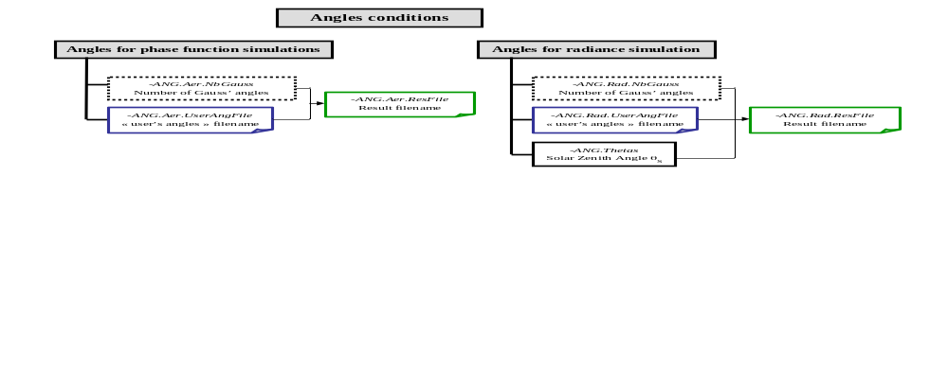

radiance field simulation parameters
The Sun’s elevation is expressed by its zenith angle θ_{s} (degrees) : 0 for the Sun at zenith.

The radiance is computed for a discretization of the radiation field with Gauss angles. The user may specify the quadrature order by including the argument ANG.Rad.NBGauss directly in the command line (positive μ_{G} numbers). If not, the value sos_default_nbmu_lum defined by default in SOS.h is used.
The user may also define the angles for which radiance values are expected. The file name is given by the argument -ANG.Rad.UserAngFile. This file contains a list of angles (degrees) , one record per line.

Example of user-defined angles
5.
10.
20.
25.
30.
Requirements :
- Angle values must lie between 0 and 90 degrees (in order to define μ > 0 values, opposite values are automatically added by the code).
- Number of records shall not exceed sos_nbmax_user_angles (in SOS.h).

The user specifies the output file name (–ANG.Rad.ResFile). This file contains the angles to be used by the SOS code as well as the maximum orders of the expansions to be applied.

NB_TOTAL_ANGLES | Total number of angles to be used
NB_GAUSS_ANGLES | Number of Gauss angles
ANGLES_USERFILE | Filename for user-defined angles (NO_USER_ANGLES if no file ).
SOLAR ZENITH ANGLE | Solar zenith angle (degrees)
INTERNAL_IMUS : | Index number in the 2D array for solar zenith angle
INTERNAL_OS_NB | Maximum order for expansion of phase functions as Legendre polynomials
INTERNAL_OS_NS : | Maximum order of the Legendre polynomials for the Fresnel matrix elements and Fourier series for the radiance.
INTERNAL_OS_NM | Maximum order of the Fourier series for the G function which acts as a weight factor to the Fresnel matrix during computation of the reflection matrices.
INDEX COS_ANGLE WEIGHT OUTPUT  •  •  • |  | For each line: angle index, cosine, weight, and whether the angle is a user’s defined: (1) if yes, (0) if no.  Format: I4,X,2D21.14,X,I4.

Example of an angle file for radiance computation:
NB_TOTAL_ANGLES : 24
NB_GAUSS_ANGLES : 24
ANGLES_USERFILE :NO_USER_ANGLES
SOLAR ZENITH ANGLE : 32.479
INTERNAL_IMUS : 9
INTERNAL_OS_NB : 80
INTERNAL_OS_NS : 48
INTERNAL_OS_NM : 128
INDEX COS_ANGLE WEIGHT OUTPUT
1 0.99877100725243E+00 0.31533460522976E-02 0
2 0.99353017226635E+00 0.73275539012758E-02 0
3 0.98412458372283E+00 0.11477234579235E-01 0
4 0.97059159254625E+00 0.15579315722944E-01 0
5 0.95298770316043E+00 0.19616160457356E-01 0
6 0.93138669070655E+00 0.23570760839325E-01 0
7 0.90587913671557E+00 0.27426509708357E-01 0
8 0.87657202027425E+00 0.31167227832799E-01 0
9 0.84358826162439E+00 0.34777222564771E-01 0
10 0.80706620402944E+00 0.38241351065831E-01 0
11 0.76715903251574E+00 0.41545082943465E-01 0
12 0.72403413092381E+00 0.44674560856694E-01 0
13 0.67787237963266E+00 0.47616658492491E-01 0
14 0.62886739677651E+00 0.50359035553855E-01 0
15 0.57722472608397E+00 0.52890189485194E-01 0
16 0.52316097472223E+00 0.55199503699984E-01 0
17 0.46690290475096E+00 0.57277292100403E-01 0
18 0.40868648199072E+00 0.59114839698396E-01 0
19 0.34875588629216E+00 0.60704439165894E-01 0
20 0.28736248735546E+00 0.62039423159893E-01 0
21 0.22476379039469E+00 0.63114192286254E-01 0
22 0.16122235606889E+00 0.63924238584648E-01 0
23 0.97004699209463E-01 0.64466164435950E-01 0
24 0.32380170962869E-01 0.64737696812684E-01 0

phase function parameters
The same settings as above are offered for the processing of aerosol properties.

The SOS_ANGLES program generates a file for angles and expansion orders used for the determination of aerosol phase functions.
The file contains the following information :
NB_TOTAL_ANGLES | Total number of angles to be used
NB_GAUSS_ANGLES | Number of Gauss angles
ANGLES_USERFILE | Filename for user-defined angles (NO_USER_ANGLES if no file ).
INTERNAL_OS_NB | Maximum order for expansion of phase functions as Legendre polynomials
INDEX COS_ANGLE WEIGHT  •  •  • |  | For each line : angle index, cosine and weight.  Format: I4,X,2D21.14,X,I4.

Example of files with angles for determination of aerosol radiative properties:
NB_TOTAL_ANGLES : 40
NB_GAUSS_ANGLES : 40
ANGLES_USERFILE :NO_USER_ANGLES
INTERNAL_OS_NB : 80
INDEX COS_ANGLE WEIGHT
1 0.19511383256794E-01 0.39017813656307E-01
2 0.58504437152421E-01 0.38958395962770E-01
3 0.97408398441585E-01 0.38839651059052E-01
4 0.13616402280914E+00 0.38661759774076E-01
5 0.17471229183265E+00 0.38424993006959E-01
6 0.21299450285767E+00 0.38129711314478E-01
7 0.25095235839227E+00 0.37776364362001E-01
8 0.28852805488451E+00 0.37365490238731E-01
9 0.32566437074770E+00 0.36897714638276E-01
10 0.36230475349949E+00 0.36373749905836E-01
11 0.39839340588197E+00 0.35794393953416E-01
12 0.43387537083176E+00 0.35160529044748E-01
13 0.46869661517054E+00 0.34473120451754E-01
14 0.50280411188878E+00 0.33733214984612E-01
15 0.53614592089713E+00 0.32941939397646E-01
16 0.56867126812271E+00 0.32100498673488E-01
17 0.60033062282975E+00 0.31210174188115E-01
18 0.63107577304687E+00 0.30272321759558E-01
19 0.66085989898612E+00 0.29288369583267E-01
20 0.68963764434203E+00 0.28259816057277E-01
21 0.71736518536210E+00 0.27188227500486E-01
22 0.74400029758360E+00 0.26075235767565E-01
23 0.76950242013504E+00 0.24922535764116E-01
24 0.79383271750461E+00 0.23731882865930E-01
25 0.81695413868146E+00 0.22505090246332E-01
26 0.83883147358026E+00 0.21244026115782E-01
27 0.85943140666311E+00 0.19950610878142E-01
28 0.87872256767821E+00 0.18626814208300E-01
29 0.89667557943877E+00 0.17274652056270E-01
30 0.91326310257176E+00 0.15896183583725E-01
31 0.92845987717245E+00 0.14493508040509E-01
32 0.94224276130987E+00 0.13068761592400E-01
33 0.95459076634363E+00 0.11624114120797E-01
34 0.96548508904380E+00 0.10161766041103E-01
35 0.97490914058573E+00 0.86839452692619E-02
36 0.98284857273863E+00 0.71929047681184E-02
37 0.98929130249976E+00 0.56909224514043E-02
38 0.99422754096569E+00 0.41803131246912E-02
39 0.99764986439824E+00 0.26635335895143E-02
40 0.99955382265163E+00 0.11449500031887E-02

Surface conditions
The SOS code may simulate various model of homogeneous surfaces : sea surface with or without waves, lambertian land surfaces, or surfaces with BRDF/ BPDF.

Sea surfaces
The sea surface is characterized by a lambertian term of diffuse reflectance and by a directional term of specular reflection of the direct and scattered solar radiation illuminating the sea. The properties of surface reflection are characterized by Fresnel’s laws. They depend on the refractive index of water (real value in the visible domain) and on the slope of the waves. The software allows to simulate the case of a calm flat sea ( no wind) and the case of a rough sea for which wave slope statistics is function of wind speed (sunglint case) [cf. DR5, DR9].

Land surfaces
The SOS code simulates light reflection on a flat surface. Reflectance may be Lambertian or may follow a law of directional reflection with intensity (BRDF) or polarisation (BPDF).

It is possible to simulate the BRDF of a vegetation cover or of a bare land according to Roujean’s model [DR14]. Only 3 parameters (k₀, k₁, k₂) are necessary to characterize this model. They are estimated by the user with respect to the surface conditions he wishes to simulate. These parameters are dependant on the nature of the surface. Their values must have a dimension allowing to simulate reflectance.

BPDF available models are :
- Rondeaux’s model allows to simulate vegetation polarisation [DR13],
- Bréon’s model is well-defined for polarisation of bare surfaces [DR2],
- Nadal’s semi-empirical model [DR12] is function of two parameters α and β.
We have chosen Roujean’s model for the BRDF associated to these models (BRDF is added to the intensity term of the polarisation reflection matrix).
These models require the refractive index of surface / air for the determination of Fresnel’s reflection.

Files for surface reflection matrices
The computation of a surface reflection matrix is time-consuming and often redundant from one simulation to another. Therefore, it was decided to write the estimated surface reflection matrices to disk and save them instead of recomputing them every time. The output matrices are saved in a directory defined by the user in the script runOS.ksh.
The SOS_SURFACE application generates reflection matrices for the models. In the case of a simulation of type BRDF / BPDF, the user may define the output file named surface. The user may also let the application pick a name by entering DEFAULT instead. The file name will then be defined with respect to the simulation parameters. For example, in the case of sunglint simulations, the file name will depend on the water index, wind speed and viewing angles according to the pattern « GLITTER-index-wind-MUnnn-ficUser ». For a water index of 1.5, a wind speed of 12.5 m.s⁻¹ and working with 24 Gauss angles completed by a user-defined angle files named « MyAngles » (independently of its location), the output filename will be « GLITTER-1.500-12.5-MU24-MyAngles ». The application verifies if the file already exists and if it does, it does not recompute it.

Caution :
- Even if physically correlated, the values of the surface physical parameters and the value of the simulation wavelength are defined independently in the file runOS.ksh. The user must make sure they are consistent.
- A change in the user-defined angles without change of filename does not lead to reprocessing of the file surface. The user must change the names of the modified angle files or suppress the existing surface files in order to avoid simulation errors.
- In the case user-defined angles are being used, the output surface files indicates the basename of the input angle file without its path. It is recommended to use one unique folder for angle files and/or to apply a rigorous filenaming convention.

Table 2 : Format of parameters relative to the file naming convention used for SURFACE files
Parameter | Bounds | Last significant digit | Associated format
Wind speed | < 100 m.s⁻¹ | Numerical error is ~ 10⁻¹ | F4.1
Surface index |  | Numerical error is ~ 10⁻³ | F5.3
K₀, K₁, K₂ from Roujean’s model |  |  | F7.3
α from Nadal’s model |  | Numerical error is ~ 10⁻⁴ | F6.4
β from Nadal’s model |  | Numerical error is ~ 10⁻¹ | F4.1

Table 3 : Format of parameters relative to the file naming convention used for SURFACE files
Type of surface | Associated name
Roujean’s model | ROUJ-k0-k1-k2-VL-SL-MUnnn-ficUser  NB : VL, SL are constant values defined in SOS.h (limits of viewing and solar angles).  nnn : number of Gauss angles  ficUser : filename of user-defined angles (optional)  Ex : ROUJ-000.243-000.073-000.642-VL60-SL60-MU24
Rondeaux’ model | RH-indSurf-ROUJ-k0-k1-k2-VL-SL-MUnnn-ficUser  Ex : RH-1.500-ROUJ-000.243-000.073-000.642-VL60-SL60-MU24
Bréon’ model | BREON-indSurf-ROUJ-k0-k1-k2-VL-SL-MUnnn-ficUser  Ex : BREON-1.500-ROUJ-000.243-000.073-000.642-VL60-SL60-MU24
Nadal’s model | NADAL-indSurf-α-β-ROUJ-k0-k1-k2-VL-SL-MUnnn-ficUser  Ex : NADAL-1.500-0.0229-38.0-ROUJ-000.243-000.073-000.642-VL60-SL60-MU24

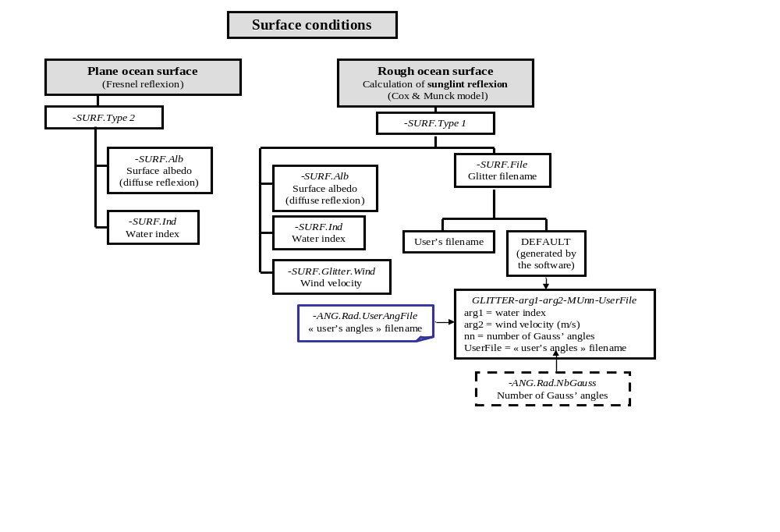

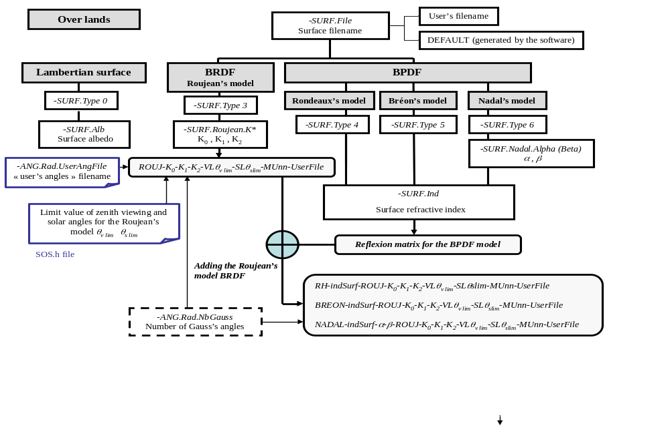

Atmospheric conditions
The SOS code computes light propagation in a scattering atmosphere by clear sky. The atmospheric components considered are molecules and aerosols. Gaseous absorption is not considered.

Molecular diffusion
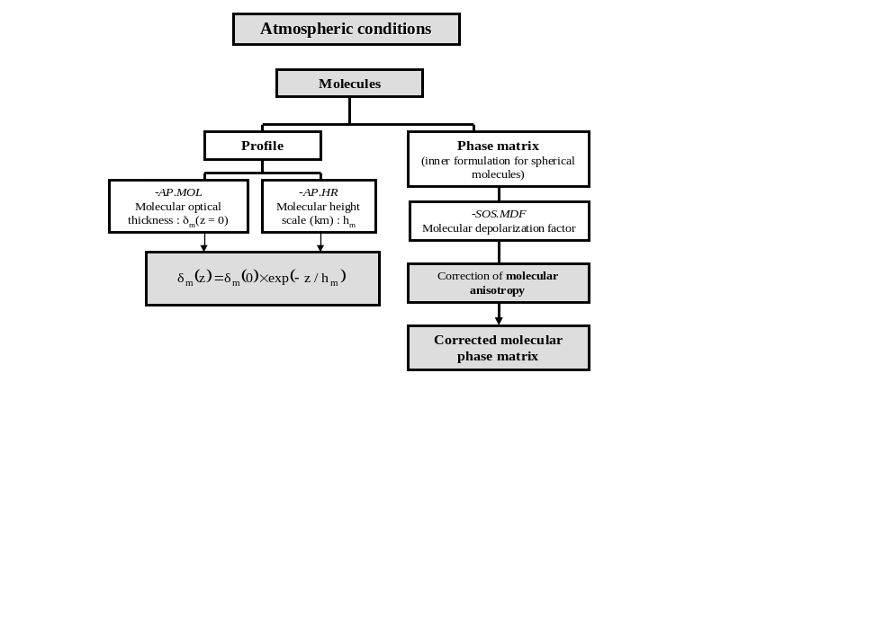
Molecular scattering depends on the profile of atmospheric pressure and of the considered wavelength. Instead of using the optical thickness computed by the application, for a given pressure and wavelength, the user may enter the molecular optical thickness (integrated over the atmospheric column). As such, the user may simulate the inherent radiation of an aerosol layer by suppressing the molecular component with a null optical thickness.
The pressure profile is estimated by a decreasing exponential exp(-z / h_{m}), characterized by a height scale h_{m} (typically 6 to 8 km). Molecular scattering properties are well-known and implemented by the SOS code. Molecular anisotropy is considered in terms of a depolarisation factor [DR9]. By default the proposed value for this factor is 0,0279.

The molecular optical thickness may be estimated according to the classical equation of Hansen & Travis [DR8] at the surface level and for a standard atmospheric pressure of 1013 mb :
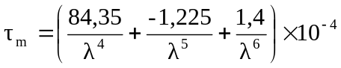 for λ in μm (1)
The more recent formalism by Bodhaine et al. [DR1], which takes into account the increase of carbon dioxide, could lead to a better estimation.

Aerosol diffusion and absorption
• Aerosol vertical profile :
The aerosol vertical profile may be characterized by an exponential decrease of the optical thickness exp(-z / h_{a}), with a typical height scale h_{a} of about 2km. The user may simulate an aerosol layer (homogeneous mixture of molecules and aerosols) between 2 pure molecular layers. The total aerosol optical thickness, τ_{a}, depends on the type and abundance of particles for a given wavelength λ. Its value is defined by the user. It is possible to simulate pure scattering by setting τ_{a} = 0.
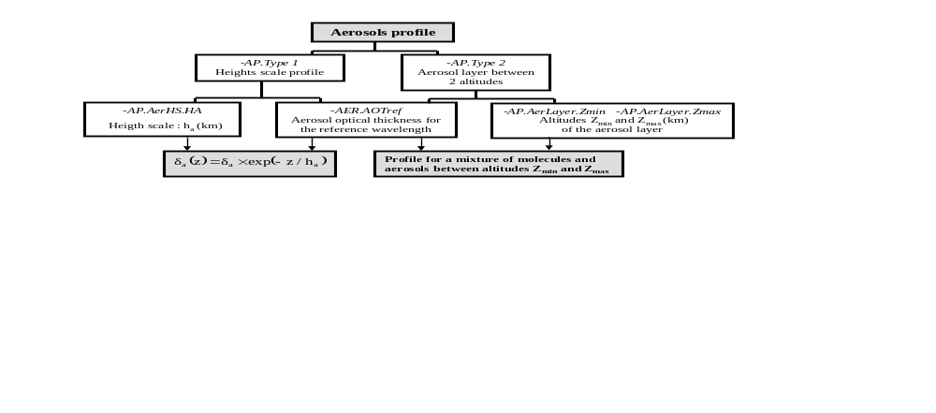

• Aerosol model :
Aerosol radiative properties can be defined as :
- The user may select a model type : it is possible to simulate mono-modal size distributions (log-normal law or Junge law) as well as more complex models such as bi-modal distributions or predefined models from WMO [DR19] or Shettle & Fenn [DR15] (continental, urban, maritime and coastal models considering the air relative humidity).
- The user may use a file of external phase functions, which allows to simulate scattering of non-spherical particles (with random orientation, so as to consider the symmetry of the radiation field about the main solar plane). The content and format of this file are given in section §III.2.4.c, p. 40.
- The user may also reuse the output file of a previous run from SOS_AEROSOLS (giving the scattering and extinction coefficients, and the decomposition coefficients of the phase matrix). The content and format of this file are given in section §III.2.4.d, p. 42.

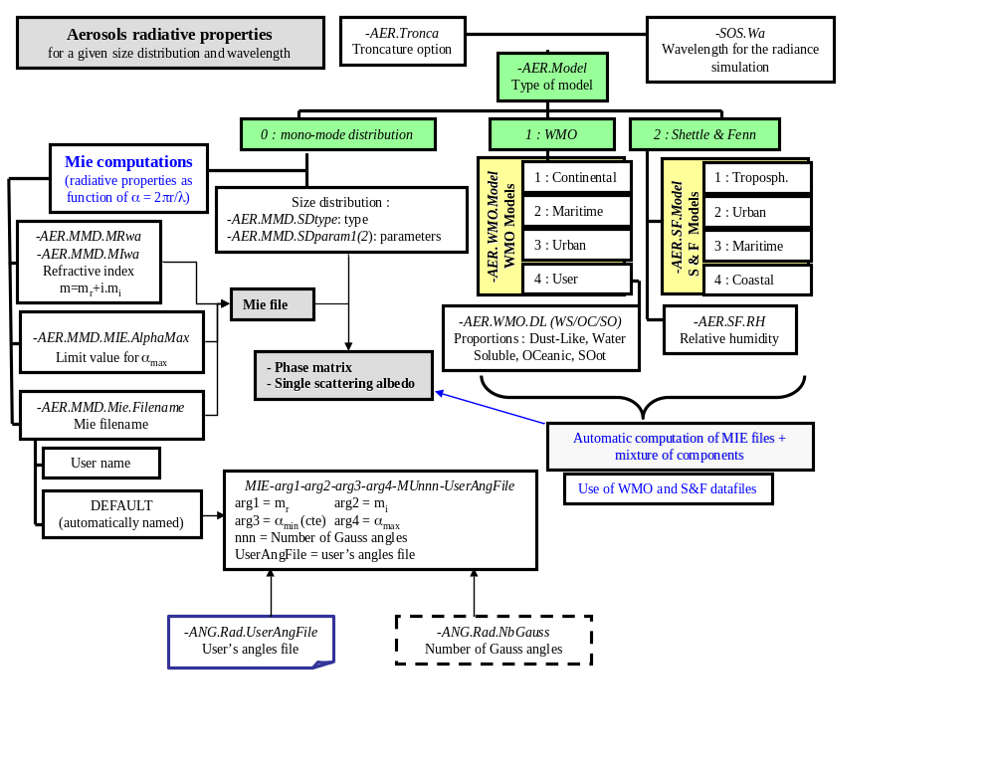
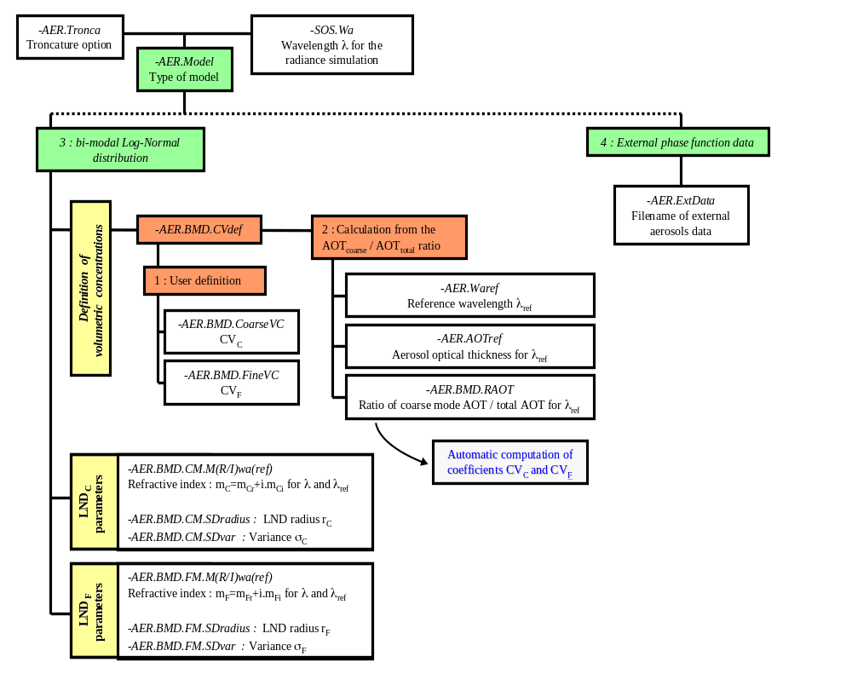
The radiative properties of an aerosol specie are computed for a size distribution N(r) and wavelength λ. Aerosols are considered spherical. Their chemical nature is defined by their refractive index m = m_{r} +i.m_{i} (m_{i} ≤ 0 for absorption), assuming an homogeneous composition.
Mie’s theory allows to estimate radiative properties of a spherical particle of radius r and index m, for an incident radiation of wavelength λ. Mie’s equations are solved in terms of the size parameter α = 2.π.r / λ, in the range α_{min} to α_{max}. The solution is then applied to the size distribution N(r) in order to estimate the radiative properties at the macroscopic scale for the particle distribution and for the wavelength of interest.
Mie’s processing is time-consuming. The output is saved to disk in a user-specified directory. If the file already exists (same name), it is not recomputed. In the case of a mono-modal distribution, the user may either define the output file name of the SOS_AEROSOLS application, or let the software define it automatically by typing DEFAULT. If the user simulates a bi-modal or multi-modal model of WMO [DR19] or Shettle & Fenn [DR15], the file naming convention for Mie’s output files is applied automatically by the software (i.e. the user can not define the name of the output file). The pattern for Mie’s output filenames is based on the refractive index, the parameters for size limits, the number of used Gauss’ angles (nnn) and may include the name of the file for user-defined angles (ficUser base name). It is such as MIE-m_{r}-⏐m_{i}⏐-α_{min}-α_{max}-MUnnn-ficUser. The precision associated to each parameter is given in the table below.

Tableau 4 : Format of parameters relative to the filnaming convention for MIE’s files.
Parameter | Range | Precision | Format | Pattern
m_{r} |  | Error is 10⁻³ | F5.3 | x.xxx (ex : m_{r}=1.53 ⇒ 1.530)
m_{i} | < 0 | Error is 10⁻⁵ | F8.5 | x.xxxxx (ex : m_{i}=-0.008 ⇒ 0.002800)
α_{min} | 10⁻⁴ < α_{min} < 10 | Error is 10⁻⁴ | F6.4 | x.xxxx (ex : α_{min} = 0.0001 ⇒ 0.0001)
α_{max} | 10⁻² < α_{max} < 10⁵ | Error is 10⁻² | F9.2 | xxxxx.xx (ex : α_{max} = 500 ⇒ 00500.00)

For example, for an index m = 1,53 – i ×0,008 and solving from α_{min} = 0,0001 to α_{max} = 500 using 40 Gauss angles, the output file is named : « MIE-1.530-0.00800-0.0001-00500.00-MU40 ».

Caution :
- The value of the molecule optical thickness is defined in the file runOS.ksh, the user must make sure that it is consistent with the wavelength selected for the radiance simulation.
- A change in the user-defined angles without change of filename does not lead to reprocessing of the file MIE. The user must change the names of the modified angle files or suppress the existing mie files in order to avoid simulation errors.
- In the case user-defined angles are being used, the output mie files indicates the base name of the input angle file without its path. It is recommended to use one unique folder for angle files and/or to apply a rigorous file naming convention.

• Definition of aerosol properties for a reference wavelength :
The user defines the following aerosol properties :
- for a reference wavelength :
  - the optical thickness of aerosol,
  - the refractive index (real and imaginary part) for each mode of particles.
- For the wavelength of the radiation field simulation :
  - the refractive index (real and imaginary part) for each mode of particles.

The application computes the extinction coefficients of the model for both the reference wavelength and the wavelength of the radiation field simulation. The aerosol optical thickness for the simulation wavelength is then deduced by:



• Truncation of the aerosol phase function:
When the scattering particles are large, scattering occurs mainly forward within an opened cone of few degrees. This strong anisotropy of the scattering effect makes the mathematical formulation of the phase function more difficult. Physically, the radiation scattered forward can not be uncoupled from the transmitted radiation. We may consider that the energy scattered at small angles is equivalent to a transmitted energy. The phase function part related to small scattering angles may then be truncated which allows to reduce the number of terms in its expression by Legendre Polynomials and therefore to reduce the computation time.
Truncating the phase function modifies the energy distribution. The other radiative parameters, which describe the atmospheric layer, must then be adjusted so that the global radiative properties remain unchanged.
It is highly recommended that the user systematically asks for truncation. The physical values entered in the file runOS.ksh must not be truncated. The software program is in charge of truncating the phase function and adjusting the radiative parameters as necessary. The output results are equivalent to what would have been obtained without truncation but the processing is much faster (i.e, the same results could be obtained without truncation but for an expansion of the phase function with much more coefficients, which involves using a quite higher Gauss’ quadrature).

File format of the external phase functions
The format of this file is compatible with the tool named DLS of Oleg Dubovik [DR7] which provides the primary scattering properties of homogeneous spheroid particles with random orientation. However, a parameter defining the number of angles describing the functions was added.
It consists of an Ascii file with the following records :
1st line : ext=Value abs=Value sca=Value
format : FORMAT(4hext=,E15.5,4habs=,E15.5,4hsca=,E15.5)
Values : ext : extinction coefficient
abs : absorption coefficient
sca : scattering coefficient
Note : the only parameters used by the SOS code are the extinction (ext=) and scattering (sca=) coefficients.
2nd line : nbAng=Value
format : FORMAT(6hnbAng=,I4)
Value : Number of angles describing the user’s phase functions.
It can not exceed the value sosmaxnb_ang_ext (in SOS.h).
3rd line : Comments
Lines 4 to (4+nbAng-1) : ANGLE F11 -F12/F11 F22/F1 F33/F11
format : FORMAT(F7.2,6E14.5)
Value: ANGLE : angle in degrees
F11 : phase function in intensity P₁₁
-F12/F11 : ratio of functions -P₁₂ and P₁₁
F22/F11 : ratio of functions P₂₂ and P₁₁
F33/F11 : ratio of functions P₃₃ and P₁₁
Sign convention: the F₁₂ function is negative for Rayleigh scattering. It is the same convention as in the internal SOS code.
The next lines are not read.
Example of file for external phase functions
ext= 0.72684E+00 abs= 0.49962E-01 sca= 0.67688E+00
nbAng= 181
ANGLE F11 -F12/F11 F22/F11 F33/F1
0.00 0.38325E+03 0.00000E+00 0.99984E+00 0.99984E+0
1.00 0.27348E+03 0.83746E-04 0.99978E+00 0.99978E+00
2.00 0.15766E+03 0.23956E-03 0.99963E+00 0.99962E+0
3.00 0.91944E+02 0.39548E-03 0.99938E+00 0.99932E+0
4.00 0.56217E+02 0.62078E-03 0.99903E+00 0.99882E+0
5.00 0.36374E+02 0.10123E-02 0.99855E+00 0.99809E+0
6.00 0.24931E+02 0.16408E-02 0.99793E+00 0.99712E+0
7.00 0.18065E+02 0.25726E-02 0.99719E+00 0.99592E+0
8.00 0.13797E+02 0.38248E-02 0.99633E+00 0.99456E+0
9.00 0.11049E+02 0.53602E-02 0.99538E+00 0.99312E+0
•
•
•
167.00 0.18637E+00 -0.10822E-01 0.76091E+00 -0.69151E+00
168.00 0.18857E+00 -0.10740E-01 0.76193E+00 -0.69161E+00
169.00 0.19077E+00 -0.10116E-01 0.76338E+00 -0.69214E+00
170.00 0.19288E+00 -0.86482E-02 0.76494E+00 -0.69391E+00
171.00 0.19502E+00 -0.61878E-02 0.76614E+00 -0.69759E+00
172.00 0.19753E+00 -0.27749E-02 0.76622E+00 -0.70338E+00
173.00 0.20101E+00 0.13766E-02 0.76422E+00 -0.71097E+00
174.00 0.20629E+00 0.54762E-02 0.75934E+00 -0.71884E+00
175.00 0.21404E+00 0.83942E-02 0.75137E+00 -0.72485E+00
176.00 0.22441E+00 0.90428E-02 0.74083E+00 -0.72721E+00
177.00 0.23650E+00 0.65456E-02 0.72965E+00 -0.72470E+00
178.00 0.24726E+00 0.22419E-02 0.72103E+00 -0.71917E+00
179.00 0.25198E+00 0.18433E-04 0.71772E+00 -0.71611E+00
180.00 0.25674E+00 0.00000E+00 0.71376E+00 -0.71240E+00

Content and format of a file of type AEROSOLS for the SOS code
An “Aerosol” file for the SOS code is a formatted Ascii file. It is organized as follows :

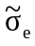 | 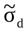 | g
A
ω₀
α₀ | β₀ | γ₀ | ξ₀
α₁ | β₁ | γ₁ | ξ₁
.  .  . | .  .  . | .  .  . | .  .  .
α_{OS_NB} | β_{OS_NB} | γ_{OS_NB} | ξ_{OS_NB}

1st line : general information (values are not adjusted with respect to truncation)
- Extinction cross-section (μm²),
- Scattering cross-section (μm²),
- Asymmetry factor (g = β₁ / 3).
Format : 2(2X, E13.5), E13.5
Note : the data of this first line are for information purpose only. They are read but not utilized by the SOS code except for the extinction cross-section which is used by the main script main_SOS.ksh for computing the aerosol optical thickness for the wavelength of radiation field simulation derived from the AOT of the reference wavelength.
2nde ligne : truncation coefficient A (null if the phase function is not truncated).
Format : 2X, F9.5
3ème ligne : Single scattering albedo (may be truncated if A ≠ 0).
Format : 2X, F9.5
Next lines : Coefficients of the phase matrix α_{k}, β_{k}, γ_{k}, ξ_{k} (may be truncated if A ≠ 0) for k = 0 to OS_NB (maximum order of development defined in the ANGLES file and correlated to the number of Gauss’ angles).
Format : 4(2X, E16.8)

Type of output
• The simulation output is a scattered field of radiance normalized by the solar irradiance. Let L* be the radiance and E_{s} the solar irradiance, the normalized radiance is then : L = π×L* / E_{s} (the reflectance is ρ = L / cos θ_{s}).

• Output level in the atmospheric profile for the normalized radiance field:
The normalized radiance field is computed for a range of atmospheric profile levels. The outputs are the upward and downward radiance for the selected level. The user may specify :
- the output level of the radiance field :
- Enter SOS.OutputLevel = -1 for generating the upward radiance at Top of atmosphere (TOA) and downward incidence at ground level,
- Enter SOS.OutputLevel = n with 0 ≤ n ≤ SOS_OS_NT for the output radiance at level n : 0 for TOA, SOS_OS_NT for the ground (constant parameter defined in SOS.h),
- The name of the output files :
- File name of the upward radiance.
- File name of the downward radiance.

• Neglecting polarisation :
One main specificity of the SOS code is to simulate the light polarisation. It is nonetheless possible to perform a simulation without taking into account polarisation effects. Polarisation is then neglected in the propagation of radiation by the SOS code, but this simplification does not affect the MIE files or BPDF files of surface products.

• Maximum order of interactions
The SO code, as its name suggests, follows the successive orders of interaction (scattering and reflections). The user may specify the maximum order « SOS.IGmax » above which no computation will be performed. The nominal number of orders of interactions is determined by the code according to a convergence criterion which checks whether the next interactions are significant enough. Typically convergence is reached within a few scattering interactions. For usual AOT, the user may set SOS.IGmax > 20 to let the code stops automatically according to the convergence criterion. On the other hand, if the user wishes to validate each successive interaction, he may set SOS.IGmax to 1, 2, 3 …
Table 5 illustrates the first orders of interaction.

Table 5 : terms of order ig computed by the SOS code. The left column illustrates the upward radiance at the ground, the right column the downward radiance. At TOA, one finds the term of surface reflection (left column) attenuated and the atmospheric scattering term (right column) for a scattering effect upwards.
Ig | Upward light at ground level | Downward light at ground level  or upward at TOA
1 | 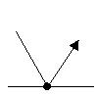  R₁ | 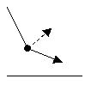  S₁
2 | 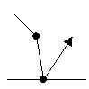  S₁R₁ | 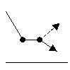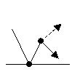  S₂ R₁S₁
3 | 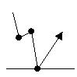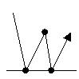  S₂R₁ R₁S₁R₁ | 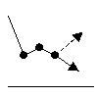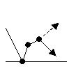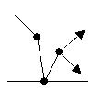  S₃ R₁S₂ S₁R₁S₁
4 | 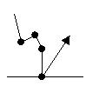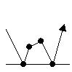  S₃R₁ R₁S₂R₁  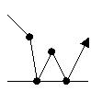  S₁R₁S₁R₁ | 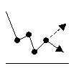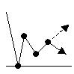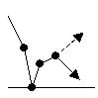  S₄ R₁S₃ S₁R₁S₂  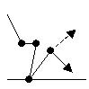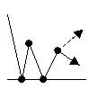  S₂R₁S₁ R₁S₁R₁S₁

• Transmissions :
On user request, the SOS code provides transmissions corresponding to the simulated atmosphere ( for the true optical thickness and not the one resulting from a truncation of the aerosol phase function) :
- Direct transmission from TOA to ground for the solar incidence.
- Diffuse transmission from TOA to ground for the solar incidence.
- Diffuse transmission from ground to TOA for all viewing angles.

• Viewing conditions :
SOS computations are performed for all the Gauss angles and additional angles of the optional list defined by the user. The radiance field is provided for all the angles or only for the user-defined angles (option).
Expansion in Fourier series, performed with respect to the relative azimuth between the solar direction and the viewing direction, allows retrieving the simulated radiance for any direction in azimuth. The user may request the simulated radiance for one given azimuth plane or for a set of azimuthal directions.

Case 1 : Output is a viewing plane
If the user wants the output for a given azimuthal plane, it sets the corresponding flag SOS.View = 1 and defines the value of the relative azimuth angle φ.
The output files then give the normalized radiance corresponding to the Gauss angles defined in the input file.
Convention :
- Sign of angles :
- The viewing angle is positive in the half-plane of relative φ.
- It is negative in the half-plane φ+π.
- Angles values :
- For the upward radiance, the viewing angle is zero when looking up towards the zenith.
- For the downward radiance, the viewing angle is zero when looking down at nadir.
- The viewing angle is ± 90° for the horizon.
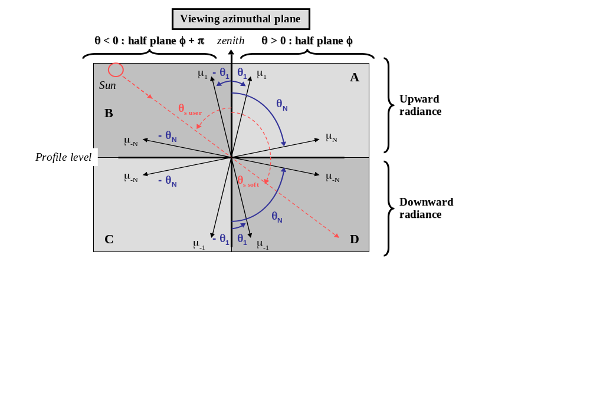

Case 2 : Ouput for a set of azimuthal directions
It is possible to obtain a full output of the upward and downward radiance for the selected profile level (SOS.View = 2). The user must specify the sampling step in azimuth : Δφ (integer value).
The output files contain 5 columns:
- 1st column : X = φ
- 2nd column : Y = θ_{v} > 0 (unsigned zenith angle for the upward field, angle defined with respect to nadir for the downward field)
- 3rd to 5th column : Z_{I} = I(θ_{v},φ) Z_{Q} = Q(θ_{v},φ) Z_{U} = U(θ_{v},φ)

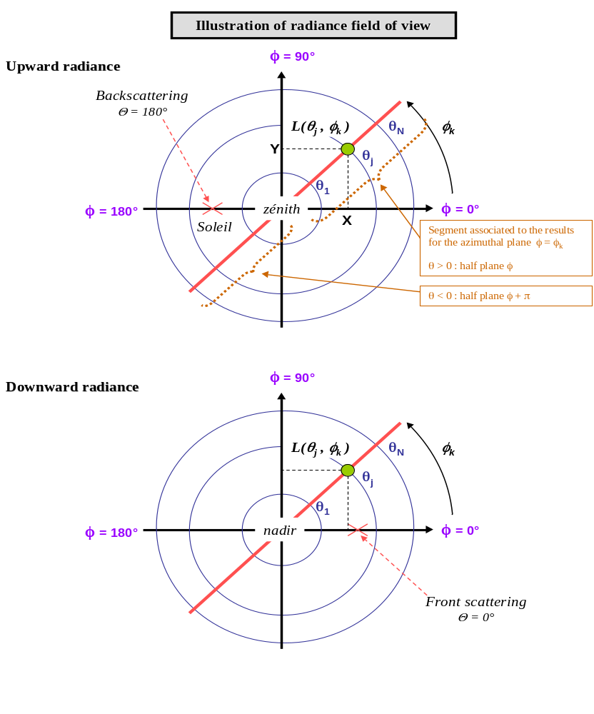

Output files
The software application generates several types of files:
- Files forming a “data base” (if automated file naming ) – the full path is specified by the user :
- Files containing the Fourier series of the reflection matrices,
- Files containing MIE’s computations.
- Temporary files which are automatically removed at the end of the processing :
- « res_fresnel » : expansion of the Fresnel matrix in Fourier series,
- « res_gsf » : Fourier series of the G function relative to the surface model and used as weighting function of the Fresnel matrix.
- « res_mat_reflex » : expansion in Fourier series of the surface reflection matrix,
- « *_bpdf » : BPDF results before the contribution of Roujean’s BRDF.
- Input files to SOS, simulation-specific (replaced at each simulation) :
- Files containing angles and orders of expansion being processed,
- Atmospheric profile of the optical thickness,
- Description of the radiative properties of the aerosol model.
- SOS output files : Final simulation results.
- Binary file for the upward and downward polarized field decomposed as Fourier series,
- Ascii file of the upward field for all angles or for user-defined angles only.
- Ascii file of the downward field for all angles or for user-defined angles only.
- Ascii file for diffuse and direct transmissions.
- Log files : they record information relative to each step. These files may be very large, so it is recommended to generate them only if necessary.

Example of launch file : Simulation over the ocean
Let suppose that we would like to simulate the sunglint reflection at 440 nm for a wind speed of 2 m.s⁻¹, an ocean albedo of 0.02 and a water refractive index of 1.34. The atmosphere is supposed slightly turbid with an aerosol optical thickness of 0.05 at 550-nm, index 1.4 (non absorbing) at 440 nm and 1.45 at 550 nm, of log-normal size-distribution (modal radius r_{m} equal to 0.3 μm and variance σ such that log₁₀(σ) = 0.4). We will request the phase function to be truncated. The aerosol layer will extend from the ground to TOA with an exponential decrease of the optical thickness. The molecular optical thickness is 0.23 at 440 nm. The zenith solar angle is 30°. We want to generate a global radiation field emerging at TOA and illuminating the ground, by step of 5 degrees in relative azimuth. We would also like to output the transmission values.

$RACINE/exe/main_SOS.ksh -SOS.Wa 0.440 \
-ANG.Rad.NbGauss 24 -ANG.Rad.ResFile ${dirRESULTS}/SOS_UsedAngles.txt \
-ANG.Aer.NbGauss 40 -ANG.Aer.ResFile ${dirRESULTS}/AER_UsedAngles.txt \
-ANG.Log ${dirLOG}/Angles.Log \
-ANG.Thetas 30. -SOS.View 2 -SOS.View.Dphi 5 \
-SOS.IGmax 30 \
-SOS.ResFileUp ${dirRESULTS}/SOS_Up.txt -SOS.ResFileDown ${dirRESULTS}/SOS_Down.txt \
-SOS.ResBin ${dirRESULTS}/SOS_Result.bin \
-SOS.Log ${dirLOG}/SOS.Log \
-SOS.Config ${dirRESULTS}/SOS_config.txt \
-SOS.Trans ${dirRESULTS}/SOS_transm.txt \
-AP.ResFile ${dirRESULTS}/Profile.txt -AP.Log ${dirLOG}/Profile.Log \
-AP.MOT 0.230 -SOS.MDF 0.0279 \
-AP.Type 1 -AP.HR 8.0 -AP.AerHS.HA 2.0 \
-AER.Waref 0.550 -AER.AOTref 0.05 \
-AER.ResFile ${dirRESULTS}/Aerosols.txt -AER.Log ${dirLOG}/Aerosols.Log -AER.MieLog 0 \
-AER.Tronca 1 -AER.Model 0 \
-AER.MMD.Mie.AlphaMax 300 -AER.MMD.MRwa 1.4 -AER.MMD.MIwa 0. \
-AER.MMD.MRwaref 1.45 -AER.MMD.MIwaref 0. \
-AER.MMD.SDtype 1 -AER.MMD.SDparam1 0.3 -AER.MMD.SDparam2 0.4 \
-SURF.Log ${dirLOG}/Surface.Log -SURF.File DEFAULT \
-SURF.Type 1 -SURF.Alb 0.02 -SURF.Ind 1.34 \
-SURF.Glitter.Wind 2.0

Constant parameters of the simulation

List of constant parameters included in SOS.h
Along with the physical simulation parameters that we have just seen, we also need to define some more processing parameters. These parameters deal with the size of 2D-arrays used in the code, as well as with threshold values required for the convergence criteria. These parameters are defined at compile time via the include file SOS.h (under $RACINE/inc). Their modification requires a good understanding of how the software works.

Caution : A change to a constant value will only be effective after the software has been recompiled.

Table 6 : software constant values
Constant values |  | SOS.h
Name | Description | Default value
1) Constant values shared by all programs
sos_lendir | Maximum length of strings for directory names. | 150
sos_lenfic1 | Maximum length of strings for file names (basename only). | 150
sos_lenfic2 | Maximum length of strings for files with full path | 300
sos_lenkeyword | Maximum length of Keywords for the arguments | 30
Sos_pi | π | 3.14159265358
2) Constant values specific to SOS_AEROSOLS
sos_mie_dim | Size of 2D arrays for the computation of Ricatti-Bessel functions (ψ_{n}, χ_{n}), derived functions (D_{n} and G_{n}) and coefficients A_{n} and B_{n}.  (sos_mie) | 10000 (for processing up to α_{max} ≈ 4990)
sos_maxnb_ang_ext | Maximum size of 2D arrays for external phase functions  (sos_aerosols) | 200
sos_mie_alphamin | Minimum value of the Alpha size parameter in MIE’s calculus.  Must lie between 0,0001 and 10.  Note : Must be given in double precision (sos_aerosols) | 0.0001D+00
sos_alphamax_wmo_dl | Maximum value of the size parameter for the MIE’s computations of the WMO Dust-like component.  (sos_aerosols) | 4000
sos_alphamax_wmo_ws | Idem for the WMO « Water Soluble » component. | 50
sos_alphamax_wmo_oc | Idem for the WMO « Oceanic » component. | 800
sos_alphamax_wmo_so | Idem for the WMO « Soot » component. | 10
sos_alphamax_sf_sr | Idem for the Shettle & Fenn « Small Rural » component. | 70
sos_alphamax_sf_su | Idem for the Shettle & Fenn « Small Urban » component. | 90
sos_coef_nrmax | Minimum value of the size distribution ratio n(r) / Nmax for the determination of the maximum size parameter for Mie’s computations. (sos_aerosols) | 0.0001
sos_aer_datawmo | File name for WMO data including the modal radius, the log of the variance, the volumetric concentration and the values of the refractive indices (real and imaginary part) as a function of the wavelength.  File location : $RACINE/fic (sos_aerosols) | Data_WMO
sos_aer_datasf | File name of Shettle & Fenn data including the log of the variance and the values of the modal radius as a function of the relative humidity.  File location : $RACINE/fic (sos_aerosols) | Data_SF
sos_aer_sr_sf | File name of « Small Rural » data from Shettle & Fenn including refractive indices (real & imaginary part) as a function of the wavelength and the relative humidity.  File location : $RACINE/fic (sos_aerosols) | IRefrac_SR
sos_aer_lr_sf | Idem for the « Large Rural » data from Shettle & Fenn. | IRefrac_LR
sos_aer_su_sf | Idem for the « Small Urban » data from Shettle & Fenn. | IRefrac_SU
sos_aer_lu_sf | Idem for the « Large Urban » data from Shettle & Fenn. | IRefrac_LU
sos_aer_om_sf | Idem for the « Oceanic model » data from Shettle & Fenn. | IRefrac_OM
sos_ph_seuil_tronca | Threshold value for the truncation coefficient  (sos_aerosols) | 0.1
3) Constant values specific to the definition of an atmospheric profile
sos_os_nt | Number of atmospheric profile layers  (sos_profil, sos, sos_os) | 26
sos_profil_min_nbc | Minimum number of molecular sub-layers for a profile with variable positioning of aerosols between 2 altitudes.  (sos_profil) | 3
sos_dztransi | Definition of the thickness of the transition layer (km).  (sos_profil) | 0.010
4) Constant values specific to the computation of surface reflection matrices
sos_ph_test | Factor for the comparison of Gmin and Gmax. (sos_glitter) | 10000
sos_ph_nu | Number of azimuthal angles (2^{SOS_PH_NQ)}  (sos_glitter, sos_roujean, sos_nadal) | 1024
sos_ph_nq | Power of 2 for sos_ph_nu. (sos_glitter) | 10
sos_seuil_sf_nadal | Threshold value for stopping the expansion in Fourier series of the function (F21 Nadal) / (F21 Fresnel). (sos_nadal) | 0.001
sos_seuil_sf_roujean | Threshold value for stopping the expansion in Fourier series of Roujean’s BRDF. (sos_roujean) | 0.001
sos_tetas_lim_roujean | Maximum solar zenith angle for computing Roujean’s BRDF (degrees). (sos_roujean, sos_nom_fic_surface) | 60
sos_tetav_lim_roujean | Maximum viewing zenith angle for computing Roujean’s BRDF (degrees). (sos_roujean, sos_nom_fic_surface) | 60
5) Constant values specific to the SOS program
sos_os_ibor | Minimal order of the expansion in Fourier series (sos_os) | 0
sos_ph_seuil_cv_sg | Convergence threshold of the geometric series (sos_os) | 0.01
sos_ph_seuil_sumdif | Multiple scattering threshold for the loop ending condition  (sos_os) | 0.00001
sos_ph_seuil_sf | Threshold for the ending condition of the Fourier series expansion (sos_os) | 0.0001
sos_seuil_z | Threshold value for computing the rotation angles (sos_trphi) | 0.0001
sos_seuil_x | Threshold value for computing the terms M21 and M31 of the reflection matrix expressed in a frame tied to the meridian plane. (sos_trphi) | 0.00001
6) Constant values specific to the definition of angles and orders of expansion

6.1) Constant values related to the size of the 2-D arrays and to the maximum orders of expansion in Fourier series or Legendre polynomials.
sos_mie_nbmu_max | Maximum number of angles ( > 0) for dimensioning the 2D arrays used for the phase functions.  Minimum value : number of Gauss angles by default + maximum number of user angles :  sos_default_nbmu_mie + sos_nbmax_user_angles.  Do not define a value artificially too large : larger is the value, slower is the algorithm.  (sos_angles, sos_aerosols, sos_mie) | 100
sos_os_nbmu_max | Maximum number of angles ( > 0) for dimensioning the 2D arrays used for the radiance field and surface reflection.  Minimum value : number of Gauss angles by default + maximum number of user angles :  sos_default_nbmu_lum + sos_nbmax_user_angles.  Do not define a value artificially too large : larger is the value, slower is the algorithm.  (sos_angles, sos_surface, sos_glitter, sos_roujean, sos_rondeaux_breon, sos_nadal, sos, sos_os, sos_trphi) | 68
sos_os_nb_max | Maximum order of expansion of the phase functions in Legendre polynomials and of expansions in Fourier series, used for dimensioning the 2D-arrays.  Use sos_os_nb_max ≥ 2 × sos_mie_nbmu_max  (sos, sos_os, sos_aerosols,  sos_surface, sos_roujean, sos_nadal) | 200
sos_os_ns_max | Maximum order of expansion in Legendre polynomials of the Fresnel matrix terms for dimensioning the 2D-arrays.  Use sos_os_ns_max= 2 × sos_os_nbmu_max  (sos_surface) | 136
sos_os_nm_max | Maximum order of expansion in Fourier series of the G function - weighting factor of the Fresnel matrix - for dimensioning the 2D-arrays.  Use sos_os_nm_max= sos_os_nb_max + sos_os_ns_max  (sos_surface, sos_glitter, sos_rondeaux_breon) | 336
6.2) Number of angles and maximum orders to use in case of no user-defined angles
sos_default_nbmu_mie | Default number of Gauss angles ( > 0 ) for computing the aerosol radiative properties. (sos_angles) | 40
sos_default_nbmu_lum | Default number of Gauss angles ( > 0 ) for the radiance field.  (sos_angles) | 24
sos_default_os_nb | Default value of the maximum order of expansion of the phase functions in Legendre polynomials and of the radiance field in Fourier series.  Use sos_default_os_nb ≥ 2 × sos_default_nbmu_mie  (sos_angles) | 80
sos_default_os_ns | Default value of the maximum order of expansion of the Fresnel matrix elements in Legendre polynomials.  Use sos_default_os_ns = 2 × sos_default_nbmu_lum  (sos_angles) | 48
sos_default_os_nm | Maximum order of expansion in Fourier series of the G function - weighting factor of the Fresnel matrix - for dimensioning the 2D-arrays.  Use sos_default_os_nm ≥ sos_default_os_nb  + sos_default_os_ns  (sos_angles) | 128
6.3) Maximum number of angles for the files describing the angles to be used
sos_nbmax_user_angles | Maximum number of user-defined angles, in addition to the Gauss angles (sos_angles) | 20
sos_nbangles_max | Maximum number of positive angles (Gauss angles + user-defined angles + 1 = solar zenith angle).  Must be the maximum of sos_mie_nbmu_max and sos_os_nbmu_max . (sos_angles) | 100
sos_seuil_ecart_mus | Difference threshold between cos(X) and cos(θ_{S}) under which θ_{S}=X (numerical error allowed)  (sos_angles) | 0.00001

Modification of the number of profile layers
In order to refine the optical thickness profile (for example, in the case of a dense atmosphere), the number of layers may be increased. Since this parameter affects the size of the 2D-arrays, the number of profile layer is defined in the file SOS.h by the constant value sos_os_nt. The user may change its value. Note that it is necessary to recompile in order to take into account the new value.

Software description
This section summarizes the software architecture. A complete description of the programs and methods is available in the following chapters
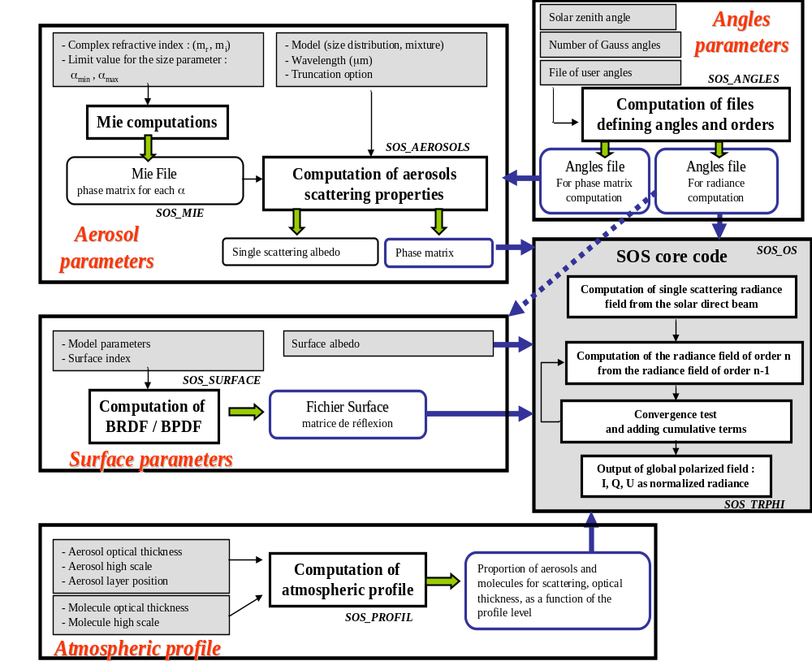
Figure 7 : High level view of the processing steps managed by the shellscript main_SOS.

The code is divided in 5 processing blocs :
- Preparation of angles to be used and maximum orders of expansion.
- Computation of the surface reflection matrix for a simulation over the sea (determination of sunglint) or over land surfaces (BRDF and BPDF).
- Processing of the aerosol scattering properties : Mie calculations as a function of the chemical nature of particle (refractive index) and determination of the phase matrix for a given model and wavelength.
- Computation of the atmospheric profile as a function of the total optical thickness of molecules and aerosols: relative contribution to scattering for the aerosols and for the molecules as a function of the profile level, total optical thickness of the mixture as a function of the level.
- Processing of successive atmospheric scattering effects and surface/atmosphere reflections.

The main script main_SOS.ksh is in charge of the workflow and calls to the different functions.
In the case of the simulation of the radiance for a wavelength λ_{simu} with the aerosol optical thickness defined for λ_{ref} the script computes the cross-section of aerosol extinction for the two wavelengths so as to estimate the optical depth for λ_{simu}.

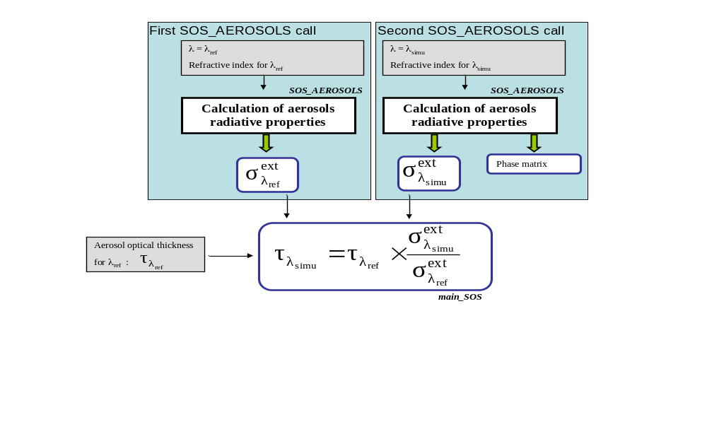
Figure 8 : Estimates of the aerosol optical thickness at the radiance field wavelength.

