**手机正方胸口中央加速减速走：**

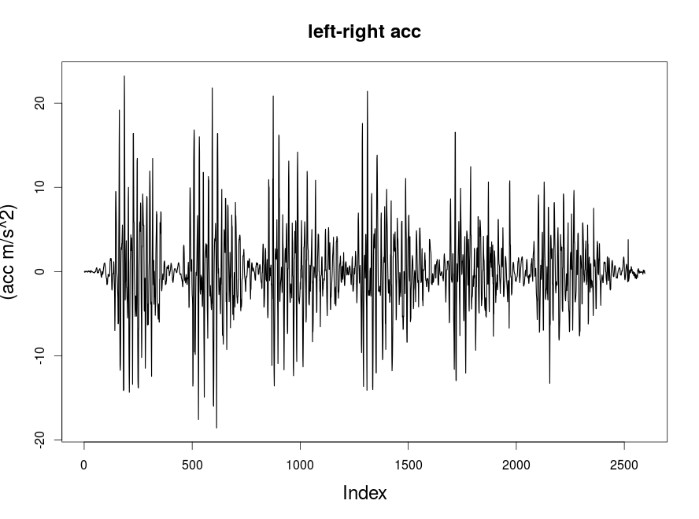

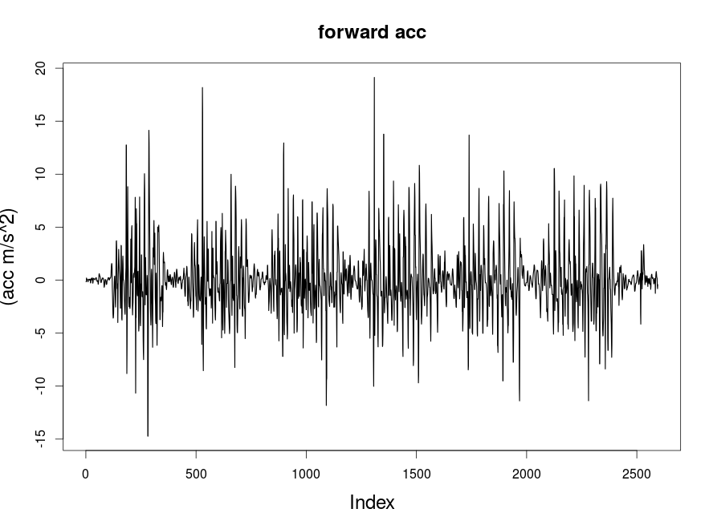

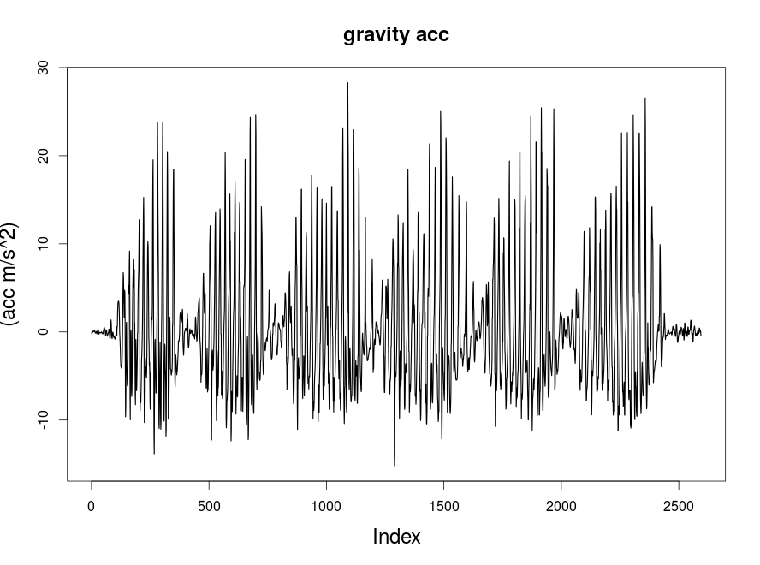

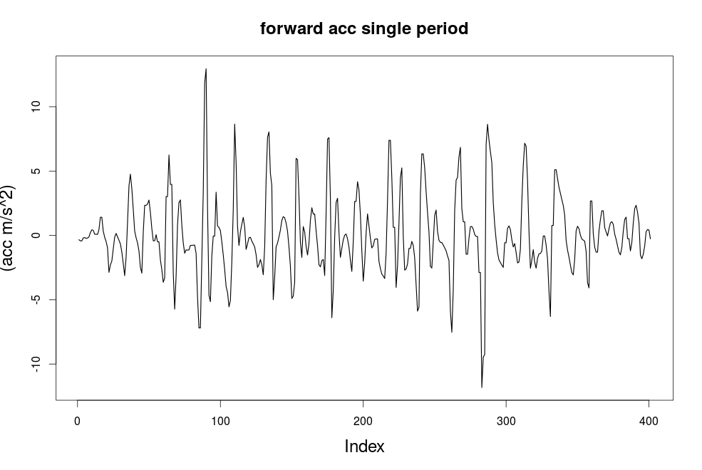

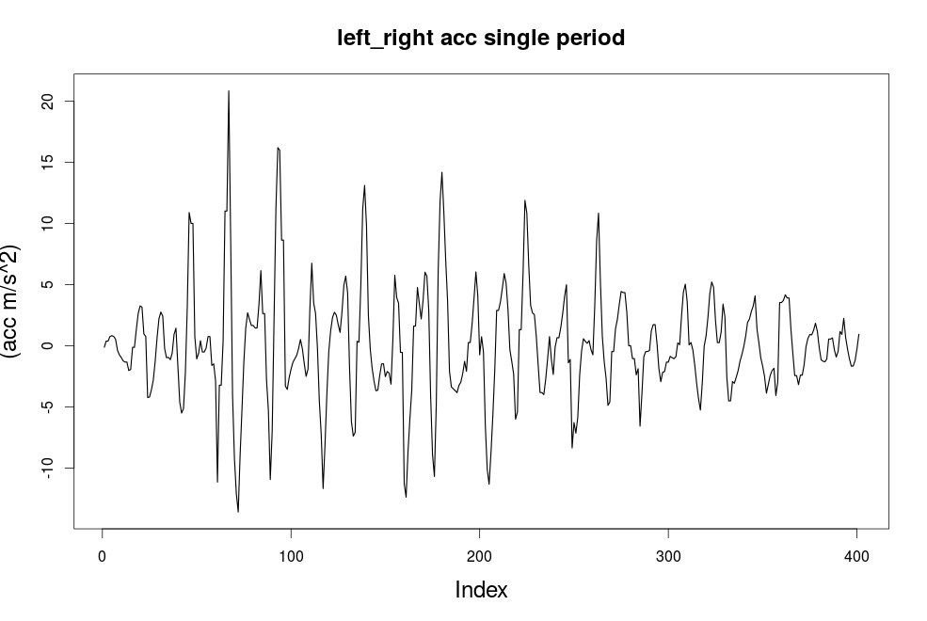

**统计值：**

|  |  |  |  |  |  |  |
| --- | --- | --- | --- | --- | --- | --- |
| 方向 | 均值 | 方差 | 大于0时的均值 | 小于0时的方差 | 前半个周期均值 | 后半个周期均值 |
| 向前 | 0.01002966 | 3.002984 | 2.144143 | 2.568739 | 0.01398753 | 0.02454111 |
| 左右 | 0.0288881 | 4.292485 | 3.03671 | 3.497695 | 0.2398035 | 0.1250738 |
| 重力方向 | 0.01228949 | 6.54754 | 5.693067 | 5.987713 |  |  |