**手机正方胸口中央匀速走：**

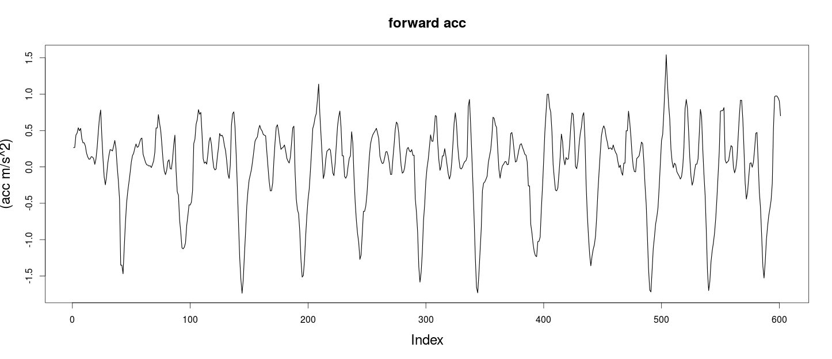

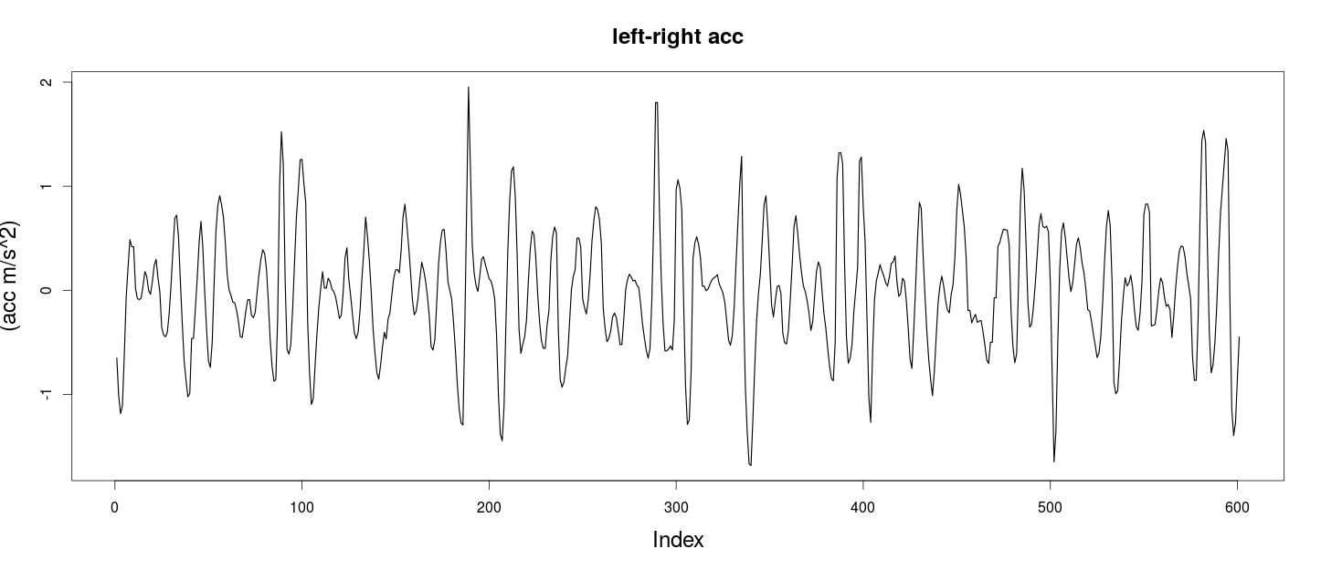

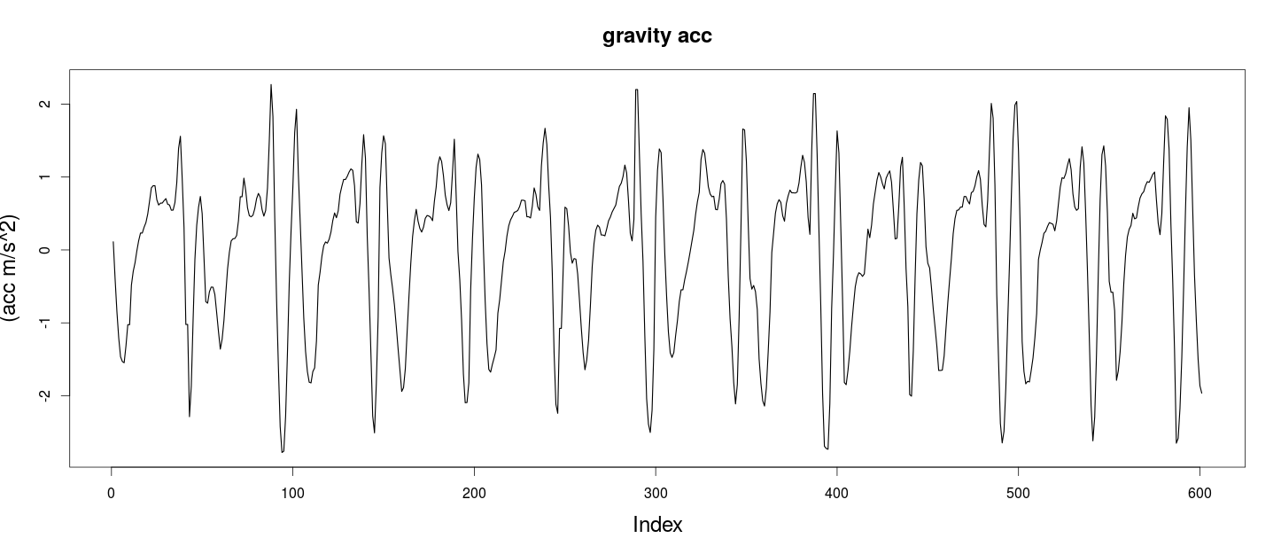

**滤波（低通，寻找波峰波谷，满足梯度幅度阈值条件并过滤）：**

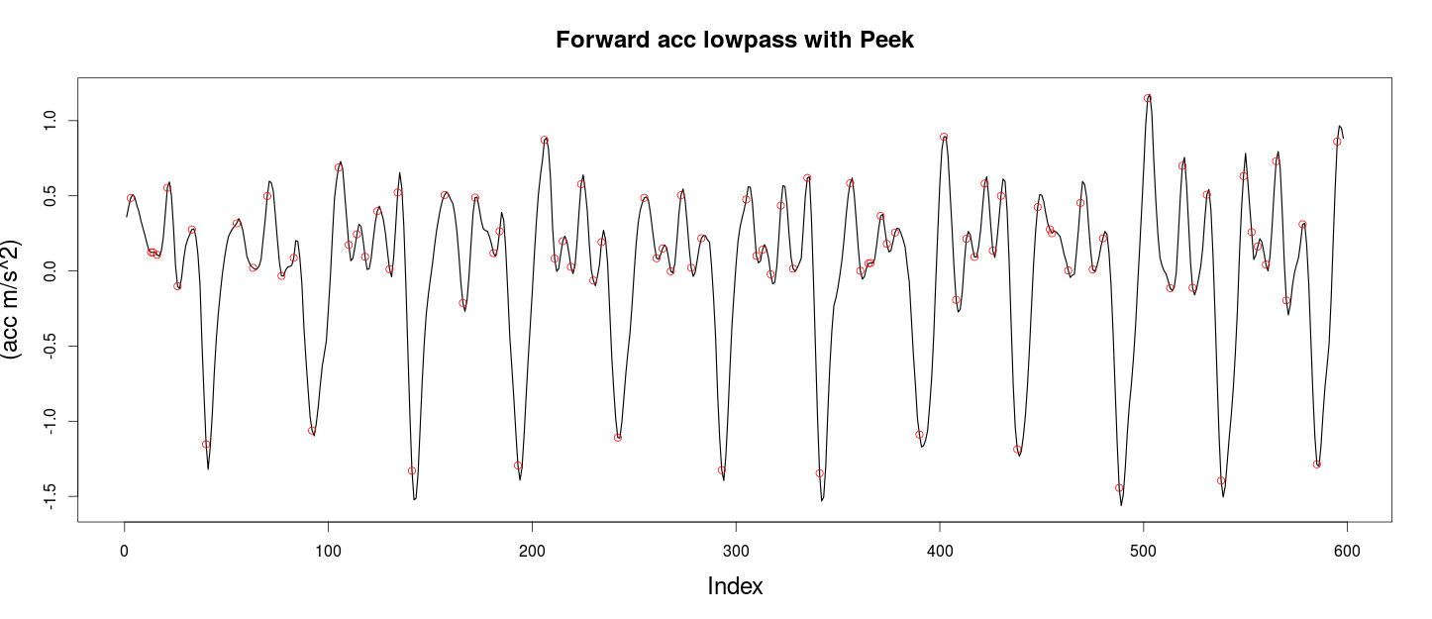

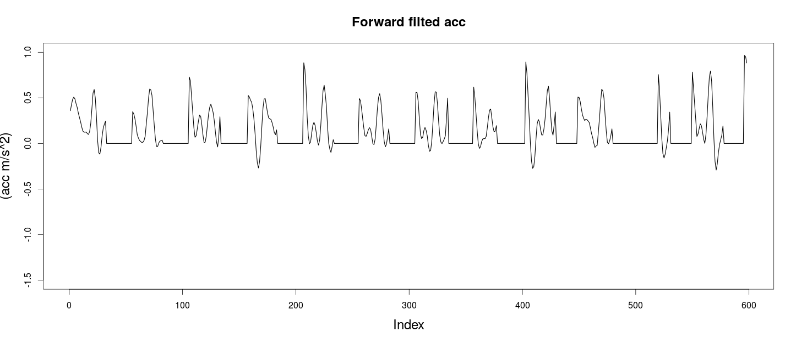

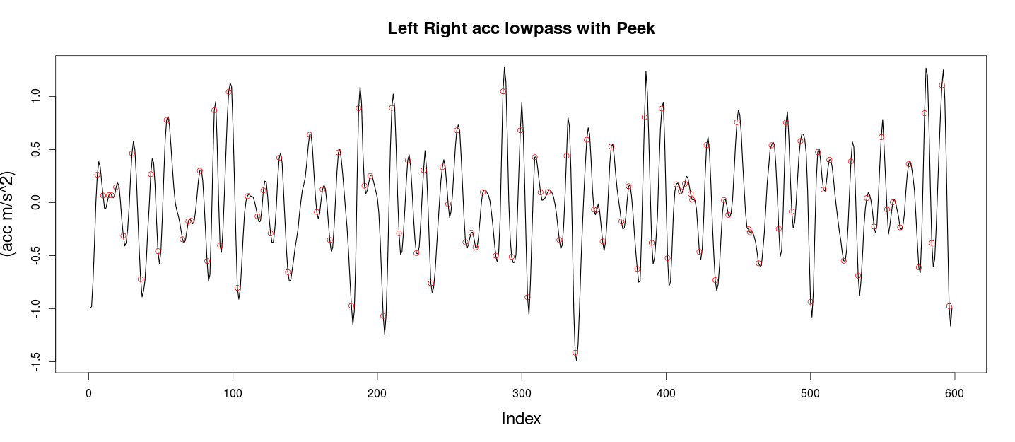

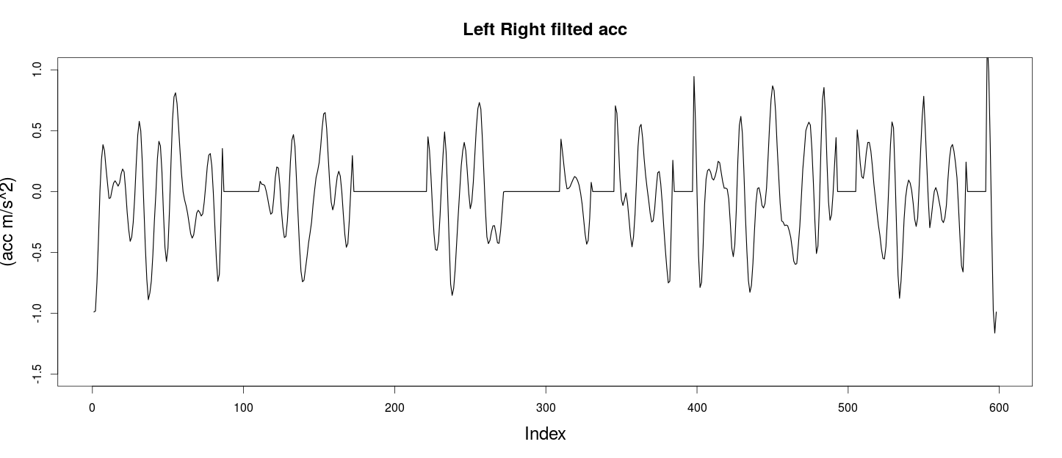

**统计值：**

|  |  |  |  |  |  |  |
| --- | --- | --- | --- | --- | --- | --- |
| 方向 | 均值 | 方差 | 大于0时的均值 | 大于0时的标准差 | 滤波后均值 | 滤波后标准差 |
| 向前 | -1.453066e-05 | 0.5815734 | 0.3425542 | 0.2645905 | 0.2255176 | 0.236497 |
| 左右 | -0.01463685 | 0.5809649 | 0.4482747 | 0.3902434 | -0.03143921 | 0.3912544 |
| 重力方向 | -0.002747512 | 1.091987 | 0.3425542 | 0.2645905 |  |  |

