Xiaoru Chen

chenxia2@oregonstate.edu

Project #5

CS 475/575

2021-05-19

**Machine I ran this on:**

I used my MacBook pro to ssh to OSU ENGR server (Rabbit).

**Table:**

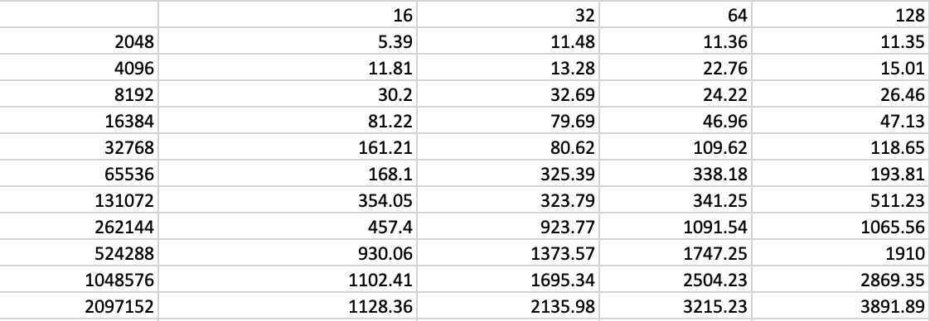

Table.1 Monte Carlo performance table.

**Two graphs:**

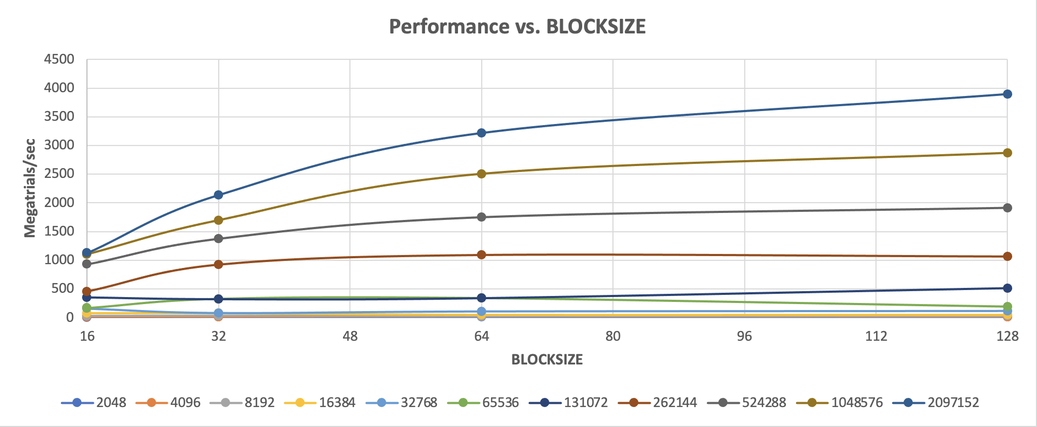

NUMTRIALS

Graph. 1 Graph of performance vs. NUMTRILS with multiple curves of BLOCKSIZE.

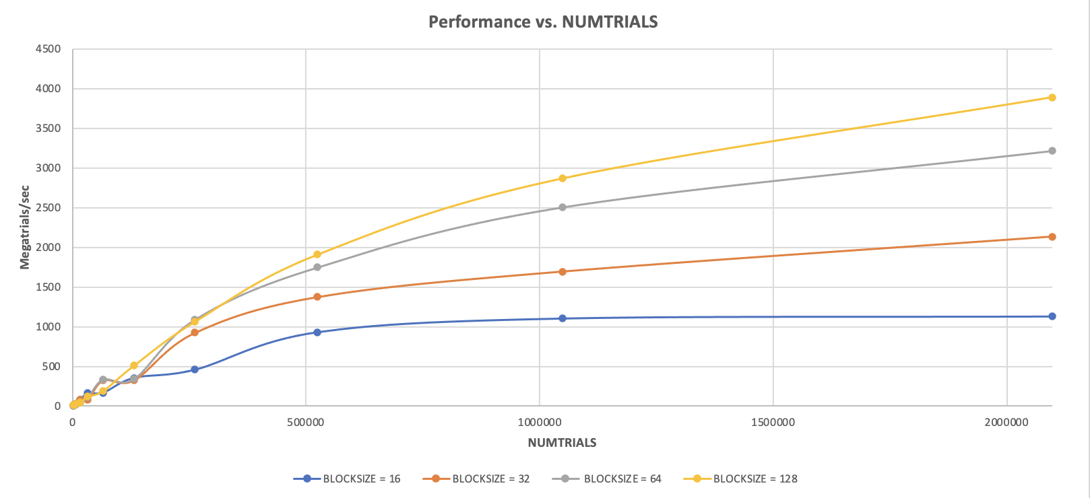

Graph. 2 Graph of performance vs. BLOCKSIZE with multiple curves of NUMTRIALS.

3. What patterns am I seeing in the performance curves?

It can be seen from Graph1 that in most cases, when NUMTRIALS increases, performance also increases. At the same time, the larger BLOCKSIZE, the higher performance.

As we can see from Graph2, in most cases, the larger the NUMTRIALS, the higher the Performance. When the BLOCKSIZE becomes larger, the performance also increases. But the increase is tapering off

4. Why do I think the patterns look this way?

Because GPU’s workload is divided into a grid of Blocks and each block can use at most some maximum number of registers. The more blocks we have, the faster the speed is.

5. Why is a BLOCKSIZE of 16 so much worse that the others?

Because there needs to be a bunch of Warps to work on so that something is always ready to run, these should be multiples of 32.

6.How do these performance results compare with what I got in Project #1? Why?

Project5 is much faster than Project1 because the GPU has many more cores than the CPU. In Project T1, we only tested a number of cores like 1, 2, 3, and 8. In Project 5, however, the number of blocks is larger and the number of threads is huge.

7. What does this mean for the proper use of GPU parallel computing?

The proper use of GPU parallel computing can give us a faster performance since it has more cores (threads).