Xiaoru Chen

chenxia2@oregonstate.edu

Project #7B

CS 475/575

2021-06-08

**Show the Sums{1] ... Sums[255] vs. shift scatterplot.**

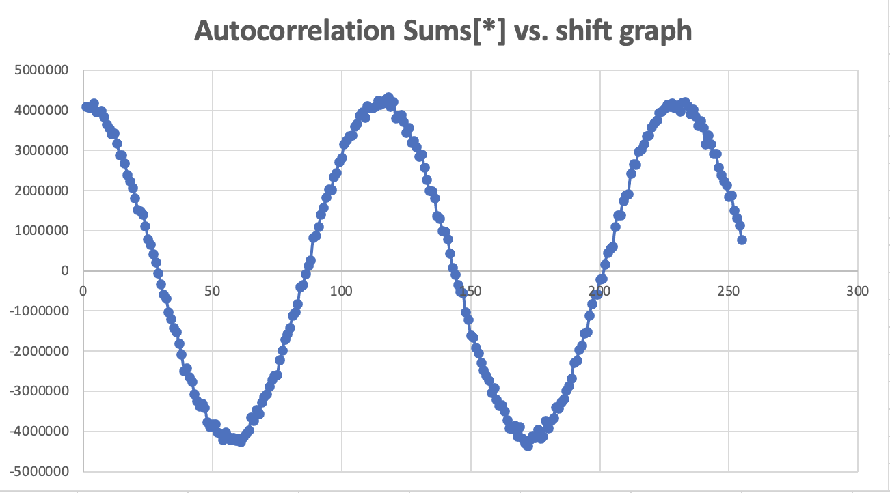

**Graph 1.**

**State what the secret sine-wave period is, i.e., what change in shift gets you one complete sine wave?**

We can see from the graph above, the secret sine-wave period is about 120, it goes down first and then it comes back to the peak.

**Graph of Performance vs. Number of Processors used.**

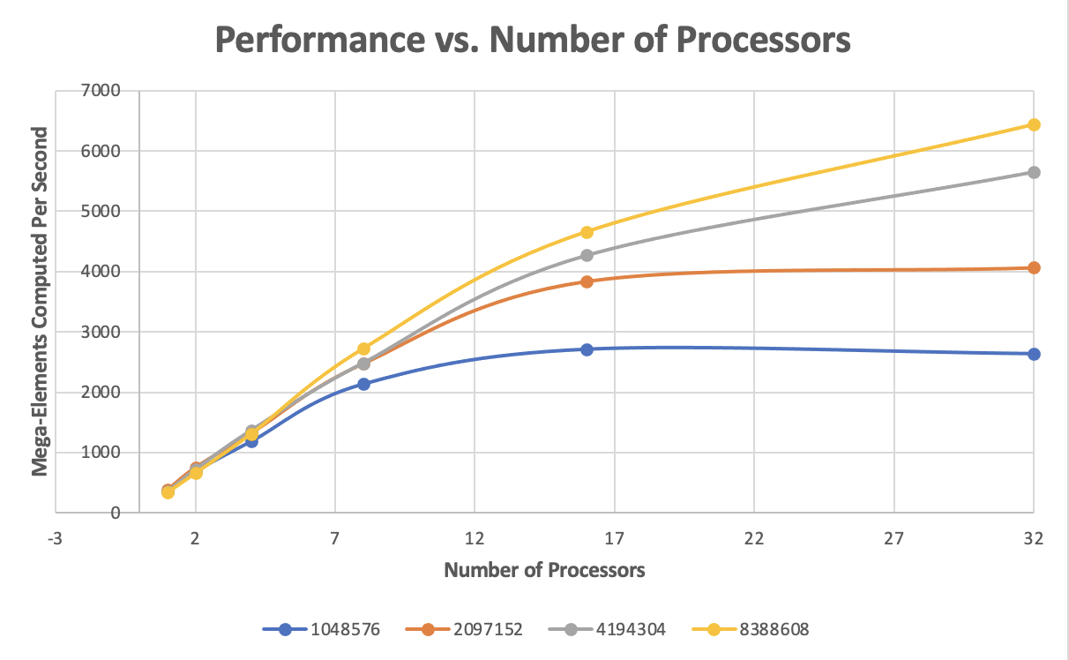

NUMELEMENTS

**Graph 2.**

**What patterns am I seeing in the performance graph?**

As you can see from the figure above, for the most part, performance is better when the number of processors is larger.

With the same number of processors, the larger the number of elements, the higher the performance.

When the number of processors is small, the performance of each NUMELEMENT is similar.

**Why do I think the performances work this way?**

Because tasks are shared and processed by multiple threads at the same time, the more threads, the faster performance.

When the number of Elements is large enough, the advantage of computing with multiple processors becomes greater. For example, when the number of elements is only 1M or 2M, and processors are more than 16, the performance barely changes and the graphics tend to be smooth. Because the number of elements limits the speed of computation. The larger the number of Elements, the higher the performance, the higher the number of tasks that can be calculated per unit time.