Xiaoru Chen

chenxia2@oregonstate.edu

Project #2

CS 475/575

2021-04-27

**Machine I ran this on:**

I used my MacBook pro to ssh to OSU ENGR server (flip).

Based on the results here, choose the run with the maximum number of NUMNODES and 8 threads, the **actual volume** should be $0.435768 ≈0.436$

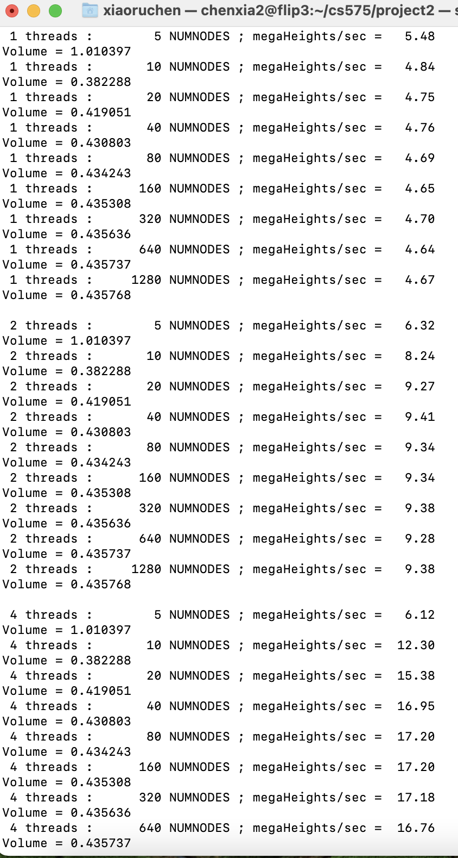

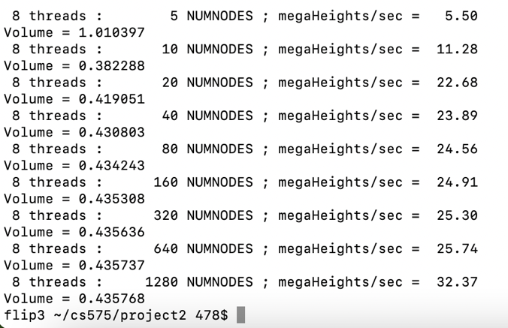

Fig.1 Running results.

Show the performances:

**Table**:



Table.1 Performances table.

**Graphs**:

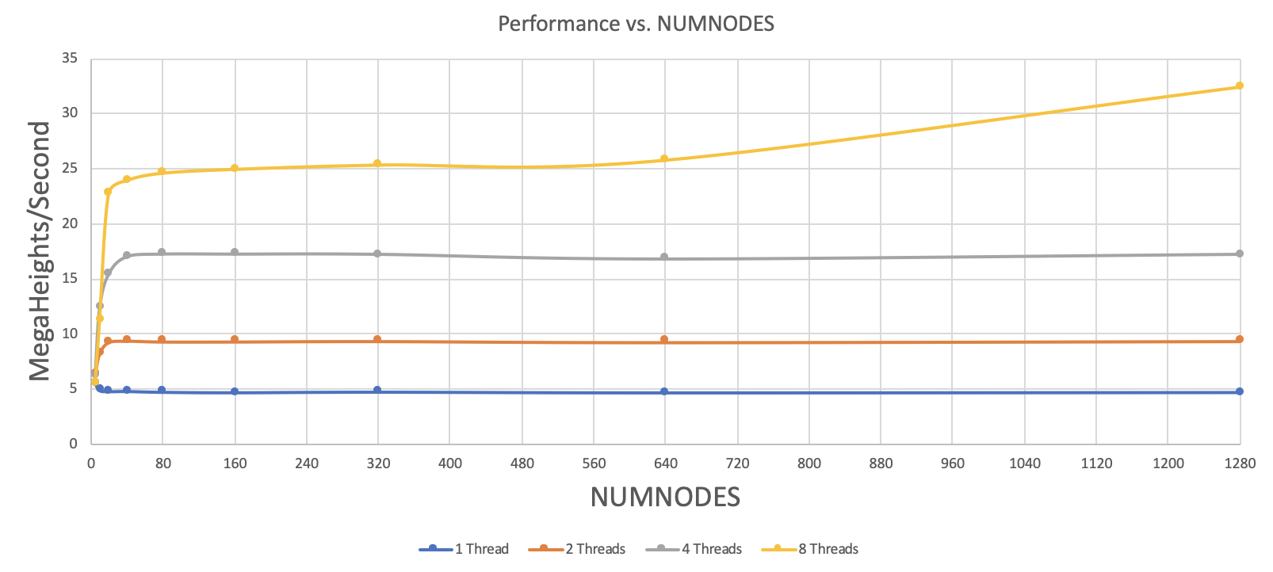

Fig.2 Performance vs. NUMNODES

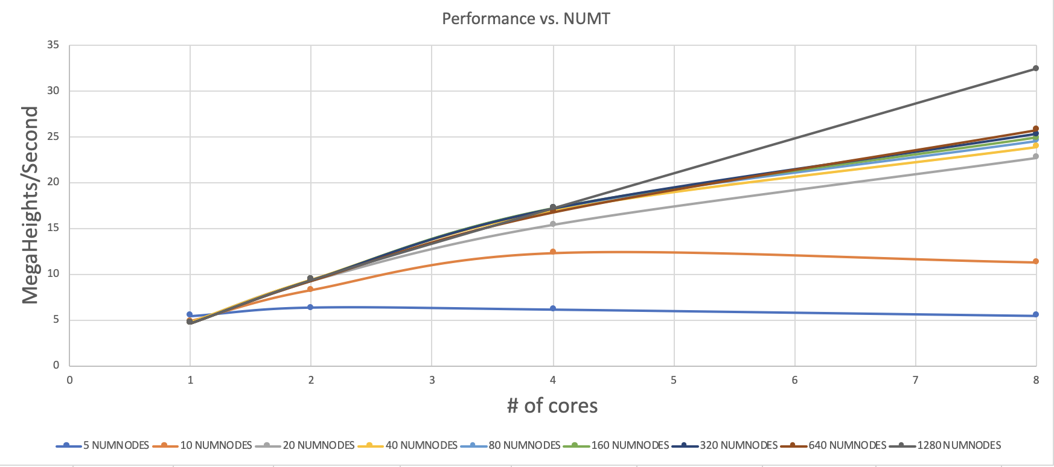

Fig.3 Performance vs. Number of threads

**What patterns in the speeds?**

In the first graphs, we can see, the more cores we have, the faster it runs. However, with the same number of cores, the speed does not change significantly as the number nodes increases. (There is a slight deviation in the picture).

In the second graph, we can see, as the number of cores doubles, the speed increases at nearly the same rate (slightly lower than the rate).

**Why is it behaving this way?**

Because the speed only depends on the number of cores/threads. It has nothing to do with the number of NUMNODES.

**Parallel Fraction & maximum speed-up**

$${Speedup}_{n}=\frac{T_{1}}{T_{n}}=\frac{Max performance with 8 threads}{Max performance with 1 threads}=\frac{\frac{32.37MegaHeights}{Sec}}{(\frac{4.67MegaHeights}{Sec})}=6.93$$

$$F_{p}=\frac{n}{n-1}×\left(1-\frac{1}{Speedup}\right)=\left(\frac{8}{7}\right)×\left(1-\frac{1}{6.93}\right)=0.978$$

$$\max{Speedup=\lim_{n→∞}\left(\frac{1}{F_{sequential}}\right)=\left(\frac{1}{1-F_{p}}\right)=\frac{1}{1-0.978}=}45.45$$