Xiaoru Chen

chenxia2@oregonstate.edu

Project #4

CS 475/575

2021-05-12

**Machine I ran this on:**

I used my MacBook pro to ssh to OSU ENGR server (flip).

**Table of performances for each array size and the corresponding speedups:**

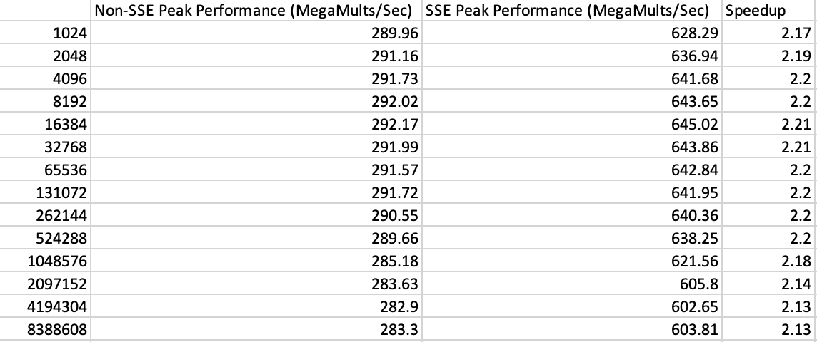

Table.1 Performances for each array size and the corresponding speedups

**Graph of SIMD/non-SUMD speedup versus array size:**

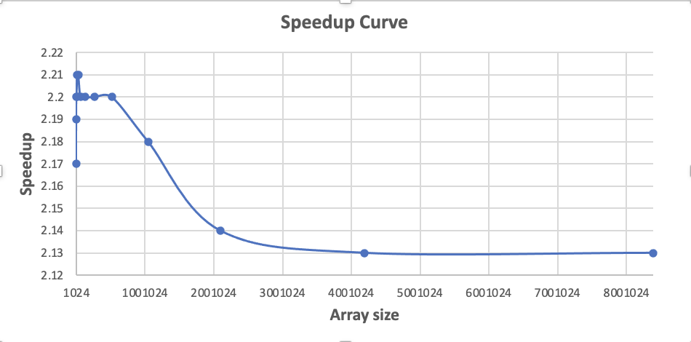

Graph.1 SIMD/non-SUMD speedup versus array size

**What patterns am I seeing in the speedups?**

When the length of the array gets larger and larger, the speed up shows a downward trend and finally becomes relatively stable.

**Are they consistent across a variety of array size?**

No, they are not.

**Why or why not, do I think?**

Because the registers are limited. Initially, when the size of the array is small, the registers are sufficient and the arithmetic wait is small. However, when the size of the array becomes very large, such as 4 million, 5 million, the registers becomes saturated, operations need to wait, but the operations still need to be performed, so at this point, the trend of decline is almost no longer reached.