- Requirements
  - Software
    - Laptop with Linux and (micro)SD-card slot
    - `zstd` for compressing and decompressing files: https://manpages.ubuntu.com/manpages/xenial/man1/unzstd.1.html
    - `gparted` or equivalent tool to format a USB-Stick
    - `hawkbit.config` and `config.toml`
Get both from Eric: jedermann@cs.uni-kl.de
  - Hardware
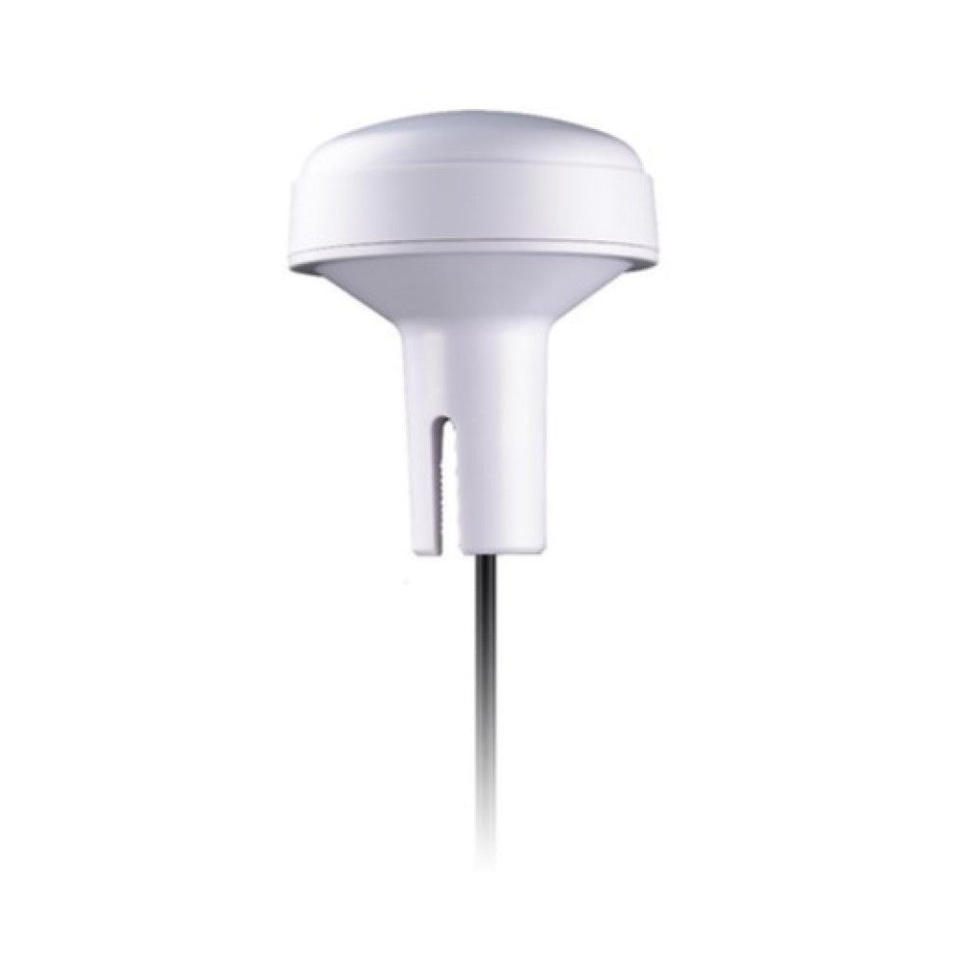
    - Iridium Antenna
Taoglas IMA.01.105111
    - Mounting hardware for the Iridium Antenna:
      - A ¾ inch (metal) pipe to screw on the antenna (length depends on the location)
      - Some zipties or pipe clamps to mount the pipe
    - Optional: Antenna extension cable
    - HackRF One
      - USB-microUSB cable
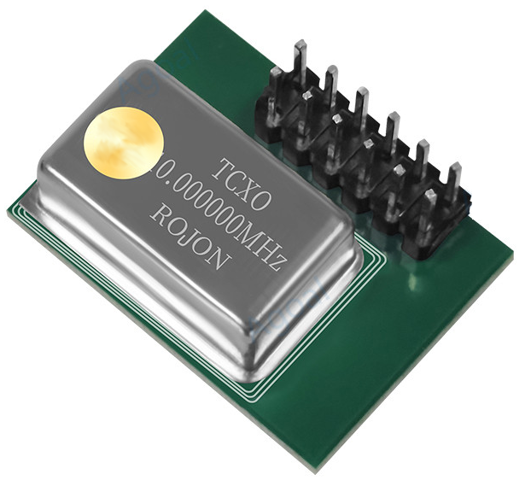
    - Temperature controlled oscillator (TCXO)
for HackRF One
    - Raspberry Pi 4
    - microSD card (>= 16GB)
    - Power Supply for Pi 4 (5.1V 3A)
    - USB-Stick with > 4GB
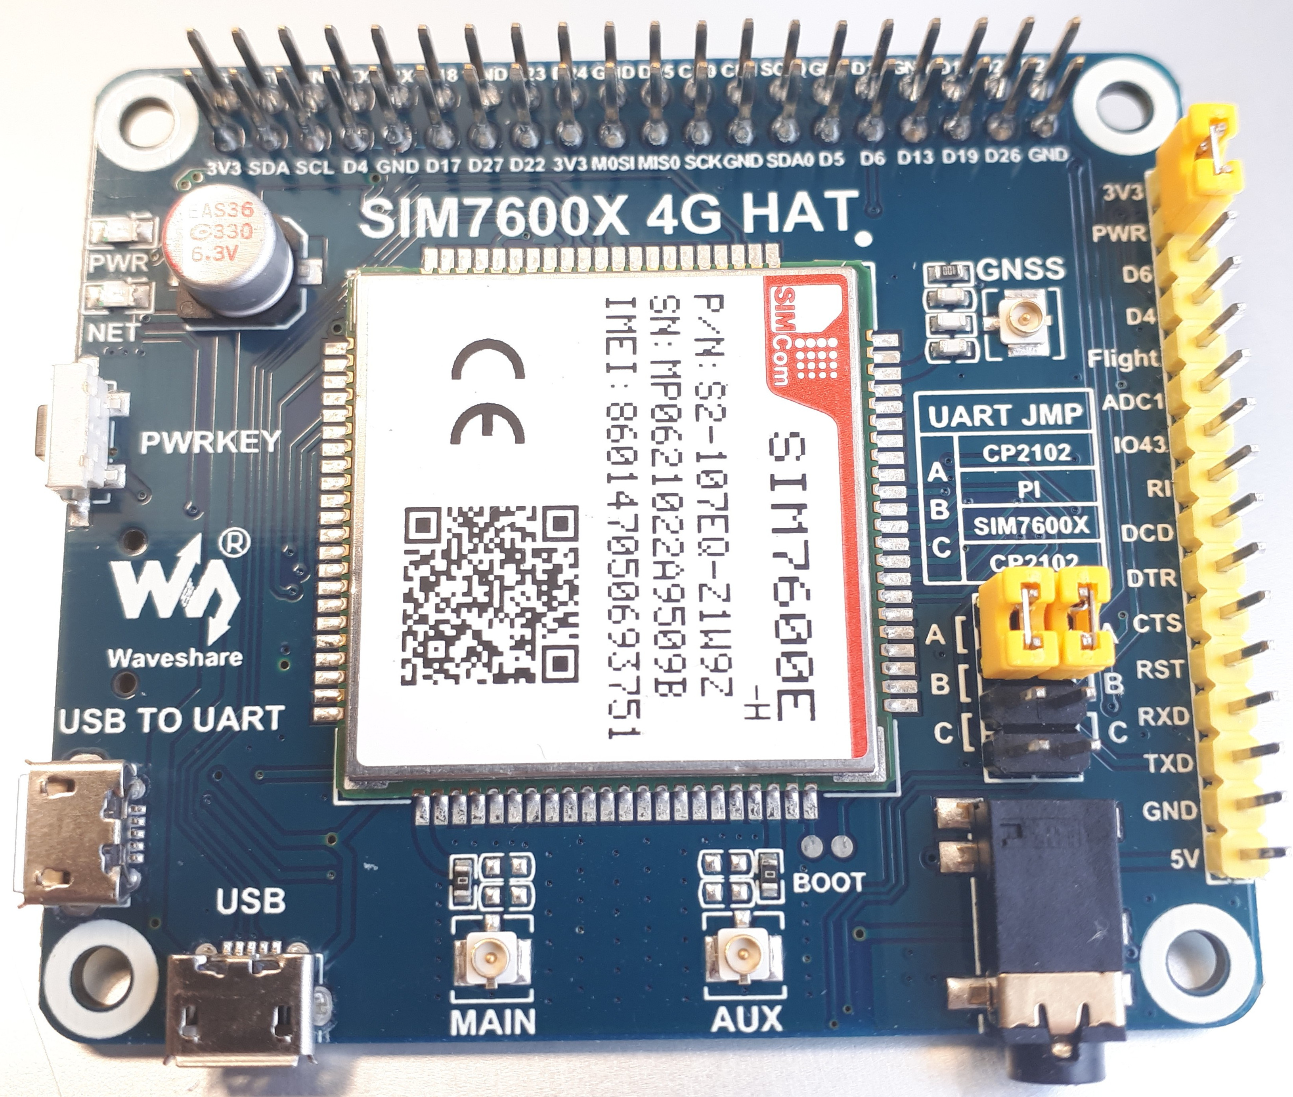
    - LTE & GPS shield SIM7600E-H
      - GPS antenna & GPS antenna connector
(SMA → u.FL)
      - Optional: LTE antenna & LTE antenna connector
(SMA → u.FL)
      - Small USB-microUSB cable
(the large USB-microUSB cable is not used)
    - Optional: SIM-card
    - weather resistant DRI-box

- Software Installation
  - Installation base Image
    - Download the newest image (sdcard.img_2.1.zst) from https://seafile.rlp.net/f/c172bc3898354b9a972f/
    - Unzip the image:
`$ unzstd sdcard.img_2.1.zst`
    - Copy the image onto a SD-card using the following commands:
`$ sudo dd if=sdcard.img of=/dev/mmcblk0 bs=4M`
`$ sync`
    - Unmount SD-card and insert into the Pi.
  - Installation Config USB-Stick
    - get usb-stick with >4GB
    - format usb-stick in "ext4" with name "discosat-data" (e.g. via gparted)
    - mount the usb-stick and create the following directories on the usb-stick:
      - `/config/apogee`
      - `/config/secrets`
    - download the two config files
      - `config.toml`
      - `hawkbit.config`
    - copy the `config.coml` into the directory `/config/apogee`
    - copy the `hawkbit.config` into the directory `/config/secrets`
    - inside the directory `/config/secrets` rename the `hawkbit.config` to `.hawkbit`
    - unmount usb-stick and insert it into the Pi

- Hardware Installation
  - Place the Iridium antenna
    - Find a spot to mount the Iridium antenna: a spot with free few to the sky, more free sky means a wider reception angle of the antenna.
    - Mount the Iridium antenna there, using the mounting equipment. The thread of the antenna is facing downward. (so rain can not drop into it)
    - If requred attach an SMA extension cable to the antennas SMA cable. If so, wrap the connectors in tape to keep them dry.
  - Core: Pi, Shield & HackRF
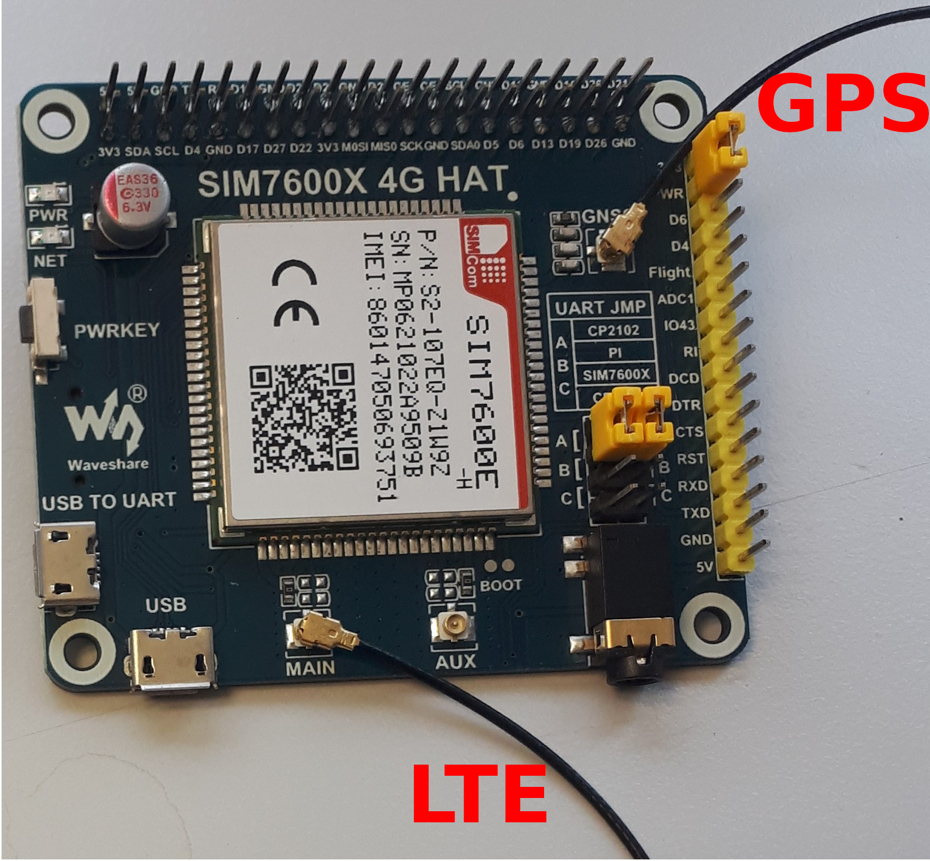
    - Connect the GPS antenna to the `GNSS`-connector
on the GPS & LTE-shield.
    - Optional: If you want to use LTE on the sensor:
      - Connect the LTE antenna to the `main`-connector on the GPS & LTE-sheild.
      - Insert the SIM-card on the bottom-side of the GPS & LTE-shield.
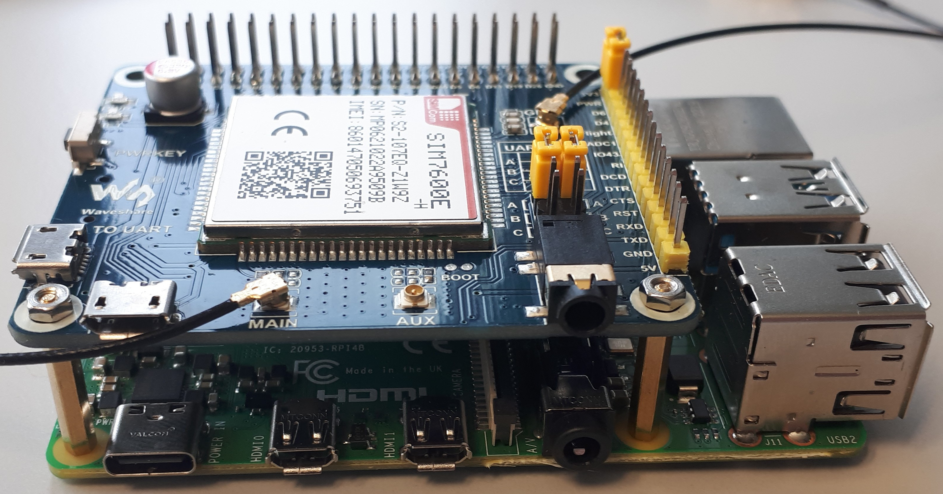
    - Mount the GPS & LTE-shield on the Pi:
      - Connect the two small spacers of the shield with the Pi, next to the power socket and the audio jack.
      - Press the GPIOs adapter of the shield on the pins of the Pi (with careful force).
      - Connect the two small spacers with the shield.
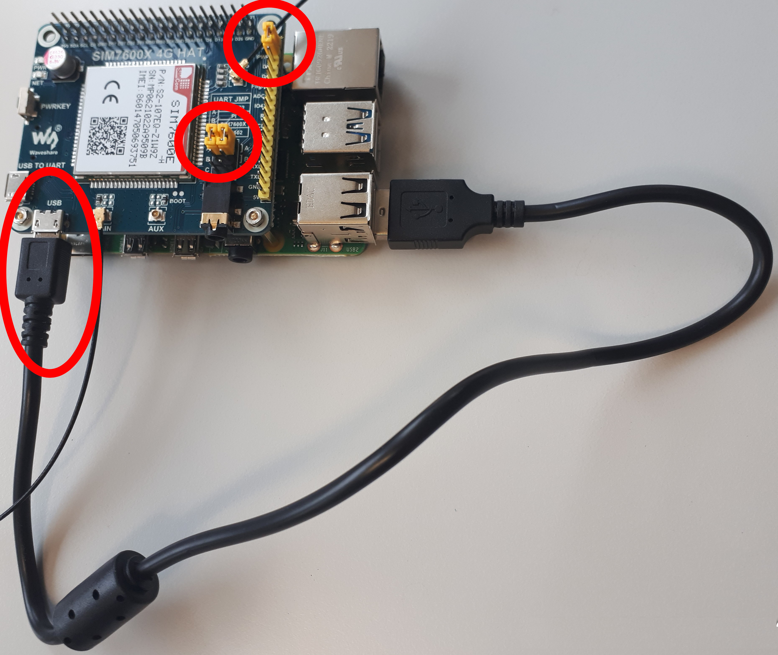
    - Use the small USB-cable to connect one USB port of the Pi with the `USB`-labeled micro-USB port on the shield.
    - Place the three jumpers on the shield:
      - Jumper on the big yellow pin-line in the upper position: [3V3 – PWR]
      - Both Jumpers on the small black double-pin-line (next to the audio jack) in the upper position (away from the audio jack): [A]

    - Optional: If you have a TCXO to improve the frequency accuracy of the HackRF
      - Open the case of the HackRF.
      - Mount the TCXO on the corner of the connector line.
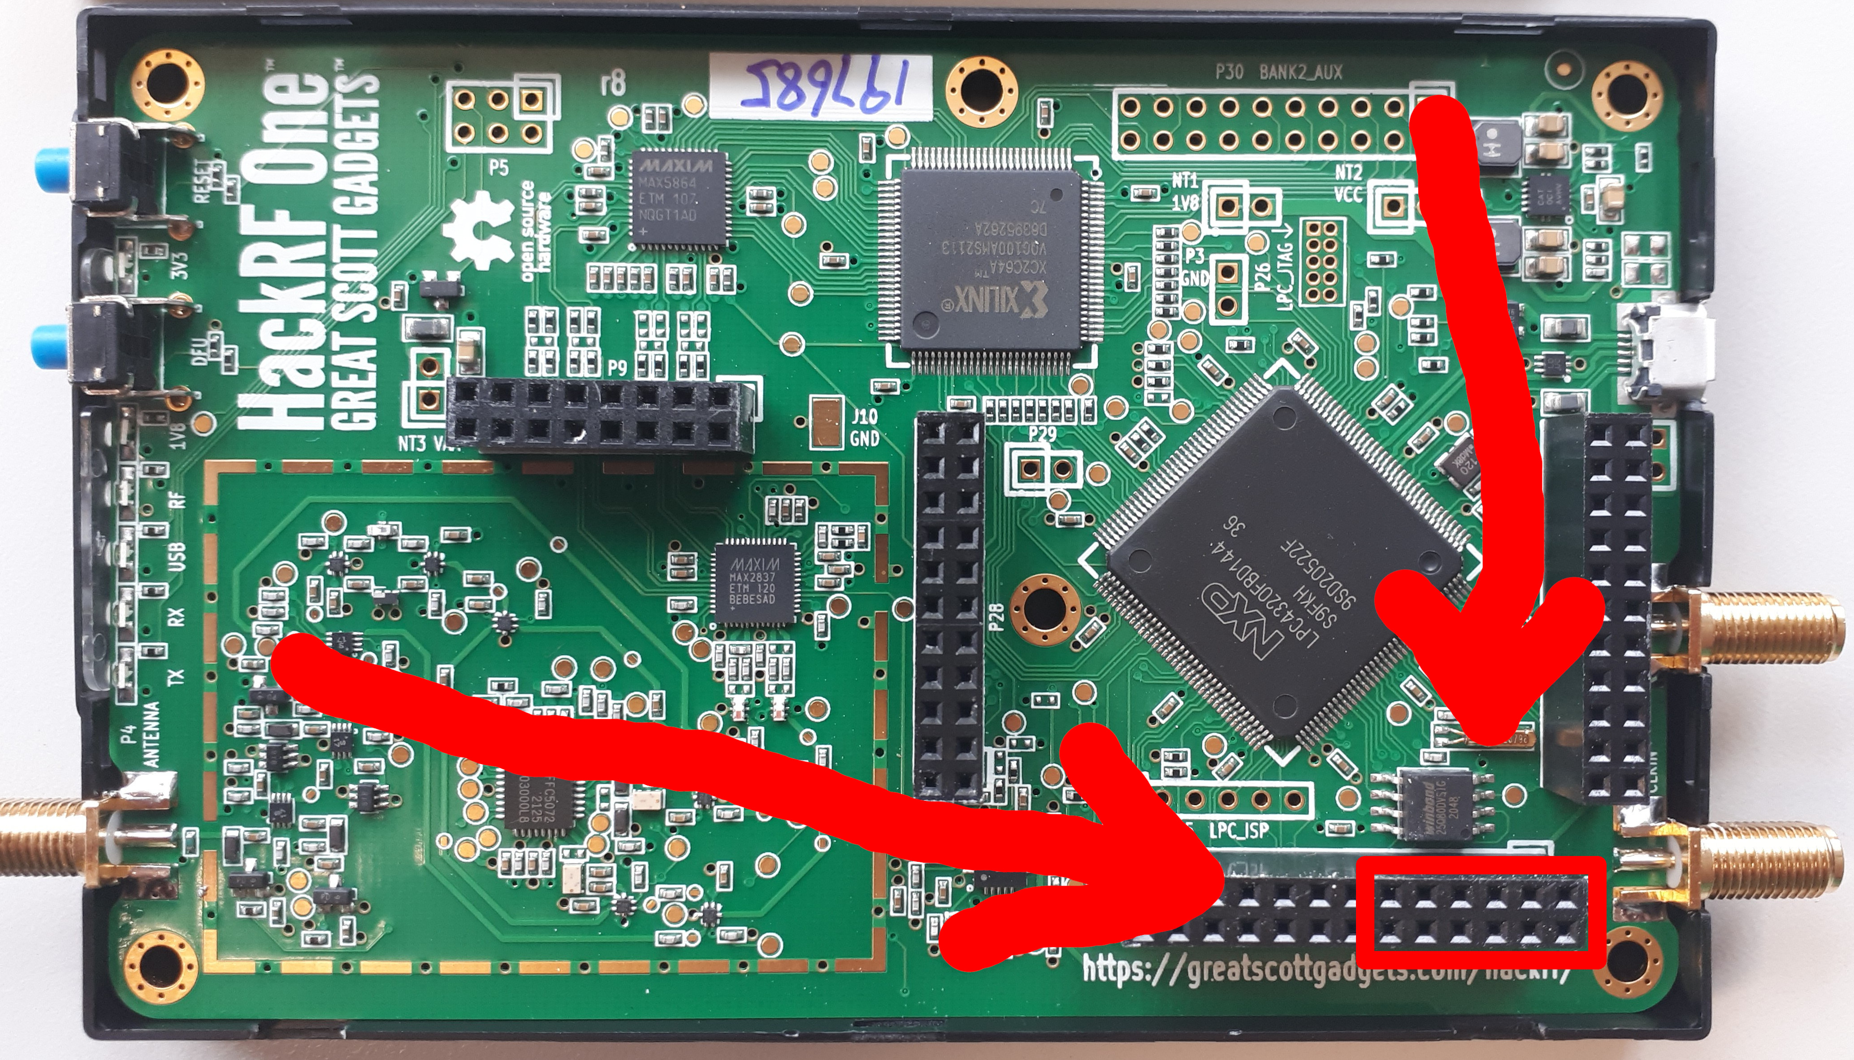
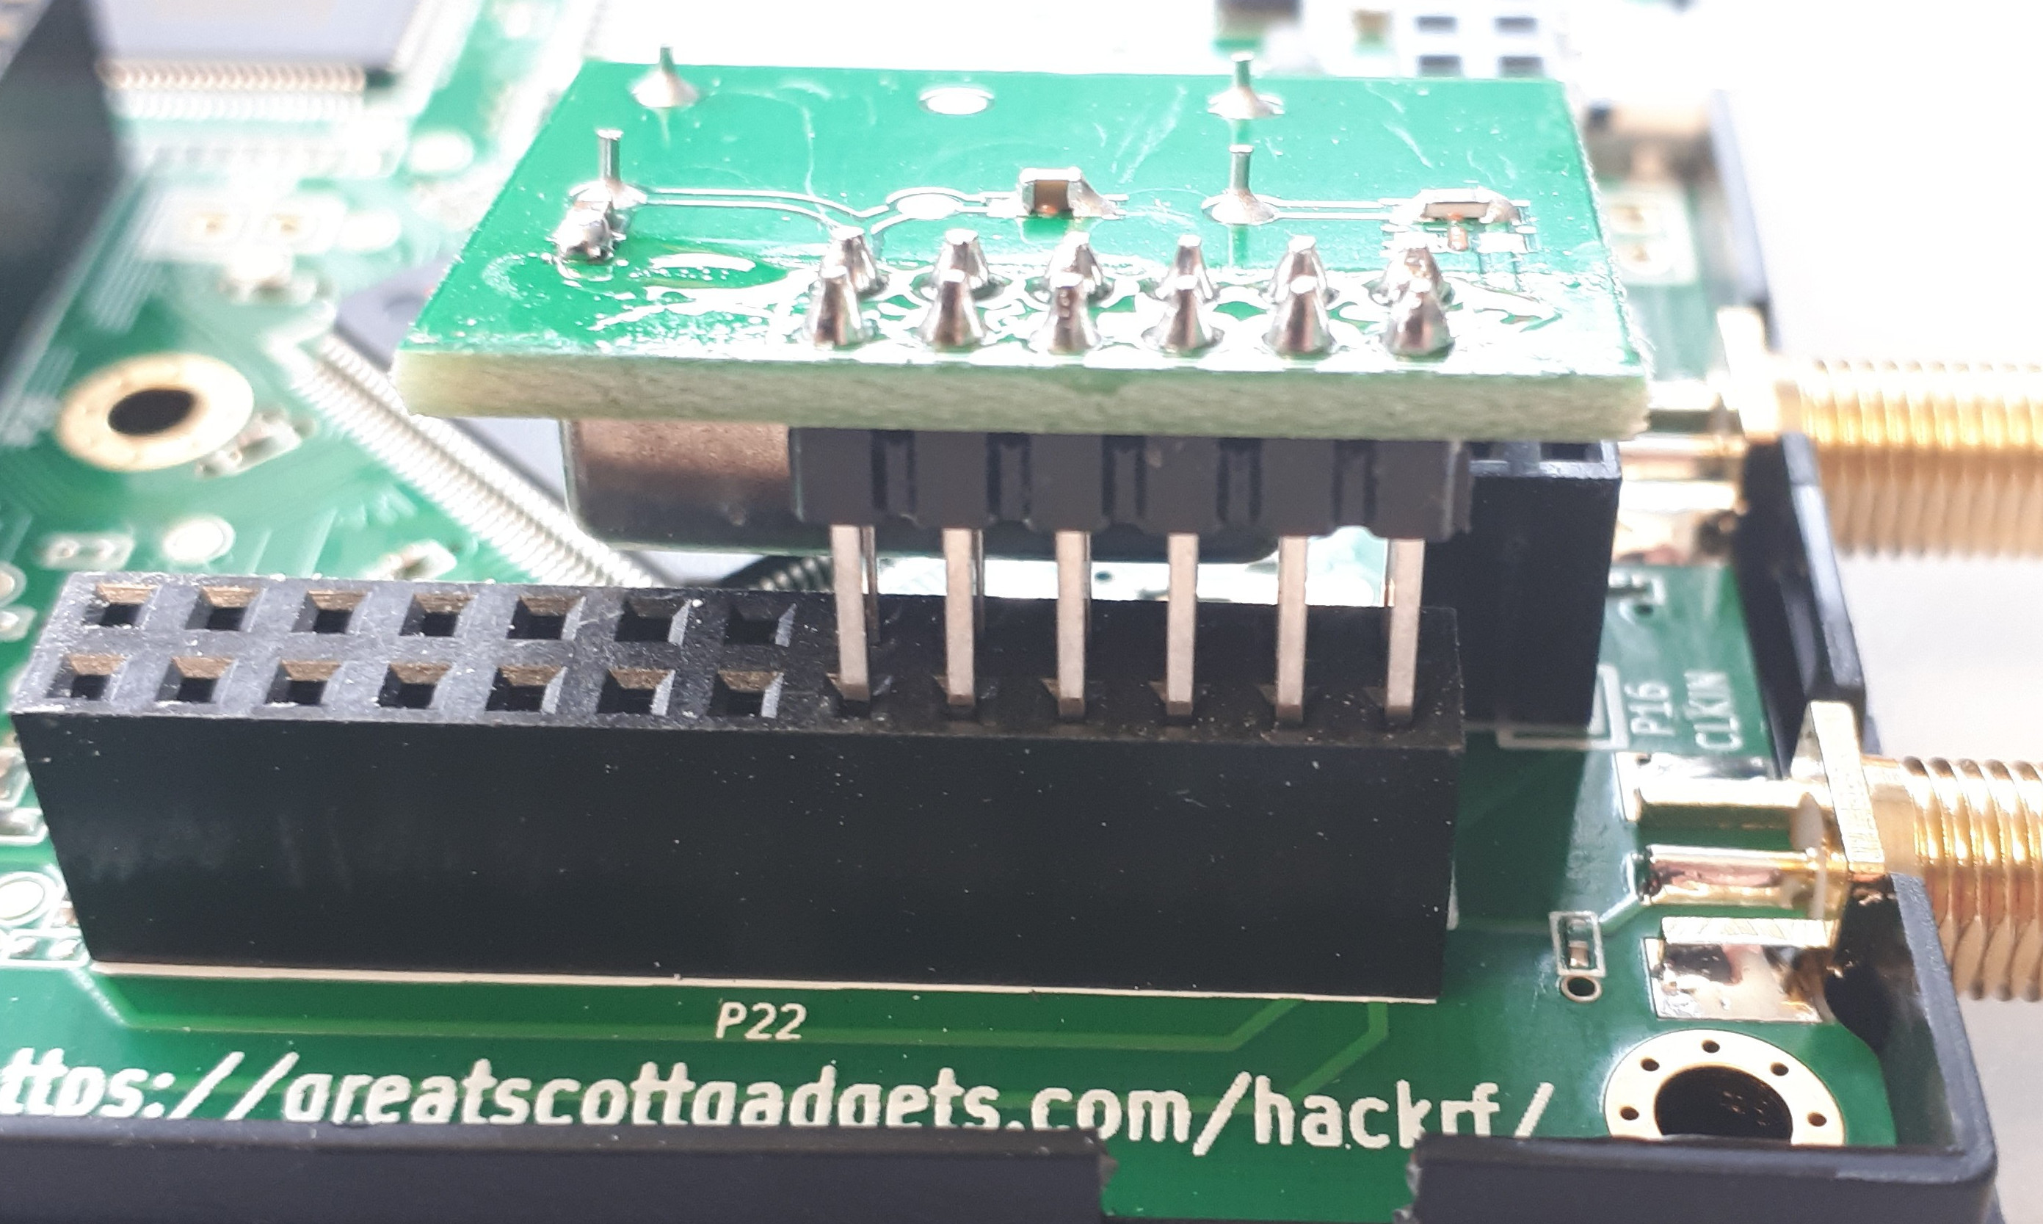
      - Close the case. (Maybe it will not close fully with the TCXO. Use tape for this.)
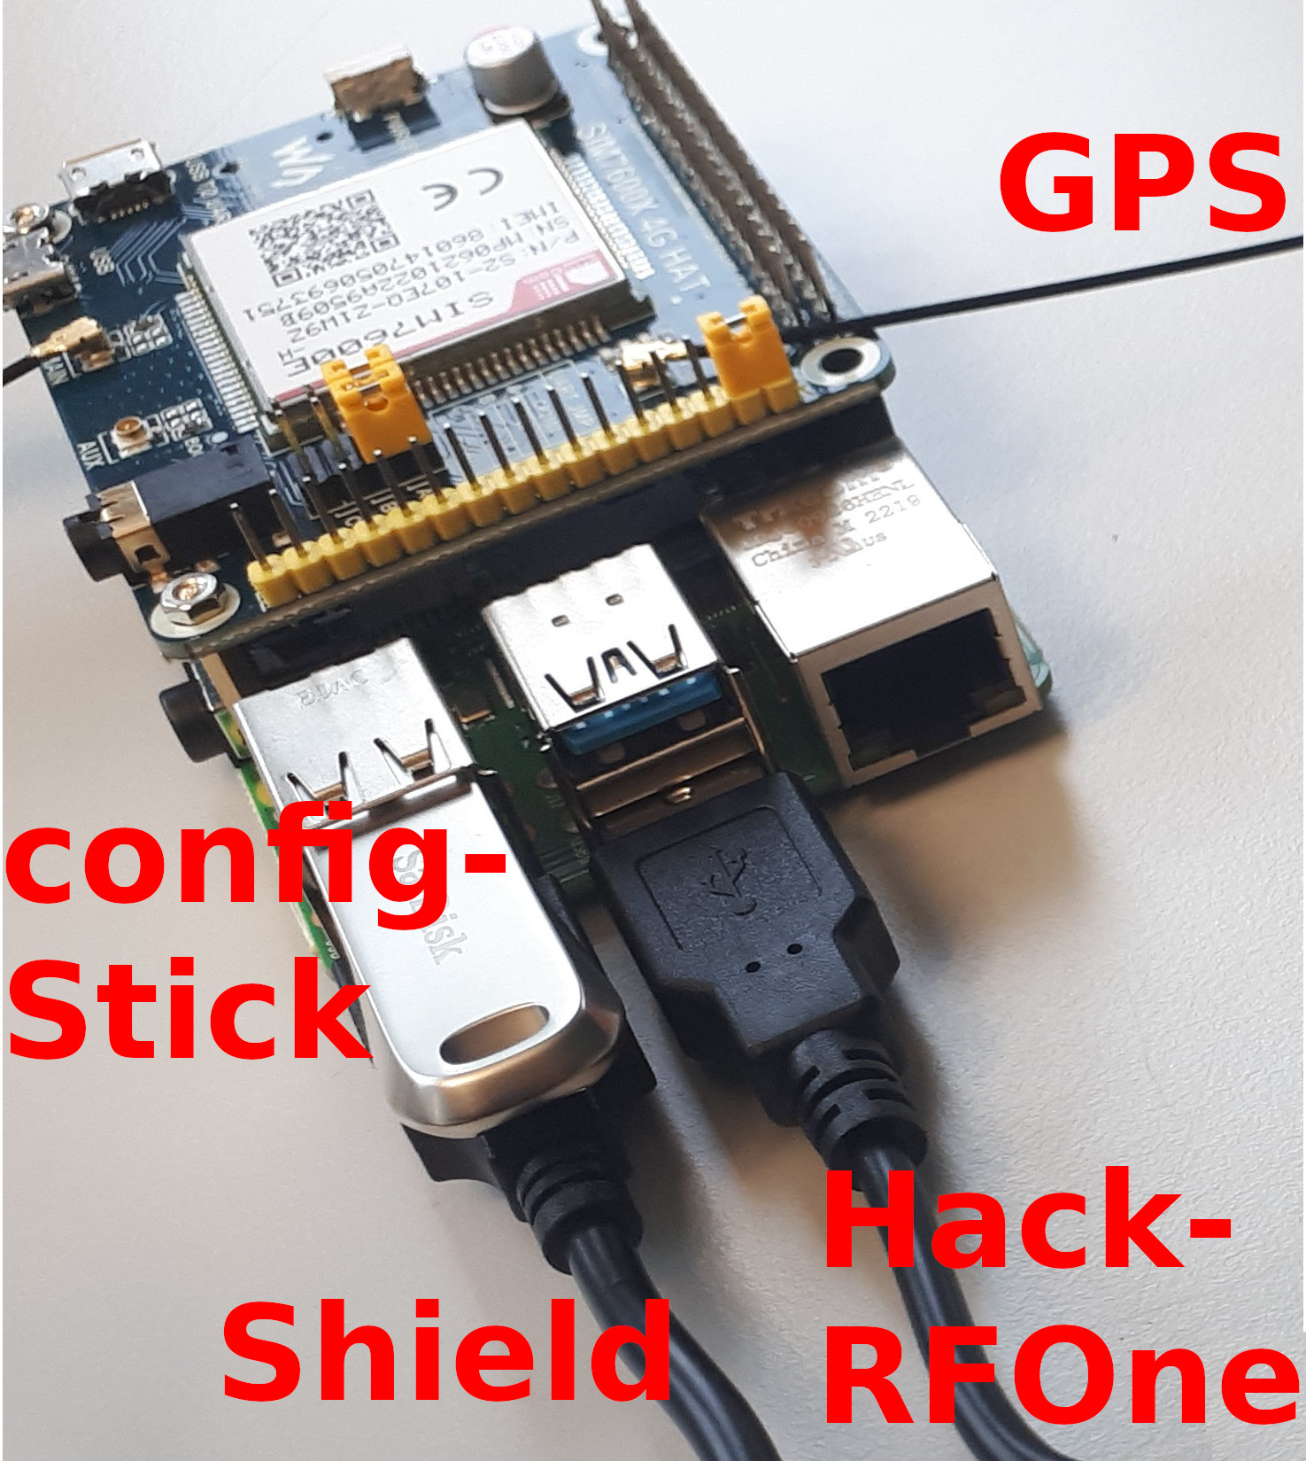
    - Connect the HackRF via a USB-cable to the Pi
(preferably to a USB-3 port of the Pi).
    - Connect the Iridum antenna to the HackRF One.
    - Ensure that the config USB-stick and the SD-card are inserted in the Pi.
    - Connect the Ethernet cable to the Ethernet port on the Pi.
(If you use PoE, put a PoE splitter between the Ethernet cable and the Pi. The splitter should be able to deliver 5V + 3A )
    - Connect the power supply to the Pi.
    - Place the Pi (with the shield) and the HackRF in the weather resistant DRI-box. The box has special outlets for the cables to prevent moisture to come into the box. On the outlets additional `hooks` can be mounted for securing the cable, to prevent the devices inside the box to be pulled out by the cables. Three cables should go to the outside now:
      - The Pis power supply.
      - The Iridium antenna.
      - The GPS antenna.
    - Mount the cover of the DRI-box and place the box on a safe spot to prevent falling down.
    - Usually the GPS-antenna can be placed inside close to a window, still providing a good GPS reception.
    - Power on the Pis power supply. The Pi should now boot and connect automatically to the networks server.

