- Requirements
  - Software
    - Laptop with Linux and (micro)SD-card slot
    - `zstd` for compressing and decompressing files: https://manpages.ubuntu.com/manpages/xenial/man1/unzstd.1.html
    - `gparted` or equivalent tool to format a USB-Stick
    - a `configs_sensor_name.zip`, including the config-files
    - get the sensor-login: two JWTs (acces- & refresh-token), sensor name,
hawkbit-sensor-name, hawkbit-login-token
Get it from Eric: jedermann@cs.uni-kl.de
  - Hardware
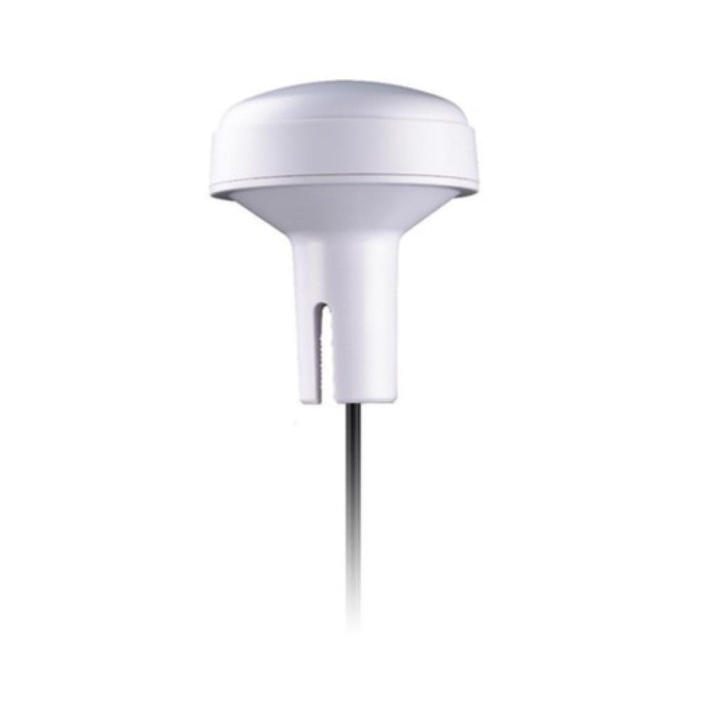
    - Iridium Antenna
Taoglas IMA.01.105111
    - Mounting hardware for the Iridium Antenna:
      - A ¾ inch (metal) pipe to screw on the antenna (length depends on the location)
      - Some zipties or pipe clamps to mount the pipe
    - Optional: Antenna extension cable
    - HackRF One
      - USB-microUSB cable
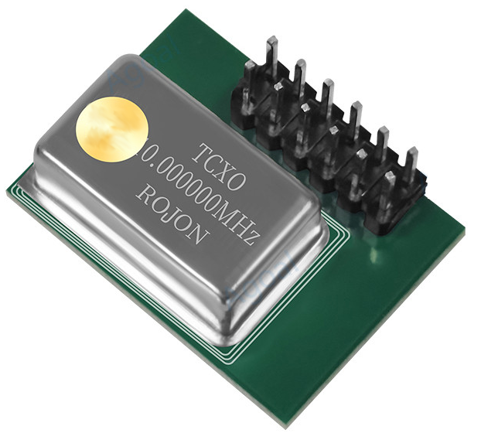
    - Temperature controlled oscillator (TCXO)
for HackRF One
    - Raspberry Pi 4
    - microSD card (>= 16GB)
    - Power Supply for Pi 4 (5.1V 3A)
    - USB-Stick with > 4GB
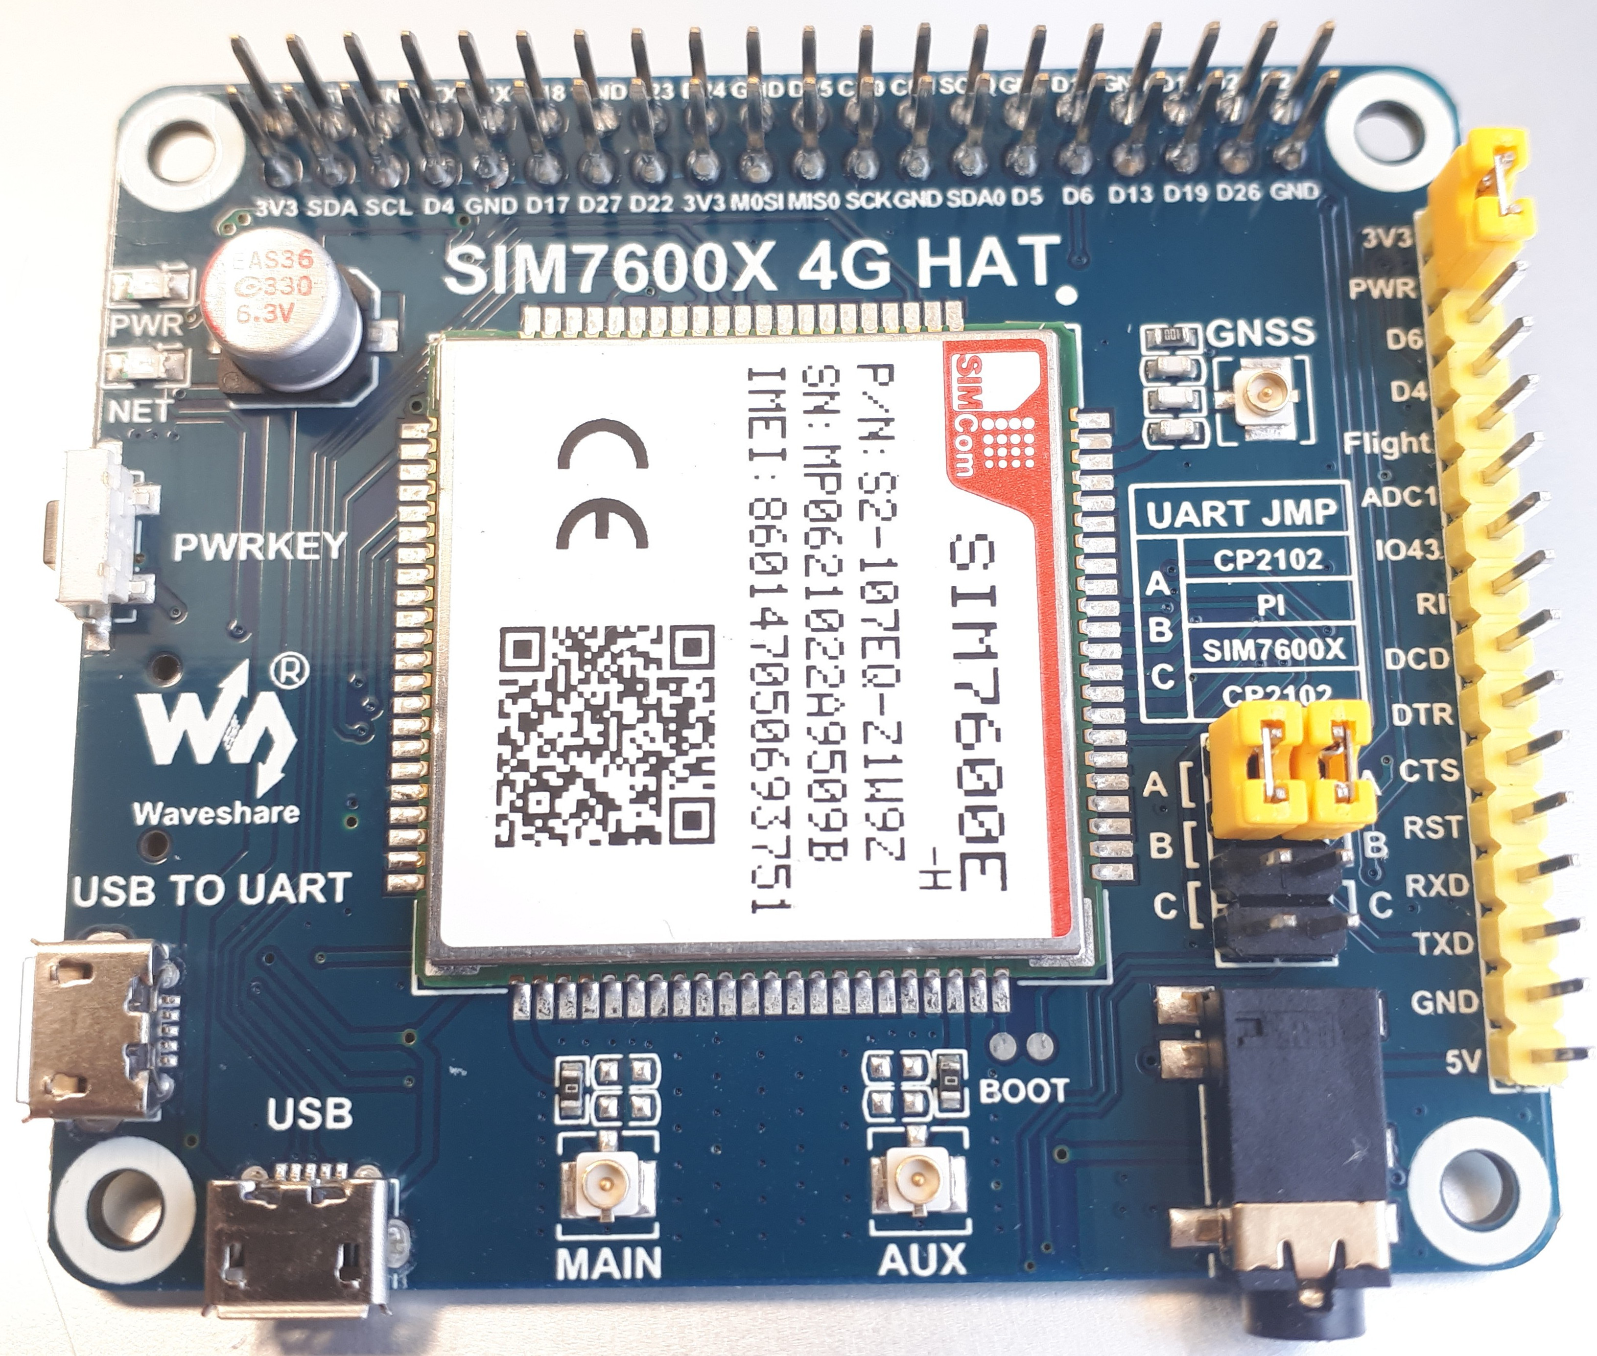
    - LTE & GPS shield SIM7600E-H
      - GPS antenna & GPS antenna connector
(SMA → u.FL)
      - Optional: LTE antenna & LTE antenna connector
(SMA → u.FL)
      - Small USB-microUSB cable
(the large USB-microUSB cable is not used)
    - Optional: SIM-card
    - weather resistant DRI-box

- Software Installation
  - Installation base Image
    - Download the newest image (sdcard_2024_11_27.img.zst) from https://seafile.rlp.net/f/20ce17a24d754ccdbc21/
    - Rename the image to: sdcard.img.zst
    - Unzip the image:
`$ unzstd sdcard.img.zst`
    - Insert the micro SD-card.
(assumption: the SD-card is mounted at /dev/mmcblk0)
    - Copy the image onto a SD-card using the following commands:
`$ sudo dd if=sdcard.img of=/dev/mmcblk0 bs=4M`
`$ sync`
    - Unmount SD-card and insert it into the Pi.
  - Installation of Config USB-Stick
    - get usb-stick with >4GB
    - format usb-stick in "ext4" with name "discosat-data" (e.g. via gparted)
    - unzip the `config_stick_setup.zip`. You get:
      - configs/config.toml
      - configs/hawkbit.config
      - configs/eth0.nmconnection
      - configs/wlan0.nmconnection
      - configs/gsm.nmconnection
    - mount the usb-stick and create the following directories (with sub-directories) on the usb-stick:
      - `/config/apogee`
      - `/config/secrets`
      - `/config/system-connections`
    - Modify the config files if required:
      - config.toml: add sensor name, refresh-JWT and acces-JWT
      - hawkbit.config: add sensor name and security-token
      - eth0.nmconnection: if necessary add static IPv4. Default: DHCP
      - wlan0.nmconnection: if necessary add wifi-ssid and password
      - gsm.nmconnection: if necessary add provider name and apn
    - copy the modified config files into their target directory on the usb-stick:
      - copy `config.toml` into the directory `/config/apogee`
      - a: copy the `hawkbit.config` into the directory `/config/secrets`
b: inside the directory `/config/secrets` rename the `hawkbit.config` to `.hawkbit`
      - copy `eth0.nmconnection` into the directory `/config/system-connections`
      - copy `wlan0 .nmconnection` into the directory `/config/system-connections`
      - copy `gsm .nmconnection` into the directory `/config/system-connections`
    - unmount usb-stick and insert it into the Pi

- Hardware Installation
  - Place the Iridium antenna
    - Find a spot to mount the Iridium antenna: a spot with free few to the sky, more free sky means a wider reception angle of the antenna.
    - Mount the Iridium antenna there, using the mounting equipment. The thread of the antenna is facing downward. (so rain can not drop into it)
    - If requred attach an SMA extension cable to the antennas SMA cable. If so, wrap the connectors in tape to keep them dry.
  - Core: Pi, Shield & HackRF
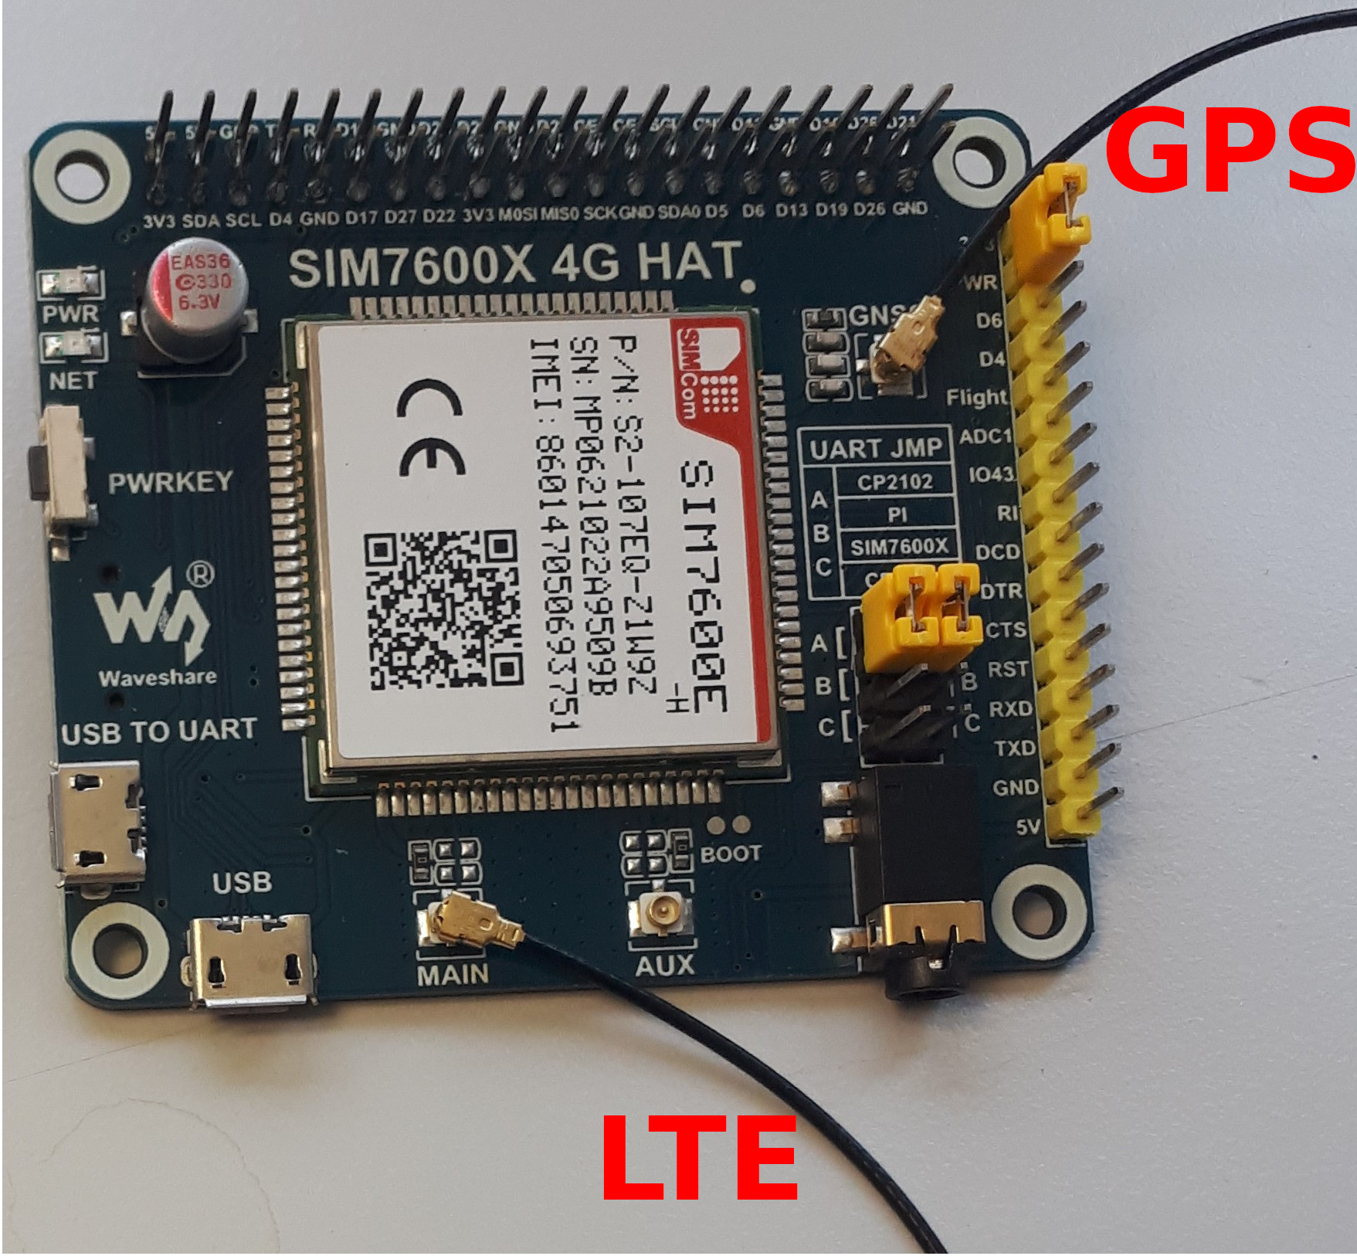
    - Connect the GPS antenna to the `GNSS`-connector
on the GPS & LTE-shield.
    - Optional: If you want to use LTE on the sensor:
      - Connect the LTE antenna to the `main`-connector on the GPS & LTE-sheild.
      - Insert the SIM-card on the bottom-side of the GPS & LTE-shield.
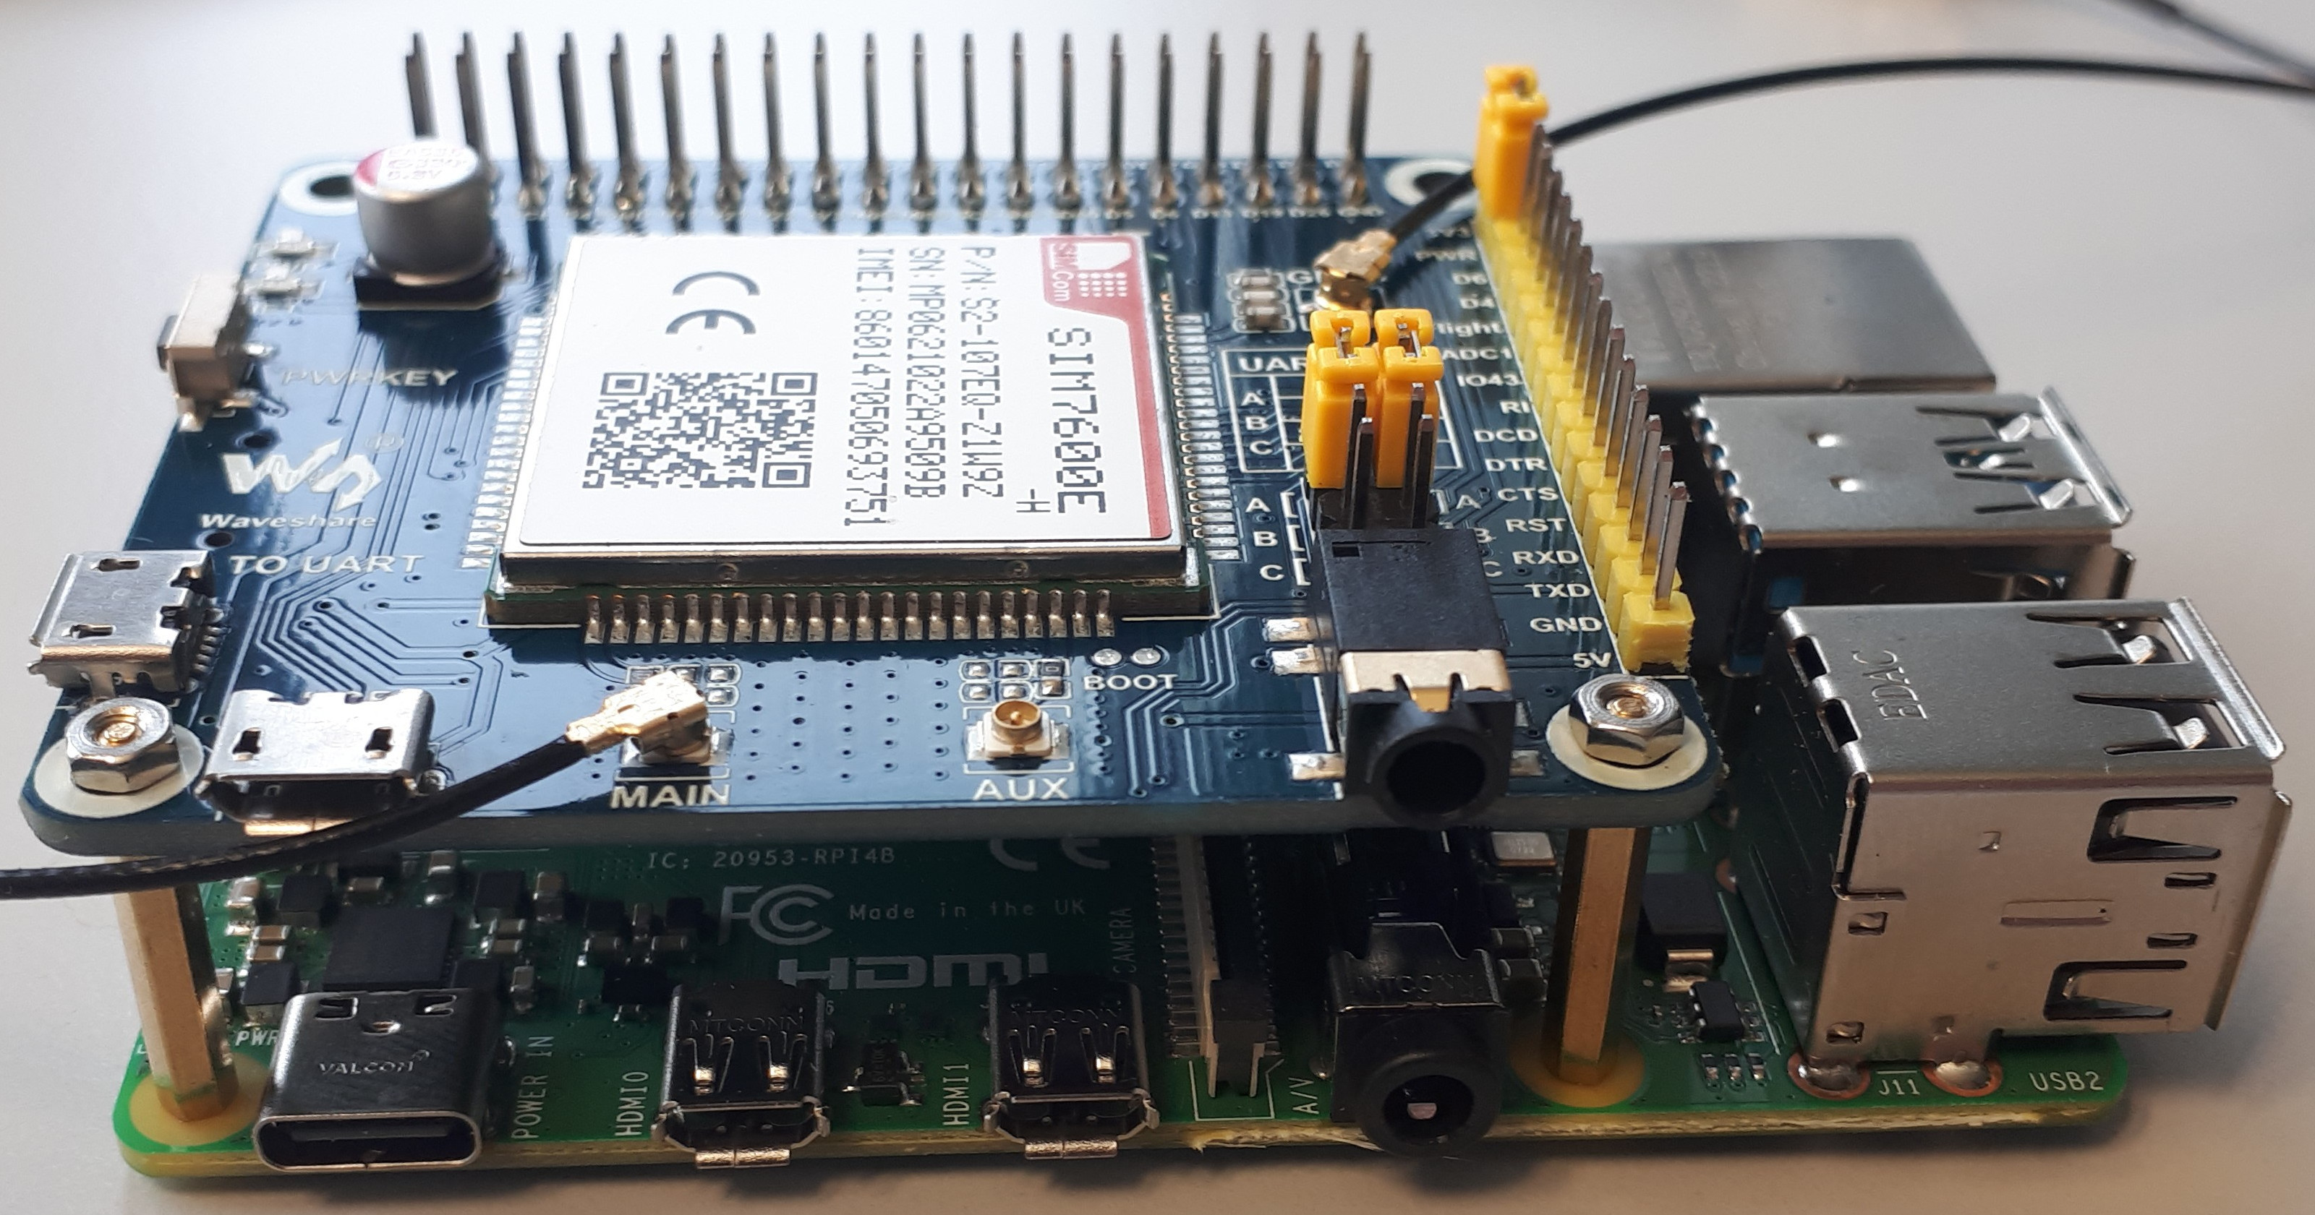
    - Mount the GPS & LTE-shield on the Pi:
      - Connect the two small spacers of the shield with the Pi, next to the power socket and the audio jack.
      - Press the GPIOs adapter of the shield on the pins of the Pi (with careful force).
      - Connect the two small spacers with the shield.
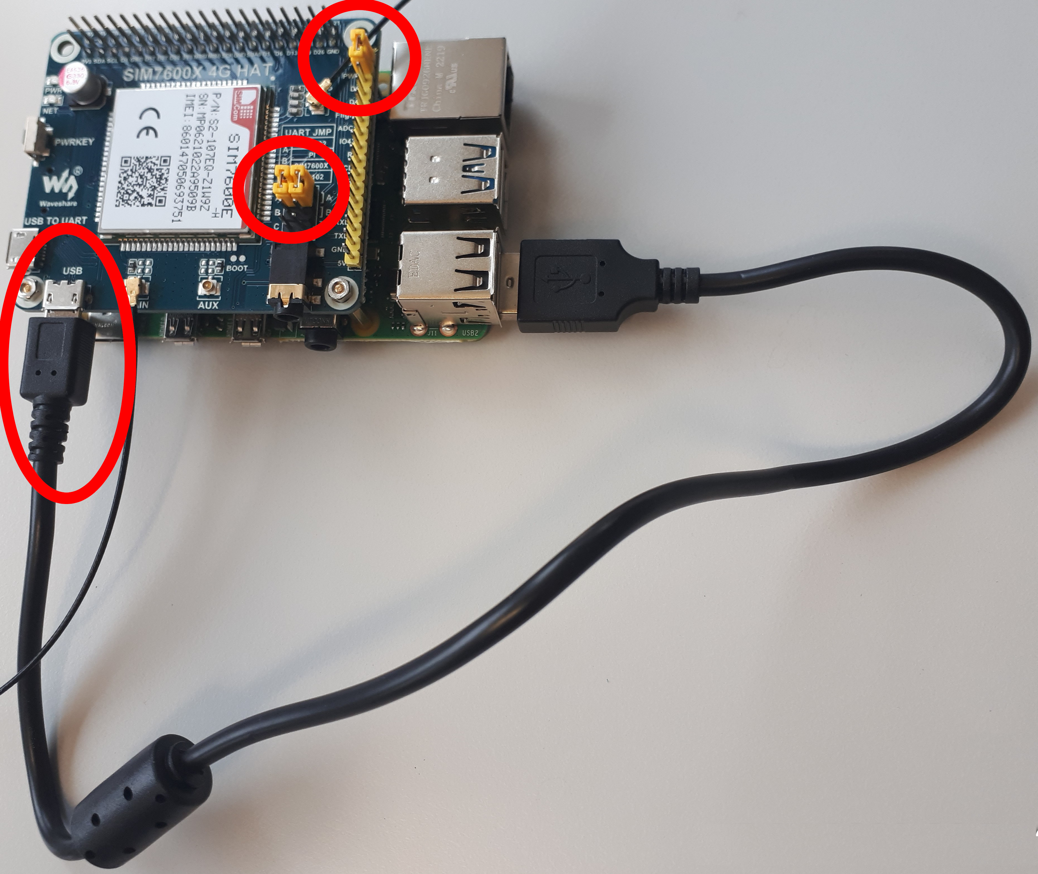
    - Use the small USB-cable to connect one USB port of the Pi with the `USB`-labeled micro-USB port on the shield.
    - Place the three jumpers on the shield:
      - Jumper on the big yellow pin-line in the upper position: [3V3 – PWR]
      - Both Jumpers on the small black double-pin-line (next to the audio jack) in the upper position (away from the audio jack): [A]

    - Optional: If you have a TCXO to improve the frequency accuracy of the HackRF
      - Open the case of the HackRF.
      - Mount the TCXO on the corner of the connector line.
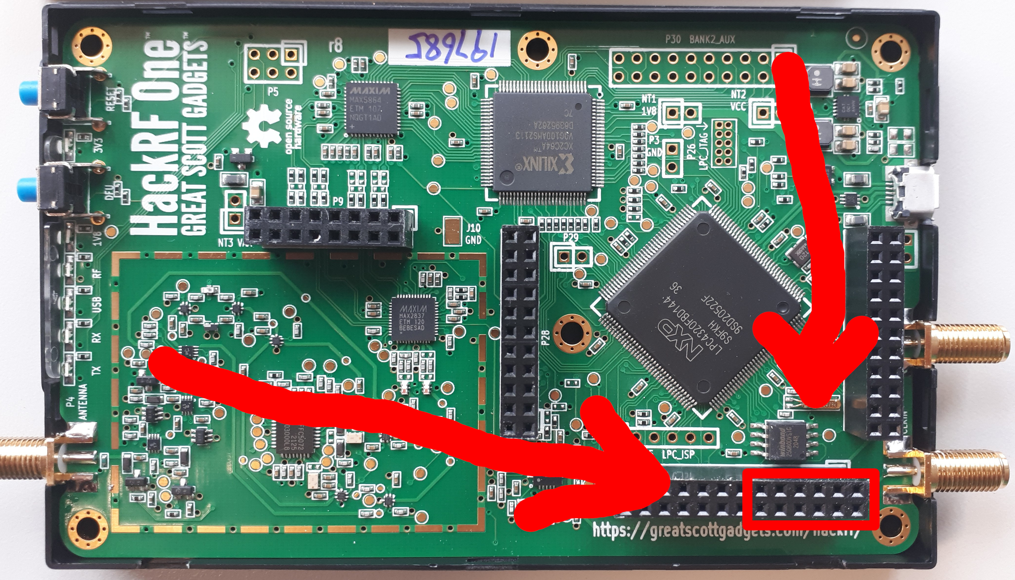
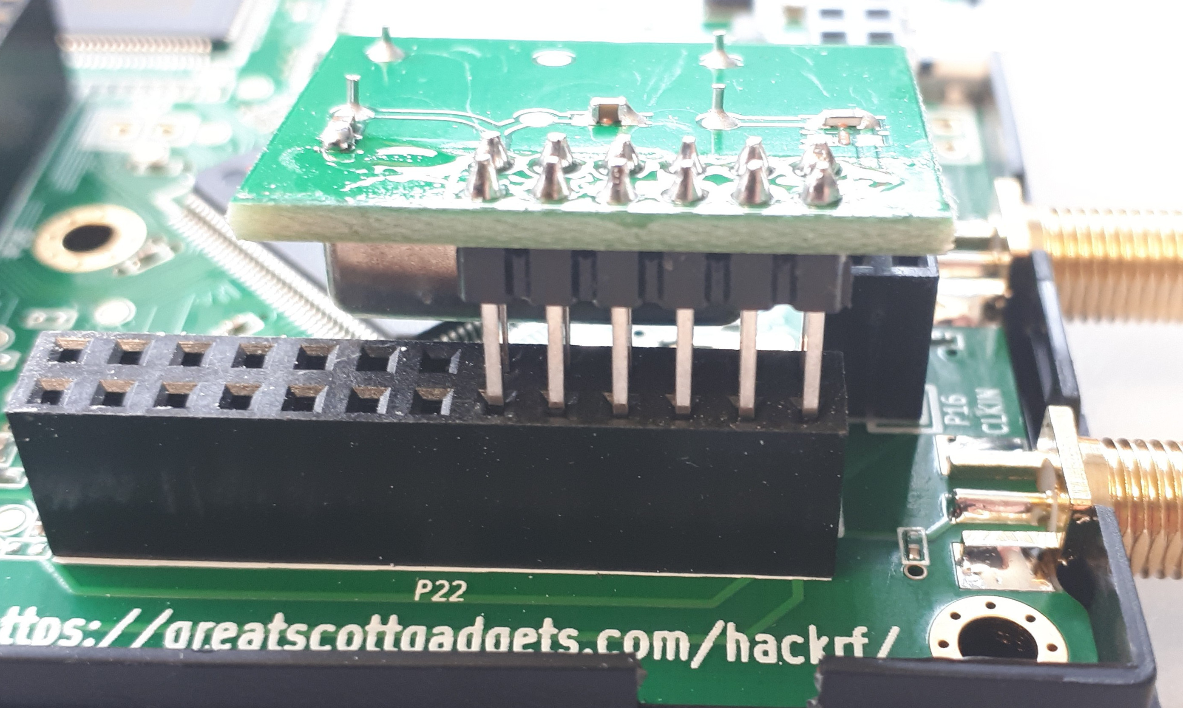
      - Close the case. (Maybe it will not close fully with the TCXO. Use tape for this.)
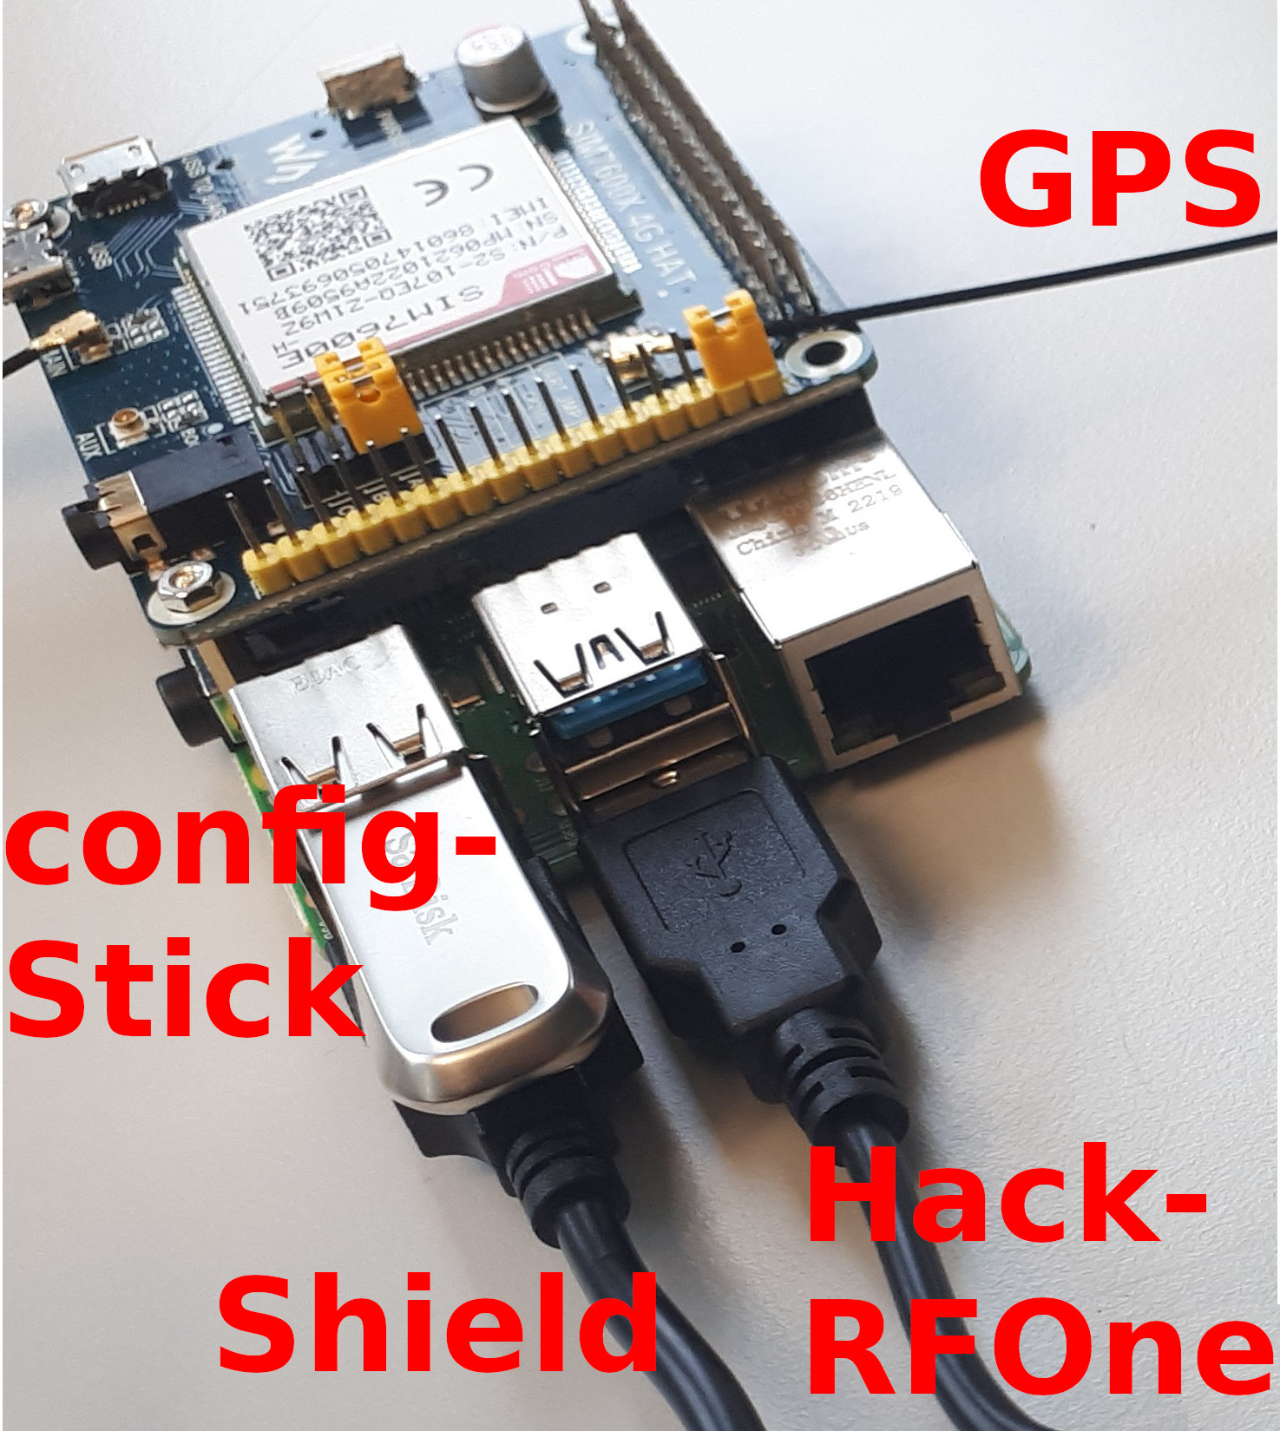
    - Connect the HackRF via a USB-cable to the Pi
(preferably to a USB-3 port of the Pi).
    - Connect the Iridum antenna to the HackRF One.
    - Ensure that the config USB-stick and the SD-card are inserted in the Pi.
    - Connect the Ethernet cable to the Ethernet port on the Pi.
(If you use PoE, put a PoE splitter between the Ethernet cable and the Pi. The splitter should be able to deliver 5V + 3A )
    - Connect the power supply to the Pi.
    - Place the Pi (with the shield) and the HackRF in the weather resistant DRI-box. The box has special outlets for the cables to prevent moisture to come into the box. On the outlets additional `hooks` can be mounted for securing the cable, to prevent the devices inside the box to be pulled out by the cables. Three cables should go from inside the box to the outside:
      - The power supply of the Pi.
      - The Iridium antenna.
      - The GPS antenna.
    - Close the cover of the DRI-box by using the clips on the left and right side. Place the box on a safe spot to prevent falling down (maybe use some zipties).
    - Place the GPS antenna. Usually the GPS-antenna can be placed inside close to a window, still providing a good GPS reception.
    - Power on the Pis power supply. The Pi should now boot and connect automatically to the networks server.

