

ECE 528/L

Robotics and Embedded Systems with Lab

Final Project
Simon Say’s Color Code
Lab Report

Leo Datta
Instructor: Aaron Nanas
Fall 2025

INTRODUCTION
This program serves as the main control logic for a color-sensing system built around the Digilent PMOD Color module and the MSP432 LaunchPad. Using the TCS34725 color sensor over the I²C interface, the application reads raw RGBC data, calibrates it, and classifies the detected color in real time. The system generates a random 4-colored sequence of 3-colors, displays that pattern to the user, and then evaluates each detected input to determine whether it matches the required sequence. Alongside color processing, the program manages onboard LEDs, motor movement, and timed events through SysTick interrupts, allowing the device to respond to correct inputs, incorrect attempts, and collision events. Overall, this code integrates sensing, actuation, and feedback into a cohesive pattern-matching and response system.
COMPONENTS USED
Table 1: Components used in Lab5 GPIO
COMPONENT DESCRIPTION | Qty
MSP432 LaunchPad | 1
USB-A to Micro-USB Cable | 1
TI-RSLK MAX Chassis | 1
PMOD Color Sensor Digilent | 1

ANALYSIS RESULTS
To ensure reliable detection, the raw RGBC values from the PMOD Color sensor were closely monitored and calibrated before use. The system captured repeated samples at 50 ms intervals, allowing the calibration routine to normalize variations caused by lighting, sensor drift, or surface reflections. By observing the numerical ranges of red, green, and blue outputs in real time, we verified that each color produced a consistent and distinguishable signature. Thresholds were then tuned so that green, red, and yellow could be cleanly separated, while unknown or noisy readings were safely ignored. This validation process confirmed that the sensor data was stable enough for pattern recognition, with minimal overlap between color clusters and predictable behavior across multiple trials.

Once the color values were verified, the detection logic implemented a structured sequence-recognition system. The program generates a random four-color pattern and displays it to the user with timed LED outputs. During operation, each measured color is passed through the detection function and then held briefly to eliminate flicker or noise. The CheckPattern routine compares the detected color to the expected position in the sequence, advancing on correct inputs, granting access on full completion, or enforcing a reset after repeated mistakes. The system provides immediate feedback through LEDs and motor movement, creating a clear cycle of showing the pattern, waiting for user input, validating each step, and responding accordingly. This process demonstrated consistent and predictable performance, confirming the effectiveness of the detection thresholds and the overall pattern-matching design.

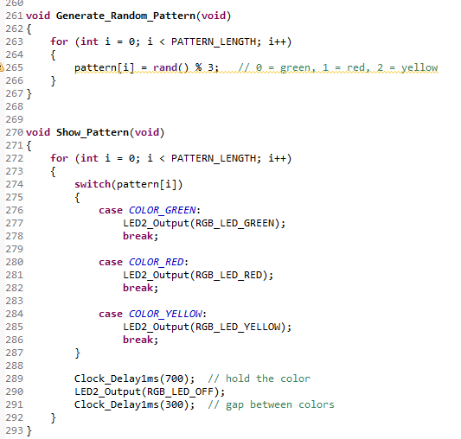
Figure 1: Generate_Random_Pattern() & Show_Pattern() functions in main.c
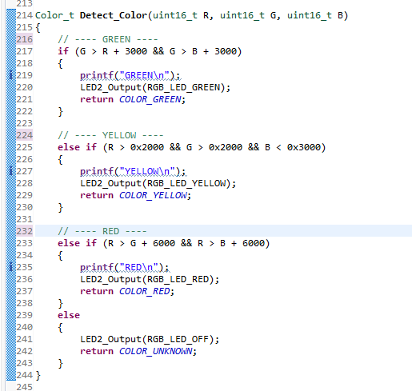
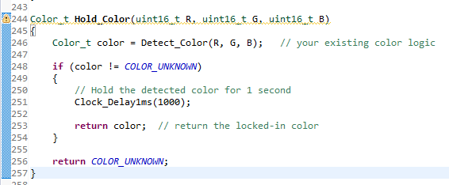
Figure 2: Detect_Color() & Hold_Color() functions in main.c
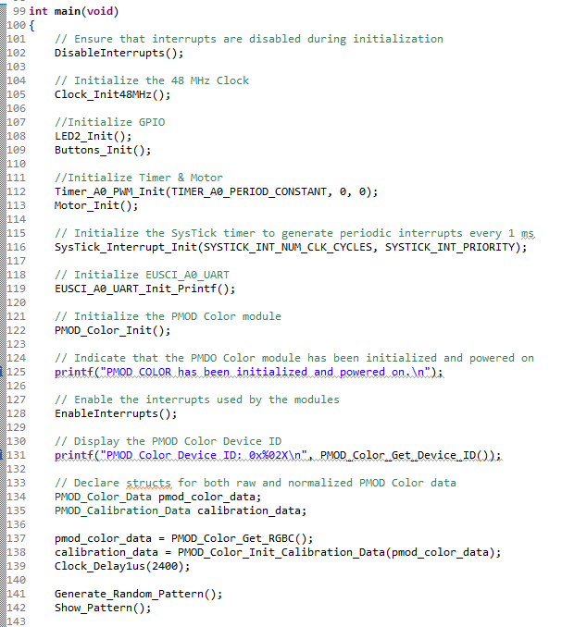
Figure 3: main() functions in main.c
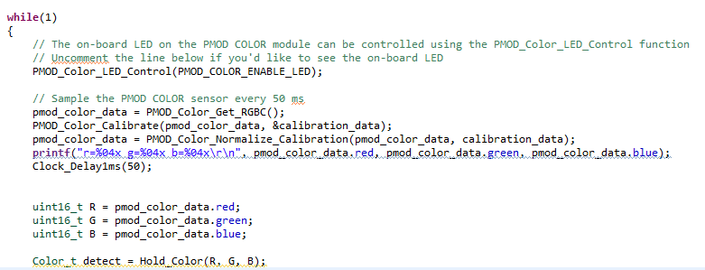
Figure 4: Polling Method in main() function

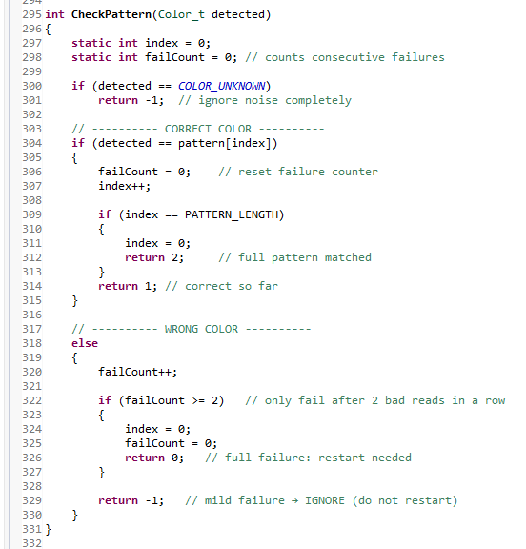
Figure 5: CheckPattern() in main() function
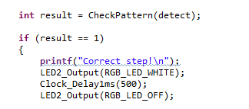
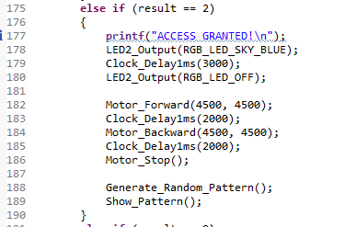
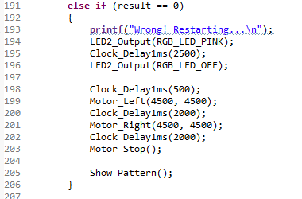
Figure 6: Result Checker in the while loop of Fig. 4

CONCLUSIONS
Overall, the system demonstrated a reliable and responsive integration of color sensing, pattern recognition, and motor control. Through careful calibration and validation of the PMOD Color sensor, the program was able to distinguish between colors with consistent accuracy, forming the foundation for a stable detection process. The sequence-generation and pattern-checking logic functioned as intended, providing immediate visual and mechanical feedback that reinforced correct actions and handled errors gracefully. By combining sensing, decision-making, and actuation into one cohesive loop, the project proved effective both as a functional demonstration of embedded color detection and as a robust interactive system capable of responding intelligently to user input.

